Camtasia for Screencasts
A Handout to Accompany the Presentation. Mark Morton and Alan Kirker
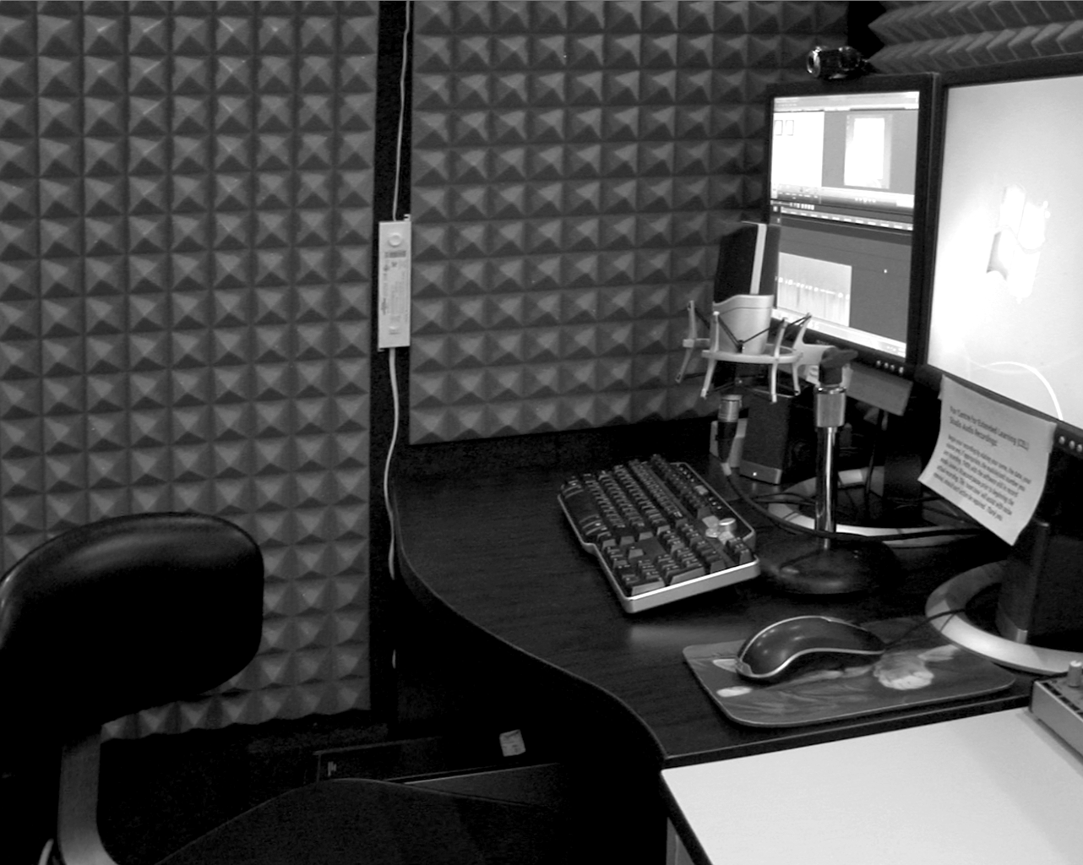
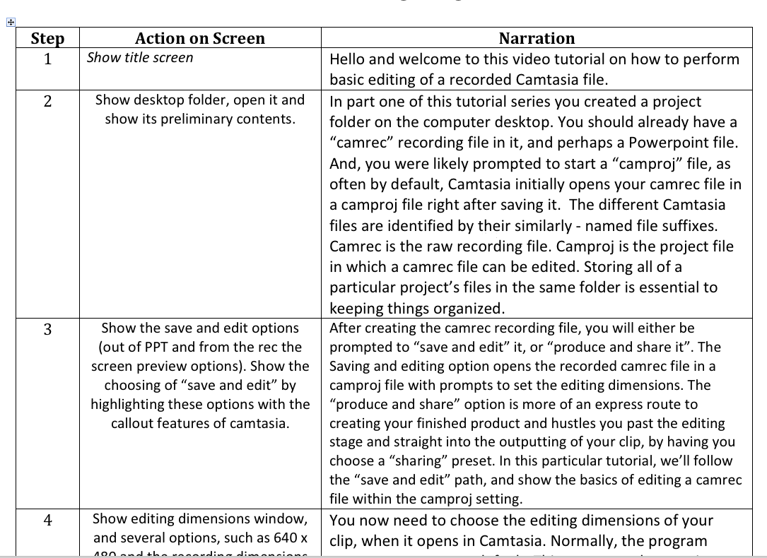

Preparing
- Depending on the nature of your project and how much time there is to invest, you may want to consider using a script.

- Having a quiet place to record and a decent microphone are essential. Consider booking the ITMS sound booth (pictured at right).
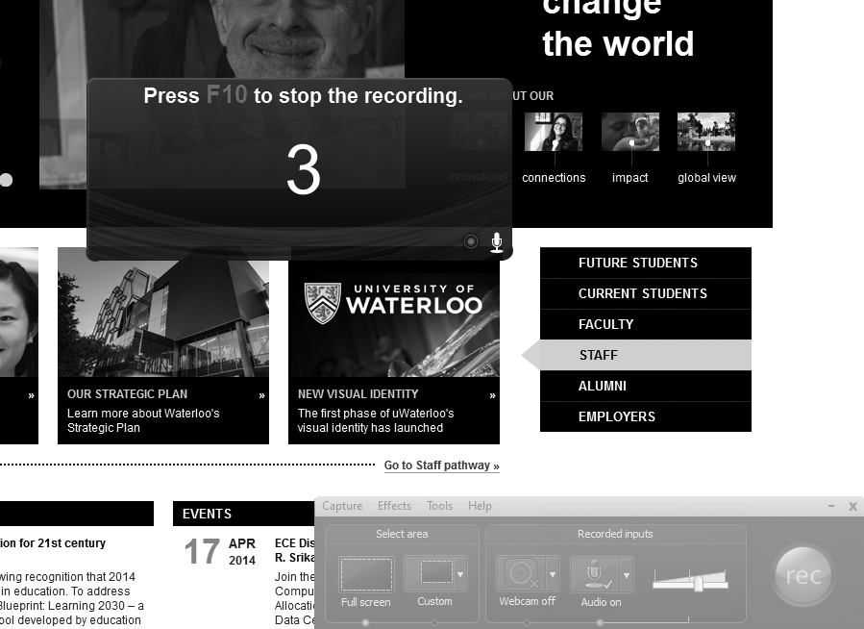

Recording
- Tidy your computer desktop and prepare a project folder into which all of the current project’s files will go.

- Briefly rehearse, or create a mental picture of what you’ll need to do as you begin recording. Have any documents or webpages to be narrated on screen, or minimized and ready to launch.

- Click the “record the screen” button within Camtasia to launch the Camtasia recorder (pictured above). Set microphone volume, begin narrating and, at the same time, performing any cursor or screen movements related to the narration.

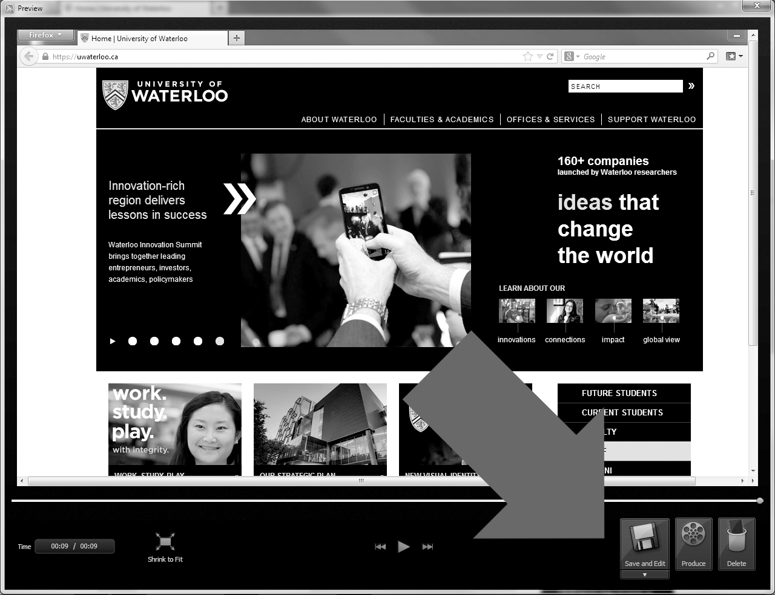
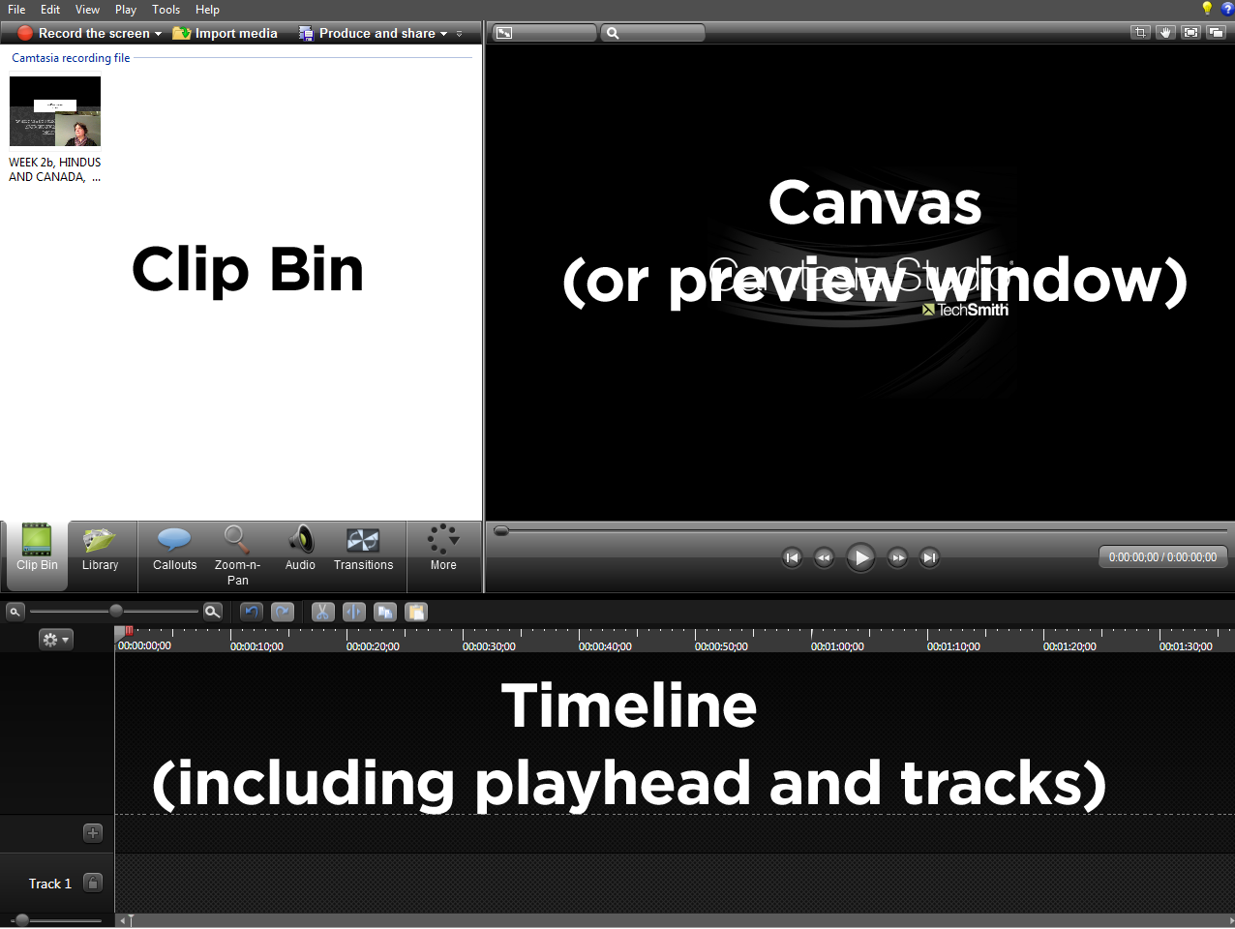
- Stop recording by pressing F10. The recording opens in a preview window (pictured below). Preview-play the recording and then choose the save and edit option. Save it to the project folder.

Basic Editing
- Become familiar with the main components of the Camtasia workspace (pictured, above, right): clip bin (or effect/function controls depending upon which tab is selected), canvas (or preview window), and timeline. Timeline editing tools (and magnifier tool) are located immediately above it to the left.
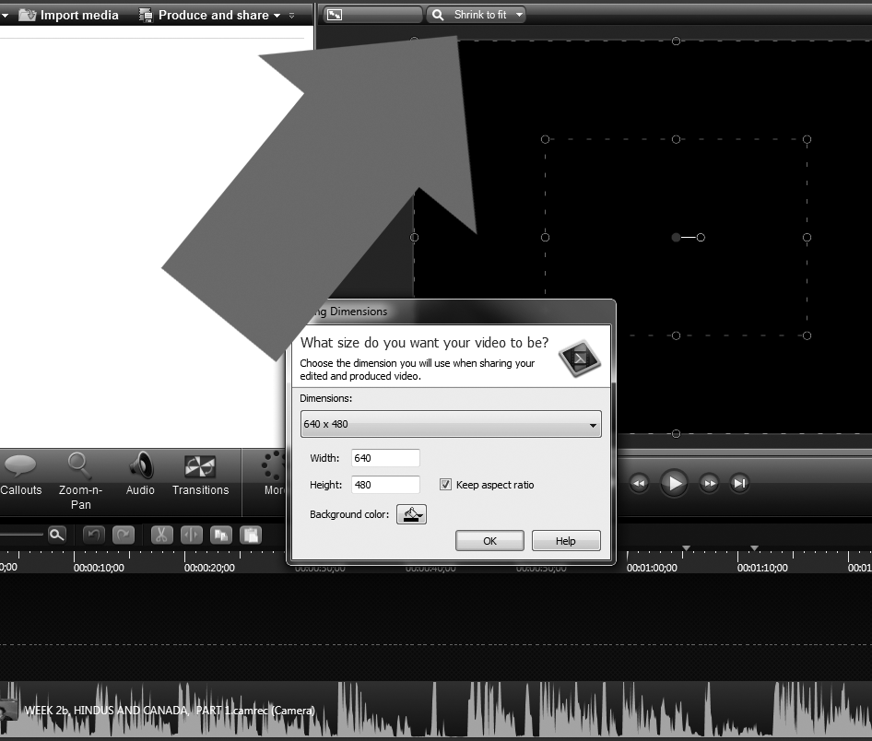
- When a recorded “camrec” file is automatically opened in Camtasia after recording, or you first drag a camrec or mp4 file onto the timeline, you are prompted to set a dimension for your project. If no prompts appear, select from the drop-down menu. For this demo, use the default. (The arrow in the picture at right indicates the location of this setting).

- The key feature of the timeline is the play-head. This can be moved to show a particular point in time of the tracks of the recording. Using the keyboard spacebar starts and stops the play-head. The point at which the play-head is at is shown in the preview window (or “canvas”).

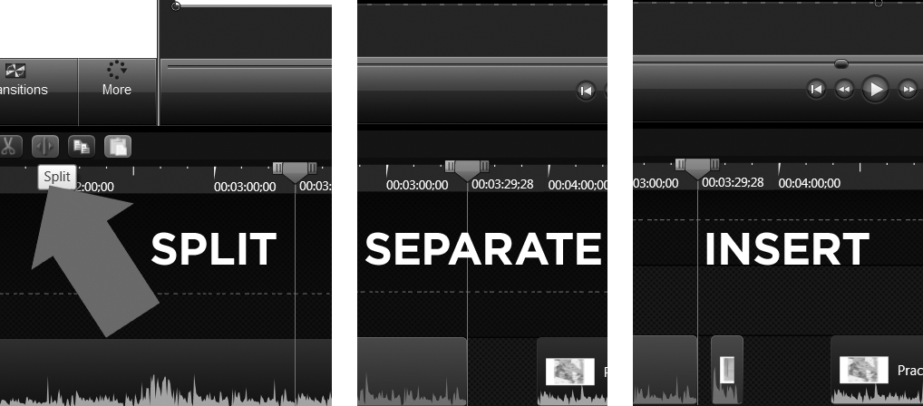
- Splitting a recording can be accomplished by first positioning the play-head at the point you want to split and selecting the clip on the timeline (note that it turns blue when selected) and then clicking the “split” button (The grey arrow is pointing to it in the picture at right). Once split, the pieces can be separated and (click-) dragged apart on the timeline. Another piece of recording can now be inserted in the space. Adjacent pieces can be click-dragged to close any gaps.

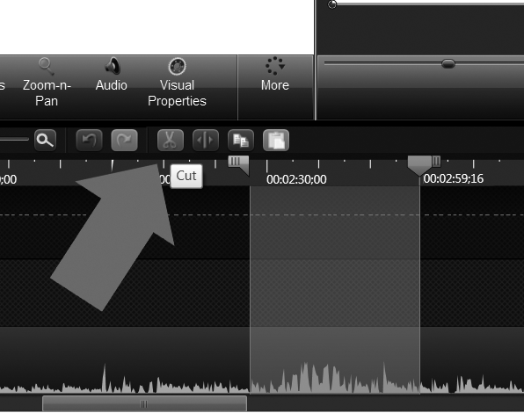
- Editing, such as the removal of an undesired piece of the recording is accomplished by positioning the play-head at one end of the piece to be removed and dragging either the red or the green tab at the top of the play-head in the direction of the piece-to-be-removed. A light-blue selection area will appear, delineating the area. (This is displayed in the image below-right as a light grey rectangular area).

The selection can be previewed (listened to / watched) by pressing the space bar on the keyboard. Adjustments to the selection area can be made by moving the respective coloured tabs that form the top of the play-head. When this area to be deleted is set, press the “cut” button (scissors icon, and pointed to by the grey arrow in the adjacent image). This removes the piece and “stitches” the adjacent ends together.

- To “deselect” an area of the timeline that has been selected in the manner described above, double-click on the grey, top-center part of the play-head. This will cause the selection area to retract. At some point early in the production, save your new project to the project folder.

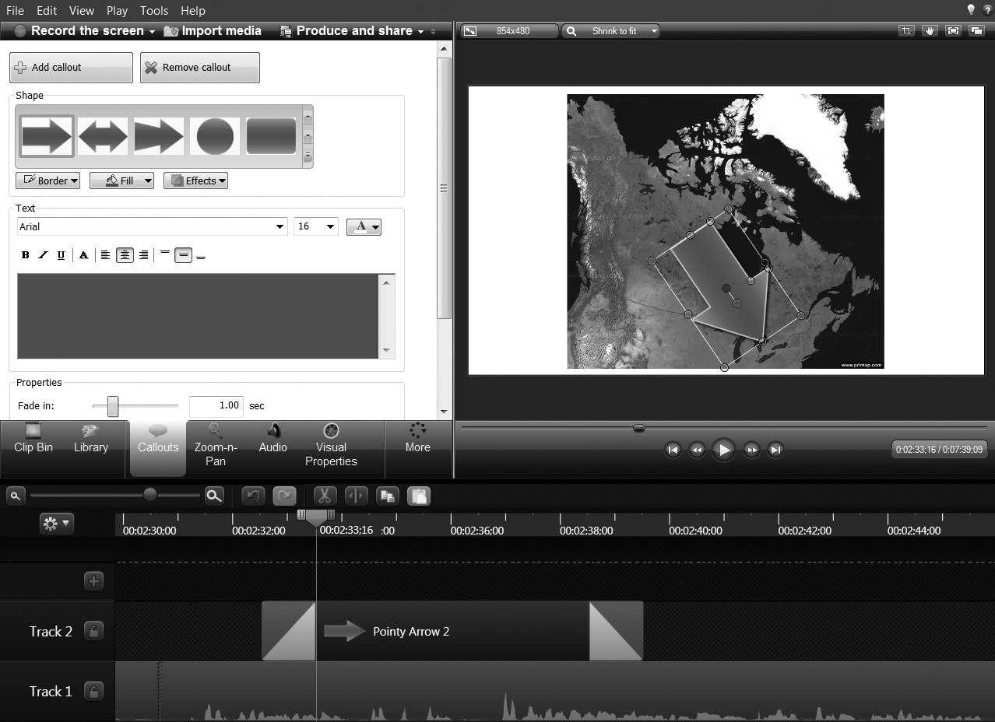
Adding a Callout or Title-card
- Add a callout by first clicking that tab under the clip bin and choosing a callout from the available selection. The callout’s parameters can be changed from the effect/function area (that now appears instead of the clip bin). Note that callouts and effects get placed on the timeline corresponding to where the play-head is. The call-out can be resized or rotated by first selecting it on the timeline, and then transforming its instance on the canvas by click-dragging the corner points, or rotating it by selecting its center point.

Similarly, a title-card can be added to the production by clicking the same callout tab and then choosing, for example, a rectangular shape, adjusting its parameters, adding text to it, resizing it, and so forth.

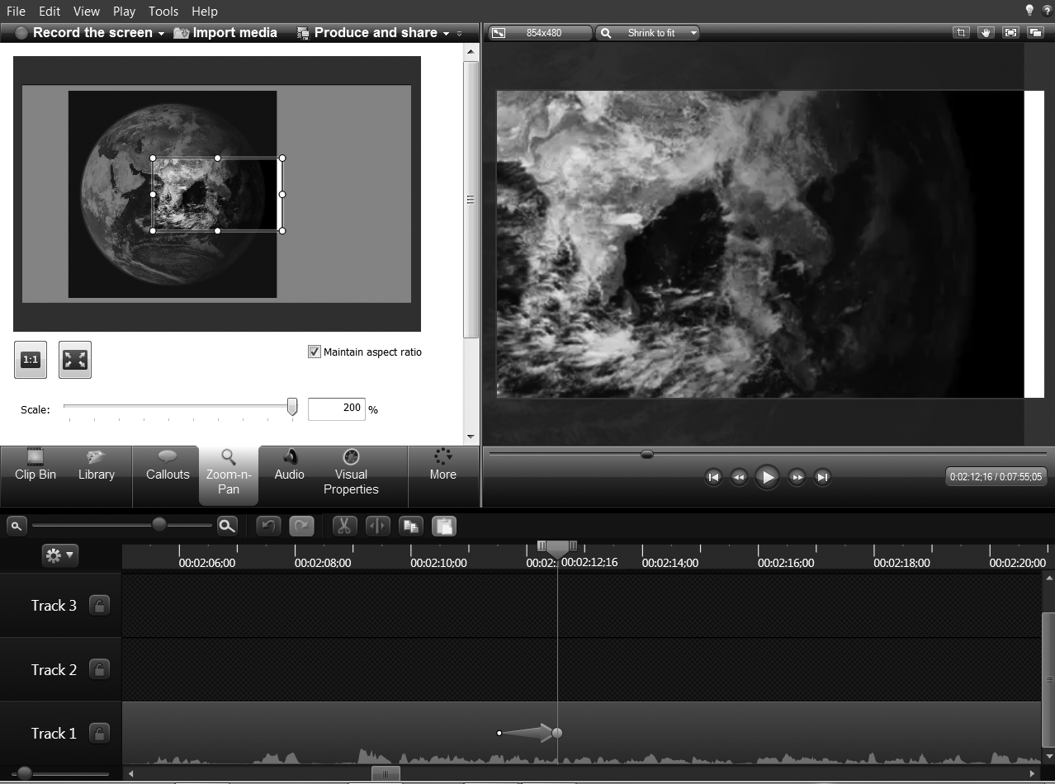
Adding Zoom & Pan Effects, Outputting
- To add zoom and pan effects, select that menu tab from beneath the clip bin. The zoom and pan parameters can be changed from the menu area that now appears instead of the clip bin. A small zoom marker appears on the timeline corresponding to the part of the clip. This zoom marker can be moved on the timeline to change its location in the recording. It can also be shortened or extended to change the speed at which the effect occurs.

- Finally, output your finished project by clicking the produce and share button that is located above the clip bin area. Select from one of the default settings or, if required, create a custom setting.

Additional Resources & Links:
- For in-depth Camtasia video tutorials, visit: www.techsmith.com/tutorial-camtasia-8.html
- Alan Kirker extension 37109.
- Mark Morton extension 37765.
- To book the ITMS sound booth: call the ITMS studio extension 36784.
- To inquire about microphone rental: contact ITMS equipment stores at extension 33257.
- To download sample script templates, and this handout, visit the SEW SharePoint.

