Centre of Research Expertise for the Prevention of Musculoskeletal Disorders
(CRE-MSD)

Highly Qualified Personnel (HQP) Travel Awards

April 2024

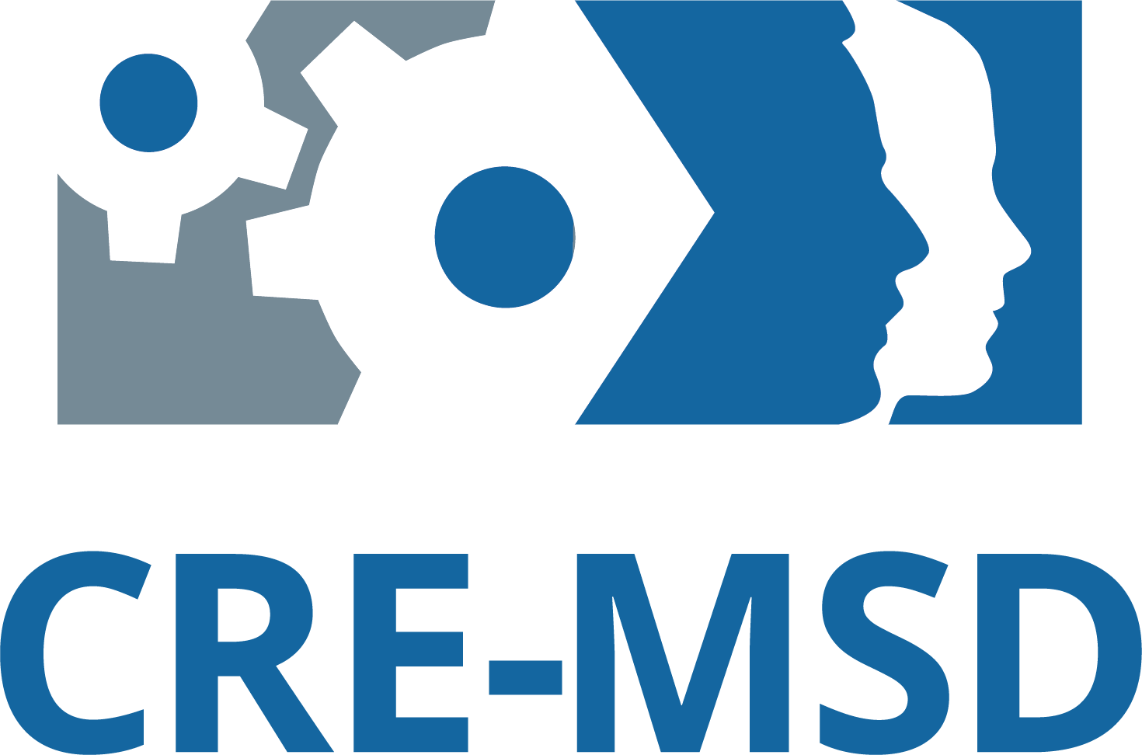
CRE-MSD HQP Travel Awards
In order to increase visibility of the Centre and provide support for the affiliated researchers who are a vital part of CRE-MSD, support is available for highly qualified personnel (HQP) working on projects under CRE-MSD researchers for travel to selected conferences such as the annual Association for Canadian Ergonomists conference; the annual Ontario Biomechanics Conference; the Canadian Association for Research on Work and Health conference; Conference on Prevention of Work-Related Musculoskeletal Disorders, or other approved events.

Questions regarding eligibility or the application procedures should be directed to Betina Butler at bbutler@uwaterloo.ca.

Eligibility:
All researchers who have been an applicant or co-applicant on a successful CRE-MSD funded project are eligible to sponsor HQP applications for funding. HQP are defined based on terminology from Canada’s tri-council of funding agencies and refers to people with highly marketable skills, including undergraduate and graduate students, as well as post-doctoral fellows.

Awards:
There are currently 15 awards available to HQP presenting work at a conference related to musculoskeletal disorders, with a maximum value of $200 each.

Application Process:
Students need to submit their abstract, a letter of support from their CRE-MSD research advisor and the completed attached application form with the one-page description of the project. The application must also include a proposed budget breakdown of conference expenses that can include travel, lodging, registration and food. Please Submit completed application packages to Betina Butler at bbutler@uwaterloo.ca.

Funding Priorities:
Submissions that meet the listed criteria will be given funding priority by the CRE-MSD evaluation committee. The following criteria are used for evaluation purposes and applicants are not required to meet all conditions.
- Abstracts that are based on work funded through CRE-MSD seed grants
- Preference will be given to less senior HQP to encourage involvement in musculoskeletal injury prevention research
- Applicants who have not received a previous travel award from CRE-MSD
- Applicants from more remote locations whose expenses to attend the meeting would otherwise be prohibitive
- Applicants working with Network Researchers (see the CRE-MSD website for a current list of researchers)
- Multiple applicants from the same project or research group will be considered, however preference will be given to distribute funding to all projects submitting applications.

CRE-MSD’s Expectations:
Travel expense forms can be submitted with required ORIGINAL receipts following the conference to a maximum value of $200. Awardees are expected to acknowledge the sponsorship of CRE-MSD during their presentation by displaying the CRE-MSD logo (the CRE-MSD logo can be obtained from Betina Butler). CRE-MSD may also place the abstracts of successful awardees on the CRE-MSD website.

CRE-MSD Student Travel Award

Name of Student: ___________________________________________________

Current Level of Education: _________________________________________________

Name of Advisor: ___________________________________________________

University: _________________________________________________________

Date (mm/dd/yyyy): _________________________________________________

With this form, please submit a one-page document outlining the following:
- Describe in detail why the study was conducted (i.e., the rationale)
- Elaborate on the significance of your results with respect to the prevention of musculoskeletal disorders
- A copy of the abstract submitted to the conference committee
- A proposed budget of expected expenses

NOTE:
To have your application for the CRE-MSD student travel award considered, your advisor MUST provide a letter of support, which needs to include a short discussion of the specific contribution(s) of the student to this study.

