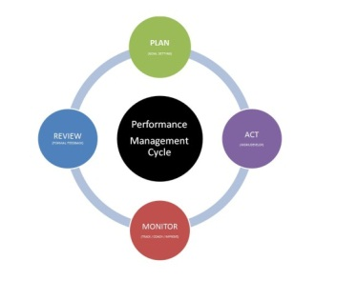
Performance Log

This form is a place for you to track your observations through the year.

NOTE: Remember to share your thoughts during the year with your staff

Employee Name:

Supervisors Name:

Date | Situation  (Positive, Negative, Neutral) | Outcome/ Results/ Action Taken

