Viewing Private, Secure reports with Mac Computers
Purpose: UWaterloo Mac machines are not maintained by IST at this time and hence may not have the required certificates to view confidential Tableau or Power BI dashboards that contain data sensitive/private reports on IAP’s SharePoint site.
Please ensure you are connected to the University’s VPN to view these reports.
To view these reports, users must enable certificates using steps outlined below.
How to enable certificates:
- Go to https://iap-tableau.private.uwaterloo.ca/
- Scroll down a little and click on Advanced and then click on Add Exception (Figure 1 for Firefox and Figure 3 for Chrome)
- A window should pop up. Click on Confirm Security Exception (Figure 2 for Firefox and Figure 4 for Chrome)
- To view the rankings dashboard, click here
Figure 1. Firefox browser:
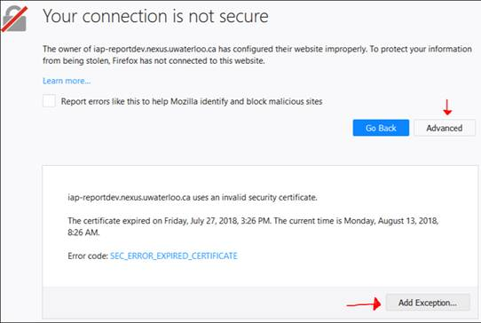

Figure 2. Firefox browser:
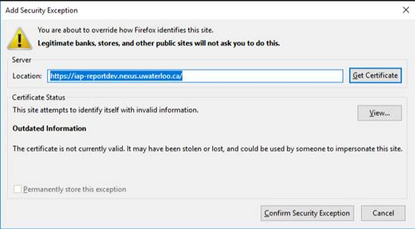

Figure 3. Chrome browser:

Figure 4. Chrome browser:

After following these steps, click on the SharePoint report link to the report again (for rankings, click here) and you should be able to view report.

