ADVISORY GROUP
Persons Living with Dementia and Care Partners

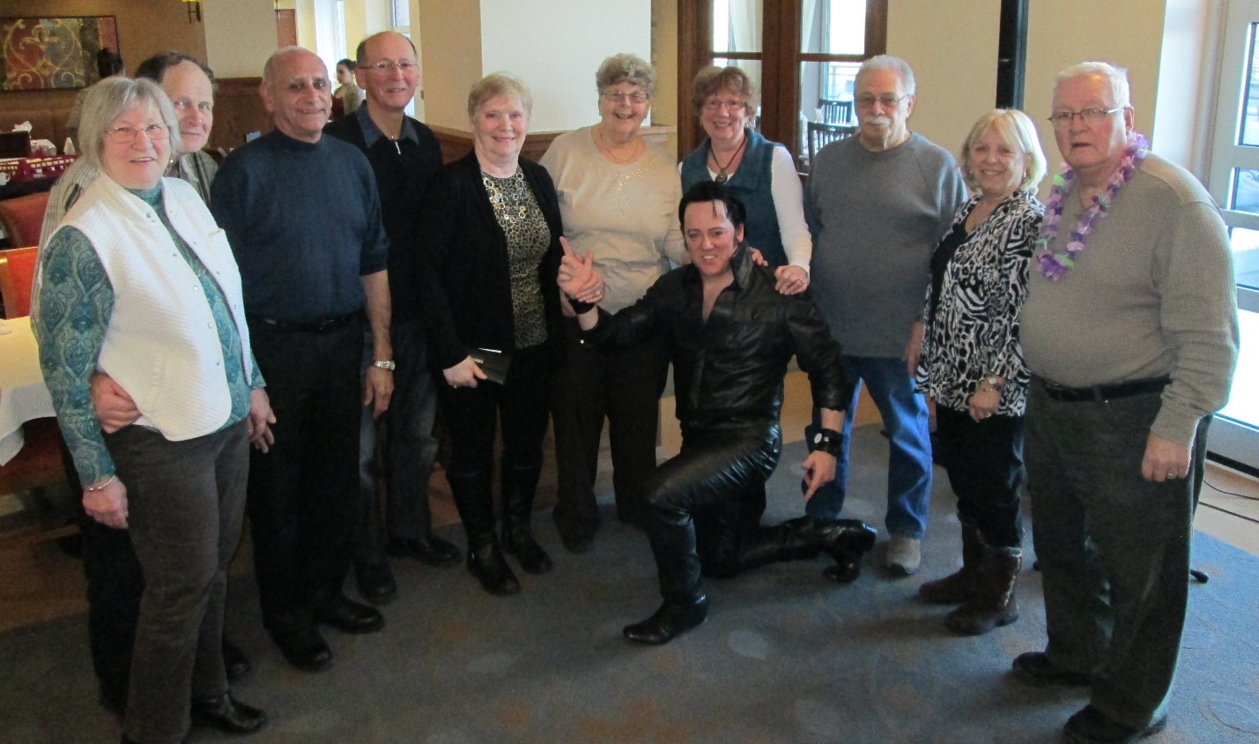
Memory Boosters Social Group
- A peer led social club for persons with dementia and their care partners, created in 2012 by Anne Hopewell, Ron Hopewell, Harry Gutoskie, and Bev McMillan.
- Goals:
  - provide a warm and supportive place for people with dementia and their care partners to socialize, relax, and have fun together.
  - share useful information, such as: educational seminars, adult day programs, and services.
Advisory Group Background
- The PiDC Alliance sent out a call inviting persons living with dementia and family members to come together and provide insight and feedback about their experiences living with dementia. A 12 member advisory group, comprised of six men with dementia living in the community and their spouses, was established. The group meets monthly and are strong advocates for the dementia cause.
Together they have:
  - Explored what supportive relationships look like
  - Examined what it means to live well with dementia
  - Wrote a story about their experiences in the Memory Boosters Social Club
  - Assisted with the development of a video on living well with dementia
  - Continue to have fun together and support each other

Memory Boosters – How we have fun!
Sample activities:
  - Visiting and socializing
  - Potluck lunches
  - Themed parties
  - Picnics and guided walks
  - Art workshops
  - Local attraction tours
  - Musical Guests
  - Reminiscence discussions
  - Games
  - Bowling

“Memory Boosters gave us an outlet to connect and expand our friendships, and to try some activities we may not have otherwise considered. It brought back some fun and he also felt an inspiration to help others.”

Memory Boosters – Why it works!
  - it’s social and fun (bowling, themed parties, music & dancing)
  - everyone is on a shared journey so there is a common experience
  - people care and often develop family-like relationships
  - it is a one-of-kind, strengths-based program
  - it has a flexible and open structure
  - it is a shared responsibility for creating a welcoming environment

“We don’t have to look for anything - we have it all here.”
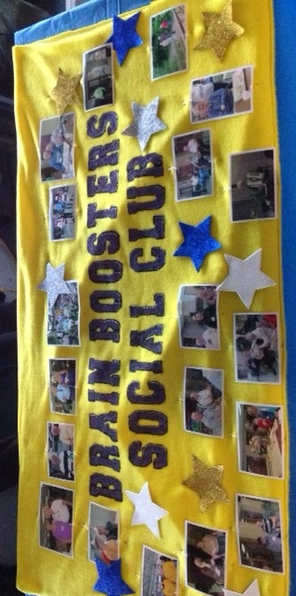
“We’re all on the same road. We all understand what we’re going through. And then you relax and you can be your silly self.”

