REACHING FOR NEW HEIGHTS Schlegel Villages
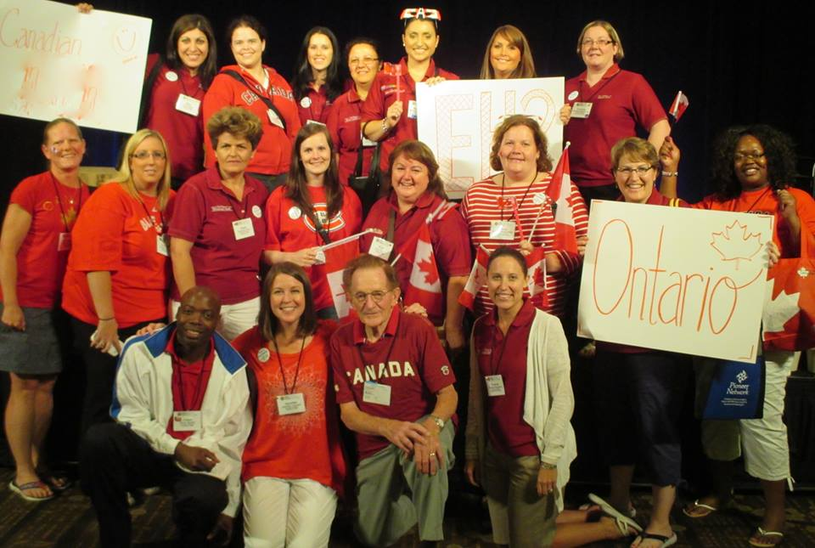
“My other favourite change is "Care-giver" to "Care Partner." Care-givers creates a relationship of co-dependence where we both have a role either as the giver or the receiver of care. I love that with Care Partners it indicates a mutual relationship where we care for each other and it transcends departments and instead makes us a real team of residents, families, volunteers, team members
...all in it together.”

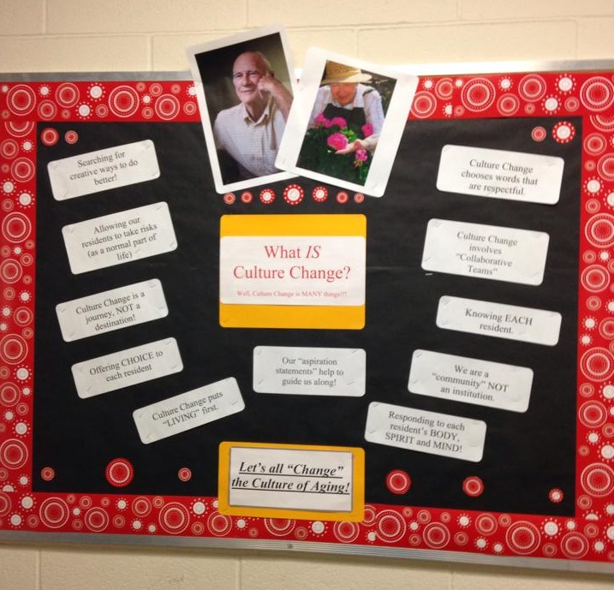
“We try to embrace our family members. We are privileged to have relationships with family members. And we want families to trust that when they go home that we are taking care of the resident.”

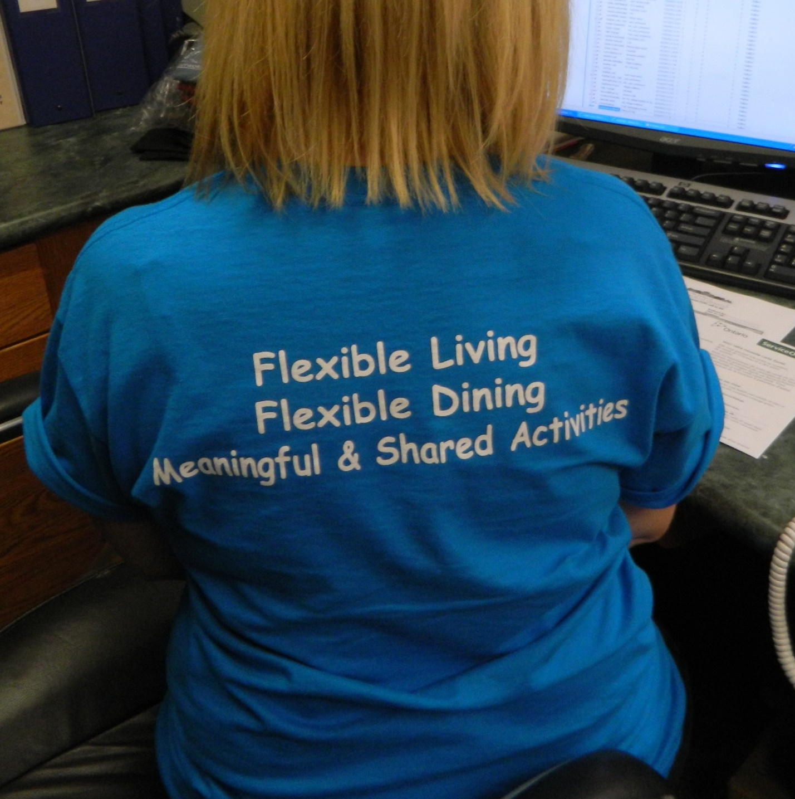
“I love the passion that newer members have as people join, they feel very excited, and they are excited to learn. We have been able to get new members to come to the committee. This means we are making a difference. The excitement is spreading. The excitement keeps us excited.”

