THE WILLOWGROVE DREAMWEAVERS
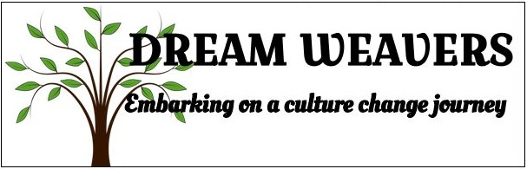

“We are evolving. There are changes happening now.”

“We work hard to include residents and encourage family involvement.”
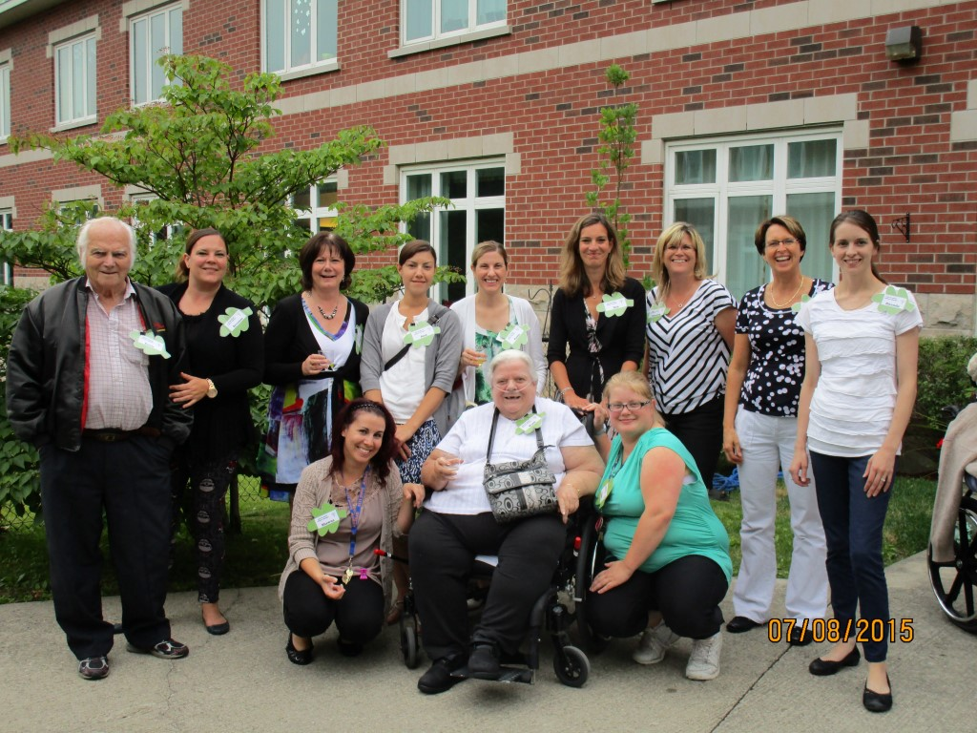
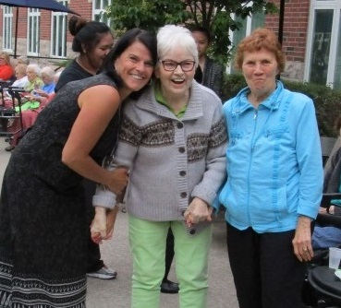
“It has really changed our mindset about how we approach things and it has brought to the forefront to take the task out of the job and to put the care into caring.”

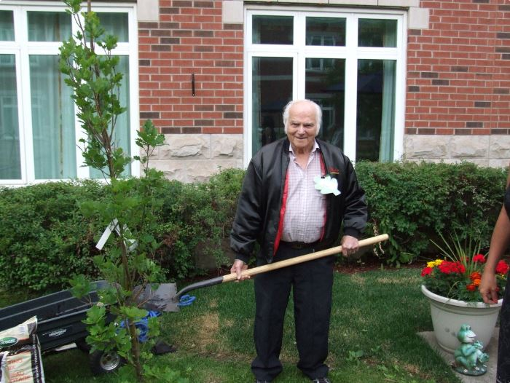
A resident planting the culture change tree.
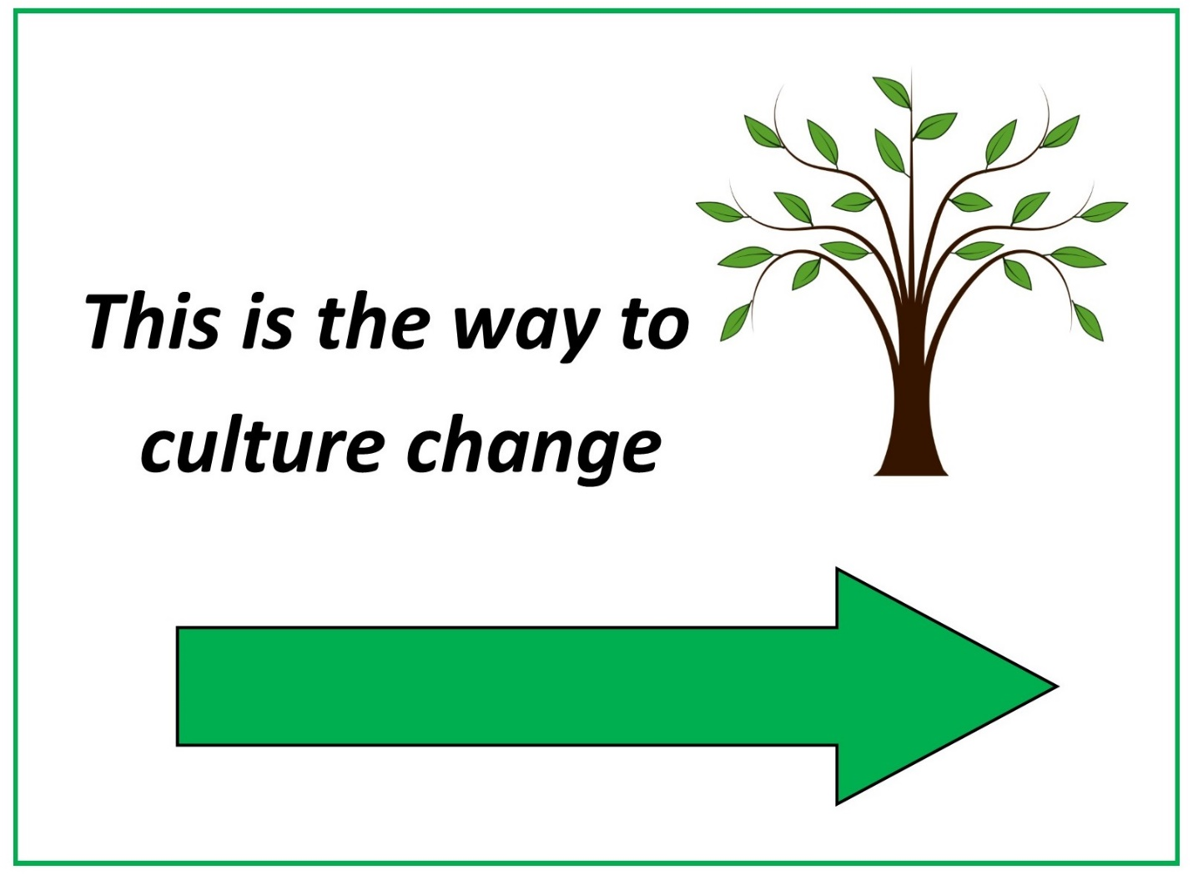
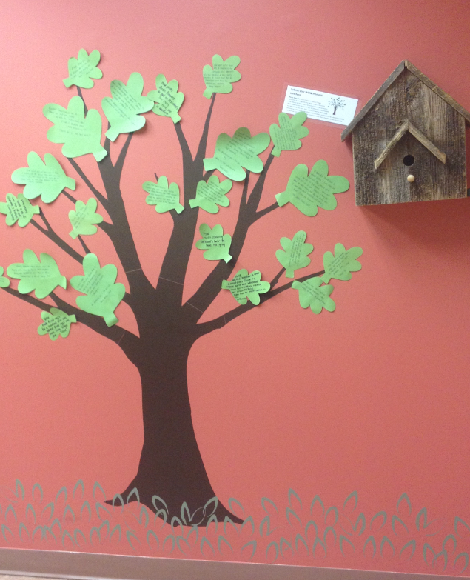
“Every day a staff member picks flowers and puts them in a resident’s hair, it makes the resident feel special and look beautiful.”
- WOW MOMENT

