YEE HONG CENTRE FOR GERIATRIC CARE - Markham
Yee Hong Centre for Geriatric Care
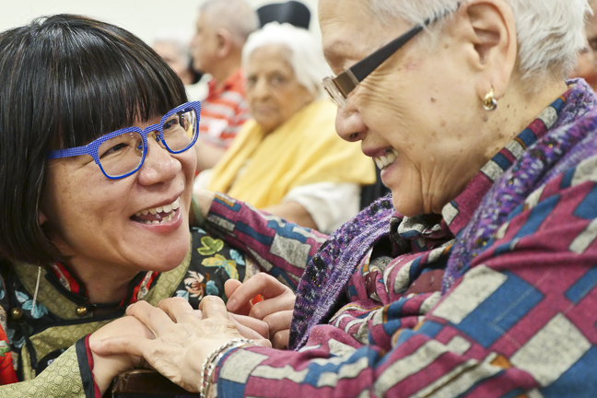

“[The process] shifts my mindset, not just based on the data, [I think] I should shift on the other side, other aspect, the emotional side of staff. When I look at all the comments from the family members, from the staff, from the community, and then I realize Yee Hong [has] a really good profile of care for the residents. So I’m so proud of the Yee Hong members.”

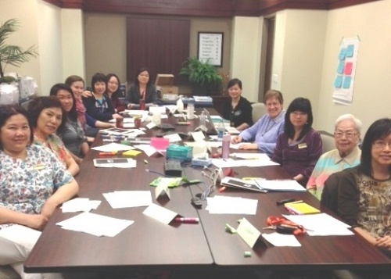

“[I’m] proud that we have been able to involve the residents in this project and find out how they enjoy their life at Yee Hong.”

We need to embrace strengths, identity and confidence -- but also recognize when we are not as strong -- so we can continue to be better and remain committed [to culture change].”
