Rationales and Data/Resources for Restricted Job Ads
PLEASE NOTE: The following document is intended as an example to guide hiring managers on the type of information and data expected to be included in a ‘Rationale for Restricted or Priority Job Advertisements’.
The information and data included are time bound. Efforts should be made by hiring managers to identify the most current data and information available tailored to the job ad for the Unit/Faculty.
Overview:
- University Commitments & Strategic Plans
- University Strategic Plan 2020-2025
- University of Waterloo’s Strategic Research Plan (no date)
- President’s Anti-Racism Taskforce
- Justifications
- Faculty (CRC) Justifications
- Recent Staff Job Ads
- Other Justifications
- Data
- Current Staff Data in the VPRI Portfolio
- Indigenous Student Data at Waterloo
- Labour Force Data
- Unit Level Responses
- Previous Efforts
- Equitable Hiring Practices

1. University Commitments & Strategic Plans
A. Strategic Plan 2020-2025
Page 18: Waterloo will make an impact on its campuses and around the world by fostering inclusivity, a sense of belonging and a culture of involvement.
The University is committed to living our shared responsibilities by building communities that imbue every aspect of our institution’s mission with genuine care and concern for our students, faculty, staff, alumni and the world in which we live. As a leading institution mobilizing knowledge and research related to the United Nations Sustainable Development Goals, Waterloo is committed to sustainability within and beyond our campus borders.
We include those who live and work on our campuses and in our alumni communities in Waterloo region and around the world. We particularly recognize Indigenous students, faculty, staff and alumni. We are committed to learning about the rich history and culture of Indigenous people of this land and an institutional response to the Truth and Reconciliation Commission’s calls for action.
Page 21: Goal: Promote and support Indigenous initiatives and a culture of equity, diversity and inclusivity for all.
Objectives:
- Embrace and act upon the Truth and Reconciliation Commission’s recommendations and calls to action and build stronger relationships with our local Indigenous community.
- Improve the representation, participation and engagement of equity–seeking groups within our community.
- Advance programs, policies and processes that foster equity, diversity and inclusivity.

B. Strategic Research Plan
Page 2: Theme of Understanding and Enhancing Human Experience
Waterloo researchers are exploring opportunities for social, artistic and cultural innovation in a rapidly changing world and the challenges this poses. They are looking for connection and commonality. They are exploring and promoting scholarship in the area of Indigenous culture. They are analyzing how technology and innovation can help knit humanity, with all its diversity, closer together.
Relevant Sub-Themes: Communication, technology and culture; Creative and scholarly innovation; Design of and experience with interactive media; Ethics, governance and politics; Human-centered technology; Identity: inclusivity, diversity, and equity; Risks, crises and conflicts of our time; Social impact of science and technology.
C. The President’s Anti-Racism Taskforce (PART)
The President’s Anti-Racism Taskforce represents a BIPOC-led team of advisors, who will help advance anti-racism initiatives at the University. Its activities will be driven by working groups and implementation teams, which are detailed below.
The Campus Representation Implementation Team:
Mandate: Beginning immediately, this team will develop a plan including how targets related to representation will be established, how targets will be reached, expected timelines, and finally will implement hiring plans.
Responsibilities:
- Review representation on campus.
- Develop and communicate an equity, diversity and inclusion (EDI) commitment statement, and a commitment to contributing to reconciliation by responding to the Truth and Reconciliation Commission’s (TRC’s) Calls to Action.
- Develop a strategy for addressing the impact of systemic racism in hiring, retention and recruitment processes that reflects best practice and includes a plan for mandatory anti-racism training for key stakeholders to be identified by this Implementation Team, including selection committees.
- Develop targets and review current state related to representation, with data presented at an aggregate level to ensure individual anonymity.
- Create a campus representation plan for meeting targets and key milestones for the plan.
- Communicate an annual report on progress made toward representation.
2. Justifications
A. Faculty (CRC) Justifications
- Canada Research Chairs Equity, Diversity, and Inclusion Action Plan – Update 2019
Waterloo aspires to be one of the top innovation universities in the world. As such, we aim to promote a culture of equity, diversity and inclusivity that supports a dynamic research environment with different perspectives, fresh ideas and new approaches. As we envision our future, increasing accountability and improving representation from the FDGs and the LGBTQ2+ communities in Waterloo’s CRC complement will be paramount – Page 5.
- Special Program Rationale for Restricted CRC Job Advertisements (from the Information and Best Practices for Canada Research Chair Selection Committees Guide 10-9-2020):
The target populations for this special program are women, Indigenous peoples and members of a visible minority as these groups have been identified by TIPS as being underrepresented in the CRCP Measures implemented by the CRCP to address the underrepresentation of these groups stem from a 2006 Canadian Human Rights Settlement Agreement. This agreement was reached between a group of eight academics who filed complaints with the Canadian Human Rights Commission in 2003. In 2017, at the request of the complainants, the 2006 Settlement Agreement was made a federal court order because they considered that not enough progress had been made in addressing the underrepresentation in the Program in the 11 years since the agreement had been signed. In lieu of a federal court process, the Program entered into a collaborative mediation process with the complainants and the commission to come to an agreement on changes to the settlement agreement that would address the inequities within the Program in a systemic, structural and sustainable way. The 2019 Addendum to the 2006 Canadian Human Rights Settlement Agreement outlines the new terms of the agreement.
The CRCP publicly acknowledges that members of the FDG face persistent and well-documented systemic barriers. The 2019 Addendum to the 2006 settlement agreement includes a number of changes to targets that will be staggered over 10 years. Waterloo’s special program for restricted CRC job advertisements will be available to Academic Unit Heads until 2029, or when targets have been met.
- Current wording on CRC job ads:
CRC Tier 2 in Indigenous Studies
The University of Waterloo regards equity and diversity as an integral part of academic excellence and is committed to accessibility for all employees. In order to address the underrepresentation of individuals from equity-seeking groups among our Canada Research Chairs, which has been identified through research (Canadian Association of University Teachers, 2018; Council of Canadian Academies, 2012; Henry et al., 2017; and Witteman, Hendricks, Straus, & Tannenbaum, 2019) to be systemic in nature, this hiring process will follow the provisions for a special program as described by the Ontario Human Rights Commission.
As such, this opportunity is open only to individuals who self-identify as an Indigenous person. Improving the representation, participation and engagement of equity–seeking groups within our community is a key objective of Waterloo’s Strategic Plan 2020-2025.

B. Recent Staff Job Ads
Note: For current information, please visit the Indigenous Relations website to learn more about the Indigenous Community at Waterloo.
Associate Director of Equity Job Ad: The University of Waterloo is seeking to prioritize candidates with lived experience, specifically those who identify as a member of the four designated groups: candidates who identify as racialized, Indigenous, women, a person with a disability; as well as members of the LGBTQ2+ communit(ies).
Senior Educational Developer, Indigenous Knowledges and Anti-racist Pedagogies Job Ad: To enhance the effectiveness of this activity, the ideal candidate will meet the articulated qualifications below and will be an Indigenous person (First Nations Status or Non-Status, Métis, and/or Inuit). Lived experience in an Indigenous community or communities is an asset. The selection process for this particular position will follow the provisions for a special program as described by the Ontario Human Rights Commission in order to address the underrepresentation of individuals from equity-deserving groups. Improving the representation, participation, and engagement of equity-deserving groups within our community is a key objective of Waterloo’s Strategic Plan 2020- 2025. As such, this position is open only to Indigenous persons (First Nations Status or Non-Status, Métis, and/or Inuit).
C. Other Justifications
- Lived expertise and a critical analysis with regards to the intersection of systemic oppressions and the elimination of inequities and racism.
- Lived experience as First Nations, Métis and Inuit, Black and/or a member of other racialized groups a to achieve credibility, and ability to connect and promote collaboration engaging others in the community, including groups who experience oppression and are racialized
- Ability to connect and engage based on credibility gained from critical analysis of lived experiences as First Nations, Métis and Inuit, Black and/or a member of other racialized groups.
3. Data
A. Current Staff Data in the VPRI Portfolio – As of January 11, 2021
From Tracey Crewe – Re: request for an equity scan for employees of the departments / committees reporting to the Vice President Research International.
The breakdown which I can provide, for all employees, is as follows:
Gender: 73% Female / 27% Male
Aboriginal Representation: 0.7%
Employees who are Visible Minority: 17%
Employees who identify as Disabled: 3.3%

The specifics related to the data used for the above is as follows:
- The data is representative as of January 11, 2021
- Employees on leave are not included in the analysis
- The data is based on the employee’s completion of the equity self-identification survey
- Of the total employee base included, 84% of employees have completed the self-identification survey

In summary, current representation of employees identifying as Indigenous Peoples across departments reporting to the VPRI is 0.7%, in comparison to the 1.4% availability of qualified members of that demographic group in the Canadian environment from which we recruit those employees (as indicated in Waterloo’s Workforce Analysis Report submitted in fulfillment of Federal Contractor’s Program Requirements).
B. Indigenous Student Data at Waterloo
Information provided by Jana Carson (Senior Manager, Institutional Evaluation and Accountability, Institutional Analysis and Planning) on July 16, 2021:
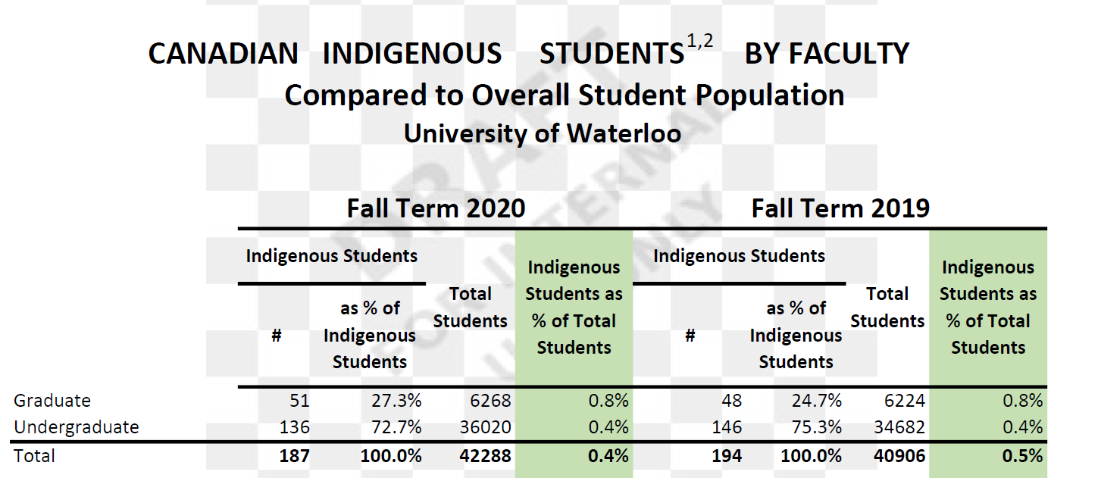
Other than self-reported survey data, Waterloo identifies Indigenous students by:
- OUAC declaration (university applications)
- Band sponsorship (from Finance)

C. Labour Force Data
- Unemployment rate of the Indigenous population in Canada 2016-2020

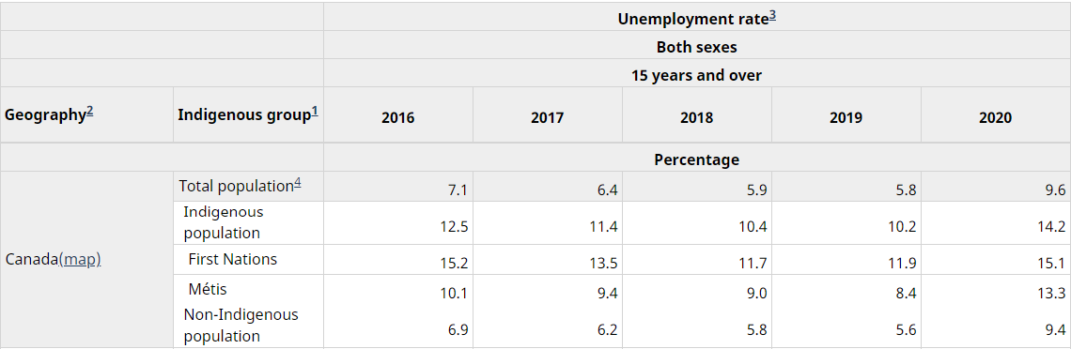
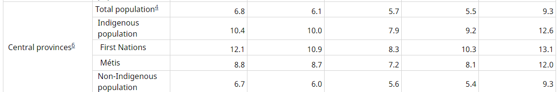

The screenshots from the table above shows the higher rate of unemployment for Indigenous groups, and in the central provinces (including Ontario), vis-à-vis the rate of unemployment for the non-Indigenous population.
- Statistics Canada Survey of Postsecondary Faculty and Researchers, 2019

First Nations, Métis and Inuit faculty and researchers accounted for 1.9% of academic community respondents. This is comparable with the share of university and college professors who reported an Indigenous identity in the 2016 Census: 1.4% of university and 3.0% of college professors. While the educational attainment of Indigenous people has been increasing, they are still less likely to have a degree at the bachelor's level than non-Indigenous Canadians. The highest share of Indigenous survey respondents was among college professors (2.2%).

- Summary of 2016 StatsCan analysis for the Waterloo Region and “catchment areas”: Toronto, Mississauga, Brampton (internally compiled).

Summary statements:
•In the 2016 StatsCan survey for Waterloo region, 8990 of 527345 individuals (1.7%) identified as Aboriginals.
•University certificates/diplomas/degrees at Bachelor level and above trailed the non-Aboriginal population 10.6% to 23.6%
•In the townships (Wilmot, Wellesley, Woolwich, North Dumfries), university certificates/diplomas/degrees at Bachelor level and above were comparable to the rest of the population- in the cities (Waterloo, Kitchener, Cambridge) that the results were poorest. That is, a focus on Aboriginal students in Cambridge/Kitchener/Waterloo could pay significant dividends.
•In a Waterloo’s main catchment areas (Region of Waterloo, GTA), the percentage of Aboriginal individuals who have a University certificate, diploma or degree at bachelor level or above is much less than that of the non-Aboriginal population, ranging from ½ to ⅓.
•Indigenous students at Waterloo come from many different regions, that is, they are not concentrated in the “catchment areas”.
•Compared to the Waterloo student population at large, Indigenous students tend to be older (does this mean that we have a higher than expected proportion of Indigenous Grad students?)
•Graduation rates for UG Indigenous students trails that of the overall population
•Retention rates for Indigenous students trail that of the overall population, although recent Retention Rates have been higher.

4. Unit Level Responses
A. Previous Efforts
The position of Manager, Research Program Development & Partnerships, Indigenous Initiatives was created in the Institutional Research unit to address the underrepresentation of Indigenous people and to increase specialized support for Indigenous faculty members. This new position would seek to fill a similar role.
B. Our Equitable Hiring Practices
We are part of various EDI efforts, including the Waterloo Awards Committee to implement an equitable recruitment and selection strategy to support increased representation from members of equity-deserving groups and Indigenous peoples.
The hiring strategy will include the use of equitable recruitment and selection strategies, beginning with job ads that use inclusive and ungendered language, a recruitment approach that leverages job sites and professional networks tailored to Indigenous candidates, selection criteria that respond to evidence of work in partnership with Indigenous researchers, and specific training provided to hiring panel members to ensure all members understand how to identify and mitigate their own unconscious biases. Indigenous representation will be included on the hiring panel to support an inclusive hiring experience, and to bring specific experience with the subject matter.

https://uwaterloo.ca/strategic-plan/sites/ca.strategic-plan/files/uploads/files/c017209-stratplan2019-simple-oct316_accessible-ua_59906.pdf
https://www.chairs-chaires.gc.ca/program-programme/srp-prs/waterloo-eng.pdf
https://uwaterloo.ca/anti-racism/contact-us/part-membership
https://uwaterloo.ca/research/sites/ca.research/files/uploads/files/september_27_2019_waterloo_eap_27_sep_2019_submit.pdf
https://uwaterloo.ca/research/sites/ca.research/files/uploads/files/caut_ad_for_tier_2_crc_indigenous_studies-25-feb-2021.pdf
https://www150.statcan.gc.ca/t1/tbl1/en/tv.action?pid=1410036501&pickMembers%5B0%5D=3.6&pickMembers%5B1%5D=4.1&pickMembers%5B2%5D=5.1&cubeTimeFrame.startYear=2016&cubeTimeFrame.endYear=2020&referencePeriods=20160101%2C20200101
https://www150.statcan.gc.ca/n1/daily-quotidien/200922/dq200922a-eng.htm

