Fire Extinguishers
Last updated: February 2023

USING Fire extinguishers in case of fire
- Quickly size up the situation and stay calm. Most fire extinguishers last approximately 10 seconds.
- Fire extinguishers are located near room exits or in hose cabinets in hallways.
- Get everyone out, pull the fire alarm. Call 9-1-1.
- If fire is small, use the appropriate extinguisher.
- Stay near the door so you have an escape.
- Stay low out of heat and smoke.
- Select the proper fire extinguisher for the job.
- Use the PASS technique with the appropriate fire extinguisher:
- Pull the pin or locking device.
- Aim low at the base of the fire.
- Squeeze the handle.
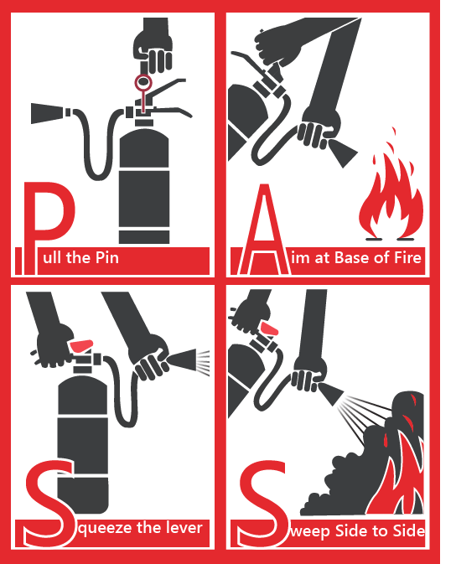
- Sweep the agent slowly and evenly at the base of the fire.
- Stay outside small rooms and shoot the agent into the room.
- Ventilate only after fire is out.

Servicing
People who use campus fire extinguishers, or notice that an extinguisher has been used or tampered with should notify Plant Operations immediately.

Choosing the right extinguisher
Selection, location, size and number of portable fire extinguishers is determined by the Ontario Fire Code and is based on the level of hazard, size of the space, and the quantity of flammable materials present.
- Be familiar with the type of extinguisher on hand.
- Do not use solely class A extinguishers on class B, C, or D fire.
- Multipurpose dry chemical extinguishers are recommended.
- Numerical ratings are also issued for class A (1-40), and B(1-640) fire extinguishers, the higher the number, the larger the fire that can be extinguished. Extinguishers with higher numbers are usually heavier.
- Install extinguishers in plain view, near escape routes, away from stoves or heating appliances.
Class of extinguisher | Class symbols | Materials to use on | Types of extinguishers
Class A |  | Ordinary combustibles: paper, cloth, wood, rubber, many plastics | - Water  - Multipurpose dry chemical
Class B | 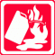 | Flammable liquids: oil, grease, gasoline, some paints, solvents etc. | - CO2  - Multipurpose dry chemical
Class C |  | Electrical: wiring, fuse boxes, electrical equipment etc. | - CO2  - Multipurpose dry chemical
Class D |  | Combustible metals: magnesium and sodium | Special Liquid or Dry Powder agent

Grading potential hazards
Additional fire extinguishers are generally not required unless the room is considered an extra hazard as per the Ontario Fire Code. If you feel the area meets the extra hazard definition below or you think you may require a specialized fire extinguisher (i.e. working with flammable metals), please contact the Safety Office for further information.

Light hazards – small fires

- Residences
- Apartments
- Offices
- Computer labs
- Lecture halls
- Study/theatre space

Ordinary hazard - moderate fires
- Kitchens
- Plant operations
- Electrical/mechanical areas
- Retail
- Workshops
- Studios and storage

Extra hazard - severe fires

- Woodworking shops
- Vehicle shops
- Extra hazard areas or labs (see table below)
- Paint booths

Hazard levels
Hazard level | Flammable or combustible liquid Class | Maximum quantity per 9.3m² (100ft²) outside storage cabinets | Maximum quantity per 9.3m³ (100ft³) including storage cabinets
Light | I | 4L (1.1 gal) | 7.5 L (2 gal)
 | I, II, IIIA | 4L (1.1 gal) | 7.5 L (2 gal)
Ordinary | I | 20L (5 gal) | 38L (10 gal)
 | I, II, IIIA | 38L (10 gal) | 76L (20 gal)
Extra | Quantities above ordinary hazard maximum

