2014/2015 Annual Review
The Sandford Fleming Foundation
An organization devoted to the advancement of engineering education

University of Waterloo, E2 3336, Waterloo, ON, N2L 3G1
Sandford Fleming Foundation
sff@uwaterloo.ca
519-888-4008

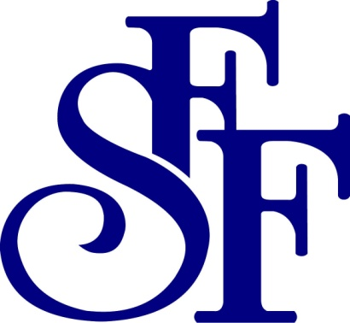
Inside This Review

Message from the Chair

Waterloo Campus Activities

National Activities

Information on the Foundation

Message from the Chair

It is amazing how fast a year passes. I would like to sincerely thank all of the members of the board for their efforts in the past year on behalf of our students. I would also like to thank Donna Armborst for her continued efforts supporting the Board and our students as office manager.
This past year, we welcomed our newest faculty board member, Bryan Tripp (SYDE), to continue our efforts to enhance the engineering student's educational experience.‎ A year ago, my role changed from Vice-Chair to Chair, a role that I would only hold for a year having been on the board for 5 years already. Now at the end of my sixth year, I'd like to start by thanking Steve Lambert who invited me to be part of this great Foundation. I'd also like to thank Bill Bishop, who like me, joined six years ago and will be stepping away from the Board after this year's Annual General Meeting. Bill has been immensely important to the Foundation, being responsible as Chair of the Waterloo Campus Committee of the Sandford Fleming Foundation. The Board, as a result, will undergo changes again this year. As we set out two years ago as part of our long term planning strategy, Steve Waslander (ME), who filled the role as Vice-Chair this year, will be putting his name forward to be Chair of the Board for the upcoming year. Steve Lambert (ME), a former chair, will be putting his name forward to be the Waterloo Campus Committee Chair.
Another significant change happened this year as Bill Wilson ‘retired’ from his position as Secretary of the Wighton Fellowship. I’d like to take this opportunity to thank Bill for all of his years of service (including being a former chair of this Foundation). In recognition of his years of service, the current Board voted in favor of making Bill Wilson a member for life. To replace Bill as the Secretary of the Wighton Fellowship, we have enlisted Waterloo’s former Associate Dean Undergraduate, Wayne Loucks. I’d like to extend a warm welcome to Wayne and his continued dedication to the Engineering undergraduate experience.
The Sandford Fleming Foundation continues to strongly support and promote a wide range of engineering educational activities that go beyond the classroom: oral and written communication, co-op work term performance, academic excellence, outstanding leadership, and participation in community and professional activities both inside and outside the university. The details of these activities are included throughout this Annual Review.
The quality of our engineering education depends on excellence in teaching. SFF is pleased to partner with the Dean of Engineering in the support of the Engineering Teaching Excellence awards. The winners of this year’s awards are Sean Peterson (ME), James Craig (CivE), Alex Wong (SYDE). Congratulations to these exceptional teachers and leaders.
SFF recognizes the importance of student leadership; we typically support 3 leadership awards each year. This year, Annamaria Reda (Chemical Engineering) is the recipient of the John Fisher ‎Leadership Award, Jacob Terry (Nanotechnology Engineering) was the recipient of the Roy Duxbury Leadership Award, and Diana Dickson (Management Engineering) was the recipient of the Memorial Leadership Award.
Congratulations to the many winners of the Work Term Report awards, the Academic Excellence and Cooperative Proficiency awards, the SFF-WCDE award for the best case study, the Sandford Fleming Debates, the Technical Speaker Competitions, and the Teaching Assistant Excellence awards. These awards recognize the excellence of our students in a broad range of activities associated with engineering education and represent the essential core of the Foundation’s activities. Many of these students will be recognized at the annual Faculty of Engineering Awards Dinner.
Finally, I would like to thank Dean Pearl Sullivan for her continued support of our activities. The Foundation would not exist but for the support of the Dean’s office.
Marc Aucoin, Chair

Waterloo Campus Activities
The Waterloo Campus Committee of the Sandford Fleming Foundation, chaired by Bill Bishop, maintains an active awards program at the University of Waterloo. Funds for the program come from student donations, faculty donations, and endowment earnings. The cost of awards and other programs of direct benefit to students during the past academic year was in excess of $55,000. Participation in SFF sponsored activities increased from previous years but there remains a continued need to ensure that awards and programs are fully utilized by students in the future. The foundation will strive to ensure that students at the University of Waterloo continue to recognize the value of the foundation and its many activities on campus in the coming year.

Teaching Excellence Award
The Teaching Excellence Award is presented annually to three professors who have shown an exemplary record of outstanding teaching, concern for students, and commitment to the development and enrichment of engineering education at Waterloo. Recipients are publicly recognized and funds are provided to enable each professor to appoint two Undergraduate Research Assistantships. One of these is funded by the Foundation, the other by the Faculty of Engineering. The 2015 winners are the following:
- TBA
- TBA
- TBA

Awards for Academic Excellence
The Sandford Fleming Foundation provides awards for Academic Excellence to students who display outstanding performance in the Engineering Undergraduate Program. 15 awards were given to students at the June 2015 Convocation.

Awards for Cooperative Proficiency
The Sandford Fleming Foundation provides awards for Cooperative Proficiency to students who display outstanding performance in satisfying both the academic and work term requirement of the Engineering Undergraduate Program. 13 awards were given to students from across engineering at the June 2015 Convocation.

Work Term Report Awards
The Sandford Fleming Foundation funded 28 of the work term report awards made by all Engineering Departments during the past year. These awards, granted for excellence in work term report writing, are made in all undergraduate departments in the Faculty of Engineering at Waterloo.

TA Excellence Awards
Each term, undergraduate students are invited to nominate TAs for a Sandford Fleming Teaching Assistantship Award. This annual award consists of a certificate and $500 and recognizes excellence in a most important aspect of teaching at Waterloo. The 2015 recipients were as follows:
- Junhua Gu, Chemical
- Nathan Grishkewich, Chemical
- Wei Jiang, Civil
- Hassan Ali, Civil
- Jeff Luo, Electrical & Computer
- Sakib Imtiaz, Electrical & Computer
- Mohamoud Allam Alsanbaway, Electrical & Computer
- Victoria Strong (nee Sirega), Mechanical
- Chris Kohar, Mechatronics
- Forough Pourhossein, Management Science
- Andrew R. Kacheff, Nanotechnology
- Gabriel Richard, Year 1 Engineering
- Christian Gould, Year 1 Engineering
- Srikajan Santhirakumaran, Year 1 Engineering
- Ryan Barrage, Year 1 Engineering

The SFF-WCDE Award for Best Case Study based on Work Term Experience
The Sandford Fleming Foundation is pleased to collaborate with Waterloo Cases in Design Engineering (WCDE) for this annual award. This is awarded to the student author of the best case study released in the previous year. The award includes a certificate and a $500 honorarium and is presented at the Faculty of Engineering Awards Dinner.
For this year, all case studies released in 2014 were considered and the selected recipient is Andrés Cárdenas of Mechanical and Mechatronics Engineering, for the case study “ArcelorMittal Press Structure Analysis”, co-written by David Effa of WCDE.

Memorial Leadership Award
The Memorial Leadership Award was established in 2010 in recognition of the late Professors Saip Alpay and Wm. C. Nichol, and Sam Ceccerallo, Robert Elligsen, late former students of the Faculty of Engineering. This award is granted to an intermediate-level undergraduate student in the Faculty of Engineering who has demonstrated outstanding contributions to the Faculty in extra-curricular activities. The award includes a certificate and a $1,000 honorarium.
The 2015 winner is Diana Dickson of Management Science.

Undergraduate Travel Grants
Often there is little or no financial support for undergraduates to attend scholarly or professional conferences or to participate in competitive team projects. SFF recognizes four eligible categories for funding. First and foremost is the desire to assist in the presentation of students’ work at technical conferences. Second, smaller awards may assist with conference fees for students, who are attending a conference but not presenting. Third, if there are team projects in which a Waterloo team competes with student teams from other engineering schools, SFF may assist in team travel to the place of the competition. Finally, there is some support for attendance at conferences that emphasize the engineering profession (rather than technical projects). The Sandford Fleming Foundation’s annual budget for this activity was $7,500 this past year. Travel grants given in the past year included the Year included the American Physical Society Meeting in Baltimore, MD, the Global Vision Arctic Youth Ambassador Forum in Iqaluit, Nunavut, the ASCE Steel Bridge Competition in Westpoint, NY and the International Submarine Racing Competition in Bethesda, Maryland.

Exchange Program Awards

Dr. F. Hecker Exchange Scholarship
This scholarship is given annually to an outstanding undergraduate Engineering student at the University of Waterloo who is participating in one of the Faculty’s student exchange programs. It honours the contribution of Dr. Hecker, Technische Universität Braunschweig, who was co-ordinator for two decades of exchanges with his university and who was noted for his dedication to those programs and the particular care he took of the Waterloo participants.
The recipient of this scholarship is Nissrine Bouslama, Civil Engineering.

SFF Exchange Scholarships
The Foundation has established up to eight other exchange scholarships that are given annually. The winners for 2015 are the following:
- Chengyao Li, Mechanical
- Marc Jaikissoon, Nanotechnology
- Vincent Zhu, Chemical
- Nidhi Juthani, Chemical
- Adrian Kovacevic, Software
- Akshay Budhkar, Computer
- Dhruv Guliani, Mechatronics
- Alexandru Ardelean, Civil

Other Activities Supported

Iron Warrior
The Waterloo Campus Committee of the Foundation supports the Engineering Society through the purchase of advertising space in the Iron Warrior. The advertisements describe the Foundation’s programs and give the names of award winners. This is the Foundation’s chief publicity outlet on campus.

The Faculty of Engineering Awards Dinner
This event features a noteworthy speaker and provides recognition for the large number of engineering students who have won awards and scholarships over the past year.

Co-operation with the Engineering Society
Two or more Engineering Society directors sit on the SFF Board of Directors. The SFF Board considers the student director’s contributions to be vital in determining the needs of the undergraduate students and highly values their assistance.

John Fisher Leadership Award
The John Fisher Leadership Award was established by the Sandford Fleming Foundation in recognition of the outstanding contributions made towards the work of the Foundation by a former Chair, Dr. John Fisher. This prestigious award is made to a graduating student who has shown outstanding leadership throughout his/her academic career in activities that relate to engineering education. Since its establishment in 1981 the award has been given 29 times.
Annamaria Reda (Chemical Engineering) was chosen to receive this year’s Fisher Leadership Award in recognition of the exemplary leadership, commitment and enthusiasm displayed in a wide range of activities, including:
- the Engineering Federation Orientation Committee and Orientation Week, where she played many roles from being a Huge (Orientation Week Leader), to being a Director, to managing a team of 350 leaders to welcome groups of over 1500 first year engineering students;
- the Engineering Society, in her role as Vice-President Internal, where she oversaw and supported directors and events organized for the student body, as well as worked on bringing back the Interview Skills Workshop for First Year Engineering students;
- EngPlay and TalEng, where she took on the role of Director for these events; and
- Women in Engineering, where, she mentored incoming students but also served as a role model by leading by example.

During her time at Waterloo, Annamaria has continually been active in leadership roles and is extremely worthy of receiving the John Fisher Leadership Award.

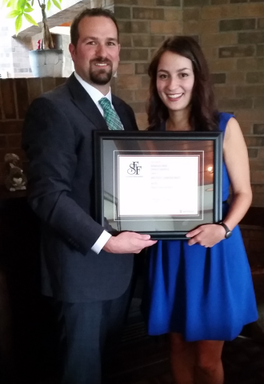
Figure 1: 2015 John Fisher Leadership Award Winner Annamaria Reda with Marc Aucoin, SFF Chair (photo credit – Bill Bishop)

The Roy Duxbury Leadership Award
The Roy Duxbury Leadership Award was established in 2011 to recognize the valuable contributions of Dr. Roy Duxbury, a former Chair of the Foundation. Like the John Fisher Leadership Award, this award is granted to a graduating student who has shown outstanding leadership throughout his/her academic career in activities that relate to engineering education.
Jacob Terry (Nanotechnology Engineering) was chosen to receive the Duxbury Leadership Award in recognition of the exemplary leadership, commitment and enthusiasm displayed in a wide range of activities. Most notably, Jacob has used his gift of communication to distinguish himself as a leader.
Within the Engineering Society, Iron Warrior, Orientation and Graduation Committee, Jacob held positions requiring him to be able to truly communicate to others such as being the Communications Commissioner for EngSoc, Writer and Editor-in-Chief for the Iron Warrior, Book Director for the Federation of Students and the Editor of the Engineering Yearbook. Within these roles Jacob: redesigned a first-year handbook; maintained and monitored communications to over 800 students; wrote and, provided constructive feedback on what other people wrote, for the Engineering newspaper; and assembled and organized stakeholders to collate the adventures of classmates created in the last 5 years.
Jacob is an extremely worthy winner of the Roy Duxbury Leadership Award.
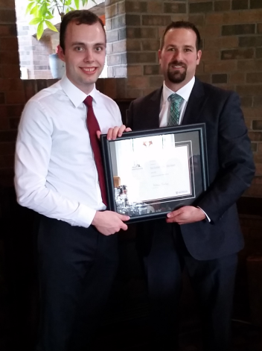
Figure 2: 2015 Roy Duxbury Leadership Award Winner Jacob Terry with Marc Aucoin, SFF Chair (photo credit – Bill Bishop)

Qualifying Competitions for the Ontario Engineering Competition
These awards were developed to support the Waterloo Engineering Competition (WEC), used to help select the two teams that will represent University of Waterloo at the annual Ontario Engineering Competition (OEC). The University of Waterloo sends two teams to represent both streams of our engineering programs.

Design
There are three competitions: the Junior Design Competition, the Senior Design Competition and the Consulting Engineering Competition. The winning teams for each of these competitions share a $500 award, with $250 going to the second place teams. The Sandford Fleming Foundation provides the awards for these three design competitions.

Programming
For the first time, WEC has introduced a new Programming Competition to help select student teams to represent Waterloo at the new Programming Competition at OEC. SFF is very pleased to support this new event in the same manner as the existing design competitions.

Debates
The Sandford Fleming Foundation has established these awards to encourage the art of debate among engineering undergraduates. The debates are normally held each term and the winners of this competition represent University of Waterloo at the OEC. The Foundation would like to thank Professor Bill Bishop of Electrical and Computer Engineering for acting as the debate coordinator, along with the many faculty members who volunteer their time to make the debates a success.
Spring 2015 Winners:

1st Place:
- Graham Bleaney, SYDE
- Ali Vira, SYDE
2nd Place:
- Christian D’Cruz, CHEM
- Jennifer Cerullo, CHEM
Rookie Team:
- Nolan Dey, SYDE
- Cole Jackes, SYDE

Technical Speaking
The Technical Speaker Competition was established to encourage public speaking skills within the student body. The presentation is to be based on a work term experience and the winners of this competition represent University of Waterloo at the OEC. The Foundation would like to thank Professor Jason Grove of Chemical Engineering for acting as faculty coordinator, along with many other faculty members and graduates who have served as judges.
Spring 2015 Winners:
1st Place - Andrew Andrade, MTE
2nd Place - Ian Holstead, ECE

Endowment Fund Awards
The foundation acts as Trustee for three funds which provide awards for our students.

Karen Mark Scholarship
This award was established in 1989 by family and friends of Dr. and Mrs. J.W. Mark, in memory of Karen Mark. Karen Mark was a third-year student in Chemical Engineering at the time of her death. This scholarship of $1000 is awarded to a woman studying in the third year of an undergraduate engineering program at the University of Waterloo who has demonstrated outstanding academic achievement and involvement in student life. The 2015 winner was Clarisse M. Schneider of Software Engineering.

George J. Dufault Memorial Fund
The George Dufault Awards arise from a fund established by the Sandford Fleming Foundation from contributions made by faculty, staff, students, and friends in memory of the late Professor George Dufault of the Department of Electrical and Computer Engineering. Awards of $300 each are given to undergraduate students in Electrical and Computer Engineering for the best work-term reports in their class. Up to four awards are given each calendar year.

Donald J. Clough Memorial Fund
The fund was established in memory of Professor Donald Clough, the founding Chair of the Department of Management Sciences at University of Waterloo. Recipients of the Award are required to display superior scholarship during their first year of graduate studies in Management Sciences at the University of Waterloo. The award is valued at $300 and this year’s winner is Yangzi Jiang.

National Activities

Ontario and Canadian Engineering Competitions
The Sandford Fleming Foundation will be a Special Awards Sponsor starting in 2015 for the Ontario Engineering Competition and is a bronze sponsor of the Canadian Engineering Competition.

W.R. Petri Engineering Design Award
W. R. (Peter) Petri served as an Adjunct Professor in Civil Engineering at the University of Waterloo from 1977 to 1994. He owned his own structural consulting practice and was responsible for many outstanding and innovative designs especially in the area of lightweight structures and the use of aluminum.

In his will, Dr. Petri left funds for the establishment of an engineering design competition to encourage and reward young engineering designers and to draw the attention of industry to the engineering design talent in Canadian universities. SFF administers the award and has arranged for the Canadian Engineering Competition (CEC) to include the Petri Award as part of its annual competition.

The 2015 W.R. Petri Engineering Design Award was given to the fourth-year nanotechnology engineering team of Kristopher Bicanic, Richard Garner, Matthew Mulvale and Adam Svatos, who also took second place in the Canadian Engineering Competition Innovative Design category for its microfabricated ion thruster design. The students devised their own nano-scale deposition method and thruster topology to maximize thrust and reduce the complexity of manufacturing. One of the most technically challenging projects at the Canadian Engineering Challenge, the team nonetheless was able to translate the complex deposition process into terms that could be understood by the diverse attendees and judging panel of the event. The design is being included in WATSAT-2, the microsatellite developed by the University of Waterloo Satellite Team for the Canadian Satellite Design Challenge. The winning team in the national challenge will have its satellite launched into orbit.
Figure 2: 2015 Petri Award winner Kristopher Bicanic, Richard Garner, Matthew Mulvale, and Adam Svatos with Professor Steve Waslander (Sandford Fleming Foundation)

Wighton Fellowship
The Wighton Fellowship is a national award to recognize excellence in the development and teaching of laboratory courses in Canadian undergraduate engineering programs. The award is funded by a generous endowment from Dr. J. L. Wighton, former Professor of Engineering, University of Regina, whose commitment to the laboratory component of engineering curricula led to the establishment of the Fellowship in 1986 in cooperation with the National Council of Deans of Engineering and Applied Science (NCDEAS) and the Sandford Fleming Foundation. The Fellowship is administered by the Foundation.
The Fellowship consists of a $3,000 stipend and a certificate. The Wighton Fellowship Selection Committee consists of the Chair, Vice-Chair and Secretary of the National Council of Deans of Engineering and Applied Science (NCDEAS) and Wayne Loucks, the Secretary of the Wighton Fellowship. Their efforts on behalf of this important award are much appreciated.
The Sandford Fleming Foundation is pleased to announce that Dr. Amar Sabih of McGill University was awarded the 2015 Wighton Fellowship. The Fellowship is awarded annually to recognize innovative and exceptional instruction in engineering undergraduate laboratory based courses. Instructors in Faculties and Schools of Engineering at Canadian Universities are eligible for nomination. Since its inception, twenty-ninth Wighton Fellows have been named.
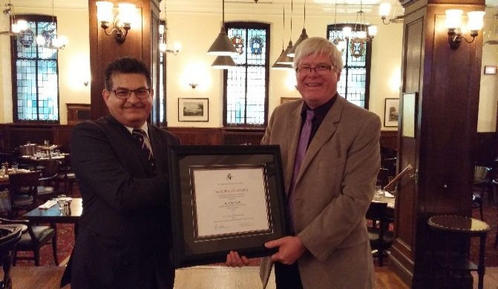
Figure 3: 2015 Wighton Fellow Dr. Amar Sabih with Dr. Wayne Loucks (Sandford Fleming Foundation)

The Foundation

Treasurer’s Report
The Foundation’s income is derived from donations by students and faculty and income from investments held in our Endowment funds. All funds raised at Waterloo and so designated must be used for Waterloo Campus Activities. Endowment fund investments are managed by TD Waterhouse Canada, a well-known firm of investment managers. The market value of our investments at June 30th, 2015 was $1,732,818. Investment income (interest and dividends) for the twelve months ended June 30th, 2015 was estimated at $53,141 or 3.25 %. Our investments continue to hold their value as well as providing sufficient income to cover operating costs.
Andrea Hagedorn

Life Members
The Sandford Fleming Foundation recognizes those who have supported its activities and objectives by their participation and interest through their designation as Life Members:
R. Brooks, C.M. Burns, P. Calamai, D.H. Copp, V.R. Duxbury, G. Farquhar, P. Fieguth, A.J. Fisher, R.A. Fraser, R. Gorbet, J. Hanson, J. Hooper-Yan, S. Jones, S.N. Kalra, J. Keeler, S. Lambert, W.C. Lennox, J. Metz, V. Ojala, H.C. Ratz, P.H. Roe, P. Rossignoli, R. Sadler, D.S. Scott, J.H. Shortreed, K.D. Srivastava, H. Sullivan, W. Weinstein, J. D. Weller, J. Westlake, J.D. Wheeldon, J.L. Wright. W. Wilson

Board of Directors 2014/15

Student Directors
- Adele Vickery (President A)
- Hanna Gautreau (President B)

Faculty Members
- Marc Aucoin, Chemical Engineering
- Bill Bishop, Electrical & Computer Engineering
- Steve Waslander, Mechanical & Mechatronics Engineering
- Bryan Tripp, Systems Design Engineering

Community at Large
- Phil Bezaire, Student and Faculty Relations
- Robin Jardin, Student Relations, Dean of Engineering Office

Co-op Student Employer
- Chris Metaxas, EBS Geostructural

Executive Secretary and Treasurer
- Andrea Hagedorn

Office Manager
- Donna Armborst
E2-3336
Telephone: 519-888-4567 ext. 84008

Office Hours:
Monday & Wednesday, 10:00 a.m. – 1:00 p.m.

