Microsoft Word and the UWaterloo thesis template
The best way to ensure consistent formatting in a Word document is by consistent use of Word styles.
The style assigned to the current paragraph is indicated in the Home tab and in the Styles section.
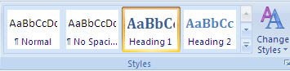
A document can contain many different styles, but most documents will have paragraphs of “Normal” style, which are standard paragraphs, and one to three levels of headings (Heading 1, Heading 2 and Heading 3).
- Heading 1 is used for chapter titles
- Heading 2 is used for section headings
- Heading 3 is used for subsections

The UWaterloo thesis template does this for you.

Using the UWaterloo Microsoft Word thesis template
The UWaterloo thesis template is designed for your thesis, or it may be a useful starting point to then modify.
To download and use the available UWaterloo thesis template:
  - Go to Graduates in Vision Science (GIVS) website: > resources > thesis-defense-checklist > thesis-templates
  - When prompted, click on the Save button.
  - (In the Save As window you may have to rename the extension to .dotm
  - Click on Save.
  - A new document will open up using the template. Instructions on how to use the template are included in the template itself. (NOTE: If you save the document other than in C:\Users\userid\AppData\Roaming\Microsoft\Templates, you may see a yellow bar at the top when you use the template. Click Enable Editing or Enable Content to continue

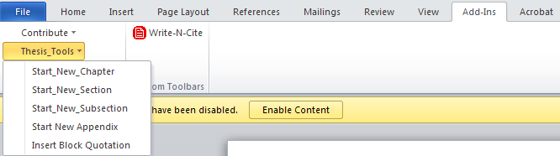

To use this template:
- Replace all text in parentheses in the front part of the document with your own information.
- Select the text “First Chapter” and replace it with the title of your first chapter.
- Delete the remainder of the body text and replace it with your text.
- To begin a new chapter, from the “Thesis_Tools” menu item, select “Start_New_Chapter”
- To begin a new chapter sectioned (one numbered 1.1, or 1.2 or 3.1, etc.) select “Start_New_Section” from the “Thesis_Tools” menu.
- To begin a new subsection (one numbered 1.1.1 or 3.2.3 etc.) select “Start_New_Subsection” from the “Thesis_Tools” menu.
- If you have more than 3 levels of headings, you must select the appropriate heading (heading 4, heading 5, etc)

Adding existing files (documents) to the thesis template.
While you are creating your thesis, you may create a number of smaller files, perhaps storing each chapter in a separate file. In order to build a table of contents, create cross references and get pages numbered sequentially, you will want to combine them into a single file at the end.
The easiest way to do this is to simply amalgamate all files by selecting the Insert tab then Object/Text from File. This method will combine all your smaller files into one large file.

Formatting a Table of Contents
When you are ready to generate a Table of Contents, right click inside the current Table of Contents area that can be found within the UWATERLOO Thesis template, and choose Update Field
Now select Update entire table and click OK.

Captioning and Numbering of Tables and Figures
In a longer more structured document, you will frequently want to number and add captions to your tables and figures. You could do this manually, but a better idea is to let Word add these captions and automatically assign the numbers. You need this automated approach for a number of reasons.
- If you want to easily make a cross-reference to the table or figure, Word must maintain the caption.
- If you want to automatically create a List of Tables or List of Figures for your Table of Contents, Word must maintain the captions.
- If you insert or delete tables or figures, Word will automatically re-number if captions are maintained.
A caption consists of the word “Table” or “Figure”, whichever is appropriate, followed by a number. You may then choose to add punctuation, such as a period or a colon, and then the text you wish to have for the caption.

Captioning Tables
You may want to add captions to tables already entered into your document or, alternatively, you may want to have captions automatically added to any new tables you create.
If you have tables without captions in your document and wish to add captions, you can do so quite easily. For each table:
- Click somewhere in the table
- Click on the References tab
- Click the Insert Caption button
- In the Caption box, it will read Table 1 (if it reads Figure 1, choose Table from the Label: drop down list) and allow you to add further information. If you wish to have punctuation appear after the number, type it, and then type the text of the caption. Notice that the Position box lets you select Above or Below for the caption, but table captions are generally positioned above the table.
Repeat the above procedure for every table in your document. Word will automatically provide the correct table number.

Captioning Figures
To caption an existing figure, select the figure and:
- Click on the References tab
- Click the Insert Caption button
- Make sure that Figure is selected in the Label box. The Caption box will read Figure 1 and permit you to type additional information. Type any punctuation that you wish to have after the number, and then type the text of the caption. Repeat this process with each figure in your document. Note that the caption appears by default at the bottom of the figure.
Questions?
Please don’t hesitate to ask us for assistance in the Witer Learning Resource Centre!
Tel: (519) 888-4005
E-mail: wlrc@uwaterloo.ca

