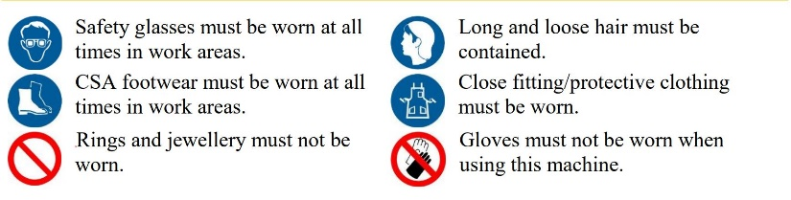

STandard Operating Procedure

CNC Mill

AXYZ 4004

**Required Personal Protective Equipment:**

Safety glasses must be worn at all times

Closed toe footwear must be worn at all times.

Rings and jewellery must be removed.

Long and loose hair must be contained.

Loose clothing must be contained.

Gloves must be removed.



# DO NOT use this equipment unless you have been instructed in its safe operation

## Pre-Operational Safety Checks

* Ensure no slip/trip hazards are present within working area
* Locate and ensure you are familiar with the operation of the Pause button and E-Stop.
* Programming must be reviewed and approved by AEMS staff.
* Turn on the dust extraction before using machine.
* Read the “CNC User Guide” for warning signs of potential issues
* Faulty equipment must not be used. Immediately report damaged machinery to lab supervisor.

## Operational Safety Checks

* The machine must be supervised at all times
* The part must always be secured to the machine table
* Be familiar with the program and ensure the correct tool is being loaded for each operation
* Do not touch the part or machine during operation
* Do not stand near the machine during operation
* Ensure that bystanders also keep their distance

## Post-Operational Safety Checks

* Move the cutterhead to a safe location before cleaning or removing part.
* Return tool to Automatic Tool Changer before turning the machine off.
* Switch off the machine.
* Leave the machine and work area in a safe, clean, and tidy state.

# This SOP does not necessarily cover all possible hazards associated with the machine and should be used in conjunction with other references.

# It is designed to be used as an adjunct to teaching Safety Procedures and to act as a reminder to users prior to machine use.

|  |  |
| --- | --- |
| **Date issued:** June 2020 | **Date of last review:** June 2020 |
| **Reviewed by:** Dan Jessel | **Date of next review:** June 2021 |

Document uncontrolled if printed.

**Potential Hazards:**

* Cuts and Abrasions
* Amputation
* Eye injury
* Entanglement
* Crush Hazards
* Flying material