ARCH 684-002 - Fall 2014 Graduate Seminar
Topologies of New Liberal Urbanization: Learning from Asian Metropoles

Course Instructor: Adrian Blackwell, adrian.blackwell@uwaterloo.ca
Class hours: Wednesday 9:30am-12:30pm
Class location: 2008
Office location: 2024
Office hours: Wednesday 1:30-2:30 (e-mail to schedule in advance)

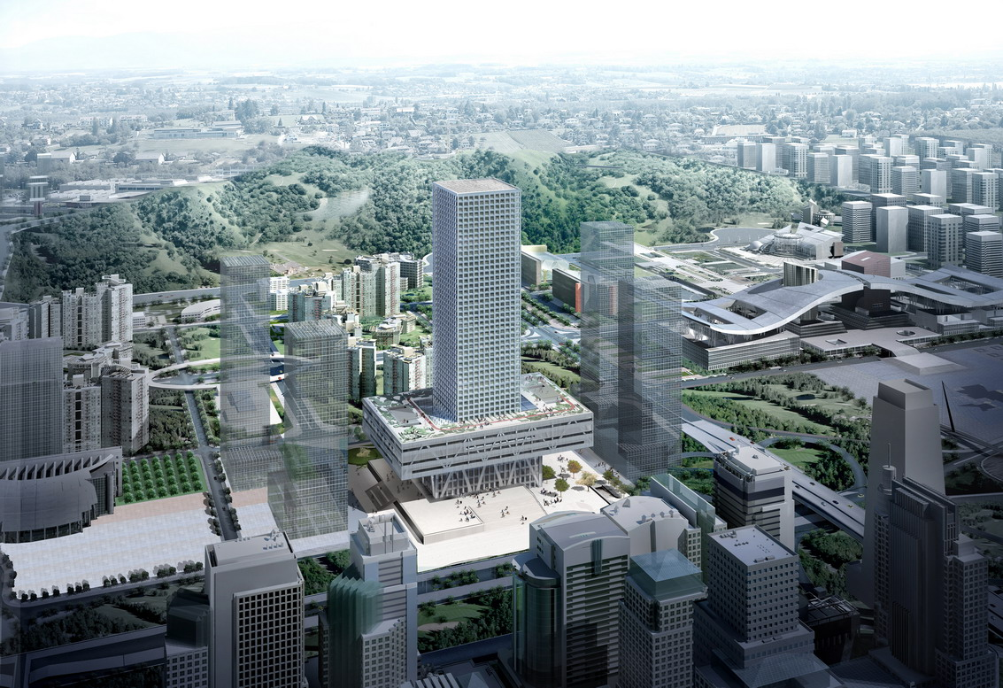
OMA, Shenzhen Stock Exchange, 2014

Topologies of New Liberal Urbanization: Learning from Asian Metropoles

This course will act as an introduction to contemporary urban theory through an examination of urbanization occurring in emerging Asian metropoles. In the last forty years we have witnessed a shift in the global balance of power, in which a Europe and North America dominated world economy has titled toward Asia. In the process Asian countries have initiated an unprecedented process of urbanization, which is both the result and driver of this global rebalancing. The far smaller growth that North American and European cities have experienced over the same period, has been a byproduct of the incredible expansion of the world’s productive capacity and consumer markets, through the opening of China, the center of this emerging Asian market system, to capitalist development. We need to better understand this process for three reasons: (1) because Asia is the world’s construction site; (2) it is the most dynamic laboratory for studying processes of urbanization; and (3) we are directly tied to its economy through global capital and commodity chains.

This investigation will be organized through six polarized topologies of Neoliberal Urbanization: ports/borders, infrastructures/centers, villages/compounds, (ecological) preservation/appropriation, creativity/forgery, and speculation/debt. These both designate expansive territories of contemporary theoretical inquiry and are themselves forces that have concrete formal effects within cities. For this reason the course will involve discussion of canonical theoretical texts on each of these topologies, as well as texts which localize them in the context of specific cities. Each student will be responsible for presenting readings to the class, and for exploring one of these topologies through both writing and diagrams. The course will function as a laboratory for building tools to better understand the relationships between political and economic processes of globalization and the forms of contemporary urbanization.

Course objectives:
This course is designed to introduce students to contemporary debates about urban theory, urban space and processes of urbanization, as well as key thinkers who have engaged these issues. Secondly it will serve as a laboratory through which to explore contemporary Asian metropoles.

Course requirements:
The seminar will involve close readings of texts each week for 8 weeks from week 2 to week 9. You will be required to have finished the readings and to participate in all class discussions with an informed perspective on each text. Over the term you will express your engagement with the ideas of the seminar through four 500-750 word written reading responses. You will also make two verbal presentations on a reading, which will summarize the thesis and key points of the reading and raise questions for class discussion. The term project is a graphical and textual analysis of an Asian metropolis through the framework of one of the six topologies of new liberal urbanization that we are studying.

This will include at least 4 drawings of the topology and an up to 5000 word critical essay. This final project has three deadlines: A project proposal of 1000 words, an illustrated in class presentation of the key arguments and evidence, and the final written document.

Relative weight and due date for assignments:
1a - Seminar Participation 10%
1b - 4 Reading Responses 4 x 5% = 20% due by 9am the Tuesday before class
1c - 2 In-class presentations of readings 2 x 10% = 20% due in assigned class
2a - project proposal 5% - due October 1
2b - In class presentation of research 15% - due either,
2c - Final Hand-in 30% - due December 12

Description of the Course Assignments:

Assignment 1 - Seminar participation and reading
Each class will begin with a presentation of the day’s themes by the course instructor. After this individual students will introduce the classes three readings, one at a time, and ask the class to answer specific questions about them. The instructor will moderate and focus the ensuing conversation amongst the class comparing the three readings. The class will finish with the instructor introducing next week’s clas.

1a - Seminar participation 10% in each class during the term
Each Student is expected to have read the week’s assigned texts and to participate during the discussion during each class. Carefully read the reading each week, underline important passages, and take notes on its key concepts. Come to class with questions you have about both readings. The primary purpose of the discussions is to engage the content of the readings themselves, in order to explore and better understand the ideas of key theorists of contemporary Asian urbanization. It is important that you engage the content of the readings and not simply your general knowledge of the subjects discussed.

1b - Four reading responses 4 x 5% = 20% due by 9am the Tuesday before class
Each student will submit 6 reading responses of 500-750 words. The reading responses should compare key concepts from two of the three readings assigned for the week. Each response should be framed as a concise essay. The first half should consist of a clear description of the key ideas of each thinker and end with your thesis about the relationship between their ideas. The rest of the response should argue for the points of agreement and divergence between them. All references to the texts should include page numbers. The reading response can make reference to other thinkers with footnotes, but should not contain unsubstantiated conjecture. The days that you will submit reading assignments will be decided on the first day of class.

1c - In class presentations of two readings 2 x 10% = 20% due digitally by 9am Tuesday before class
Each student will lead the discussion during two classes of the term. In advance of the class prepare a short hand out of 500-1000 words, illustrating the key theses and arguments of one of the two readings and a series of 2-4 detailed questions about the reading for the class. Questions should make specific reference to ideas in the text and focus discussion on the text itself. A digital copy of your hand out is due by 9:00am on the Tuesday before class. You are responsible for making double-sided copies for each class member. The days that you will do-in class presentations will be decided on the first day of class. The presentations are distinct from the reading responses and will occur on weeks when you are not required to write a reading response.

Assignment 2 – Topologies of New Liberal Urbanization
The term project involves the investigation of one of three Asian Metropoles: Singapore, Kaohsiung and Busan through the lens of one of six topologies of new liberal urbanization.

2a - project proposal 5% - due October 1
Each student will prepare an illustrated proposal for their term project. The proposal should be 500-1000 words and contain one or more illustrations. The outline should introduce the chosen city through the students chosen topology.

2b - In class presentation of research 20% - due on an agreed upon class
Each student will present their findings as a 15 minute paper presented to the class. All papers should be accompanied by images of the site and original drawings. The purpose of the presentation is to workshop your ideas and to rehearse the form of the academic paper. It should have a clear thesis and substantial evidence. Two students will present during the last six classes of the term, the presentation will be followed by 15 minutes of discussion about each presentation.

2c – Final Project 25% - due December 12
The final document should be 4000-5000 words in length and include at least 4 original diagrams: an annotated plan and a section of the everyday condition of the space, and an annotated plan and section of an event occurring in the space showing informal occupation, make these drawings in black and white lines on an 20x25cm frame horizontal format, at a metric scale of 1:250, 1:500, 1:1000, or 1:2000. The purpose of the project is to explore a paradox specific to the space and to be able to compare these spaces one to another. All projects will be posted online by the deadline.

Course Schedule and Readings
Week 1 – September 10 - Introduction to Topologies of New Liberal urbanization

David Harvey, “Neoliberalism and the Restoration of Class Power”, in Spaces of Global Capitalism (London: Verso Books, 2006), 7-68.

Adrian Blackwell, “Shenzhen: Topology of a Neoliberal City” in Rodolpge el-Khoury and Edward Robbins Eds. Shaping the City: Studies in History, Theory and Urban Design 2nd Edition (London: Routledge, 2013)

Week 2 – September 17 - The Urbanization of Capital

David Harvey, “The Urban Process under Capitalism: A Framework for Analysis” The Urbanization of Capital (Oxford: Basil Blackwell, 1985), 1-31

Jamie Peck and Adam Tickell, “Neoliberalizing Space” in Neil Brenner and Nik Theodore Eds. Spaces of Neoliberalism: Urban Restructuring in North America and Western Europe (Malden, MA: Blackwell Publishers Ltd, 2002) 33-57.

Neil Brenner, “Urban theory Without an Outside” in Neil Brenner Ed. Implosions/Explosions: Towards a Study of Planetary Urbanization (Berlin: Jovis, 2013), 14-35.

Week 3 – September 24 - The Urban Revolution

Henri Lefebvre, “From the City to Urban Society” in The Urban Revolution, Trans. Robert Bononno (Minneapolis: The University of Minnesota Press, 2003), 1-22.

Kanishka Goonewardena, “The Country and the City in the Urban Revolution” in Neil Brenner Ed. Implosions/Explosions: Towards a Study of Planetary Urbanization (Berlin: Jovis, 2013), 218-235.

Christian Schmid, “Networks Borders, Differences: Towards a Theory of the Urban” in Neil Brenner Ed. Implosions/Explosions: Towards a Study of Planetary Urbanization (Berlin: Jovis, 2013), 67-85.

Week 4 – October 1 - Ports / Borders

Giovanni Arrighi, “China’s Market Economy in the Long Run” in Ho-fung Hung Ed. China and the Transformation of Global Capitalism (Baltimore, Maryland: Johns Hopkins University Press, 2009), 23-49.

Sandro Mezzadra and Brett Neilson, “ Zones, Corridors, And Postdevelopmental Geographies” in Border As Method, or, The Multiplication of Labour (Durham: Duke University Press, 2013), 205-242.

Aiwha Ong, “Zoning Technologies in East Asia” in Neoliberalism As Exception : Migrations in Citizenship and Sovereignty (Durham: Duke University Press, 2006), 97-118.

Week 5 – October 8 - Infrastructures / Centers

Manual Castells – “The Space of Flows”, in The Rise of the Network Society, The Information Age: Economy, Society and Culture Vol. I. (Cambridge, MA: Blackwell 1996). 407-459.

Stephen Graham, “Constructing Premium Network Spaces: Reflections on Infrastructure Networks and Contemporary Urban Development.” International Journal of Urban and Regional Research. Volume 24.1 (March 2000)

Saskia Sassen, TBD.

Week 6 – October 15 - Villages / Compounds

Mike Davis, “Planet of Slums: Urban Involution and the Informal Proletariat” in New Left Review 26 (March April 2004), 5-34.

Duanfang Lu, Workunit Urbanism” in Remaking Chinese Urban form: Modernity, Scarcity and Space, 1949-2005 (London, Routledge, 2006), 47-79.

Chris Smith, Ngai Pun, “The dormitory labour regime in China as a site for control and resistance”,
The International Journal of Human Resource Management Volume17:8 (August 2006), 1456-1470.

Week 7 – October 22 - Preservation / Appropriation (of Nature)

Jason W. Moore,“Transcending the metabolic rift: a theory of crises in the capitalist worldecology'”,
Journal of Peasant Studies, 38: 1 (2011), 1- 46.

Chiara Piovani and Minqi Li, “Is Climate Stabilization Compatible With Economic Growth? The Cases Of China And India” World Review of Political Economy 3, no.4: 477-494..

Erik Swyngedouw, Maria Kaika and Nikolas Heynen, “Urban Political Ecology: Politicizing the Production of Urban Natures” in Erik Swyngedouw, Maria Kaika, Nikolas Heynen Eds. In the Nature of Cities: Urban Political Ecology and the Politics of Urban Metabolism. (Oxford and New York: Taylor and Francis, 2007), 1-20.

Week 8 – October 29 - Creativity / Forgery

Bianca Bosker “Residential Revolution: Inside the Twenty-first Century Chinese Dream” in Original Copies: Architectural Mimicry in Contemporary China (Honalulu: University of Hawai’I Press, 2013), 93-117.

Reinhold Martin, “Multi-National City: Inside Outsourcing” in Eds. Anthony Burke and Therese Tierney Network Practices: New Strategies in Architecture and Design (New York: Princeton Architectural Press, 2007), 198-211.

Winnie Wong, “After the Copy”, Van Gogh on Demand: China and the Readymade (Chicago: University of Chicago Press, 2014), 1-34.

Week 9 – November 5 - Speculation / Vacancy

Jonathan Nitzan and Shimshon Bichler, “Differential Accumulation and dominant Capital” in Capital As Power a Study of Order and Creorder (New York: Routledge, 2009), 305-333.

David Harvey, “The Urban roots of Capitalist Crises” in Rebel Cities: From the Right to the City to Urban Revolution.

You-Tien Hsing “Land and Urban Politics” in The Great Urban Transformation (Oxford: Oxford University Press, 2010), 5-29.

Week 10 – November 12 - Student Symposium on Singapore

Week 11 – November 19 - Student Symposium on Kaohsiung, Taiwan

Week 12 – November 26 - Student Symposium on Busan, South Korea

General Notes:

Academic Integrity: To create and promote a culture of academic integrity, the behavior of all members of the University of Waterloo is based on honesty, trust, fairness, respect and responsibility.

Grievance: A student who believes that a decision affecting some aspect of his/her university life has been unfair or unreasonable may have grounds for initiating a grievance. Read Policy 70 - Student Petitions and Grievances, Section 4, http://www.adm.uwaterloo.ca/infosec/Policies/policy70.htm

Discipline: A student is expected to know what constitutes academic integrity, to avoid committing academic offenses, and to take responsibility for his/her actions. A student who is unsure whether an action constitutes an offense, or who needs help in learning how to avoid offenses (e.g., plagiarism, cheating) or about “rules” for group work/collaboration should seek guidance from the course professor, academic advisor, or the Undergraduate Associate Dean. When misconduct has been found to have occurred, disciplinary penalties will be imposed under Policy 71 – Student Discipline. For information on categories of offenses and types of penalties, students should refer to Policy 71 - Student Discipline, http://www.adm.uwaterloo.ca/infosec/Policies/policy71.htm

Appeals: A student may appeal the finding and/or penalty in a decision made under Policy 70 - Student Petitions and Grievances (other than regarding a petition) or Policy 71 - Student Discipline if a ground for an appeal can be established. Read Policy 72 - Student Appeals, http://www.adm.uwaterloo.ca/infosec/Policies/policy72.htm

Note for students with disabilities: The Office for Persons with Disabilities (OPD), located in Needles Hall, Room 1132, collaborates with all academic departments to arrange appropriate accommodations for students with disabilities without compromising the academic integrity of the curriculum. If you require academic accommodations to lessen the impact of your disability, please register with the OPD at the beginning of each academic term. Once registered with OPD, please meet with the professor, in confidence, during my office hours to discuss your needs.

