School of Architecture University of Waterloo at Cambridge

ARCH 684/385 – 004

Material and Energy Flows Seminar

Faculty John McMinn

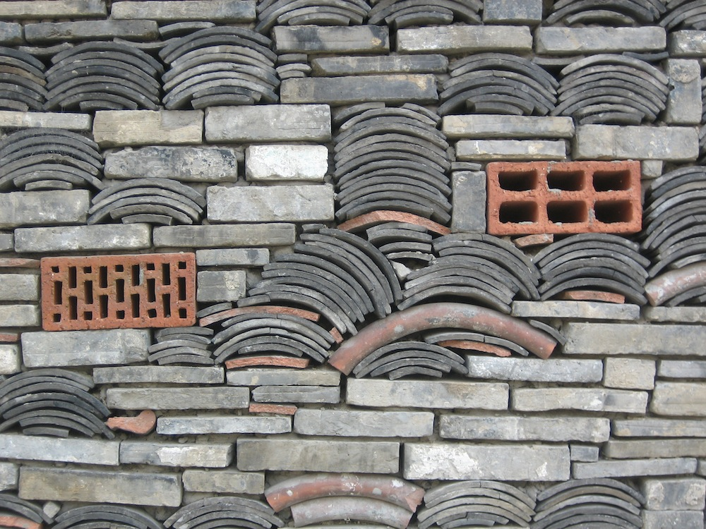

COURSE DESCRIPTION
The Material and Energy Flows Seminar will give students the opportunity to consider issues of the flow of materials and energy in the making of architecture, looking at the embodied energy of building construction on the one hand, and life cycle energy use on the other, and the implication of Rees and Wackernagel’s conception of the ecological footprint on the construction industry. The course examines the implications for architecture might be of seriously taking on the three R’s mantra of sustainability to reduce, re-use and recycle. The focus on material and energy flows in architecture leads in this course to an examination of three strategies in reducing the impact of the built environment on the natural environment.
- The embodied energy of materials used to create buildings, coupled with alternatives to using conventional sources of new construction materials.
- Ambitious life cycle energy use reduction.
- The implications of energy generation, intrinsically tied to architecture.

Focus on embodied energy in building assemblies, requires awareness of the embodied energy of various commonly used construction materials and an examination of alternative material sources, including engaging two of the three R’s for the making of a building using a percentage of recycled and re-used materials, as well as alternative new material sourcing. Environmental impact and material sourcing, as well as energy use reduction is looked at through various measurement systems, like LEED, BREAM and GBC, understanding their strengths, weaknesses and implications for the design and construction process, as well as other protocols, such as Pasivhaus, enabling buildings to operate without or with a significantly reduced mechanical system. Energy generation tied to architecture is examined via a wide range of renewable energy sources, with a particular focus on the way in which the generation of energy can impact the making of buildings.

The course will explore the sourcing of pre-used construction materials, using case examples of similarly conceived buildings from North America and around the world, situating the work done in the course within the contemporary discourse of architecture and construction culture. Reference to the available resources in the Kitchener-Waterloo region will also be made as an example of this potential material source for the construction industry. We will also examine the impact of using recycled materials on the design process in architectural practice. Given that up to 45% the total mass of materials produced annually in North America, either extracted from the earth or grown on its surface, are used in building construction, the use of construction materials in the building industry has a major environmental impact. With the upgrading, renewal or replacement of buildings, only a tiny percentage of the resulting demolition materials are recycled, with the vast majority of it going to landfill.

The various measurement systems which assess everything from siting, to construction material sourcing to life cycle energy use, currently in use throughout the world have both supporters and critics. We will examine the pros and cons of these assessment systems, to try to understand what their strengths and weaknesses are and assess their impact on buildings and the building industry. The Passivhaus protocol developed in Germany, has been gaining acceptance and is beginning to be more widely used in Europe. It is just beginning to be adopted in a small number of buildings in Canada and the USA. We will look at examples of Passivhaus buildings, understanding the implications in design, construction and costing, in implementing the proptocol, and disincentives to its wider adoption in the North American building industry.

Renewable energy generation is practiced throughout the world with varying degrees of use in different climates, geographic conditions and with respect to various cultural habits. Broadly speaking renewable energy generation can grouped in four categories: Heliac, Kinetic, Cthonic and Biotic. These primary categories of renewables include various kinds of solar energy generation, use of kinetic energy, particularly with wind and water as an energy source, earth based energy sources, grouped under geothermal power, and biologically grown material used as an energy source. Some renewables can be directly tied to buildings and can have an impact on the way buildings are designed and used. We will explore examples of this as well as the ways the built environment can be tied to and implicated within the broader networks and sphere of renewable energy generation.

We live in a culture of consumption and disposal with all too little awareness of the source and environmental impact of the materials we consume and discard. Over 95% of materials that enter the North American production/consumption cycle, in the ‘consumer goods’ sector, end up in landfill within a month. While the building industry has a substantially longer use cycle than this, the same habits of extraction, processing, consumption and disposal exist, and the same mesmerizing preoccupation with the allure of newness, is equally at work in the design and building industries.

In a world where energy and materials become ever more critical commodities, in increasingly scarce supply, the management of these resources becomes an important aspect of a role architects can play. With the diminished role of the architectural profession in recent decades, there is a potential to regain lost ground by taking a leading role, responding to the potential in managing the impact of the building industry within the challenges of resource management and its ensuing impact on climate change. In specifying the materials used in their designs and the efficient configuration of their buildings, architects can have a significant impact on the materials and energy that enter and are consumed in the built environment. Initiatives that stem the huge material and energy flow, consuming large quantities of the earth’s limited resources, are one way that architects and the architectural profession can re-establish its relevance.

Arguably architects are uniquely positioned with an important overview in the complex interface between material sourcing, construction assembly, cultural and aesthetic judgment, with the ability to discern the relevance of a given project initiative in regard to this resource management perspective and to describe and illustrate it to a public audience. This course addresses these issues and examines their implications for the design of buildings.

COURSE WORK AND STRUCTURE
The course is structured around the three main areas of concern related to material and energy flows cited above: material sourcing, energy use and energy generation, with lectures and assignments associated with each area. Roughly a third of the course will be devoted to each of these areas and assignments for each will form the basis of the course grading. The work of the course will involve students choosing research topics within each of these areas, and developing presentations, to be made to the class for each topic area. Class presentations are followed by critical discussion of issues raised with the presentations

LEARNING OBJECTIVES
- Examining of material and energy sources and uses in building construction with particular reference to reducing the impact of the built environment on the larger ecological environment
- Awareness of differentials in embodied energy in conventionally sourced versus alternatively sourced building materials
- Understanding the impacts of energy use reduction in life cycle assessment of buildings
- Understanding the potential and use of renewable energy and its implications for building design
- Understanding the implications of Elkington’s ‘triple bottom line’ in the built environment, of environmental, social and economic concerns
- Understanding the implication of Rees and Wackernagel’s conception of ‘ecological footprint’ on the construction industry.

EVALUATION
Assessment for grading will be based on level and quality of participation in the seminar discussions as well as the assignments completed and presented to the class. 75% of the course grade will be based on assignments and 25% on class participation.

REVIEW OF ASSIGNMENTS
There will be ongoing discussions and review of individual presentations made by students throughout the period of the course as well as written feedback on the assignments handed in.

HAND-IN REQUIREMENTS
Hand-in of the individual assignments will take place one week after the presentation of the assignment, enabling students to incorporate feedback received following their presentation. Late penalties of 5% of the assignment grade per days apply for any assignment handed in after the due date.

SCHEDULE AND COURSE ATTENDANCE
The course will run from 5:30 to 8:30 every Wednesday during the fall terms in room 2008. You are expected to attend all classes and any absence from class must be discussed in advance with the course instructor. Missing three or more classes will result in failure of the course. Please check your email the day of class for updates on specific course scheduling.

COMMUNICATION WITH STUDIO COORDINATOR
During the course, the course instructor may need to send communications to members of the class. It is required that each student confirm their current active email address with the Undergraduate Student Service Coordinator during the first week of class. Any official correspondence that must be addressed to the studio coordinator at jcmcminn@uwaterloo.ca

ACADEMIC INTEGRITY AND AVOIDANCE OF ACADEMIC OFFENSES
In order to maintain a culture of academic integrity, members of the University of Waterloo community are expected to promote honesty, trust, fairness, respect and responsibility. [Check www.uwaterloo.ca/academicintegrity/ for more information.]
Grievance: A student who believes that a decision affecting some aspect of his/her university life has been unfair or unreasonable may have grounds for initiating a grievance. Read Policy 70, Student Petitions and Grievances, Section 4, www.adm.uwaterloo.ca/infosec/Policies/policy70.htm. When in doubt please be certain to contact the department’s administrative assistant who will provide further assistance.
Discipline: A student is expected to know what constitutes academic integrity [check www.uwaterloo.ca/academicintegrity/] to avoid committing an academic offence, and to take responsibility for his/her actions. A student who is unsure whether an action constitutes an offence, or who needs help in learning how to avoid offences (e.g., plagiarism, cheating) or about “rules” for group work/collaboration should seek guidance from the course instructor, academic advisor, or the undergraduate Associate Dean. For information on categories of offences and types of penalties, students should refer to Policy 71, Student Discipline, www.adm.uwaterloo.ca/infosec/Policies/policy71.htm. For typical penalties check Guidelines for the Assessment of Penalties, www.adm.uwaterloo.ca/infosec/guidelines/penaltyguidelines.htm.
Appeals: A decision made or penalty imposed under Policy 70 (Student Petitions and Grievances) (other than a petition) or Policy 71 (Student Discipline) may be appealed if there is a ground. A student who believes he/she has a ground for an appeal should refer to Policy 72 (Student Appeals) www.adm.uwaterloo.ca/infosec/Policies/policy72.htm.
Note for Students with Disabilities: The Office for Persons with Disabilities (OPD), located in Needles Hall, Room 1132, collaborates with all academic departments to arrange appropriate accommodations for students with disabilities without compromising the academic integrity of the curriculum. If you require academic accommodations to lessen the impact of your disability, please register with the OPD at the beginning of each academic term.

