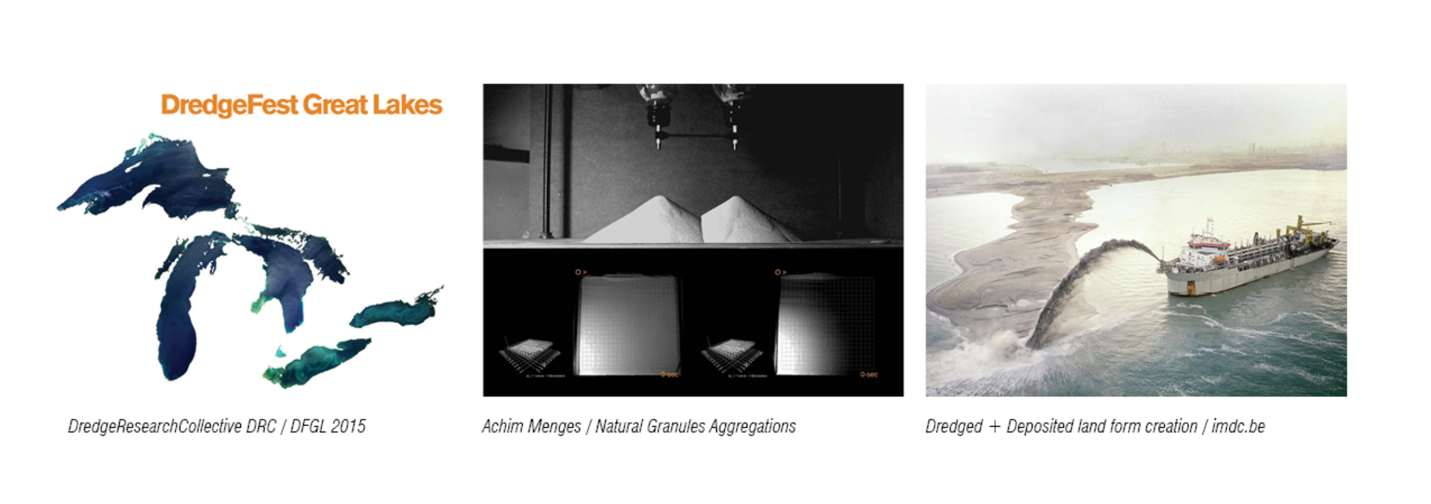
THE INTERFACE SCALE
Architecture Elective: 0.5 Credits
August 14th- 21st 2015
Course #: 520_002

The Interface Scale is a compressed elective credit course structured around the Dredgefest Great Lakes (DFGL) event organized by the Dredge Research Collective (DRC) and hosted / co-organized in partnership with University of Minnesota’s School of Architecture and the Department of Landscape Architecture. The event will be held in two Minnesota cities, Minneapolis and Duluth. The course will be led by both Fionn Byrne and Matthew Spremulli as a collaborative landscape and architecture design opportunity.

The DRC is an academic / design group that investigates human sediment handling practices through publications, self-directed projects, and its annual event series. This year’s DFGL event includes a symposium, and tours along with the series of workshops exploring the human manipulation of sediment on North America’s fourth coast, The Great Lakes.

The Interface Scale course will have students examine the potential of dredging activities as an opportunity for designers to create both new landscape forms and functions. Participants will be challenged to explore methods of producing and maximizing variability in form and especially pattern making using dredging/sediment-depositing techniques while focusing on ‘lakeshores’ as an explicit site of interface. Participants will work in pairs to explore patterning: one architect (from UWSA) paired with one landscape architect (from UofT). Through patterning one can test local variability against regional order while addressing edge conditions. Participants will be encouraged to work between digital (parametric/generative, formal complexity) and physical media (dredge: soil, sand, clay, rock, water) and will have to test, experiment and accept new challenges. As with a variety of software, parametric tools allow for rapid iteration, precise measured control and testable outputs. Physical materials, on the other hand, deny the same level of precision, and are limited in the forms they can produce. Studying both together will assist participants in manipulating their pattern and evaluate its scale and performance towards a target ecological goal. Additionally, participants will also be required to consider their formal operations as producing a cultural artifact with qualitative readings and programmatic potentials.

The goal of the workshop is to develop an iterative design workflow with dredge/sediment-depositing techniques informed by the sensibilities of both landscape and architecture, and produce representation that reflects evolutionary design decisions.

SCHEDULE
The course is built around the 1-week DFGL event in Minneapolis and Duluth from August 14 -21 2015. This event will include both a 2-day conference with lectures and tours along with an intensive 5-day workshop. Students are expected to carry out the majority of their design work for the course over the DFGL workshop. However, to complete the course students are expected to participate in 1-weeks’ worth of work before and after the DFGL event. The precise time to be allocated before and after the DFGL event will be coordinated to consider the schedule of the participating students.

INSTRUCTOR BIO / SUMMARY
Fionn Byrne
Fionn Byrne is a full-time instructor, teaching landscape/building architecture students at the John H. Daniels Faculty of Architecture, Landscape, and Design at the University of Toronto and the University of Waterloo: School of Architecture in Cambridge. He holds a Master of Landscape Architecture from the University of Toronto, where he also completed his Bachelor of Physical Education and Health. His research and design interests depart from the convergence of technology and ecology; he is most intrigued by how velocity and information interact with biological systems. Byrne is also the founder of the Office of Pedonic Operations.
www.pedonicoperations.com

Matthew Spremulli
Matthew Spremulli is a part-time instructor, teaching architectural design students at the University of Waterloo: School of Architecture in Cambridge. He holds a Master of Architecture from the University of Toronto, where he also completed his Honours Bachelor of Arts. His research and design interests explore the intersection between technology and ecology; focusing on the role design and technology can play in creating “eco-ambient” spaces and how digitally created/fabricated geometry will interact with ecological systems. Spremulli also collaborates with institutions that share his interests including the Center for Advanced Urbanism at MIT.

COURSE FEES
Students will be expected to fund their travel and admission to the DFGL event (which will include student residence accommodation) in Minnesota. Students should also allocate an amount of funding for the materials and fabrication of their sand depositing machines.

Travel Cost (round trip *estimate) = $1,000
DFGL Registration / Accommodation = $241
Sand Machine (materials and fabrication *estimate) = $100
TOTAL = $1,341

PROCESS TO APPLY
Students interested in participating in The Interface Scale elective must submit a brief (one half page maximum) statement of interest by email to Donna Woolcott donna.woolcott@uwaterloo.ca (current undergraduate students) or Emily Stafford emily.stafford@uwaterloo.ca (incoming or current graduate students) no later than Wednesday June 17, 2015 at 4:30p.m. Enrolment is limited to 6 students.

