2015 Fall Term

Masters 1 Design Studio Course Outline

The Comprehensive Building Studio

Arch691
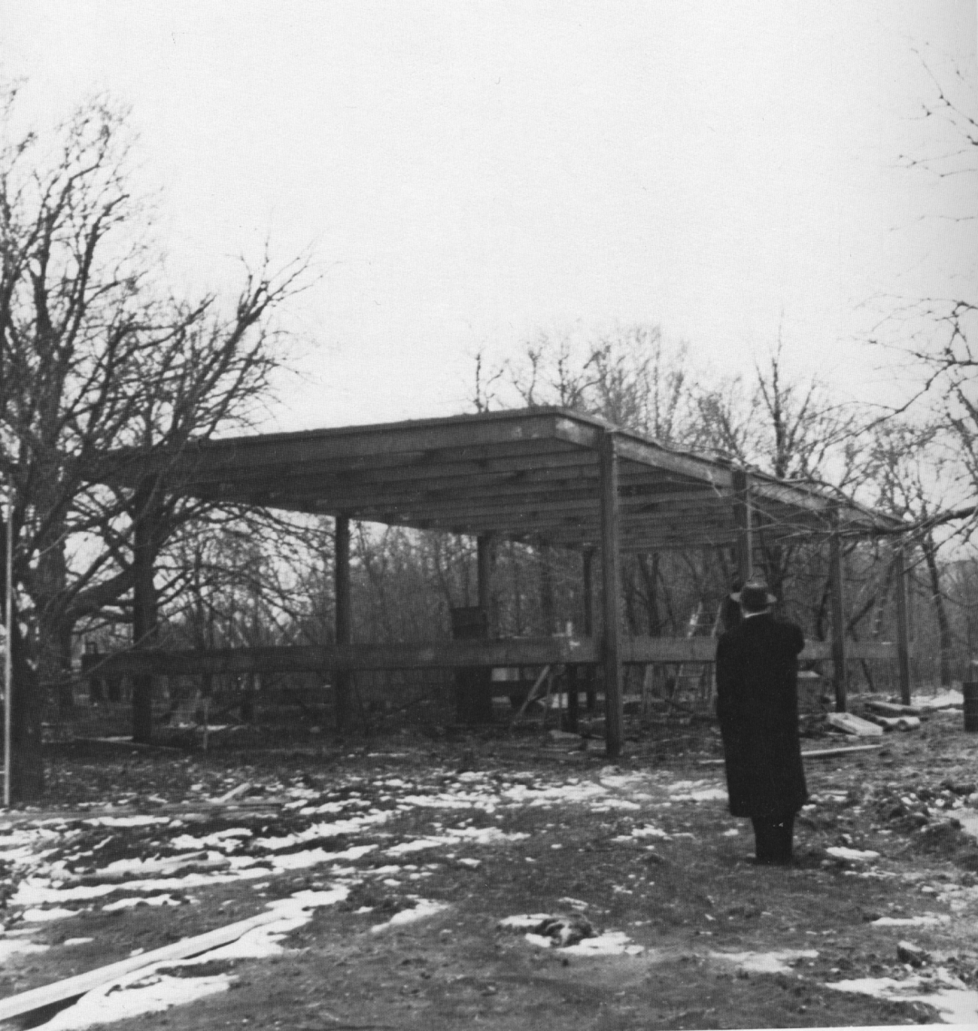

Studio Faculty: Prof. Val Rynnimeri, Terri Boake (Design and Technical Report)
Teaching Assistant: Jonathan Clark, MArch candidate

To study everyday life would be a completely absurd undertaking, unable even to grasp anything of its object, if this study was not explicitly for the purpose of transforming everyday life.”
Guy Debord, Perspectives for
Conscious Alterations in Everyday Life

“Thus the new majority is born in a multitude of colors; normality is created out of the sum of many abnormalities. … The new market of the majority can be described as a “matrix”, made up of a brightly colored parking lot, a chessboard made up out of many different forms of conduct. …
To go back to design, it is my impression that an era has come to an end. New problems are reaching maturity. And they are not at all the same as the old ones. The new era requires the ability to produce stable codes, many stable codes, many compartments of that matrix on which the new majority is based.”
Andrea Branzi,
Domestic Animals

I remember. for example, two small, black, cast-iron radiators, which stand in two corresponding corners of a small room. The symmetry alone of the two black objects in the light room gives a feeling of well-being! The radiators are so flawless in their proportions and in their precise, smooth, slender form, that it was not noticeable when Gretl used them after the cold season as a base for one of her beautiful art objects. One day when I was admiring these radiators, Ludwig told me their story and of his own difficulties, and how painfully long it had taken until the precision which constitutes their beauty had been reached. Each of these corner radiators consists of two parts, which stand precisely at right angles to each other, and, between them, calculated down to the millimeter, a small space has been left; they rest on legs upon which they had to fit exactly. At first models were cast, but soon it turned out that the kind of thing that Ludwig had in mind could not be cast in Austria. Consequently, ready-made castings for individual parts were imported from abroad, although it seemed impossible to achieve with these the kind of precision which Ludwig demanded. Entire sets of pipe sections had to be rejected as unusable, others had to be exactly ground to within half a millimeter. The placing of the smooth plug, too, which were produced in accordance with Ludwig's drawings by a quite different process from the conventional products, caused great difficulties. Under Ludwig's direction, experiments often went on into the night until everything was exactly as it should be. As a matter of fact, a whole year passed between the drafting of the seemingly so simple radiators and their delivery. And yet, I consider the time well spent when I think of the perfect form which arose from it.
Hermine Wittgenstein speaking about her brother
Ludwig's design for her sister Gretl's house.

This idea, that the realization of a chosen emotional situation depends only on the thorough understanding and calculated application of a certain number of concrete techniques, inspired this "Psychogeographical Game of the Week" published, not without a certain humor, in Potlatch #1:

"In accordance with what you are seeking, choose a country, a more or less populated city, a more or less busy street. Build a house. Furnish it. Use decorations and surroundings to the best advantage. Choose the season and the time of day. Bring together the most suitable people, with appropriate records and drinks. The lighting and the conversation should obviously be suited to the occasion, as should be the weather or your memories.

'If there has been no error in your calculations, the result should satisfy you.'"
Guy Debord

Arch 691 Comprehensive Building Studio is the first of the series of four Masters Studios leading to the Masters thesis. The main goal of the studio is to teach the student how to design buildings comprehensively, hence its name, the Comprehensive Building Studio. Such a studio course is part of the overarching requirement for professional accreditation, and such studios are taught in every professional programme in North America. Waterloo Architecture is one of the few schools who teach this studio as part of its undergraduate curriculum. New graduate students to the Waterloo Masters, if they have not done such a studio before, have thus been placed in the two-year Waterloo Architecture Masters programme to complete this requirement and to give a strong grounding in the material and building systems of the buildings they will design.
The studio also introduces new students to Canadian urban places, climate, social mores and habits, and Canada’s architecture and practical building culture.

A Children’s Library and Discovery Centre
for the Galt City Centre of Cambridge, Ontario

The studio design building is a children’s library and discovery centrefor the City of Cambridge. It will be located near the present main library building in the historical Galt town centre of the city. The site is a nearly square empty lot of approximately 1200 square metres on the same block as the main library but separated from it by two houses with businesses in them. The site is across from a small park square a city block from the main city square, and also near several churches and a large downtown senior’s residential complex. The rest of the area is a residential area with a scattering of businesses occupying some of the houses.
A children’s library is well suited for a comprehensive building studio. It requires the student to interpret its programme elements, and internally it has a variety of spaces ranging from large meeting and activity areas to smaller more private quiet areas. This is true for both inside and outside activities. There is opportunity for a large role for sustainable building systems and construction as both a demonstration and ongoing operation. Opportunities also arise for varied structural systems both those spanning large volumes, a development of a wall and skin that encourages light penetration and a wall system that encourages occupation with activities.
The children’s library programme has been left open ended to allow the student the chance to choose the scale and composition of the building activities and to establish the appropriate sizes for those activities in relation to the site and the anticipated building size.

