Using LEARN's Rubric Feature
What is a Rubric?
A rubric is an assessment tool that clearly outlines marking criteria. It can be used for evaluating assignments, class participation, or overall grades. There are two types of Rubrics:
- Analytic rubrics: Two-dimensional rubrics with levels of achievement as columns and assessment criteria as rows. Allows you to assess participants' achievements based on multiple criteria using a single rubric. You can assign different weights (value) to different criteria and include an overall achievement by totaling the criteria.
- Holistic rubrics: Single criteria rubrics (one-dimensional) used to assess participants' overall achievement on an activity or item based on predefined achievement levels.
Why Use a Rubric?
A rubric provides a set of criteria that outlines the important components of the activity being planned or evaluated. Rubrics help clarify the criteria and expectations for the assignment. When used effectively, Rubrics can:
- Provide timely and detailed feedback that students can use
- Encourages critical thinking/self-evaluation
- Communicate expectations (i.e., to students, Teaching Assistants)
- Expose the component skills of any task
- Encourage fair and consistent marking
Creating Rubric Content
- Reflect: consider what your expectations are for this assignment
- List: Break down the assignment into smaller components: assignment details, learning objectives, specific tasks, observable skills, etc.
- Group and Label: group similar expectations together and give that dimension a name (e.g., Critical Thinking and Reflection, Spelling and Grammar)
- Application: choose the type of rubric, achievement levels, etc. Enter your chosen dimensions and descriptions onto the grid; set the rubric status to ‘Published’

- Assigning Feedback: align rubric to assessment (i.e. Dropbox, Quiz, ePortfolio) and then assign feedback with it

Other Resources
CTE Rubrics Tip Sheet: https://uwaterloo.ca/centre-for-teaching-excellence/teaching-resources/teaching-tips/assessing-student-work/grading-and-feedback/rubrics-useful-assessment-tools
VALUE Rubrics: http://www.aacu.org/value/rubrics/
LEARN help with rubrics: https://uwaterloo.ca/learn-help/instructors/additional-topics/rubrics
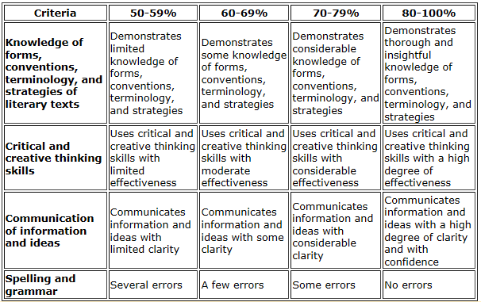

Sample A: Analytic Rubric

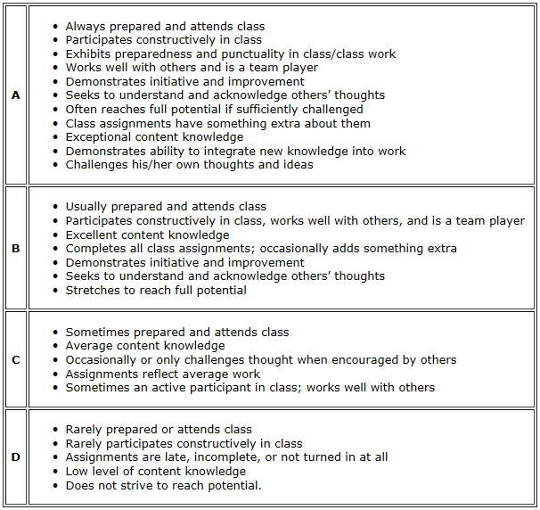

Sample B: Holistic Rubric

