TITLE IN BOLD, CAPS AND CENTERED, ABSTRACTS SHOULD BE LESS THAN ONE PAGE

FirstNameA LastNameA1, FirstNameB LastNameB1,2, FirstNameC LastNameC3
1Department/School, University Name, City, ON
2Department/School, University Name, City, ON
3Department/School, University Name, City, ON

Introduction: The title should be in bold, capital letters which are centered [1]. The names which appear below should have the authors, in the format shown where the first name is followed by the last name for up to SIX authors. The superscripts following the names should indicate the department or the school in which that specific author is associated. The author may have multiple associations, in which there should be multiple superscripts (see FirstNameB above). Along with the department or school association, the university in which this school/department is located should be included [2]. The city where this university is located should also be outlined. All schools which have been invited to participate are located in ON (Ontario) so please include the ‘ON’ designation.
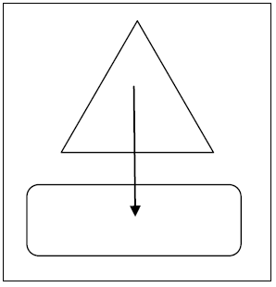
Methods: There should be FOUR or FIVE sections for an abstract. These should include Introduction, Methods, Results, Discussion/Conclusion and References (if applicable). In the abstract, when referring to equipment or software etc. please include the device in the following format: “The measurements were taken with a Widget™ Device (Widgets Inc., State/Province, Country).

Results: Within the document, Figures should be referred to in the text with a capitalized first letter such as Figure 1. If the Figure or Table is referred to within parentheses, please do so like (Figure 1) or (Table 2). Figures and Tables should be placed close to the text or may be placed below the last section containing text.
Figure 1: this should be in font size of 10 and bolded

Discussion and Conclusions: The margins, text size, justification and format outlined in this document should be adhered to for ALL submissions [3]. If there are any remaining questions, please do not hesitate to contact us at obc2023@uwaterloo.ca.

References:
[1] Author Initial et al. (YEAR). Title. Journal Vol (Issue); p. 34-6.
[2] Smith UK. Some Book Title; Publisher, YEAR.
[3] Author Initial et al. (YEAR). Title. Journal Vol (Issue); p. 34-6.

Table 1: This is the place larger tables / figures should be located to ensure the text does not look disjointed. Table captions should also be in 10 pt Times New Roman bolded.Data | 234 | 23434 | 23 | 232323 | 443 | 3432 | 234 | 32423 | 23423
Stuff | 23423 | 23423 | 233 | 234323 | 3243 | 43242 | 23434 | 234 | 342

