Name of Change Initiative

Change Management

Communications Plan

By: Authors Name(s),
Title(s)

Contents
Change Management Communication Plan 3
1. Stakeholder group inventory and key messages 3
2. Communication channels by stakeholders 3
3. Sample communications 4
4. Communication timelines – pre-implementation 4
5. Communication timelines – implementation and post-implementation 4
6. Communication tips for the author 4
Document Revision History 5

Template overview
The Change Management Communications Plan template is designed to assist the author to systematically plan out how the change will be communicated to stakeholders, what the key messaging will be, and which channels will be used to disseminate and receive messaging.

The completed template will:
- Document your stakeholder list
- Define the key messages by stakeholder group.
- Identify the preferred communication channels, ideally allowing for 2-way open feedback
- Identify the appropriate sender for each communication
- Identify the target communication dates

Of note: The template is designed to help the writer articulate:
- Who the stakeholder(s) is/ are
  - Who do we communicate with? / Who will be impacted by the change?
  - How many unique groups are there?
  - What do they know already?
  - What will motivate them to adopt the change? / What are their needs? And Are we able to meet the needs?
- What to communicate in the key messages
  - For each stakeholder group what do we need to communicate ie address the “What’s in it for me”.
  - What is it that is changing?
  - What are the benefits to the change?
  - What is the key take away?
  - Who will approve the messaging?
- The preferred communication channels to use
  - What channels to you have access to?
  - What channel will work best for each stakeholder group?
  - Who will be the sender of the message? ie Sponsor, middle management, team lead, other?
- Establish effective communication timelines
  - When will you need to communicate the key messages?
  - How often will the message need to be shared?

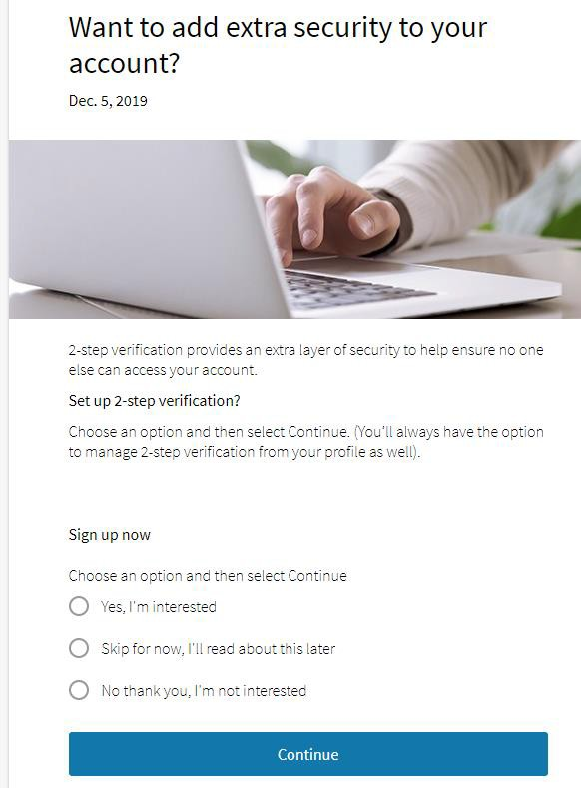
Change Management Communication Plan

Stakeholder group inventory and key messages
When informing the key messages, consider the following:
The audience needs to hear, understand and remember the message relayed. Keep messaging succinct. Personalize content where possible. To ensure the messaging is effective, define your communication objectives.
- WHAT: define the change
- WHY: Capture the importance or urgency of the change, align this to institutional values / mission / vision
- WHEN: provide timelines, establish expectations
- WHO: Define who the change will impact and HOW.

Stakeholder Group | Key Message
i.e. management team | What is changing?  Why are we changing (include benefits that will resonate with the specific group)  Why now?  What does this mean for me?  What does this mean for the department?  Risks of not changing?  What is my role in supporting / implementing this change?  What are the timelines and plans for training?  What supports exist for me / my team?

Communication channels by stakeholders
Channel | Stakeholder group | Preferred sender
In person (meetings, town halls, coffee chats, walks around campus etc.)
Memos and mass emails
MS Teams
Daily Bulletin
Dedicated project website
Social media (X / FB / Instagram)
Digital screens
Print Materials
Survey
Lunch ‘n Learns / Training Sessions
Senior leadership meetings
Department meetings
Team meetings
Campus committees
Administrative & technical support staff (EOs/ AOs)
IT Change Champions (limited to IT changes)

Sample communications
In this section provide links to sample or drafted communications / key messages

Communication timelines – pre-implementation
In this section record your communication timelines to help organize and visualize communication events in a chronological order

Target Date | Target stakeholder group | Target channel | Target content | Sender | Content approver
i.e. June 20 2024 | Management team | Teams Channel | Introducing the change, roles and responsibilities etc. | Unit leader / sponsor | Executive sponsor

Communication timelines – implementation and post-implementation
Target Date | Target stakeholder group | Target channel | Target content | Sender | Content approver
i.e. September 20 2024 | Management team | Teams Channel | Today’s the day!  Reminders…. | Unit leader / sponsor | Executive sponsor

Communication tips for the author
- Repeat each message a minimum of 5-7 times
- Clearly define the change, the reason for the change and the benefits for the change
- Clearly define the future state and the benefits the future state brings to each stakeholder group
- For a large project create templates for key messages for mangers to access
- Communicate proactively, adjust your approach to the stakeholder group and their reactions to the change.
- Use a variety of channels to deliver each message. The preferred channel is in person. Be visible. Use both formal and informal approaches to deliver the message
- Keep all parties updated on the progress of the change
- If there is a downside to the change, communicate this. Where possible, provide the rationale for the decisions being made
- Be as transparent as possible to minimize misconceptions and rumors.
- It’s ok to not have all the answers. Share this along with a commitment to update impacted parties as the answers are determined. Do not guess the answers.
- Create a feedback mechanism, engage stakeholders in the change. Ask yourself: am I answering the question asked? Have I captured the concerns raised? Do the concerns need to be escalated?
- Align the Change Management communication plan with the Project Management communication plan
- Emphasize when the change will happen. Be clear on timelines. Where there are adjustments to the timeline, communicate these

Document Revision History
Change Made By | Date Change Made | Details of Change | Change Reviewed/ Approved by | Date change reviewed/ approved

