COVID-19 operational return to campus safety Plan Template

Introduction
This is a safety plan template based on the hierarchy of controls model of risk management. The premise is to prioritize and implement controls that are known to be most effective (removing/eliminating exposure vs using PPE). The image in Figure 1 depicts this model with COVID-19 specific controls.
Least Effective
Most Effective
Figure 1: Hierarchy of controls as it applies to COVID-19

Purpose
This document has been designed to assist department heads and supervisors in establishing appropriate protocols to minimize risk for work occurring during COVID-19.

Instructions for use
To use this template, insert your instructions in the relevant sections, and delete the template instructions provided. Once complete, review with your employees.
Review involves going through the processes you have established and getting acknowledgement from all members of the employee group that they understand and will comply with this plan.
Sections in Part A do not require any data to be submitted, they may be left blank. All sections in Part B must be completed.
Notes
- You will need to develop one plan per work location (e.g., per building).
- Include any service areas (students, public, customers) under your control, including access control, screening measures, entry and exit to/from the space.
- All sections in Part B must be completed.
- You will need to sign the plan at the end signifying that you will enact the plan as outlined as well as be accountable for enforcing this plan.
- At minimum, all safety plans should contain the following elements:
  - Statement that all work that can be done remotely is performed remotely
  - Occupancy limits for all rooms under departmental control
  - Schedules that match occupancy limits
  - Designation of workstations and outlining precautions for use of shared workstations or equipment
  - Consider moving shared equipment to locations that could reduce person-to-person contact
  - Designation and frequency of cleaning for high-touch and shared work surfaces (at least twice daily)
  - Outlining when face coverings are required

Part A

1.0 Employee Training
Before returning to campus, employees, students, and researchers must complete the following training:
- Mandatory “Return to Campus Safety during COVID-19” (SO 2036) online training
- Training from the supervisor on the new practices outlined in this procedure

2.0 Responsibilities

2.1 department head
- Develop the overall departmental plan with input from management team/supervisors.
- Ensure this plan meets Health & Safety Guidance during COVID-19.
- Enforce all criteria within this plan.
- Ensure appropriate hand hygiene and surface disinfection supplies are provided for employees.
- Hold supervisors accountable for overseeing the implementation and monitoring of the plan.

2.2 Supervisor
- Meet with employees remotely before they return to the workplace to review the plan and discuss individual aspects and employee concerns. Orientation shall cover all items within this plan.
- Ensure this plan meets Health & Safety Guidance during COVID-19.
- Enforce all criteria within this plan.
- Ensure appropriate hand hygiene and surface disinfection supplies are provided for employees.
- Physically visit and inspect the workplace on a monthly basis to:
  - Identify hazards as per the Occupational Health and Safety Act
  - Ensure the adequacy and adherence to this safety plan

2.3 Employees and Students
- Follow all guidance within this plan.
- Work from home as directed.
- Notify their supervisor if supplies are not sufficient to maintain hand hygiene and surface decontamination requirements.
- Notify their supervisor of any hazards that are discovered while working.
- Do not come to work if ill and report all illnesses to their supervisor using the process outlined in section 3.2 Illness and Absence Reporting.

3.0 Health Protocols

3.1 Self-Assessment Screening
To minimize risk, employees and students must not come to campus when ill. For this reason, the University requires that employees and students monitor themselves daily for symptoms of COVID-19. Before arriving on campus each day, complete the COVID-19 screening questions using the Campus Check-In Tool. Signage posted at building entrances will remind employees and students to conduct self-assessments.

3.2 Illness and Absence Reporting
Do not participate in work or allow a member of your team to participate if exhibiting COVID-19 symptoms. Review and follow the University’s Health Protocols at all times.

4.0 Hand Hygiene
Hand hygiene should be performed regularly throughout the day. At minimum, employees and students shall wash hands or perform hand sanitization:
- When entering or leaving a new space
- When they remove gloves
- After using shared equipment
Hand washing is the preferred method of hand hygiene at UW. If hands are soiled (dirt, debris, oils, grease, and other contaminants), hand sanitizers will not be effective. Use soap and warm water in these cases. If work consistently causes hands to be soiled, hand washing facilities need to be provided and accessible (sink and soap).
Communicate these requirements to your employees and students.

5.0 Group PRotective Equipment (GPE)
If physical distancing is practiced, additional group protective equipment (GPE)/ personal protective equipment (PPE) will not be required. Should physical distancing not be possible for specific tasks or specific situations, GPE such as cloth face coverings should be used. If PPE is required (e.g., health care), outline these measures. Face coverings are required in all common use areas of University buildings. The requirement for face coverings within employee areas should be considered and locations where required determined by management.

Part B
Department Head:_________________ Unit: ___________________
Business Hours: __________________________
Building Hours: __________________________

continuing work from home (Elimination)
Eliminating the hazard is the best means of ensuring that risk is minimized. Differentiate work that should be performed remotely versus what work must occur on campus. List the work here and discuss these expectations with your employees.
Remote work | On-Campus work
*All work that can occur remotely should be conducted remotely.

2.0 Adjust the workplace - Physical Distancing
Physical distancing is the next best way to reduce risk. To ensure that 2m physical distancing can be maintained, implement these two main tools:
- Occupancy limits and traffic flow
- Scheduling work

2.1 Occupancy Limits and Traffic Flow
Before allowing people back into the workplace, occupancy limits must be established and communicated. Traffic flow will also have to be considered through a thorough review of the work being undertaken. To do this, consider the following:
- Allot 12.5 m² / person when determining occupancy in the work area. Do not forget to consider common and public space usage and requirements to determine occupancy.
- Provide room dimensions used to support occupancy limit calculations.
- Identify high frequency use and shared equipment (consider moving this equipment to minimize individual interactions).
- Designate work stations so that only one person is at that station at a time and is separated by 2m from others (consider using tape or other markings).
- Workstations put into use should be away from high-traffic areas (e.g., internal corridors, entryways, lunchrooms, washrooms) where people would be passing within less than 2 metres of a seated worker.
- Employees should have designated workstations. Limit or omit completely any shared desks or workstations (touch-down/hoteling stations) to limit cross-contamination. Any shared desks or workstations must be sanitized before and after use.
- Identify desks that are to remain unoccupied.
Diagrams help people visualize change. Insert a diagram of the work space and include the following on it:
- Max occupancy (for each room in suite)
- Designated single occupancy workstations
- Identify shared or frequently used equipment
- Develop paths of travel
  - Consider traffic flow in situations where it will limit person to person interaction (e.g., high-traffic areas and narrow hallways (if needed)
Figure 2 provides an example diagram. Follow this link to access Floor Plans (WatIAM login required).

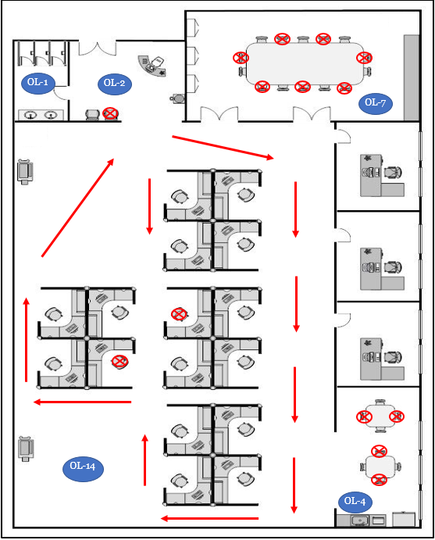
Figure 2: Example office diagram outlining occupancies and traffic flow
Legend
- Red arrows ( ) indicate the suggested one-way flow pattern
- Circles with OL ( ) indicate an occupancy limit for the room
OL-2
- Red circles with x’s ( ) indicate suggested reductions in occupancy
- Green rectangles ( ) denote shared equipment locations

2.2 Work Schedules
Some work will require schedules to maintain physical distancing. Outline scheduling plans here. The scheduling plan should include:
- Where shared calendars or logs will be located
- How they will be accessed
- How schedules are made
- Meetings should be held virtually. Where in-person meetings cannot be avoided, meeting rooms must indicate the maximum number of occupants and be sanitized after use.
- Measures to ensure that Working Alone guidelines are followed at all times

2.3 Other considerations for Physical Distancing
- Post occupancy limits on all entrances (if needed).
- Post hand hygiene procedures on all sinks and hand hygiene stations.
- Remove extraneous seating.
- Use barriers like plexi-glass to protect employees where physical distancing cannot be maintained (e.g. cash transactions)
- Designate workstations that will be occupied.
- Ensure hand hygiene stations are present for employees to use.
- Communicate all changes being made due to COVID-19 to all employees, students and visitors.
- Post standardized or work-specific COVID-19 posters.

3.0 Surface Decontamination
Surface decontamination is the responsibility of the supervisor to conduct or assign to responsible individuals. Commonly used surfaces should be disinfected twice per day. Fill out the sections below regarding decontamination plans for the work area.

3.1 Work surface and equipment Decontamination
Complete the table below regarding disinfection details for shared work surfaces or equipment.
Table 1: Shared equipment disinfection details
Equipment/surface identifier | Disinfectant | Contact time | Frequency of disinfection | Person responsible
*Contact time refers to the amount of time that the disinfecting agent is required to be in wet contact with the surface/object to appropriately disinfect.
Notes on surface disinfection:
- Ensure the disinfectant chosen is appropriate for the surface being disinfected. Cleaning kits ordered through Plant Operations are appropriate for general office environments and kitchenettes.
- Ensure there is enough disinfectant to last the workweek.
- All work surfaces should be decontaminated twice daily.

3.2 High-touch area Decontamination
All high-touch surfaces inside the work area should be disinfected twice daily. Designate responsible persons and a schedule for this to be done. Complete the table below for the work area.
Table 2: High-touch surface disinfection summary table
Item Identifier | Disinfectant | Responsible Person | Frequency of disinfection | Time
Shared phones
Shared keyboards and mice
Cleaning kits ordered through Plant Operations are appropriate for high-touch surface disinfection.
Click here for more information on the disinfection of surfaces.

4.0 contingency plan
All departments are required to have contingency plans. This includes actions that will be taken if an employee has symptoms of COVID-19, tests positive for COVID-19, or is required to self-isolate. It also includes reverting to a previous phase (E.g., fewer employees in the workplace) or a return to all non-essential employees (which may be directed by the University, provincial or public health authorities) reverting to a work from home state.
Please identify who is responsible for this process:_______________________
Describe your contingency plan here:
Click or tap here to enter text.

5.0 Acknowledgements
Employee acknowledgements
By printing and signing my name in the table below, I acknowledge that I have been trained on and will follow the procedures outlined in this document. Electronic acknowledgements are acceptable.
Employee Name | Signature | Date
Department head acknowledgement:
I have implemented all procedures outlined in this document to reduce infection risk of COVID-19. Those found not following these directives will be subjected to corrective action up to and including disciplinary measures.
Name: ______________________________
Signature: ______________________ Date: ___________

