April 25, 2013
Opportunities and New Directions Conference, 2013
University of Waterloo

David Pace, & Leah Shopkow

Breakthroughs in the Classroom: Reviving Teaching and Learning with Decoding the Disciplines

Part 1: The Origins of Frustration
Part 2: An Introduction to Decoding the Disciplines
Handout 1: The Decoding the Disciplines cycle
Handout 2: Your Bottleneck
Activity: Brief Bottleneck interview demonstration with James Barnett, School of Accounting and Finance
Part 3: Three Iterations in Three Years: the development of Arlene Díaz
Handout 3: The Development of Arlene Díaz
Handout 4: References

“In scholarship and research, having a ‘problem’ is at the heart of the investigative process; it is the compound of the generative questions around which all creative and productive activity revolves. But in one’s teaching, a "problem" is something you don’t want to have, and if you have one, you probably want to fix it.”

Randy Bass, “The Scholarship of Teaching: What’s the Problem?”

This presentation is based on the work of Indiana University Freshman Learning Project (FLP) and the History Learning Project (HLP—pictured left). The History Learning Project is directed by Arlene Díaz, Joan Middendorf, David Pace, and Leah Shopkow and has been funded by the History Department and the college of Arts and Sciences, and the Center for Innovative Teaching & Learning at Indiana University, as well as the Teagle and Spencer Foundations.
http://www.iub.edu/~hlp/

Handout 1

Decoding the Disciplines

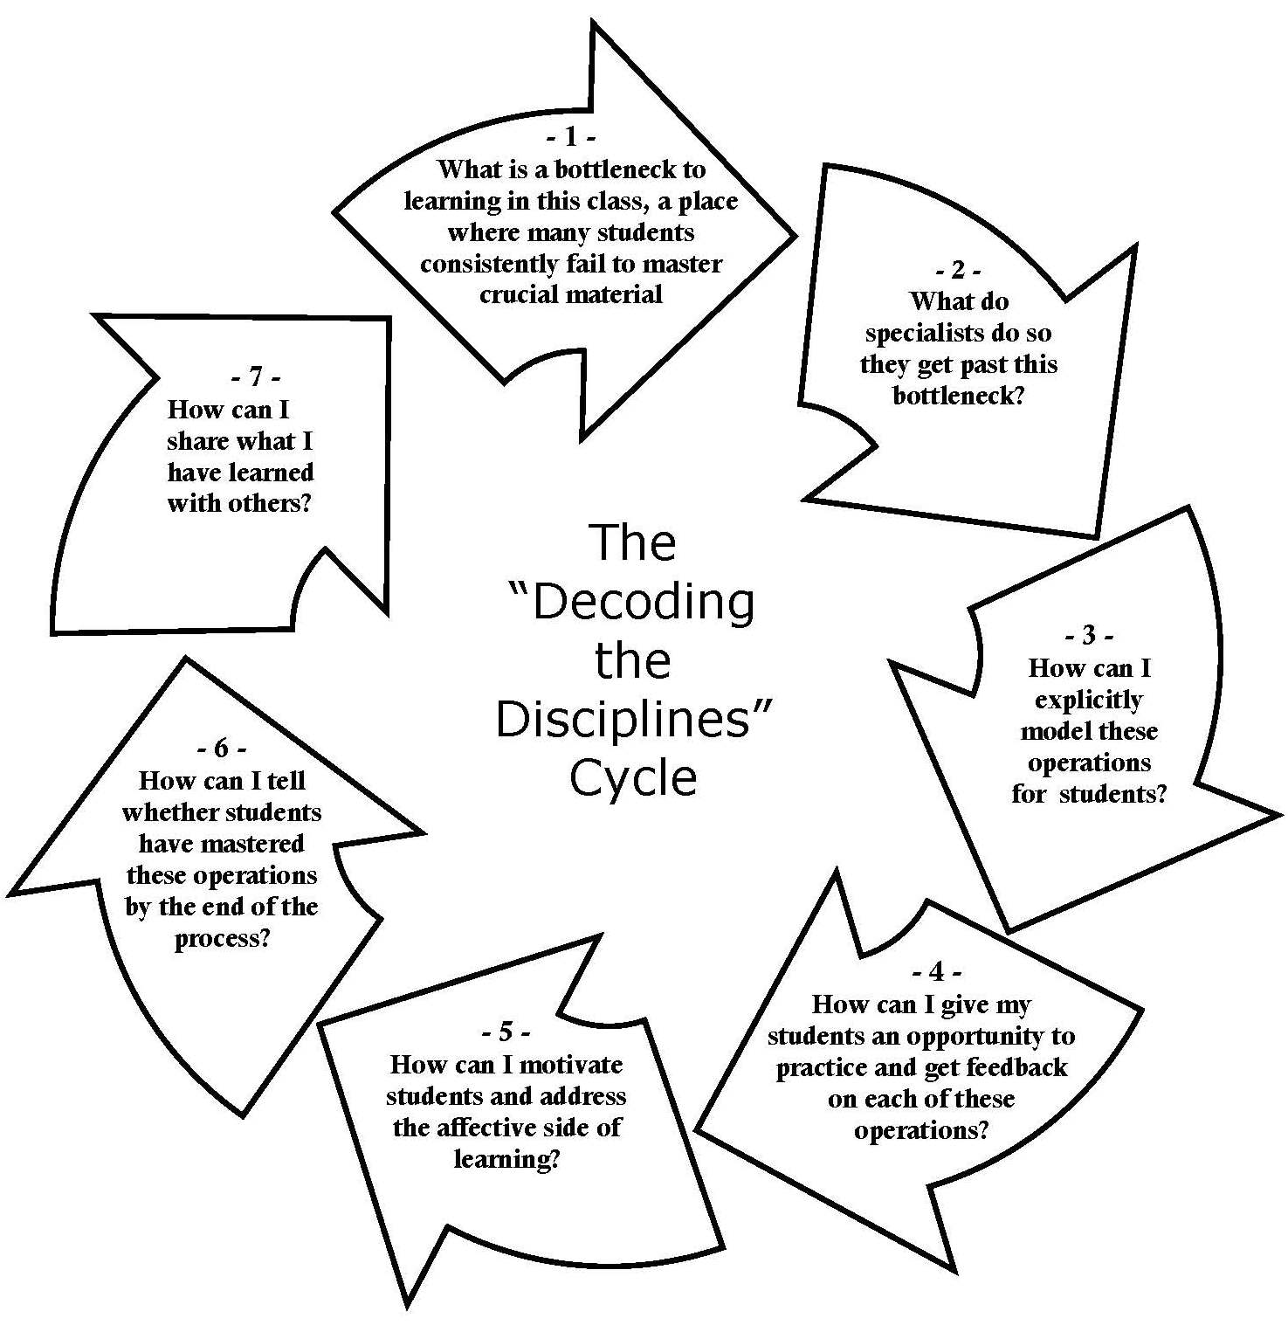
Handout 2
What’s your bottleneck?

1) Identify a specific moment in your course in which your students face a learning bottleneck (i.e. something that is essential for their success but which semester after semester large numbers of students fail to grasp).

2) Describe as precisely as you can what they are getting wrong. (What is the nature of the bottleneck?)

Here are examples of productive and unproductive ways to approach this issue:

1. English
Vague: Students cannot interpret texts.
Useful: “Students in literature classes have a particular problem in the basic approach to textual interpretation. Students forever want to go directly to interpreting a text without first getting a good grasp of a text’s content. They need to observe before they interpret, but they are constantly skipping a thoughtful observation stage. Skipping this stage leads to poor interpretations.” (This observation is specific enough and provides enough information that it can serve as a starting place for the analysis of the bottleneck.)
-Gutjahr, 2004

2. Biology
Vague: Students have difficulty moving from fact learning to a deeper understanding of biological processes
Useful: Students have difficulty visualizing chromosomes, appreciating the distinction between similar and identical chromosomes (i.e., homologs and sister chromatids), and predicting their segregation patterns during mitosis and meiosis.
-Strome, 2004

________________________________________________________________________

________________________________________________________________________

________________________________________________________________________

________________________________________________________________________

________________________________________________________________________

________________________________________________________________________

________________________________________________________________________

________________________________________________________________________

Handout 3

The Development of Arlene Díaz
(Ten Years of Gradual Change)

Pre-2004 | Díaz is untenured faculty, working on gathering course materials and developing courses. She considers where her students are coming from but doesn’t have time to do more than this.
2004 | Arlene Díaz gets tenure, begins working on improving student learning. Develops a set of guiding questions to help students grasp the relationship between Church and State. Results: It helps students grasp this specific point. This leads to other similar developments she characterizes as “baby steps” focusing on individual concepts.
2005 | Her interest in pedagogy leads her to join the History Learning Project as a founding director (with Middendorf, Pace, and Shopkow)
2006 | Introduced to Decoding the Disciplines through the Freshman Learning Project. She works on getting students to understand the nature of the historical discipline through series of exercises in class. Results: Pre- and Post-class surveys show clear student conceptual improvement.
2008 | First year of three-year iterative process. Teaching “problem”: getting students to consider primary sources in relation to each other and as situated documents, rather than as isolated factual documents (Step 2, a procedural focus). She begins with a focus on basic skills of historical understanding, taught by modeling the skills, and giving students many opportunities to practice. Results: students can do this when specifically asked to do it, but they do not automatically do it and did not mobilize these new skills on the final examination.
2009 | Second year of a three-year iterative process. Since students can master the skills, the problem is getting them to deploy them (Step 5, a motivation focus). The solution is to flip the classroom and deploy Team-Based Learning (see references). The readings for each class remain the same, but students are organized in learning teams, take readiness assurance tests together (tests of mastery of the content of the readings) and then apply the reading to discussions and projects in class. While this seems a big change, the materials remain the same and the applications use exercises Díaz developed in earlier classes. Results: Sustained improvement in students’ work on exams, but strict Team-Based Learning format not well suited to a humanities course.
2010 | Third year of a three-year iterative process. Adjustments are made to the orthodox structure of Team-Based Learning to fit better with History. Final projects and applications are changed to be more in tune with authentic historical activities and to make clearer what the student had learned. (Step 6, an assessment focus). The final assessment changed to a poster session, to require students to demonstrate their ability to detect and explain scholarly arguments; students had to explain and defend their posters. Exam essays became detailed outline essays instead of formal essays. Results: More than half the students improved in their ability to deploy evidence and create arguments in the outline essays across the semester.

Handout 4
References

Decoding the Disciplines and the History Learning Project
Díaz, Arlene, Joan Middendorf, David Pace, and Leah Shopkow (2008). The history learning project: A department "decodes" its students. Journal of American History 94(4), 1211-24.
Middendorf, J., Pace, D., Shopkow, L. & Diaz, A. (2007). Making thinking explicit: Decoding history teaching. National Teaching and Learning Forum, 16(2). 1-4.
Middendorf, J. and Pace, D. (2007). Easing entry into the scholarship of teaching and learning through focused assessments: The “Decoding the Disciplines” approach. In D. Robertson & L. Nilson (Eds.), To Improve the Academy: Resources for faculty, instructional and organizational development, 26, 53-67. San Francisco: Jossey-Bass.
Pace, D., & Middendorf, J. (Eds.) (2004b). Decoding the disciplines: Helping students learn disciplinary ways of thinking. New Directions for Teaching and Learning, 98. San Francisco: Jossey Bass.
Shopkow, L., Diaz, A., Middendorf, J., & Pace, D. (2013). The History Learning Project “Decodes” a Discipline: The Union of Teaching and Epistemology. In Kathleen McKinney (ed.) SoTL in and Across the Disciplines, 93-113. Bloomington, IN: Indiana University Press.

Useful References
Angelo, Thomas and Cross, Patricia (1993). Classroom Assessment Techniques: A Handbook for College Teachers. San Francisco: Jossey-Bass.
Calder, L. (2006). Uncoverage: Towards a signature pedagogy for the history survey. Journal of American History, 92(4), 1358-1370.
Chi, M.T.H. (2008). Three types of conceptual change: Belief revision, mental model transformation, and categorical shift. In S. Vosniadou (Ed.), Handbook of research on conceptual change, 61-82. Hillsdale, NJ: Erlbaum.
Dragon, T., Arroyo, I., Woolf, B., Burleson, W., el Kaliouby, R., Eydgahi, H. (2008). Viewing Student Affect and Learning through Classroom Observation and Physical Sensors, <http://centerforknowledgecommunication.com/publications/recentPubsandAwards/2008/DragonAffectITS08Final.pdf> accessed 3/10/2010.
Meyer, Jan and Land, Ray, eds. (2006) Overcoming Barriers to Student Understanding: Threshold concepts and troublesome knowledge. London: Routledge.
Michaelson, Larry; Knight, Arletta Bauman; and Fink, L. Dee (2004). Team-Based Learning: A Transformative Use of Small Groups in College Teaching. Miami: Stylus.
Novak, Gregor et al. (1999). Just-in-Time Teaching: Blending Active Learning with Web Technology. Saddle River, NJ: Prentice-Hall.
Perkins, David (2006). Constructivism and Troublesome Knowledge. In Meyer, Jan and Land, Ray, eds. (2006) Overcoming Barriers to Student Understanding: Threshold concepts and troublesome knowledge, 33-47. London: Routledge.
Savion, Leah & Middendorf, Joan (1994). Enhancing Concept Comprehension and Retention. The National Teaching & Learning Forum 3(4), 6-8.
Weimer, Maryellen (2006). Enhancing Scholarly Work on Teaching and Learning: Professional Literature that Makes a Difference. San Francisco: Jossey-Bass. (For listing of journals on teaching in the disciplines.)
Wiggins, Grant & McTighe, Jay (1998). Understanding by Design. Saddle River, NJ: Prentice-Hall. (I have listed the first edition. I find the second edition much longer, but no better. However, they do include more examples from university classes.)

Links
History Learning Project: <http://www.iub.edu/~hlp/>
ardiaz@indiana.edu; middendo@indiana.edu; dpace@indiana.edu; shopkowl@indiana.edu

