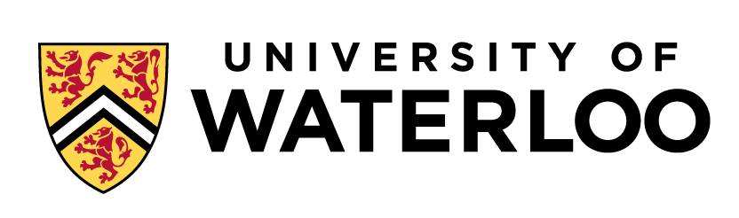

Interview Guide

Role – Department

Name of Candidate:
Interviewer:
Date:

Qualifications:
X

- Please tell us, what interests you about working for the University of Waterloo? Why are you interested in this particular positon?

- Let’s go over your resume. Please describe your previous work experience, preferably how it relates to this position and why you left each role.

- Where are you with your current job search? Are you actively interviewing with other companies/positions? If you are, what stage of the process are you at?

- What are you looking for in your next position? What is going to keep you motivated and engaged?

- Based on the requirements of this position, what transferable skills do you feel you have that makes you a qualified candidate?

- Are there any other skills or experiences you would like to highlight that we did not have a chance to discuss yet today?

Candidate Questions:

Interviewer’s Comments:

