Giga-to-Nanoelectronics Centre – Operating Policies and Procedures

Prepared by: Graeme Williams, Richard Barber September 19, 2010
Modified by: Graeme Williams, Richard Barber & William Wong January 28, 2011
Modified by: Richard Barber & William Wong March 17, 2021
This guide is prepared as a general introduction to lab use, safety guidelines, equipment operations, user conduct, and general lab practices. This guide should be read by all new users to the G2N lab so as to maintain a high level of both safety and cleanliness in the clean room.
This document also serves as a refresher guide to all existing users in the G2N lab and should be reviewed on a regular basis as it is updated with new information.

List of Emergency Contact Numbers
Lab Manager (Richard Barber) ext. 33864
UW Police ext. 22222 (1-519-888-4911)
Safety Office ext. 33587
Health Services ext. 84096 (1-519-888-4096)
Ontario Poisoning/Overdose Help Line 1-800-268-9017
TeleHealth Ontario 1-866-797-0000
Contents
1. Introduction 7
1.1. Operating Philosophy 8
1.2. G2N Main Users 8
1.3. Lab Equipment and Prime Users 9
1.3.1. Prime User Listing and Contact Info 10
1.1.1. Persons-In-Charge, Operating Expenses and Lab Fees 12
2. Access and Required Training 13
2.1. Building Access and Visitors 13
2.1.1. Visitors in Groups 14
2.2. Laboratory Access and Training 14
2.2.1. Laboratory Users Training 15
2.2.2 Coop Students 16
2.2.3 Visitors Access to Laboratories 16
2.2.4 Preparing for Visitors to Laboratories 17
2.3 Cleanroom Access and Training 17
2.4 Specialized Training Requirements 19
2.4.3 Specialized Laboratories 19
2.4.4 Equipment Training 19
2.4.5 Microfabrication Cleanroom Housekeeping 20
2.4.6 Microfabrication Cleanroom Maintenance and Equipment Installation 20
2.5 Emergency Response 20
3 Universal G2N Procedures 21
3.2 Access 21
3.2.3 Revocation of Access Privileges 21
3.2.4 Safety Training Documentation 22
3.2.5 Equipment Competency and Certification 22
3.2.6 Financial Arrangements 23
3.3 Laboratory and Microfabrication Cleanroom Rules 23
3.3.3 Operational Hours 23
3.3.4 Hazardous Materials 24
3.3.5 Material Safety Data Sheets 24
3.3.6 New Chemicals 25
3.3.7 Existing Chemicals 27
3.3.8 New Processes 29
3.3.9 Personal Protective Equipment (PPE) 30
3.3.10 Required PPE for the Laboratories 30
3.3.11 Chemical Usage Rules 31
3.3.12 Empty Chemical Bottles 31
3.3.13 Chemical Waste 32
3.3.14 Compressed Gas Cylinders 34
3.3.15 Certification for Equipment Use 35
3.3.16 Reserving Equipment 36
3.3.17 Log Books/Online Equipment Log 36
3.4 Consequences of Rules Violation 37
3.4.3 Restriction of Laboratory or Microfabrication Cleanroom Access 37
3.5 Laboratory and Microfabrication Cleanroom Billing Policies 38
4 Microfabrication Cleanroom Procedures 41
4.2 Gowning Procedures 41
4.2.3 Basic Clothing Requirements 41
4.2.4 Pre-Gowning Procedure 44
4.2.5 Gowning Procedure: Clean Room Jumpsuits/Bunny Suits 44
4.2.6 Degowning Procedure: 45
4.2.7 Material Entry Procedure 46
4.3 Equipment Maintenance Procedure 46
4.4 Housekeeping Procedure 47
5 Cleanroom Evacuation Procedure 50
5.2 Supplemental Evacuation Procedures 51
5.2.3 Blindness or Visual Impairment 52
5.2.4 Deafness or Hearing Loss 52
5.2.5 Mobility Impairment 52
6 General Lab Notes and Procedures 55
6.2 Restocking Lab Wipes 55
6.3 Garbage Overflow: Changing the Garbage Bags 55
6.4 Notes on Lab Temperatures 56
7 Lab Etiquette 58
7.2 Wet Bench Technique and Etiquette 58
7.3 Notes on the Sonicator 64
7.4 Notes on the Spincoaters 65
7.4.3 Photoresist Spinner 65
7.4.4 Polymer Spinner 66
7.5 Notes on the Lab Ovens 68
Appendix A – Prime User Certification Form 70
Appendix B – Request to Work Outside Normal Working Hours Form 71
Appendix C – Authorization for New Chemical Form 73
Appendix D – Listing of Chemical Supplies Maintained in the G2N 75
Appendix E – Giga-to-Nanoelectronics Centre Code of Conduct 76

Introduction
The Giga-to-Nanoelectronics (G2N) Centre is a 17 million dollar laboratory, established in 2005, to help facilitate multidisciplinary research in the areas of nano-scale and thin-film electronic materials and devices. This facility is the one the most advanced facilities in the world, combining expertise in fabrication and characterization capabilities of thin-film devices with nano-scale materials synthesis and processing. The Centre also enables interdisciplinary research in the field of large-area electronics and electronics on unconventional substrates and fosters interaction between researchers and research disciplines. The G2N Centre is committed to supporting graduate and undergraduate research in applications of micro- and nanofabrication and in disseminating knowledge to the research community.

This facility is open to users both within the University as well as the community. The G2N Centre is a “hands-on” training facility; operating under the philosophy that users are trained and then allowed to independently operate equipment to prototype novel electronic devices and systems. As well, students are offered the unique opportunity to undergo training at all stages of the research and development process in electronics, including new materials development, fabrication process design and optimization, thin-film deposition and characterization, and device, circuit and system design and fabrication. This unique environment combines innovative research with practical training, resulting in pioneering solutions to complex industrial problems.
The laboratory areas provide specialized facilities for non-cleanroom equipment and experimentation including thin-film device characterization, surface analysis capabilities, optical and laser systems, electron microscopy and electrical characterization laboratories.
The Centre welcomes industrial partnerships to perform research and development projects in the facility in collaboration with academic researchers. Long term collaborative projects are given a priority. Extended fabrication projects are considered and planned individually subject to the facility load and to ensure protection of all facility users' interests.

Operating Philosophy
    - Giga-to-Nanoelectronics Centre Policies Governing Users, Space, and Equipment
          - Office space in G2N building will be assigned by the Director, the Associate Director, and the Technical Lab Manager.
          - Laboratory space in the G2N building will be assigned by the ECE Departmental Chair, the Director, the Associate Director, and the Technical Lab Manager.
          - Users and Occupants of G2N must maintain an active research program that utilizes equipment in G2N or that benefit from close interaction with other occupants and users of G2N.
          - It is expected that laboratory space, clean room space, and equipment in G2N will be open to all qualified users, except in cases where such access adversely affects the cleanliness, safety, or functionality of the space or equipment.
          - Introduction of new equipment into the G2N building must first be approved by the Director, Associate Director and the Technical Lab Manager.

G2N Main Users
G2N main users are active faculty members with their primary research conducted in G2N. Members are nominated by existing main users and confirmed by the Executive Committee (consisting of the Director, Associate Director, and Lab Manager). Main users are expected to contribute funding to provide support staff in G2N.
Main users also make up part of the Safety and New Processes committee, Grievance and Appeals committee, and the G2N Main User Selection committee.

Lab Equipment and Prime Users
The G2N Centre operates on the basis of prime users in order to maintain the many pieces of equipment throughout the lab. In the event that a regular lab user encounters a problem, malfunction or error with a specific piece of equipment, he or she should first contact the prime user for that equipment. In the event that the prime user is unavailable or unable to solve the issue, the lab manager may be contacted.
If a regular lab user would like to be trained on a particular piece of equipment, he or she should contact the corresponding prime user to initiate training. Upon demonstration of competency, the prime user will provide the lab supervisor with a form certifying the lab user on that piece of equipment. A copy of the certification form can be found in Appendix A at the end of this document.
A prime user is a master’s or Ph.D. student or a postdoctoral fellow who has shown the highest level of skill and expertise on a particular piece of equipment in the G2N lab. Prime users are given the following responsibilities:
- Safety: Ensuring that equipment users know and comply with safe working practices for the piece of equipment
- Regular maintenance of the equipment: Verifying safety and proper performance of the equipment
- Ensuring that the equipment is usable by all interested parties
- Training of new users on the equipment
- Addressing any immediate problems or concerns with the equipment
- Providing assistance in any necessary repairs to the equipment
- Maintaining process information and documentation for their system.
- Inspecting and maintaining logbooks
The role of the prime user is an absolute necessity in a multi-user, multipurpose lab such as the G2N lab. It is important that people who are assigned these roles make themselves available to satisfy the above requirements.

Prime User Listing and Contact Info
A current listing of the G2N prime users is given below. The role of deputy has been assigned to regular lab users who help manage the machine with the prime user. Deputies may also be regular lab users who will take over the task of prime user once the current prime user has left the university. For the instances where prime users are not listed, no suitable lab users for the positions have yet to be identified. In some circumstances, a critical need for prime users and deputies has been identified, as the current prime users will be leaving the university soon.
As a regular lab user, if you feel that you should be a prime user on a particular piece of equipment, you should contact the lab manager to let him know of your interest/expertise.
Equipment | Prime User | Deputy | E-mail | Office Number | Phone
BCB Vacuum Oven
CVE
Dicing Saw |  | Richard Barber | richard.barber@uwaterloo.ca | E3 3135 | x33864
Edwards Sputter | Czangho |  | czangholee@gmail.com
General Vacuum Oven
Lithography Cluster | Richard Barber |  | richard.barber@uwaterloo.ca | E3 3135 | x33864
Lithography MA6 | Feng Chen |  | f27chen@engmail.uwaterloo.ca | E3 3140 | x34803
Mask Aligner MJB3
Mask Fabrication
OLED System | Umar Shafique | Graeme | ushafique@uwaterloo.ca | E3 3140 | x34803
EvoVac Evaporator | Hossein (Afshin) Zamani |  | hzamanis@uwaterloo.ca | DC 3729
Plasmatherm | Kyung |  | talezshin@gmail.com | DC 3721
RIE Metal
RIE Oxide | Minoli |  | minoli.pathirane@gmail.com | DC 3731 | x38183
RIE Polymer | Minoli |  | minoli.pathirane@gmail.com | DC 3731 | x38183
Se evaporator | Shiva | Chris
Wirebond
WL01 Cluster | Bright | Czangho | czangholee@gmail.com | E3 3176
WL02 Cluster | Bright | Czangho | czangholee@gmail.com | E3 3176
WLOS Sputter |  | Richard Barber | richard.barber@uwaterloo.ca | E3 3135 | x33864
Wetbenches | Hossein (Afshin) Zamani | Qi Wang | hzamanis@uwaterloo.ca | DC 3729
Dektak | Richard Barber |  | richard.barber@uwaterloo.ca | E3 3135 | x33864
Raman spectrometer | Anming Hu |  | a2hu@uwaterloo.ca | E3 4403 | X35464
UV/IR Spectrometers
SEM
AFM | Jian Zhang |  | j242zhang@uwaterloo.ca | E3 3176 | X34829
Reel-to-Reel | Ehsan Fathi |  | efathi@uwaterloo.ca
High Temp PECVD
Probe Station | Melissa |  | mjchow@engmail.uwaterloo.ca

Persons-In-Charge, Operating Expenses and Lab Fees
In addition to the Prime Users noted above, each laboratory room on the 3rd floor characterization facility and each item of equipment will be assigned a “Person-in-Charge” (PIC). The PIC will be the faculty member (or designee) most intimately involved with the use of the space or equipment. The PIC will establish rules governing access to the laboratory or equipment, including training requirements, scheduling, operational procedures, functional restrictions, etc. Such rules are subject to approval by the G2N Director, the Associate Director, and the Technical Lab Manager.
In cases where equipment outside the cleanroom is shared by a large number of users, a user fee will be established to prorate the cost of maintenance among users proportional to their actual usage. The fee will be established by the PIC, subject to approval by the G2N Director and G2N Associate Director, and will not exceed the actual per-use maintenance cost of that equipment. If a piece of equipment is restricted to a small group of users, that group can elect to provide their own maintenance.
The G2N Director and the G2N Technical Lab Manager will act as the PIC of the cleanroom and will establish regulations governing access, training requirements, operational protocols, and penalties for violation of operating rules. Equipment maintenance within the cleanroom will be managed centrally by G2N. G2N will fund and supervise a maintenance staff, and will collect user fees to offset the cost of maintenance.
To support operating expenses of the cleanrooms, a per-semester cleanroom access fee will be charged. In cases where these fees would inhibit users from utilizing the facilities, users can apply to the G2N Director for a waiver of fees. Each such request will be considered on an individual basis.

Access and Required Training

Building Access and Visitors
All persons entering G2N, whether users of the G2N facilities or visitors, must stop at the lobby area and read the orientation brochure or view the orientation slides online (see here: web link to training slides). This information gives a capsule view of the facility and how to respond to an emergency situation. All people entering the building must be familiarized with emergency information, building layout, and rules regarding controlled-access portions of the building.

Visitors in Groups
Visitors should be informed of emergency alarms & exits prior to touring the facility.

Laboratory Access and Training
Access to a laboratory in G2N is granted only to those who have a need to work in the laboratory. A visitor may enter a laboratory provided they are accompanied by a certified user of that laboratory at all times. To gain access to a laboratory unescorted and/or to work in a laboratory, Laboratory Users’ training is required. To obtain this access level you may sign up for orientation courses scheduled through the Technical Lab Manager. A laboratory access key will be issued when: 1) A message is sent to Key Distributions from the Technical Lab Manager authorizing entry; 2) The necessary training course(s) are completed; 3) the required safety quiz is passed. See Section 2.2.3 for policies pertaining to hosting visitor access to the laboratories. Access to the service galley is not permitted unless authorized by the Technical Lab Manager. Some laboratory areas will have further restrictions on personnel entry, depending on the processes and equipment present in the laboratory.

Laboratory Users Training
Laboratory users are those who work in a laboratory on a regular basis, or those who work in a laboratory – even infrequently – when unaccompanied by a certified user. Also, anyone who has any contact with hazardous materials is considered a laboratory user.
Laboratory users must complete a training and safety seminar prior to working in the laboratories. This seminar includes laboratory rules, principles of laboratory safety, and hazardous materials information. It is the responsibility of the laboratory users to ensure that they have received the appropriate safety information/training for any material or process before beginning an experiment.
Certified laboratory users will receive an RFID access badge indicating their certification. This badge must always be present when entering a laboratory, and access to the laboratory can be achieved by ‘swiping’ this badge over the badge readers near the lab doors.
Note: Every person entering a laboratory must swipe their own badge on every entry in order to keep track of the users currently within the laboratory. This is a necessary safety precaution in the event that a lab evacuation is required (for a building fire alarm, for example).
Research done with specific laboratory tools and equipment is generally unique to the lab user. As such, separate orientation, training and access for specific equipment may be required. A schedule of available training sessions can be arranged with current users or with prime users to obtain training.
Note: If a user does not enter the laboratory for a period of one year, then badge access is terminated and retraining is required prior to resuming work in the laboratories.

2.2.2 COOP STUDENTS
Coop students on a work term are allowed to use the G2N Clean Room as long as they are carefully supervised and trained.
2.2.2.1 Coop students must be supervised at all times while working in the G2N clean room for at least the first month of their work term.
2.2.2.2 After 1 month of supervised training and demonstrated satisfactory work inside the clean room, and after certification by the user prime on any equipment used, the coop student’s supervisor may request that the lab manager provide independent access to the lab for the student, and extended access hours may be requested. The student must have a supervisor or safety buddy at all times while working in the clean room.

Visitors Access to Laboratories
Laboratory visitors are those people who enter a laboratory area under escort, and are accompanied by a certified laboratory user at all times. A laboratory visitor may not enter a laboratory unaccompanied, nor may he/she be left alone in a laboratory. Under no circumstances should a laboratory visitor have a laboratory key. Exceptions are made in the case of contractors. Such individuals necessarily work independently. They must be made aware of hazards in their work vicinity, and about evacuation routes in the event of emergency situations.

Preparing for Visitors to Laboratories
A visitor’s host is required to review all safety rules that apply to laboratories as well as general facility rules. The host is responsible for his or her visitor at all times and must ensure that safety protocols are followed. The visitor must be accompanied by the host at all times while in the laboratories. Laboratory visitors may NOT handle chemically or biologically hazardous materials. Laboratory visitors may NOT handle any instrumentation while in the labs. They must comply with all posted rules for that laboratory.

Cleanroom Access and Training
Cleanroom access is granted to those who have a need to work in the G2N microfabrication cleanroom. To gain initial access to the microfabrication cleanroom, applicants must attend the users training and safety seminar. A microfabrication cleanroom RFID badge key and microfabrication cleanroom garment set will be issued when the training and entry requirements have been satisfied.
Visitors may view the operations of the cleanroom through the many viewing windows that have been designed into the cleanroom perimeter.
Entry to the G2N microfabrication cleanroom requires the completion of specialized training. This training involves the general seminar course as well as hands-on sessions. Training is provided for visitors to the microfabrication cleanroom as well as for those who will work in the cleanroom for an extended period of time. The appropriate training course(s) must be completed prior to entry into the microfabrication cleanroom.
Note: If a user does not enter the microfabrication cleanroom for a period of one year, then badge access is terminated and retraining is required prior to resuming work in the cleanroom. Also, if a user does not use a specific piece of processing equipment for a period of 6 months, then the access is terminated and the user must be recertified on the equipment by going through the specific training for that equipment prior to using the tool.
Access to the microfabrication cleanroom chases from outside of the microfabrication cleanroom is not allowed. Chases may only be entered from within the microfabrication cleanroom, and only G2N staff members or maintenance personnel are approved to enter the chase area. Exiting the cleanroom and/or cleanroom chases through the emergency exit doors is prohibited except in an emergency.
Entry into the service chase has the same restrictions as entry into the microfabrication cleanroom. Access to the service chase is highly restricted; the service chase should only be entered by those who have a valid reason for entry. Microfabrication cleanroom training is required for all persons who have access to the service chase, but only G2N staff members or maintenance personnel are approved to enter the service chase area.

Specialized Training Requirements
In addition to the training requirements for entry into various portions of the facility, training courses are required for those performing specialized functions in the facility or use of dedicated tools and equipment.

Specialized Laboratories
There are several recognized labs which require documented safety training. These areas include labs classified for processing and characterization equipment including Laser Use and X-Ray Equipment. Please contact G2N Staff Management for specifics.

Equipment Training
Prior to operating equipment in the facility, specialized training is required. The training requirements for a piece of equipment are designated by the Prime User for that equipment and the Technical Lab Manager. It is the responsibility of the user to obtain certification on a piece of equipment prior to use. After successful training, users will be allowed to use the equipment for a period of time set forth by the Technical Lab Manager. The Technical Lab Manager has the right to deny access to an individual user, if the Technical Lab Manager feels the user does not understand the procedure, or if the user fails to comply with the proper procedures. Access to equipment can be revoked by the Technical Lab Manager at any time due to failure to comply with facility or equipment rules.

Microfabrication Cleanroom Housekeeping
Housekeeping personnel working in the microfabrication cleanroom must receive specialized training and certification. This certification must be received prior to working in the microfabrication cleanroom.

Microfabrication Cleanroom Maintenance and Equipment Installation
All personnel performing maintenance functions and/or equipment-installation functions within the microfabrication cleanroom must receive specialized training and certification. This certification must be received prior to working in the microfabrication cleanroom. A separate document, the G2N Equipment Installation Manual, provides guidance on maintenance and installation materials and procedures.

Emergency Response
Select University of Waterloo professional staff members have had specialized training related to building emergencies and evacuations due to hazardous conditions that could infrequently occur. This training includes the use of a breathing apparatus and emergency response protocols. This team of trained professionals is known as the “Emergency Response Team” (ERT).
Additional Safety Procedures are outlined and detailed in the Safety Awareness Guide located in a separate document. Users are required to read and understand the safety protocols for G2N outlined in the document.

Universal G2N Procedures
THE FOLLOWING PROCEDURES APPLY TO ALL THE LABORATORIES AND THE MICROFABRICATION CLEANROOM. THERE ARE ALSO SPECIFIC PROCEDURES REQUIRED FOR EACH AREA, WHICH ARE DESCRIBED INDIVIDUALLY IN SEPARATE SECTIONS.

Access
Access to the laboratories and the microfabrication cleanroom is strictly controlled and considered a privilege at UW. All users are expected to adhere to a high standard of ethics, safety protocol, and lab courtesy to obtain and retain access to any of the facility’s aforementioned areas. Access and Training is described in Section 2.

Revocation of Access Privileges
User safety and the maintenance of shared equipment are the primary concern of all G2N members. To this end and to ensure uninterrupted research, Safety and Equipment Protocols are taken very seriously. The Process and Equipment Owners (Cleanroom Staff and Laboratory Staff) and/or faculty members have the right to immediately restrict access privileges of any user who violates laboratory, microfabrication cleanroom, or University policies. The disciplinary procedure is outlined below.
All access revocations will be reviewed by the disciplinary committee which is comprised of the Director, Associate Director, G2N Main Users, and the Technical Lab Manager. A log of violators will be kept by the chairperson of the disciplinary committee. Sanctions for serious and/or repeated violations can be up to, and including, permanent expulsion from the laboratories or the microfabrication cleanroom. Suspensions are further discussed in Section 3.3.

Safety Training Documentation
No one will be allowed access to the laboratories or the microfabrication cleanroom, until they have submitted documentation to the G2N Technical Manager certifying that they have received proper safety training. Appropriate safety guidelines issued by, but not limited to, G2N, will be followed. Information on training required for specific labs can be obtained by contacting the Technical Lab Manager or reading the Safety Awareness Guidelines for G2N.

Equipment Competency and Certification
No one will be allowed to use any piece of equipment in the laboratories or the microfabrication cleanroom unsupervised until they have demonstrated their competency to the Prime User of that particular piece of equipment and have achieved certification on that equipment. See Section 2.5.1

Financial Arrangements
No one will be allowed access to any of the laboratories or the microfabrication cleanroom until they have provided a valid account number or made other suitable financial arrangements. It is the responsibility of the user to make sure the account number stays valid. Any account number that is found to be invalid will result in suspension of laboratory privileges.

Laboratory and Microfabrication Cleanroom Rules
NOTE: IN THE EVENT OF AN EMERGENCY, CALL 911.

Operational Hours
The following lab hours have been put in place for various levels of lab access:
Regular user (Master’s, PhDs, etc. paying for full term usage)
Monday - Friday: 8am – 10pm
No access on weekends
New/inexperienced/infrequent user (undergraduates, specific-equipment users)
Monday - Friday: 9am – 5pm
No access on weekends
Regular users may wish to extend their work hours beyond the regular hours shown above. By university policy, no person is allowed to work in a lab after hours alone. Therefore, in order to work in the lab beyond these hours, the user must pair up with a second regular lab user (‘buddy’) and fill out a form stating that both parties will be present in the lab at all times. This form is available at the end of this document in Appendix B, and must be signed by:
      - The regular lab user
      - His or her lab buddy
      - The regular lab user’s supervisor
      - The lab manager

Hazardous Materials
Hazardous materials work may only be performed from 8:00 AM until 10 PM Monday through Friday and no work may be done on Saturdays and Sundays. On weekday evenings (after 5 p.m.), prudent lab users are expected to work with a trained buddy in the clean room labs, even though university buildings are normally ‘populated’ at these times. This is in accordance with University of Waterloo Safety Office guidelines (http://www.safetyoffice.uwaterloo.ca/lab_safety/general_lab.htm). Weekend access is allowed only with special permission, and formal, written commitment to work with a designated buddy.

Material Safety Data Sheets
In accordance with federal and provincial law each chemical manufacturer is required to provide the users with a Material Safety Data Sheet (MSDS) for all chemicals or compounds they manufacture. This sheet contains information on the name, physical characteristics, health hazards, reactivity and compatibility along with disposal requirements etc. G2N Staff are responsible for maintaining a file of MSDSs on all currently used materials. Files may be kept using hardcopy or downloaded electronic copies. These files shall be maintained in the galley with immediate access to all individuals working in that laboratory wing. MSDS information shall be updated as new information is received or electronic updates are made available.
It is the responsibility of the user to read all relevant MSDS before handling chemicals and to take appropriate precautions before initiating an experiment.

New Chemicals
No new chemicals – solid, liquid, or gaseous – will be introduced into the laboratories or microfabrication cleanroom without the approval of the Technical Laboratory Manager and the Safety Manager. This includes different concentrations/blends or grades of an existing chemical.

New chemicals may be purchased using a purchase requisition form, which can be obtained from the Technical Laboratory Manager or from Chem Stores in ESC-109. Completed forms should be given to the Laboratory Manager, who will forward them Purchasing in East Campus Hall (ECH), provided the approval process outlined below is completed.
Note: Select individuals, such as the Technical Laboratory Manager, have access to an online purchase requisition system. For simple purchases, such as those from Sigma Aldrich, the Technical Laboratory Manager may be able to assist in completing the purchase orders.

Before bringing a new chemical into any G2N lab, use the ‘Chemical Import Form,’ attached in Appendix C, to provide information about the proposed chemical and any pertinent safety information. If you are unsure if the chemical is new to G2N, it is best to first check the MSDS files of existing chemicals, then ask the lab manager. Prior to the ordering of the new chemicals, the MSDS must be submitted to the Technical Lab Director. Upon introducing a new chemical into the lab, an electronics copy of the Material Safety Data Sheet (MSDS) should be provided. All new chemical must be delivered directly to the Technical Lab Manager. The manager will then inform the user of the chemicals arrival.

Upon introducing the chemical into the cleanroom or the laboratory, the MSDS must be on file in the master file and near the location of use, the chemical must be listed on the inventory for the appropriate laboratory, or microfabrication cleanroom, and all people working in that laboratory or microfabrication cleanroom must be trained on the safety aspects of the chemical.

Existing Chemicals
- Restocking Common Chemicals (Acetone, IPA)
This lab depletes bottles of both acetone and isopropyl alcohol (IPA) on a very regular basis. As such, a system has been put in place to ease the restocking of these chemicals:
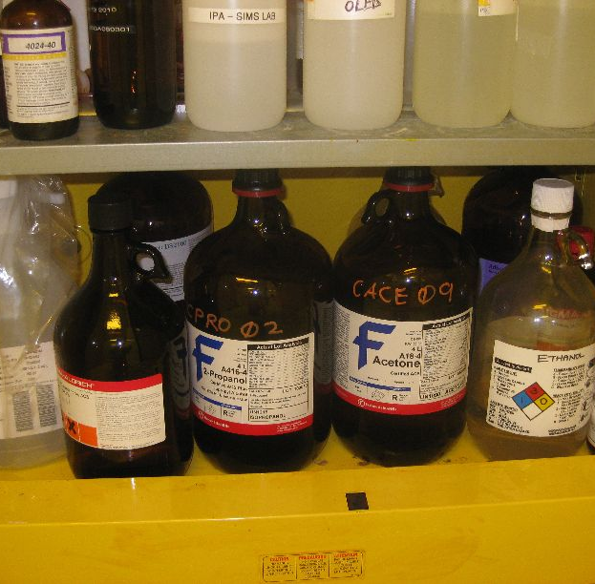
- IPA and Acetone bottles are normally kept in the flammables cabinet in the wet etch/spincoater room, shown below.

- A second set of IPA and Acetone bottles are kept in the flammables cabinet in the storage room, E3-1132, shown below.
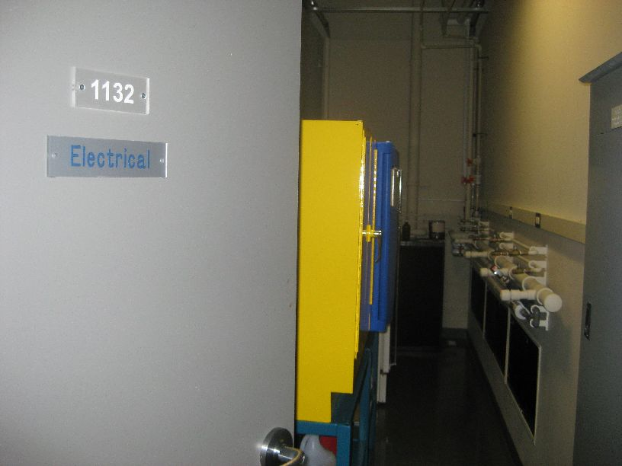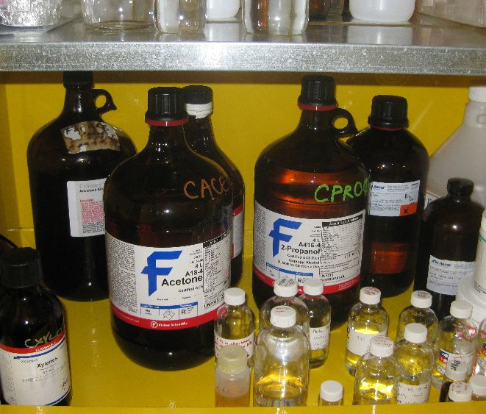
When the IPA or acetone bottles in the wet etch/spincoater room are exhausted, this set of IPA and Acetone bottles should then be brought to the flammables cabinet in the wet etch/spincoater room.
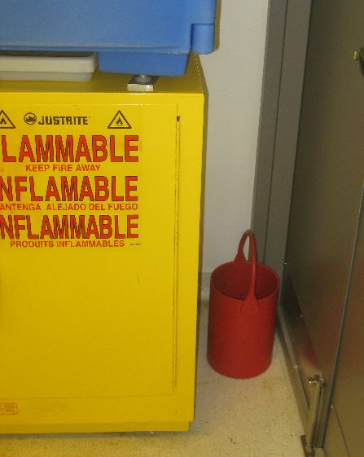
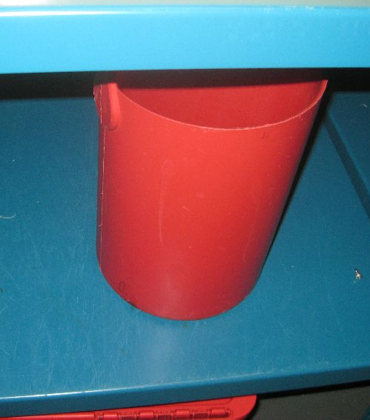
- The lab manager will frequently leave the bottles of IPA and acetone in the gowning room for lab users to bring into this second flammables cabinet in E3-1132. These bottles are transferred into the lab using large red containers. When not in use, one of the containers is kept under the flammables cabinet in E3-1132 and the other is kept next to the flammables cabinet in the wet etch/spincoater room, as shown below.
- Refilling Acetone and IPA Squirt Bottles
All lab users are responsible for refilling both the acetone and IPA squirt bottles as they are emptied. Both acetone and IPA are located in the flammables cabinet in the wet etch/spincoater room. The acetone squirt bottle labelled ‘Wash Acetone’ may be filled with the wash acetone, also found in the flammables cabinet. WEAR SAFETY GLASSES!
All general laboratory chemicals are purchased by the Technical Lab Manager; separate purchases by individual researchers are allowed with prior approval of the Technical Lab Manager. This procedure prevents unnecessary confusion and large inventories. A partial list of chemical supplies maintained by G2N Staff can be found in Appendix D. All chemicals must be deliver directly to the Technical Lab Manager who will then notify the user of its arrival.
The Technical Lab Manager reserves the right to terminate the use of any chemical in any and all laboratories if it is determined to be unsafe or if it interferes with another regular process.

New Processes
No new materials or processes may be introduced into the laboratories, or microfabrication cleanroom without the approval of the Technical Lab Manager and the Safety Coordinator. Every reasonable accommodation for new processes will be provided, but the safety and the cleanliness of a given system must be maintained.
The Technical Lab Manager reserve the right to terminate any process in any and all laboratories or the microfabrication cleanroom, if it is determined to be unsafe or if it interferes with another regular process.

Personal Protective Equipment (PPE)
Personal protective equipment must be worn in accordance with standard procedures for the laboratories and the microfabrication cleanroom, and the requirements listed on the MSDS for the chemical(s) in use. THE MSDS FROM THE MANUFACTURER OF THE MATERIAL MUST BE CONSULTED TO DETERMINE MINIMUM PPE REQUIREMENTS.
For hazardous liquid chemical usage, personal protective equipment (PPE) consists of splash- proof goggles, apron and sleeves or apron with sleeves, and chemical-resistant gloves. If a user is pouring chemicals and/or performing operations with a higher risk of chemical exposure, a face shield must be added to the above PPE. The chemicals must be used in a vented chemical hood.

Required PPE for the Laboratories
At all times while working in the laboratories, all personnel are required to wear eye protection. The sole exception to this rule is equipment labs without fume hoods or pressurized gasses (including house nitrogen). Splash-proof goggles are required while working in front of fume hoods. Face shields and splash-proof goggles are required when pouring chemicals.
Appropriate chemical-resistant gloves must be worn when working with any chemical. Chemical-resistant aprons are required when working with corrosive chemicals. Lab coats are required when working with solvents.
Wavelength-specific protective eyewear must be worn while in a laboratory with an operating laser.

Chemical Usage Rules
In the laboratories or the microfabrication cleanroom, when using chemicals, empty one bottle before opening another. This has a direct effect on safety issues, storage efficiency and cost.

Empty Chemical Bottles
When an acid or caustic bottle is emptied, rinse it inside and outside three times with deionized water in an acid hood, dry the outside of the bottle and place it in the waste/recycling area in the far corner of the wet etch room. When a solvent bottle is empty, blow dry the inside using house nitrogen such that no residual liquid remains and place in the waste/recycling area in the far corner of the wet etch room.

Chemical Waste
- Waste Disposal Procedures
Waste disposal stickers can be found in the wet etch/spincoater room in the right side of the main cabinet (just below the spinners), as shown below. Extra stickers are kept in a cupboard in the change room – notify the lab manager if more stickers are required.
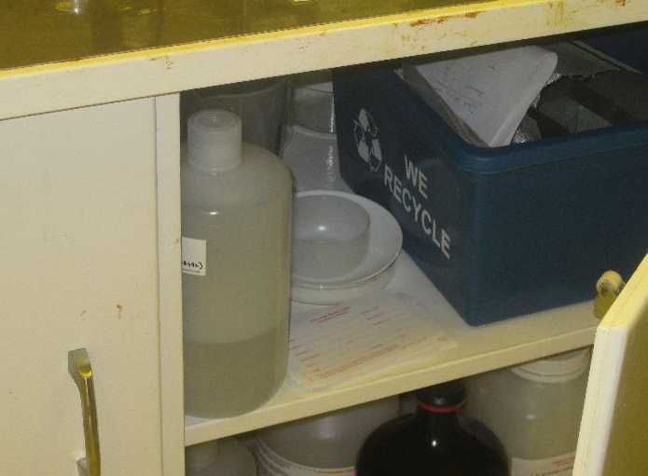
Waste Disposal Stickers
Be sure to fill this form with ALL of the following information:
- Chemical name
- Percent of the chemical in the bottle
- Amount of waste in the bottle
- The current date
- Your name/extension
- Your department
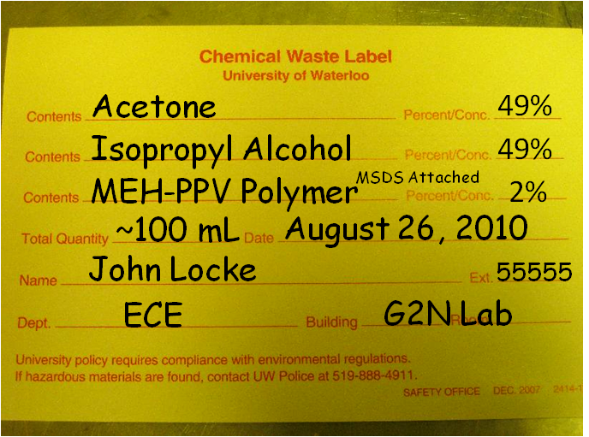
An example of a completed waste disposal sticker is shown below.

You may use a suitable empty bottle (not already being used for waste!) in the far corner of the wet etch/spincoater room for your waste disposal. Be sure to rinse and dry the bottle before its use as a waste container.
When the waste bottle is ¾ full, or all of the relevant waste has been added to it, the bottle should be brought to the waste disposal pick-up cart in the side room E3-1134. An image of the cart is shown below. For exotic chemicals/substances that are denoted by acronyms (such as MEH-PPV polymer, as shown above on the completed waste disposal sticker), include a printed copy of the MSDS with the waste bottle on the cart.
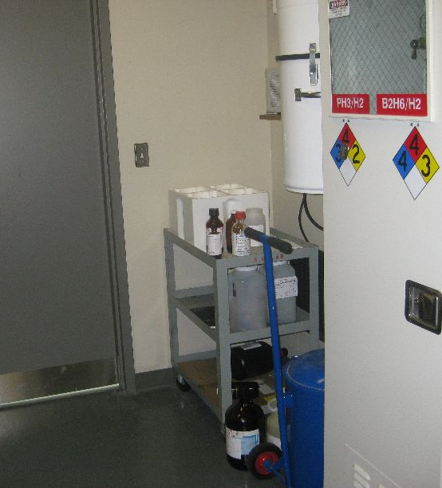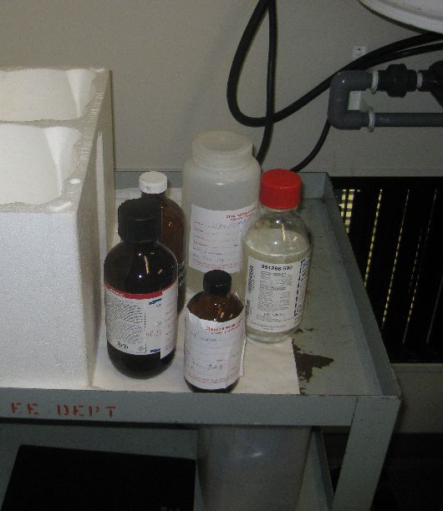
NOTE: Waste disposal stickers must be filled out accurately or they will not be accepted by University of Waterloo Waste Management!
Containers of waste chemicals must be capped at all times, unless expressly adding waste solution to the bottle. Do not leave funnels in waste containers and do not leave containers uncapped. All bottles placed in the waste chemical cabinets or other receptacles must be labeled.

Compressed Gas Cylinders
All compressed gas cylinders shall be handled as potential energy sources. This requires specific operating procedures and practices for inspection, transportation, storage, change-out and emergency handling.
All gas cylinders will be changed by laboratory staff. Gas cylinders must be properly secured when in use and when staged. Transport of cylinders must be by an approved cart with cylinder properly secured and cap securely attached. Equipment users should monitor supply levels on a regular basis and request replacements 48 hours in advance of planned use.

Certification for Equipment Use
The G2N Centre utilizes a software system called “Coral” to organize equipment use, billing, reservations, etc. Prior to training in the G2N Labs or Cleanroom, access to the Coral Software is required. The person with signature authority for the account to be charged (typically the PI) must complete the form at HTML Link. In the laboratories and the microfabrication cleanroom, the equipment may only be used unsupervised by those certified on that piece of equipment. To become certified on a piece of equipment, contact the Prime User responsible for the equipment and schedule a training session. Successful completion of the training and passing the proficiency evaluation leads to certification. Upon certification by the Prime User, the user’s login will be qualified in Coral. An asterisk will appear next to any authorized equipment name in Coral.
The Technical Lab Manager reserves the right to terminate certification of a user. Termination of a user’s certification will be based on the inability of user to safely operate the equipment or on a violation of equipment policies. If the user is determined to be incapable of operating any particular equipment safely, the certification will be terminated immediately. Recertification on any piece of equipment may be required after operational or safety updates, or after an extended period of non-use by the user. The operational and safety updates, as well as the expiration of certification on a piece of equipment are determined by the Prime User. To renew certification, contact the Prime User.

Reserving Equipment
The reservation policy for each piece of equipment can be found in the Coral hierarchy. Reservations must be continuous in time. For exceptions to the reservation policies, contact the Process Owner of the equipment. Coral allows the Process Owner to grant exceptions on a case-by-case basis. In the laboratories or the microfabrication cleanroom, be realistic and conscientious when singing up to reserve equipment.
Cancellation of an equipment reservation less than four hours prior to the scheduled use is considered a “no show.” Repeated no-show occurrences may result in forfeiture of your ability to sign up for equipment.

Log Books/Online Equipment Log
Fill out logbooks completely and legibly. It may be tedious to fill in all the blanks, but the information you provide can speed up troubleshooting and greatly reduce equipment down time. Laboratory access may be suspended for failure to completely and legibly fill out log sheets.

Consequences of Rules Violation

Restriction of Laboratory or Microfabrication Cleanroom Access
In order to maintain a safe and fair working environment it is sometimes necessary to restrict a user’s access to the laboratory or the microfabrication cleanroom, due to safety or protocol violations. This applies to University of Waterloo users as well as outside non-profit and for-profit users.
If process and equipment users, staff, or faculty members observe a protocol or safety violation they will report the infraction to a member of the G2N management team. (If the infraction is judged to be endangering other users and/or equipment, the user, staff member, or faculty will inform the user of the violation and the restriction will begin immediately.)
The management team member will report the violation to the chairperson of the G2N disciplinary committee, and the user’s access to the cleanroom and laboratories will be put on restricted status. The disciplinary committee chairperson will inform the user’s PI, who in turn will inform the user of the restriction. Appropriate due-care should be taken at the time of observing the infraction so that equipment and/or processes can be safely shut down and restored to a safe and ready condition for the next user. Note, restriction, or limited access, is defined as access to the cleanroom and laboratories only between the hours of 8:00 a.m. and 5:00 p.m. Monday through Friday. The duration of the restriction will be according to the following table:
Procedural Issue Safety Issue
First Violation 1 weeks limited access 2 weeks limited access
Second Violation 2 weeks limited access 4 weeks limited access
Third Violation 4 weeks limited access 8 weeks limited access
Fourth Violation 4 week suspension 4 week suspension
Fifth Violation Expulsion Expulsion
Note: ‘1-week is defined as 5 business days’ (Holidays and shut-down periods are not included)
A record of all violations will be kept on file by the chairperson of the disciplinary committee.
The permanent expulsion of a laboratory or microfabrication cleanroom user will require the consensus of the G2N Staff and Disciplinary Committee.

Laboratory and Microfabrication Cleanroom Billing Policies
Any person, other than faculty and staff, who enters a laboratory to use designated equipment at any time within the term will be charged the term billing fee for that laboratory. Please note that sharing a badge or entry into a laboratory without a badge to avoid these charges constitutes theft, and will be dealt with accordingly. This is regardless of whether there was one entry or many entries during that term.
In addition to general entry charges which cover the cost of consumables and fixed costs within the laboratories, there are also equipment-usage fees.
Coral is the software suite used by G2N to manage equipment reservations and billing within the facility. All users wishing to use equipment within G2N must have a Coral login that charges to a valid UW account number. Equipment must be enabled in Coral by the user controlling the equipment prior to use. Users are not to share login information.
To request a Coral login, the faculty advisor must fill out the form at:
HTML website
Expired charge accounts will be deactived, thereby preventing a user from equipment use.
Each piece of equipment in the laboratory or the microfabrication cleanroom has a logbook. Users must sign into the logbook and Coral before any work is started. Logbooks are to be filled out completely and legibly.
External users will be subject to fees determined by access requirements and equipment needs. The Technical Lab Manager will have updated costs for external users.
Users operating a piece of equipment without enabling in Coral and signing into the log book are subject to procedural violation restrictions per the previous discussion.
As a courtesy to other users, only make reservations you intend to use. Reserving time for another user is prohibited and will result in loss of equipment privileges.

Microfabrication Cleanroom Procedures

Gowning Procedures

Basic Clothing Requirements
Gloves (shown below, left image)
Gloves should be worn at all times while in the clean room. Gloves should be disposed of when dirty and replaced. This is especially pertinent when performing any lab upkeep/maintenance operations, such as those involving cleaning deposition chambers or changing spent oil from roughing vacuum pumps.
Hair Cover (shown below, right side of right image)
The bouffant cap is spun-bonded polyolefin with an elastic closure. Cap must be large enough to contain all hair and elastic must allow snug fit on head. Use care to ensure that all loose hair is contained within the cap.
Shoe Cover (shown below, left side of right image)
The shoe cover is spun-bonded polyolefin with an elastic closure at the top. Shoe cover must provide good traction on cleanroom flooring surfaces. Shoe covers should completely cover shoes and soles.
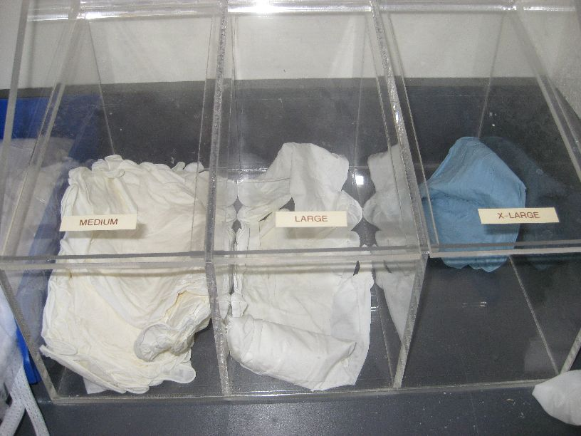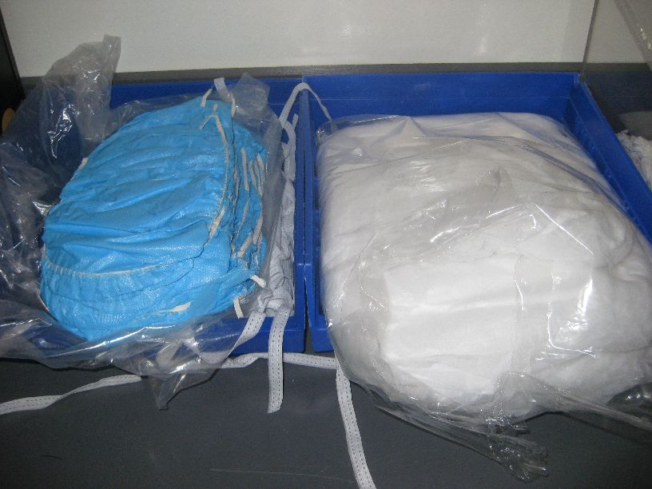
Safety/lab Glasses
Safety/lab glasses must be worn at all times in the cleanroom. Safety glasses with side shields are strongly recommended
Jumpsuit/Bunny Suit
All clean room users must use a clean room jumpsuit/bunny suit, which should contain all exterior clothing. More details on the jumpsuit are provided in Section 4.1.3 below.
Face Mask (shown below)
Depending on one’s tasks in the lab, lab users may wish to (and should) wear face masks. This is generally the case for users operating equipment that chemically or physically deposits thin films of potentially dangerous or toxic elements (such as the OLED thermal evaporator, which is commonly used to evaporate small molecule, polyaromatic compounds).
Lab users with facial hair should use beard covers or masks to reduce possible contamination in the lab. Certain types of head apparel may be unsuitable for clean room garments described above. Special hoods are available for people with such needs.
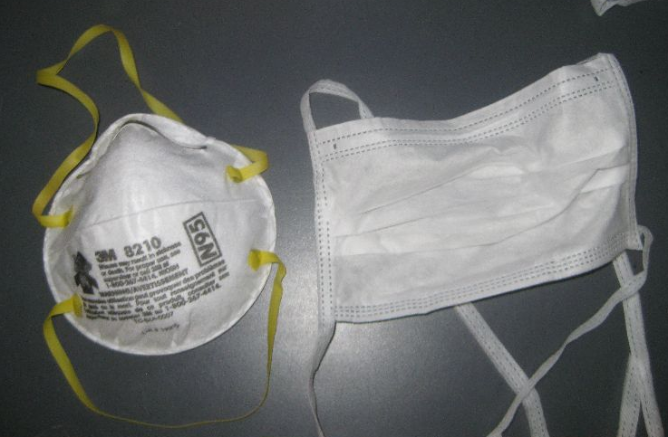
For regular users, most of the above items may be kept in assigned Tupperware containers. When not in use, the bunny suits are stored in the two closets in the gowning room (E3-1126-A/B).
As a point of note, the following items are disposable and should be replaced on a regular basis:
- gloves are disposed of replaced upon each exit and entry into the cleanroom (or as dirtied while within the clean room)
- head covers & booties should be replaced weekly
NOTE: Outdoor shoes are NOT allowed in the lab. Lab users MUST keep a spare pair of indoor shoes on campus for use in the lab! This precaution is essential in winter months.
Extra packages of all of the aforementioned clean room attire are located in the labelled cabinets in the gowning room.

Pre-Gowning Procedure
    - In the pre-gowning area, put blue shoe covers over your (approved for lab use) shoes.
    - Put on the bouffant style hair cover making sure that all hair is contained inside the cover.
    - Put on gloves prior to gowning procedure for bunny suit.
    - No one should enter the gowning area for any reason without following the pre-gowning procedures.

Gowning Procedure: Clean Room Jumpsuits/Bunny Suits
- Each regular user in the G2N lab is provided with a clean room bunny suit/gown. The user is responsible for writing his or her name legibly onto the suit, so he or she may easily be identified while in the lab and so the suit can be located when it is stored in the closet or on the racks. Over time, the bunny suit may become damaged or dirty and should be replaced.
- Visitors may use any of the bunny suits located on the visitor user rack.
- Put on the cleanroom jumpsuit without allowing any portion of the jumpsuit to touch the floor. The recommended procedure is to gather the arm and leg cuffs at the bottom of the zipper of the jumpsuit. Be seated on the gowning bench, and place one leg into the leg of the jumpsuit while releasing that leg from the zipper bottom. Pull the jumpsuit on that leg such that it completely clears the shoe cover. Repeat this procedure for the second leg.
- Holding the sleeves of the jumpsuit at the bottom of the zipper, arise and pull the waist of the jumpsuit to your waist. Put one arm into the appropriate arm of the jumpsuit while releasing that cuff. Repeat with the second arm and pull the upper part of the jumpsuit into place.
- Adjust the jumpsuit such that it is comfortable, and zip the front of the jumpsuit to the top of the zipper.

Degowning Procedure:
The degowning procedure is essentially the reverse of the gowning procedure. On exiting the microfabrication cleanroom, discard microfabrication cleanroom gloves in the trash container in the gowning room. Remove your safety glasses if you do not wear them outside the cleanroom. Proceed to the gowning station.
Sitting on the gowning bench, remove cleanroom booties and place in their designated location.
Remove cleanroom jumpsuit by unzipping the front of the garment, and removing the hands and arms from the sleeves of the jumpsuit. Gather the sleeve cuffs at the bottom of the zipper, and pull the jumpsuit well down below the waist. Sit on the gowning bench, and remove one leg from the jumpsuit, ensuring that the jumpsuit does not touch the floor. Gather the now-free leg of the jumpsuit with the arm cuffs, and repeat the procedure for the second leg.
Stand up, and grasp the jumpsuit only by the collar, allowing the jumpsuit to hang free. Place jumpsuit on hanger, again taking care not to allow it to touch the floor. Hang the hangar on the garment rack.
Remove the microfabrication cleanroom hood, and snap the hood to the snap at the neck of the jumpsuit.
Exit the gowning room and enter the pre-gowning area. Remove the bouffant cap and discard. Discard the shoe covers or store them in your assigned shoe cover bin and exit the pre-gowning area.

Material Entry Procedure
Small items may be brought into the cleanroom through the gowning room. The route for equipment is through the loading bay on the north side of the cleanroom.

Equipment Maintenance Procedure
Equipment maintenance within the cleanroom requires careful procedures to ensure that: 1) No contamination of the cleanroom occurs; 2) No unforeseen interruption of utilities to other cleanroom equipment takes place; 3) The equipment being maintained is returned to service in a clean condition.

Housekeeping Procedure
Housekeeping procedures must insure that no contamination to the cleanroom occurs. All housekeeping procedures must comply with all instructions given below:
- Vacuuming the Lab
Each week, two regular lab users are selected and assigned to vacuum the lab and perform various other simple cleaning tasks. The vacuuming schedule is sent to regular lab users via email at the beginning of each term. The schedule is also posted in the gowning room of the lab. It is ABSOLUTELY IMPERATIVE that lab users adhere to the lab vacuum schedule and that users are thorough in this task in order to maintain cleanliness within the lab. With two people, the entire process should take 30-60 minutes.
The following duties are assigned for a regular lab vacuum:
- Vacuum all floors of all rooms within the lab. The vacuum is located in the gowning room in the right closet where bunny suits are kept, as shown below. Vacuum connections can be found in most of the main rooms, also shown below.
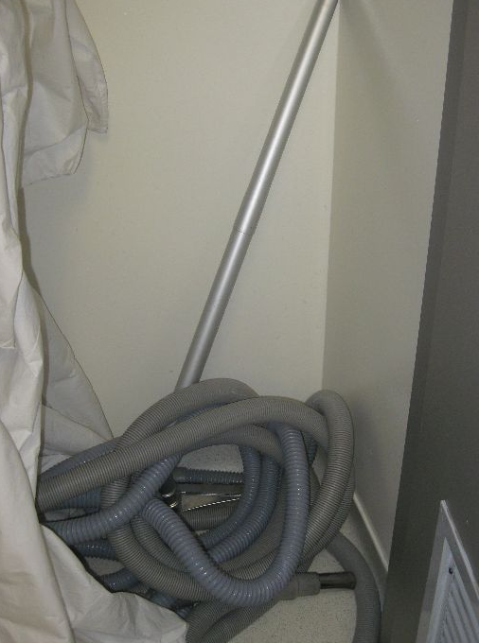
If one is unfamiliar or uncomfortable with the vacuuming procedure, one may ask any of the senior lab users for assistance.
- Remove one layer from the clean room sticky mat located at the entrance to the main hallway of the lab, as shown below. If the clean room sticky mat is on its final layer, an additional sticky mat can be found beside the doors as you enter the gowning room, also shown below.
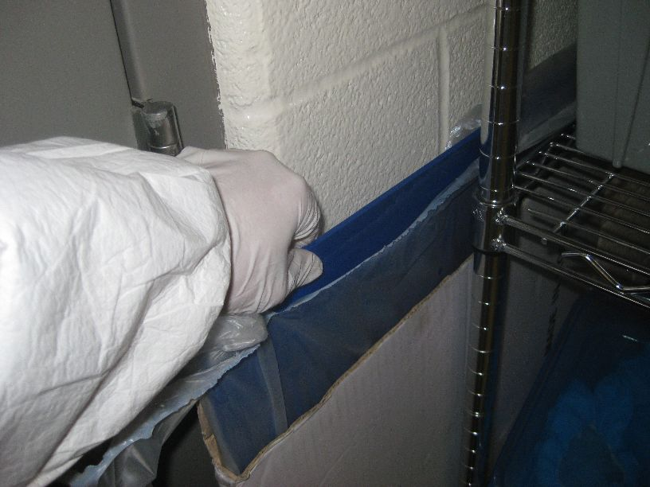
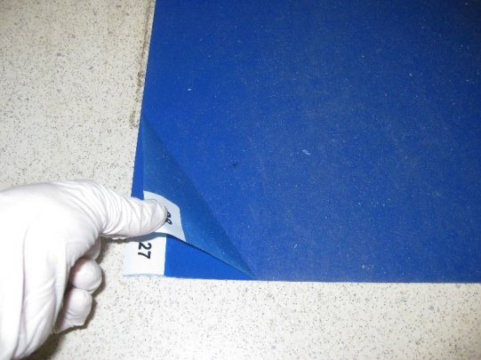
- Pick up any garbage on the floor or tables/surfaces throughout the lab.
- Wipe down any photoresist stains or other stains in the wet etch and yellow rooms in the lab.
- Take out the lab garbage if necessary.
- Re-stock the lab wipes, acetone and IPA if necessary.
- Re-fill the IPA and acetone squirt bottles if necessary
Once the lab vacuuming has been completed, one of the assigned users must email the lab manager to verify completion of the task. Failure to email the lab manager will result in the restriction of lab access for both users for the entire following week.

Cleanroom Evacuation Procedure
In case of an emergency, including the activation of any and all building alarms, evacuate the cleanroom immediately via the nearest exit. DO NOT return to the gowning room and/or remove any cleanroom garments. Upon exiting the cleanroom, proceed immediately to the evacuation site (shown below) and check-in with a staff member. Upon reaching the evacuation meeting site, you may pause to remove your cleanroom garment.
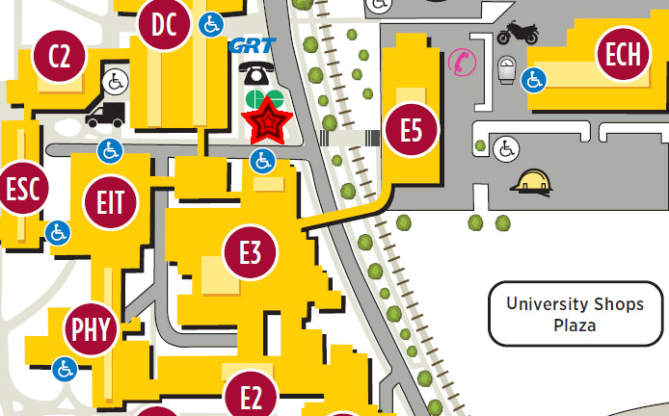
HERE

Supplemental Evacuation Procedures
The following guidelines have been adopted by G2N to assist in planning for the evacuation of people with physical disabilities.
____________________________________________________________________________
In All Emergencies, After an Evacuation has been Ordered:
• Evacuate if possible.
• DO NOT use elevators, unless authorized to do so by emergency services personnel.
• If you have a Physical Disability and are Unable to Use Stairways:
- Stay calm, and take steps to protect yourself.
- If there is a working phone, call 911 and tell the police dispatcher where you are or where you will be moving to.
- If you must move, we recommend the following:
a) Move to an enclosed exit stairway.
b) Request persons exiting by way of the stairway to notify the Fire Department of your location.
c) As soon as practical, move onto the stairway and await fire department personnel. If the situation is life threatening, call 911 from campus telephone or 911 from a pay telephone.
• Check on people with special needs during an evacuation. A “buddy system”, where people with disabilities arrange for volunteers (co-workers/neighbors) to alert them and assist them in an emergency, is recommended.
• Only attempt an emergency evacuation if you have had emergency assistance training or the person is in immediate danger and cannot wait for emergency services personnel.
• ALWAYS ASK someone with a disability how you can help before attempting any emergency evacuation assistance. Ask how he or she can best be assisted or moved, and whether there are any special considerations or items that need to come with the person.

Blindness or Visual Impairment
• Provide verbal instructions to advise of the safest route or direction using simple directions, estimated distances, and directional terms.
• DO NOT grasp a visually impaired person’s arm. Ask if he or she would like to hold onto your arm as you exit, especially if there is debris or a crowd.
• Give other verbal instructions or information (i.e. elevators cannot be used).

Deafness or Hearing Loss
• Get the attention of a person with a hearing disability by touch and eye contact. Clearly state the problem. Gestures and pointing are helpful, but be prepared to write a brief statement if the person does not seem to understand.
• Offer visual instructions to advise of safest route or direction by pointing toward exits or evacuation maps.

Mobility Impairment
• It may be necessary to help clear the exit route of debris (if possible).
• If people with mobility impairments cannot exit, they should move to a safer area, e.g.
o most enclosed stairwells
o an office with the door shut which is a good distance from the hazard (and away from falling debris in the case of earthquakes
• Call 911 or notify police or fire personnel immediately about any people remaining in the building and their locations.
• Police or fire personnel will decide whether people are safe where they are, and will evacuate them as necessary. The Fire Department may determine that it is safe to override the rule against using elevators.
• If people are in immediate danger and cannot be moved to a safer area to wait for assistance, it may be necessary to evacuate them using an evacuation chair or a carry technique.
Power Outages:
• If an outage occurs during the day and people with disabilities choose to wait in the building for electricity to be restored, they can move near a window where there is natural light and access to a working telephone. During regular business hours, Building Deputies should be notified so they can advise emergency personnel.
• If people would like to leave and an evacuation has been ordered, or if the outage occurs at night, call 911 and request evacuation assistance.
The following guidelines are general and may not apply in every circumstance.
• Occupants should be invited to volunteer ahead of time to assist people with disabilities in an emergency. If a volunteer is not available, designate someone to assist who is willing to accept the responsibility.
• Volunteers can obtain emergency evacuation information regarding lifting techniques from the Affirmative Action Office.
• Two or more trained volunteers, if available, should conduct the evacuation.
• Try to avoid evacuating people with disabilities in their wheelchairs. This is standard practice to ensure the safety of people with disabilities and volunteers.
Wheelchairs will be evacuated later if possible.
• ALWAYS ASK people with disabilities how you can help before attempting any emergency evacuation assistance. Ask how they can best be assisted or moved, and if there are any special considerations or items that need to come with them.
• Proper lifting techniques (e.g. bending the knees, keeping the back straight, holding the person close before lifting, and using leg muscles to lift) should be used to avoid injury to rescuer’s backs.
• Certain lifts may need to be modified, depending on the disabilities of the people.
Summary
Prepare occupants in your building ahead of time for emergency evacuations. Know your building occupants. Train staff, faculty, and students to be aware of the needs of people with disabilities and to know how to offer assistance. Hold evacuation drills in which occupants participate, and evaluate drills to identify areas that need improvement. Plans must cover regular working hours, after hours, and weekends. Everyone needs to take responsibility for preparing for emergencies. People with disabilities should consider what they would do and whether they need to take additional steps to prepare.

General Lab Notes and Procedures

Restocking Lab Wipes
Lab wipes are typically located on the top-left corner of the wet bench in the wet etch/spincoater room, as shown below. All lab users are responsible for restocking lab wipes on a regular basis as they are depleted. Spare packages of lab wipes can always be found in the far-right, bottom cabinets in the gowning room, as denoted by the label on the cabinet door. Notify the lab manager when the supply is getting low.
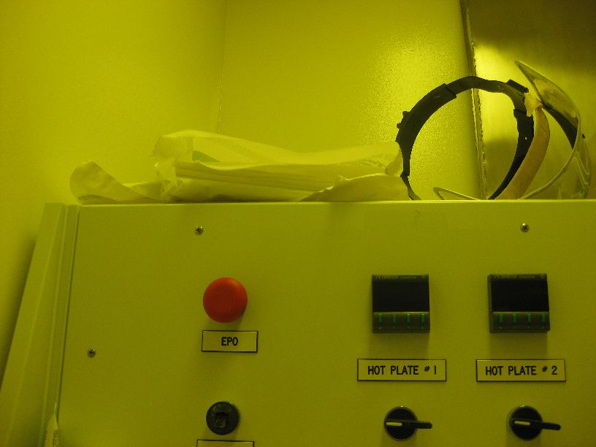
Lab Wipes

Garbage Overflow: Changing the Garbage Bags
Lab garbage is emptied and garbage bags are replaced by the lab manager on a regular basis. However, when a particular lab garbage bin is obviously full and overflowing, it is the lab users’ responsibility to change the garbage. It is neither appropriate nor safe to continually force potentially hazardous waste into an overflowing garbage bin.
Furthermore, users of the OLED machine (thermal evaporator, e-beam evaporator and glovebox) are responsible for regularly changing the garbage located next to this machine. If it is necessary, users of this machine should devise a schedule to ensure that this garbage is never full.
Garbage bags are located under the sink in the gowning room, as shown below. Full garbage bags may be placed next to the garbage located in the gowning room.
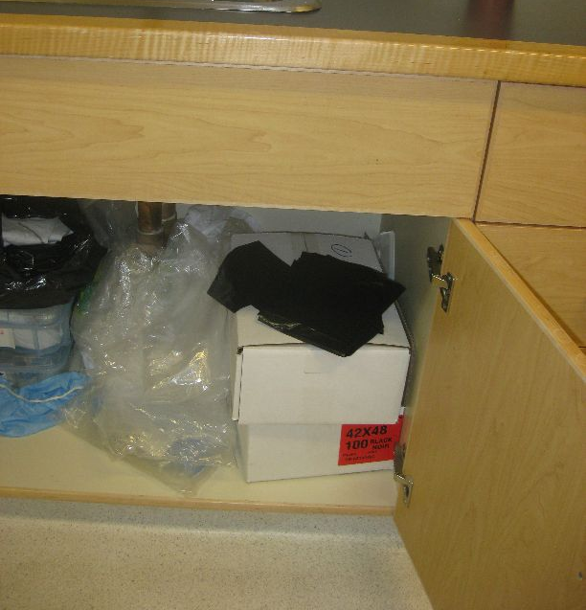

Notes on Lab Temperatures
During the fall and spring months, the lab may experience unusually high humidity and high temperatures. This is due to the fact that the supplemental cooling coils within the lab are disabled during winter months and cold weather. As such, in the case where the outside weather rapidly changes from a moderately cold day (-10 to 0ºC) to a very hot/humid day (10-20+ºC), the general air handling system is not sufficient to maintain a low lab temperature. If a lab user finds that the lab temperature and humidity are unsuitable / uncomfortable for work, he or she will have to wait until the outside temperature stabilizes.

Lab Etiquette

Wet Bench Technique and Etiquette
Lab safety and cleanliness on the wet bench remain absolute priorities. It is imperative that all lab users adhere to the following rules:
- When working with dangerous acids, only one person should be working in or around the wet bench.
  - Example 1. If user A wants to use the wet bench to use HF to etch SiO₂, but user B is currently using the wet bench, user A should inform user B of his/her work and then wait for user B to finish.
  - Example 2. Similarly, if user C wants to use the wet bench, but user D is currently using HCl/HNO₃ to etch ITO, user C should wait for user D to finish.
  - IT IS CRITICAL THAT ALL LAB USERS OBEY THIS RULE FOR VERY OBVIOUS SAFETY REASONS!
- When working with dangerous acids, both the thick rubber gloves and the face shield should be equipped.
- NEVER use piranha etchant solutions (H₂O₂ (hydrogen peroxide)/ H₂SO₄ (sulphuric acid) combinations) in the lab under ANY circumstances. These solutions are explosion hazards, especially with regard to their safe disposal.
- NEVER etch selenium using any acid in this lab, as it produces hydrogen selenide, which is EXTREMELY DANGEROUS. The Se-evaporator look glass should NEVER be cleaned using wet chemistry.
- In general, if many people are in or around a single wet bench, one should wait for the area to clear before beginning his or her work. This is a simple rule to avoid cross contamination of samples and to prevent lab accidents due to crowding.
- Under NO circumstances should there be an unlabelled beakers, crystallization dishes, flasks, etc. on the wet bench. There are two labelling conventions that you may follow:
  - The glassware is labelled with your or your group’s name
  - The glassware is labelled with the chemical present
Under both conditions, you should be in the lab and available at all times when the glassware and chemicals are being used on the wet bench.
- No chemicals should be left unattended on the wet bench for any significant period of time. This is for obvious safety reasons and to avoid clutter/contamination on the wet bench.
- Similarly, remove any glassware that is not common-use from the wet bench and place it in your storage box when finished your work.
- Do not move beakers and tools between the wet benches. This is to avoid cross contamination of the tools and benches.
- If any liquids are present on the wet bench after your work, wipe them or clean them up in an appropriate manner. This includes water, which may accidentally spray onto the surface of the wet bench during substrate cleaning or beaker rinsing.
  - NOTE: For safety reasons, any user who approaches a wet bench with an unknown liquid present on its surface must assume that it may be any number of dangerous acids or chemicals present in the lab (HF, HNO₃, HCl, etc.).
- Lab goggles or glasses must be worn at all times while in the wet etch room or near the lab bench in the yellow lithography room.
- When a fellow lab user is using the spinners in the wet etch/spincoater room, it is common courtesy to turn off the white light in the wet etch fume hood. This is to prevent accidental exposure of spun photoresist.
- Under NO circumstances should there be solid powder substances on either of the wet benches.
- Under NO circumstances should any heavy metal contaminants or salts be introduced onto or near the wet bench (ie. Ag, Au, NaCl, etc.).
- It is both unnecessary and wasteful to line the entire wet bench with lab wipes or to place very large numbers of unused lab wipes on the wet bench. Lab wipes are located on top of the fume hood and should be taken down from this position only as needed. This is to prevent clutter on the wet bench and to avoid waste.
- The wet bench should always be clean and without clutter, both during and after usage. After working at the wet bench, take a few minutes to clean up the area, throw out any used lab wipes and wipe down the bench. Please see the images below for further instruction.
BAD
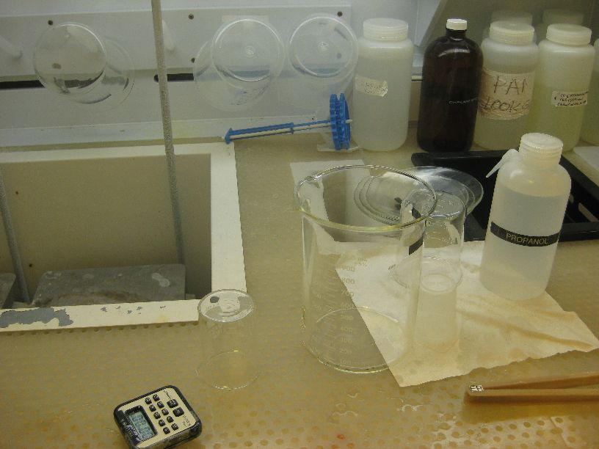

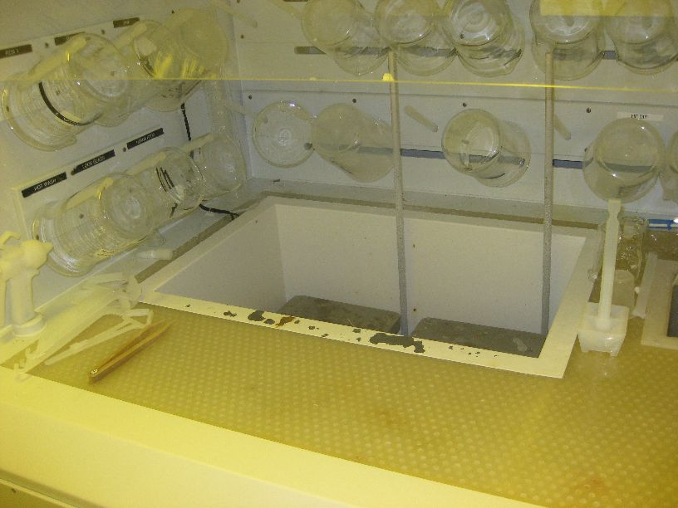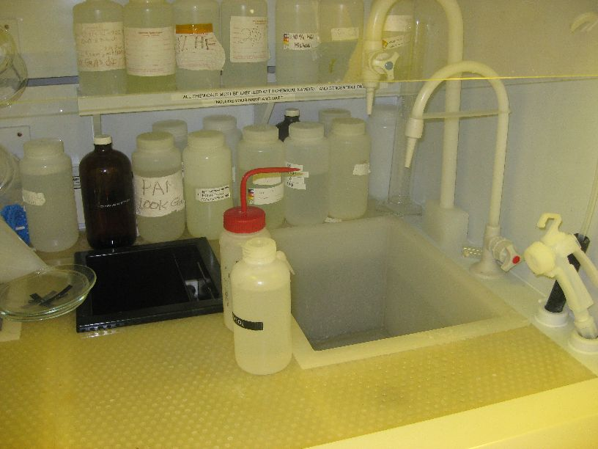
GOOD
- NEVER obstruct the path to the eye wash stations or the safety showers (ie. with chairs, equipment, etc.).
- NOTE: Lab users frequently place the acrylic light shield in the yellow lithography room in front of the eye wash station (see below). THIS IS STRICTLY FORBIDDEN.
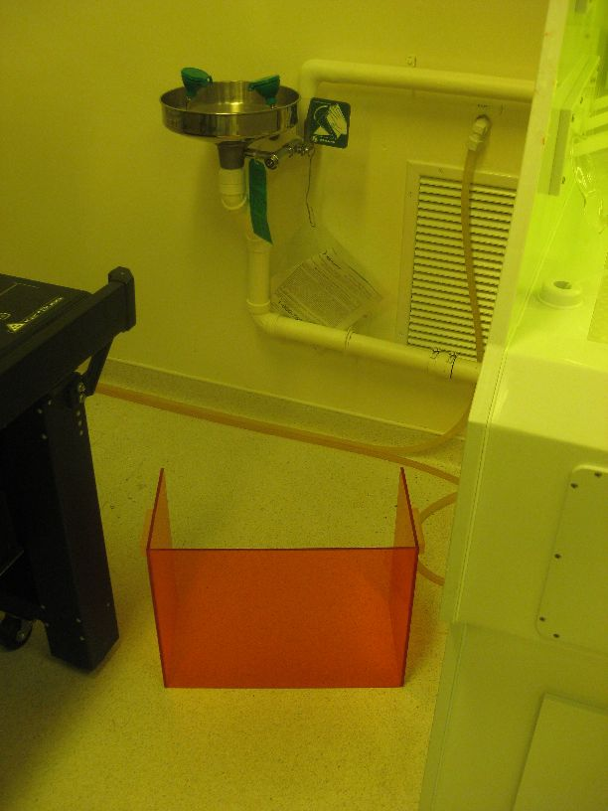
BAD
- NEVER place chemicals or bottles on the ground. This is especially true if they block your path to the eye wash station or safety shower! See below.
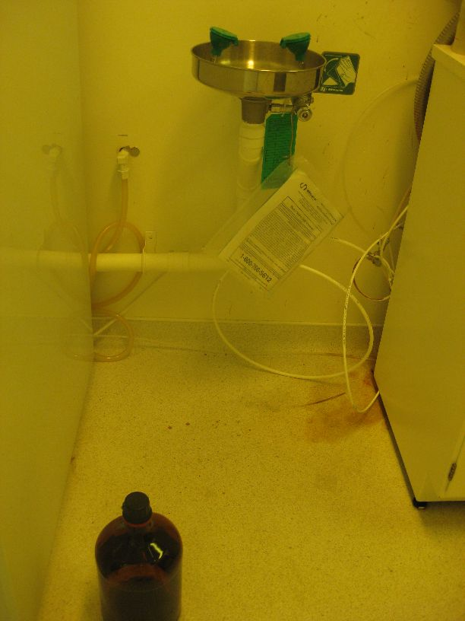
BAD
- Do not use chemicals or materials from other groups or people (ie. labelled chemicals in the fume hood, the OLED group’s q-tips, etc.) unless you have specifically asked them if it is alright to do so. This is obvious for both cross contamination issues and because stealing is unbecoming of grad students.
- ALWAYS remember to turn off hot plates and the light within the fume hood after you are finished.
- ALWAYS keep the fume hood sash/flap down for regular use of the wet bench. The sash/flap may be lifted for easier access into the fume hood for particular exercises (ie. lifting a beaker from a hot plate), but it should be placed down once finished.
- NEVER attempt to increase the water or nitrogen gas pressure in the water/nitrogen gas guns on the wet benches. These have been broken numerous times in the past due to the negligence of lab users! If adjustments need to be made, the lab manager may be informed.

Notes on the Sonicator
The sonicator must ALWAYS have water in it during operation. Operation without water in both the tank and the side sonic horn (as shown below) can severely damage the sonicator. NEVER operate the sonicator while the tank is draining.
Water must be present for operation!
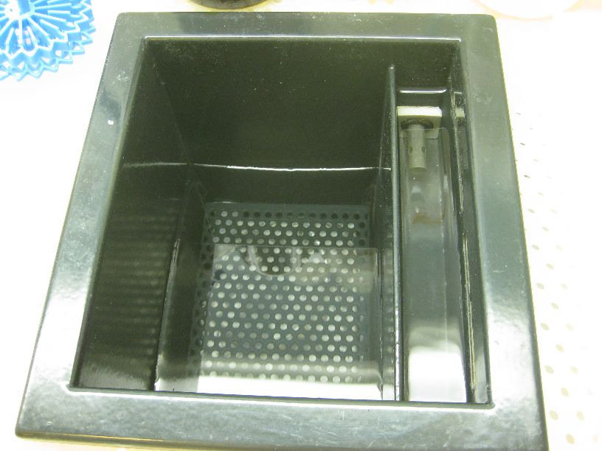
Both sonicators in the G2N lab operate on a first-come, first-served basis. As such, if the sonicator is in use by another lab user, one must wait until the sonicator is free. However, as a matter of consideration, one should not leave his or her samples in the sonicator unattended for long periods of time (> 15-20 minutes), and one should try to be accommodating to other lab users who need to use the equipment.

Notes on the Spincoaters

Photoresist Spinner
The photoresist spinner is to be used with PGMEA- or ethyl lactate-based photoresists ONLY. Use of SU8, polyimide or any other polymer photoresist in this spinner is strictly forbidden. This is absolutely necessary to minimize cross contamination, to ensure good/uniform film formation and to ease the post-process clean-up. The presence of foreign chemicals in the spinner combined with turbulence and splash back can lead to alteration of the photoresist chemical properties, streaking of the spun film and uneven film coverage. All of these factors affect future lithography steps and may severely impact a lab user’s fabrication process and future device functionality.
After use, the photoresist spinner should be thoroughly cleaned with acetone and lab wipes. The spinner should be spotless for the next person using it.
During and after use of the spinner, the negative pressure tube vent should be placed next to the spinner in order to minimize user exposure to photoresist vapours, as shown below.
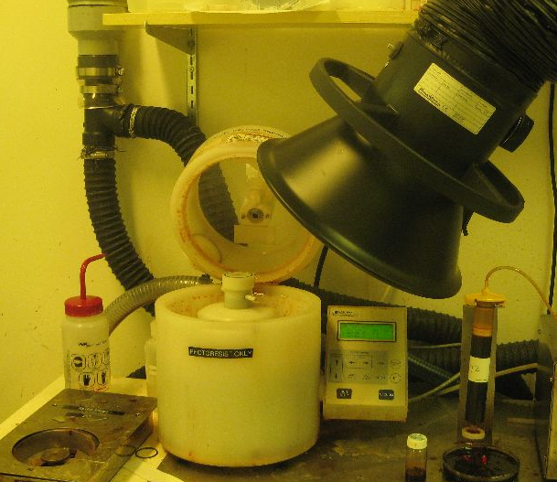

Polymer Spinner
The polymer spinner is intended for use with all non-PGMEA chemicals, which makes its upkeep difficult. Many of these materials cannot be removed from the walls of the spinner after the spincoating process. The materials then cause turbulence, splash back and contamination for all subsequent users. In order to minimize cross contamination and to promote good film formation, the following procedure should be followed:
- Prior to deposition, coat both the top and bottom of the spinner with aluminum foil (located directly above the spinner), as shown below.
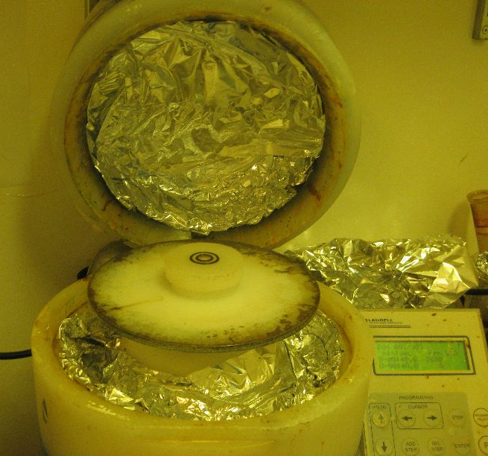
- During and especially after deposition, place the negative pressure tube vent next to the spinner in order to minimize exposure to vapours, as shown below.
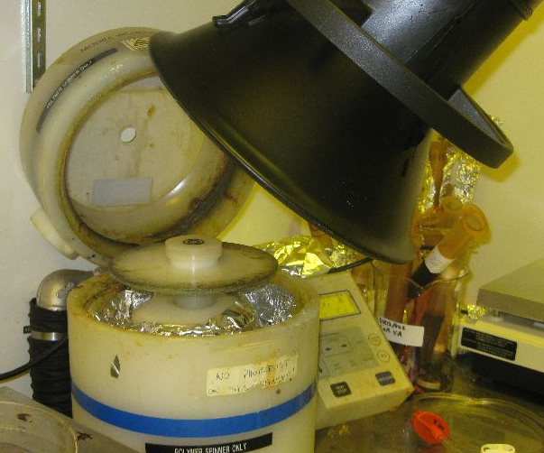
- After deposition, carefully remove the aluminum foil from the spinner.
- After deposition, clean the sides of the spinner with a lab wipe (and the appropriate solvent if necessary) to remove any polymer solution residue.
It is important that all users strictly follow this method, as failure to properly protect and clean the polymer spinner can result in hours of wasted time for other users.

Notes on the Lab Ovens
Both regular and vacuum lab ovens are available for use by all regular G2N lab users and are located in the far corner of the test room, E3-1120, as shown below.
When planning to use any of the ovens for a long period of time, it is good practice to leave a note detailing:
- the planned timeframe of usage
- your name
- your contact information (cell phone number or office extension)
Under NO circumstances should any plastic material EVER be placed in the oven. This is true even if the temperature of the oven is below the melting point of the plastic. If you must remove moisture from plastics, do so at room temperature using vacuum only.
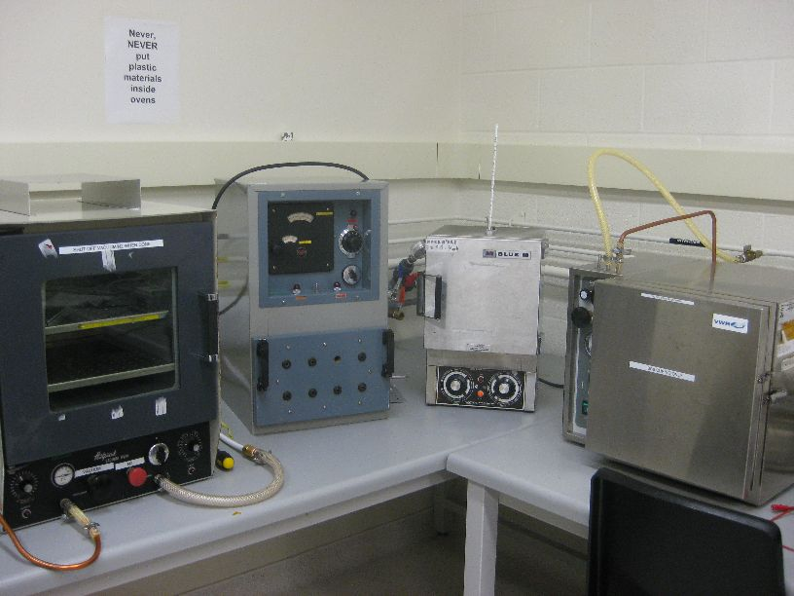

Appendix A – Prime User Certification Form
prime user
I, __________________________________________

new user
certify that ___________________________________________ has been trained and is

equipment name
fully capable of independent operation of _____________________________________.

(S)He is aware of safety hazards associated with the use of this equipment, and of the protective measures and apparatus required to safely work with this equipment.

signature
Signature: ____________________________________ Date: _______________

signature
New user: ____________________________________ Date: _______________

Please provide one copy of this certification to Richard, and maintain a copy in your records.

Appendix B – Request to Work Outside Normal Working Hours Form
Request to Use G2N Laboratory Facilities outside of Normal Working Hours

I, ______________________________ request permission to work in the G2N
(print your name here)
clean room facility on the following dates. I am committed to observing all normal

laboratory operating protocols. I will observe all safety precautions appropriate to

the work in which I’m engaged.

I am aware that University of Waterloo laboratory safety regulations and G2N

protocols require a second person (buddy) to be present while working in the lab.

______________________________ is an experienced lab user, and will be
(print ‘buddy’s name)
present while I am working in the G2N lab.

Period for which lab access is requested: ______________________________

Signature of applicant: _____________________________

Signature of ‘buddy’ _____________________________

Supervisor’s authorization _____________________________

Lab Manager’s authorization ______________________________

Appendix C – Authorization for New Chemical Form
Giga-to-Nanoelectronics Laboratory
Authorization for new chemical
Name of User:___________________________ Date:__________________
Name of Chemical: _______________________________________________
Manufacturer or supplier: ___________________________________________
Quantity to be introduced: __________________________________________
- Please attach an MSDS to this request form.
- Please provide an electronic copy of the MSDS.
- Please identify any safety issues and special precautions for this chemical.
Safety issues and/or special precautions: ____________________________________________________________________________________________________________________________________________________________

Authorization
Manager’s approval:________________________ Date: __________________
Internal Use:
- MSDS in lab binders? ________
- Chemical listed in Index? ________
- Index is updated? ________
- Electronic master list updated? ________

Appendix D – Listing of Chemical Supplies Maintained in the G2N

Appendix E – Giga-to-Nanoelectronics Centre Code of Conduct
As a member of the Giga-to-Nanoelectronics Centre community, I will support an environment marked by mutual respect, fairness, accountability, collaboration, partnership, honesty and integrity.

• I will be honest, fair, and courteous in my dealings with coworkers, staff members, and others whom I encounter in my daily work.

• I have read, have been trained, and will adhere to the safety policies of each laboratory in which I am involved.

• I will read, be aware of, and adhere to the operating and procedural policies of each laboratory in which I am involved.

• I will report honestly, completely, and promptly any safety incidents involving me or witnessed by me according to the policies of each laboratory.

• I will be honest and straightforward in my reporting of equipment or processing issues that may occur. I recognize that all equipment is shared and thus my actions will impact the work of others.

• I will fill out all forms and documents for all uses of equipment and materials as required. I recognize that failure to do so is stealing and will be handled accordingly.

• I will maintain a professional level of cleanliness throughout this shared facility.

• I will be considerate and respectful of the work and materials of my coworkers. I understand that using the Giga-to-Nanoelectronics Centre is a privilege not a right, and that this privilege may be revoked at any time.

Signed,

__________________________________________

Date: _____________________________________

Printed Name: Student ID:

__________________________________________ _____________________________

