Name of Change Initiative

Change Management Strategy

By: Authors Name(s),
Title(s)

Contents
1. Project Summary 3
2. Assessing Stakeholder Impact 4
2.1. Perceived impact to stakeholder group 4
2.2. Perceived broad benefits to stakeholder group 5
2.3. Motivating and engaging stakeholders 6
3. Communication 7
3.1.1. Available channels 7
3.1.2. Key messages 8
3.1.3. Change targets / timelines 8
4. Next steps 9
4.1. Pre-implementation 9
4.2. Implementation and post-implementation 10
5. Revision History 10

A note about the template.
The strategy describes who the impacted stakeholders will be and how the change will impact them whether it be a small workgroup or organization wide. Capturing and reporting on these unique characteristics will help to inform change management plan and activities.
The document helps the author to:
- Describe the change
- Define the impacted stakeholder groups
- Identify tactics to consider minimizing the impact the change may have on those impacted
- Capture perceived benefits for the change, which will then inform key messages and communications planning activities
Please note:
- Section headings are optional
- Blue boxes provide guidelines or suggestions for content

Project Summary
In this section consider defining:
- The change
- The size of the change i.e., small (workgroup) or larger (enterprise wide)
- The type of change i.e., process, system
- The implementation timeframe
- Individuals who will be impacted by the change
- The number of people who will be impacted
- The roles and resources that exist for the initiative i.e., who is the sponsor, manager, training lead etc.

Brief introduction of the change:
Provide a brief description of the change
Type of Change:
Define the type of change this will be. Ie, is this a change in process, change in system, change in location, mindset etc.
Implementation timeframe
Project initiation date:
Target implementation date:

Impacted stakeholder groups and estimated #’s:
Stakeholder group: | # individuals impacted

Project resources:
Role | Name | Is training needed?
Executive Sponsor
Primary Sponsor
Manager
Training Lead
Communication Lead
Change Lead
Subject Matter Expert(s)
Other?

Assessing Stakeholder Impact

Perceived impact to stakeholder group
Note to user: Interviews with stakeholder groups will be valuable to effectively fill in the table that captures:
- The perceived impact the change will have
- The degree of impact by stakeholder group. This action will help refine and prioritize messaging and CM activities.
When completing the table, consider the following:
- What’s the best way to connect with the stakeholder groups to better understand the impact the change will have?
- How much change has the stakeholder group dealt with recently? To what degree are they experiencing change fatigue?
- Who are the early adopters I can lean on to champion initiative?
- Are there location challenges that need to be overcome? Will I need to adjust the implementation approach for locations beyond main campus?
- What support will be needed beyond implementation?
- What peaks and valleys are the stakeholder groups experiencing? Is there a preferred implementation time?

Stakeholder Group  (listed in order of impact, most to least) | Perceived impact to stakeholder group

Perceived broad benefits to stakeholder group
Define the benefits of the change addressing “What’s in it for me” question for impacted employees

Stakeholder Group | Perceived broad benefits

Motivating and engaging stakeholders
Special tactics are actions we can undertake to accomplish the Change Management strategies and increase project outcome success. Ideally, tactics will:
- Mitigate anticipated resistance
- Address historical or cultural barriers
- Address unique attributes of each stakeholder group
- Leverage key influencers
Use the table below to identifying points of resistance or barriers that may be encountered. For each barrier identified, consult the ‘strategy’ column for suggestions on how to address the concerns. Highlight the strategy that may work for your change initiative.

Potential Barrier | Rational | Proposed Strategy
Inconvenience | Employees do not see the value in the change | - Build awareness of the change  - Promote benefits of the change  - Address what’s in it for me (WIIFM)
Changes to job roles and responsibilities | Employee peers, and managers resist administrative and technological changes that result in their role being changed, eliminated or reduced | - Acknowledge concerns  - Communicate frequently and clearly  - Consult with HRP early and continue beyond implementation  - Provide training opportunities (if applicable)
Absence of reward system | Rewards for adopting the change are absent | - Identify rewards.  - Where $ rewards are not possible, consider intrinsic rewards  - Celebrate successes
Fear of the unknown | Employees are not involved / engaged in informing the change | - Engage employees  - Build awareness  - Minimize rumors  - Offer two-way feedback communication  - Identify SME’s or early change adopters to promote change
Peer pressure | Employees protect their work groups | - Communicate frequently and clearly  - Leverage sponsors  - Engage managers  - Dispel myths  - Consider how font-line employees may react
Trust | Low level of trust with past experience with change initiatives. Possibly due to lack of transparency / accountability or poorly managed projects | - Create a climate of trust  - Focus attentions on re-building trust where needed  - Engage managers
Fear of failure | Employee(s) doubt abilities to perform duties | - Communicate change  - Provide training and opportunity to test Build confidence
Implementation | Changes are introduced in an insensitive manner or timing is not appropriate | - Understand and minimize impact to stakeholder groups.  - Consult with stakeholders re preferred implementation dates

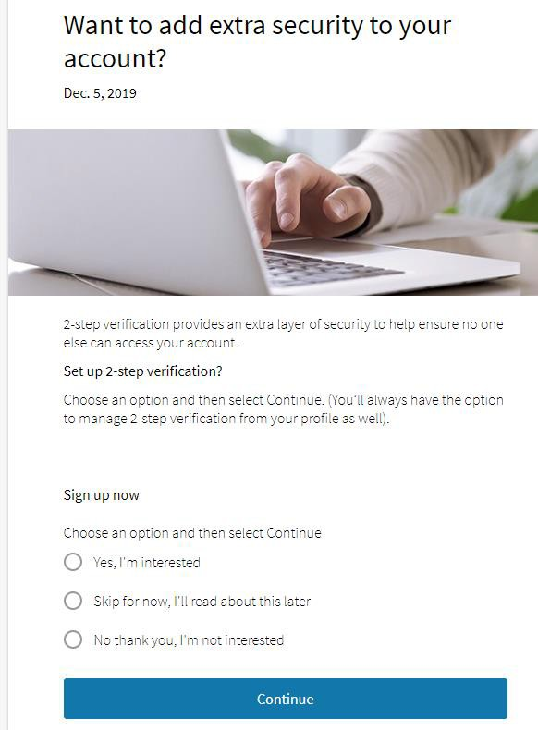
Communication
In this section consider:
- Identify preferred communication channels, ideally allowing for 2-way open feedback
- Defining the key messages by stakeholder group. Message content to focus on the: What, Why, When, How and What’s in it for me. In addition, information updates, reference to milestones achieved etc.
- Defining who the appropriate sender for each communication will be
- Identify target communication dates

Available channels
Channel | Audience | Suitable channel? (Yes/No)
Memos and mass emails | Various
MS Teams | Various
Daily Bulletin | All of campus
Dedicated project website | All of campus
Social media | Various
Campus digital screens | Various
Print Materials | Various
Survey | Various
Lunch ‘n Learns / Training Sessions | All of campus
Senior leadership meetings | Campus directors and senior leaders
Department meetings | Various
Team meetings | Various
Campus committees | Various
Administrative & technical support staff | Various

Key messages
Stakeholder group | Key message

Change targets / timelines
Target Date | Target stakeholder group | Target channel | Target content | Sender

Next steps
Capture a high-level list of pre- and post-implementation actions that will increase adoption of the change.

Pre-implementation
Date: Month, Year to Month, Year
Target date | Action

Implementation and post-implementation
Date: Month, Year to Month, Year
Target date | Action

Revision History
Change Made By | Date Change Made | Details of Change | Change Reviewed/ Approved by | Date change reviewed/ approved

