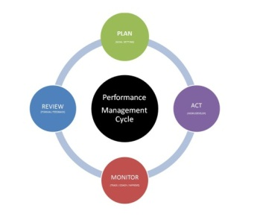
Staff Activity Form

If your manager completes the Performance Evaluation form for you, you may wish to use this form to provide information to help them complete the process. Include activities/projects/ points which you believe to be important and which you wish your manager to take into consideration

Employee Name:

Supervisor Name:

What were the accomplishments this year that you are most proud of?

What were the challenges you experienced this year and areas you learned from?

Have you made any changes to the way you did your job?

Have you attended any OHD training programs? If so how were you able to put these skills into practice over the past year?

Are there ways in which your manager or colleagues can further assist you?

What challenges do you foresee or would you like to pursue in the coming year?

Have you participated in any University committees, projects, Staff Association activities, United Way, etc., that you wish your manager to know about?

