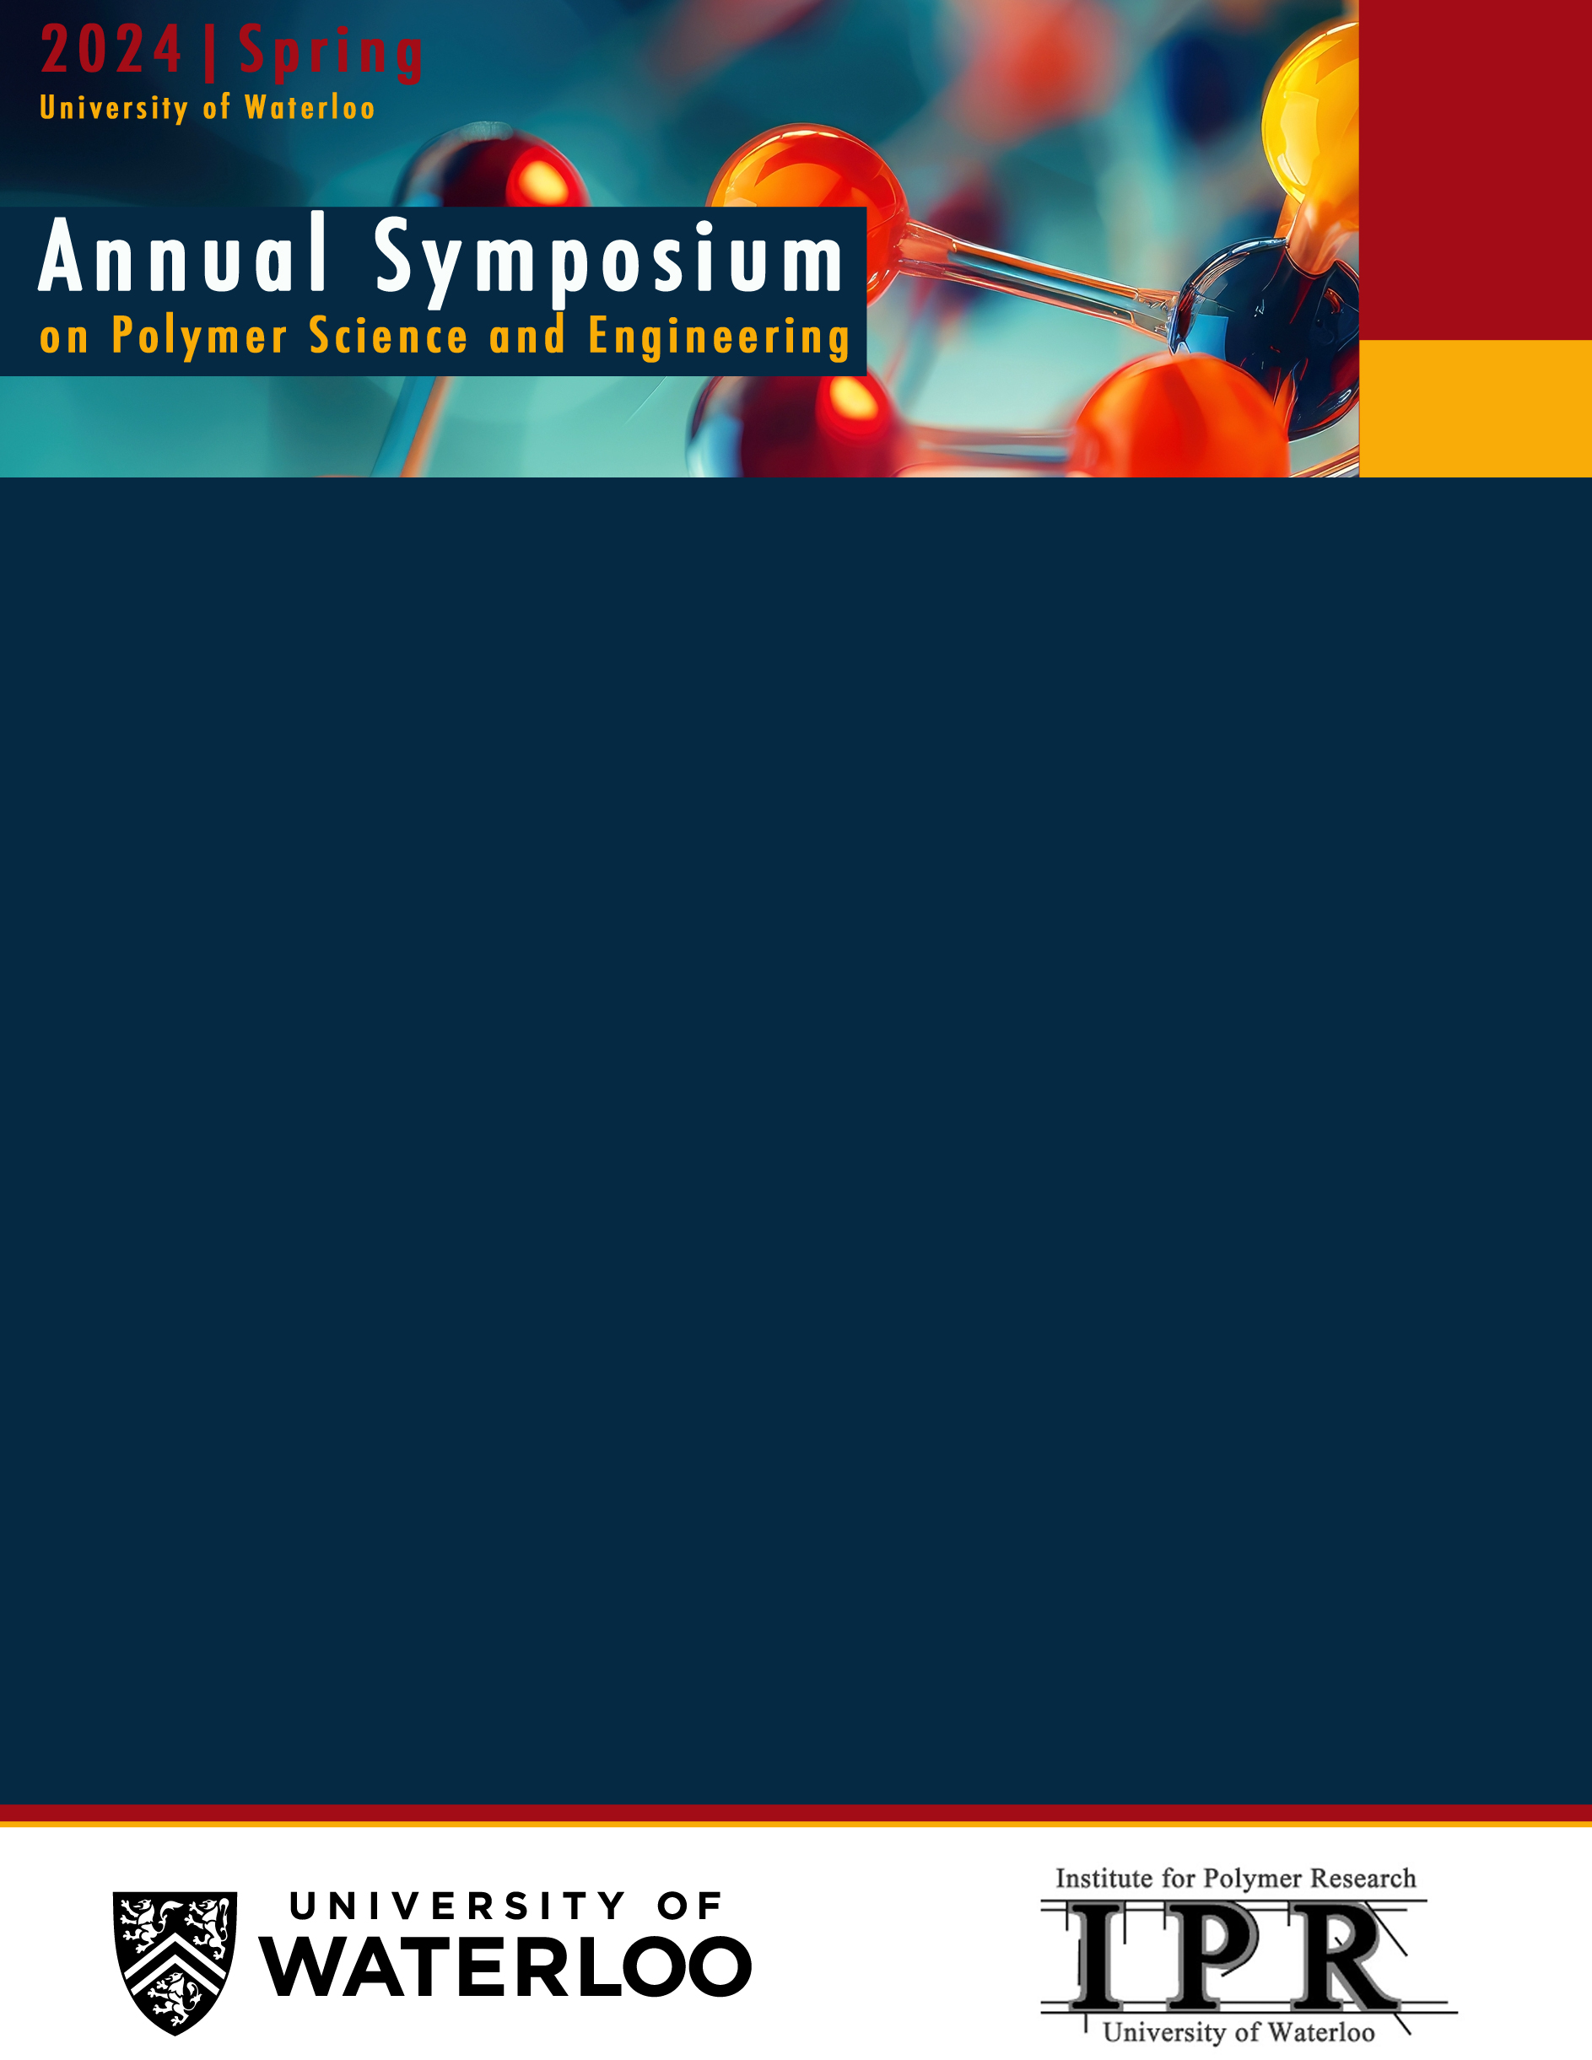

**May 2, 2024**

Location:

E7

**Schedule for Academia/Industry IPR Meet on Thursday May 2nd, 2024.**

|  |  |  |
| --- | --- | --- |
| **9:00 – 9:50** | [**Michael Tam**](https://uwaterloo.ca/chemical-engineering/profile/mkctam) | **Innovation in Sustainable Nanomaterials for Advanced Engineering Applications** |
| **9:50 – 10:40** | [**Tizazu Mekonnen**](https://uwaterloo.ca/chemical-engineering/profile/tmekonne) | **Plastics Sustainability to Serve Society and Safeguard the Environment** |
| **10:40 – 11:10** |  | **Coffee break** |
| **11:10 – 12:00** | [**Derek Schipper**](https://uwaterloo.ca/chemistry/profile/dschippe) | **Reaction Development for the Synthesis of Conjugated Organic Materials** |
| **12:00 – 1:00** |  | **Working Lunch** |
| **1:00 – 1:50** | [**Yuning Li**](https://uwaterloo.ca/chemical-engineering/profile/y382li) | **Development of Semiconducting Polymers for Flexible and Cost-effective Thin Film Sensors** |
| **1:50 – 2:40** | [**Boxin Zhao**](https://uwaterloo.ca/surface-science-bio-nanomaterials-laboratory) | **Adhesives and Coatings Research for Advanced Materials and Sustainable Development** |
| **2:40 – 3:20** |  | **Coffee Break** |
| **3:20 – 4:10** | [**Jamie Forrest**](https://uwaterloo.ca/institute-nanotechnology/profiles/james-forrest) | **Demystifying Anomalous Dynamics in Thin Polymer Films** |
| **4:10 – 5:00** | [**Jean Duhamel**](https://uwaterloo.ca/chemistry/profile/jduhamel) | **Conformation of Macromolecules in Solution Characterized by Pyrene Excimer Formation** |