Effect of Ligands on Controlled Polymerization of Methyl Methacrylate by AGET Method in Emulsion System

Mohammed Awad, Dr. Thomas Duever, Dr. Ramdhane Dhib
Department of Chemical Engineering, Ryerson University, ON M5B 2K3, Canada
IPR Symposium, University of Waterloo, ON N2L 3G1, Canada

1. Introduction

Controlled Radical polymerization (CRP) is a dominating technique in manufacturing nano-sized polymer particles. In particular, (ATRP) Atom Transfer Radical Polymerization is one of the most growing polymerization techniques that are today extensively studied in academia and industry (Matyjaszewski et al, 1995). Actually, polymers used as lubricants, adhesives, gels, additives, and biomedical applications such as artificial bones and drug delivery are synthesized by ATRP due to its versatility in using oxidizing catalysts, reducing agents, and initiator etc (Braunecher et al, 2007; Oh, 2008). Over the past few years, ATRP has been mainly limited to bulk or solution homogeneous systems. Recently, the research emphasis is directed towards environmental and sustainable aspects for benign technology. Using water as a solvent medium for safety, environmental, and easy heat transfer reasons, ATRP can be done in aqueous media. However, unlike bulk/solution medium, maintaining the stability of ‘livingness’ characterization of the polymerization in an emulsion system is a major problem (Uegaki et al, 1997; Aijoka et al, 2008; Oh, 2008). The main factors affecting the polymer stability are the solubility of both initiator and reducing agent in organic and aqueous phases, the suitability of the surfactant, high reaction temperature, and side reactions.
The most decisive factor in ATRP system is the ligand aptness, since it can help to adjust the catalyst solubility in both phases and have a crucial effect on the controlled polymerization. It is postulated that the ligand reduces the catalyst partitioning into the aqueous phase by improving the catalyst retention in the particle phase during the polymerization. However, it is well known that even with a hydrophobic ligand, not all of the catalyst complex can be prevented from partitioning into the aqueous phase. In another words, it can control the concentrations of the deactivator and activator in the reaction medium (Tian et al, 2012). Activator generated by electron transfer (AGET) ATRP has been previously applied to polymerization in aqueous medium using a continuous two-step procedure, in which low surfactant amounts were used and a controlled emulsion ATRP was obtained (Jia, 2008). The higher oxidation state transition metal complex reacts with the reducing agent to initiate new chains. The reducing agent plays an important role in the activator generation (Jakubowski et al, 2005; Min et al, 2006).
PMMA has been produced in this study using AGET ATRP two steps method in a 2 - Liters emulsion system. The ligand selection becomes a key for controlling the molecular weight of the polymerization reaction. The effect of the ligands Hexamethylenetetramine (HMTA) and 4,4-dinonyl-2, 2-bipyridyl (dNbpy) using AGET ATRP two steps method for Methyl Metharcylate (MMA) have been investigated for different experimental conditions on the MMA monomer conversion and the PMMA molecular weight distributions.

2. Experimental Procedure
2.1. Two-Step system Procedure of AGET ATRP in Emulsion Media
The required amount of MMA was used in two portions MMA (I) and MMA (II), where this path characterizes the two steps method. The organic solution is made up of the catalyst complex, MMA (I) and initiator which poured slowly under stirring into an aqueous solution of Brij 98 to form the transparent microemulsion. The whole mixture was transferred into the reactor and purged by nitrogen. Ascorbic acid (AA) reducing agent thawed in distilled water to make another aqueous solution where was injected into the reactor at the set temperature to start the polymerization. After about 15 minutes, another amount of MMA (II) was loaded into the ongoing microemulsion polymerization to form an emulsion polymerization. Amounts of each aliquot after withdrawal was shaken and cooled to stop the polymerization. Gravimetric method (Penlidis, 1986) was used to determine the conversion, while molecular weight and molecular weight distribution measured by GPC for each sample collected in certain time.
3. Results and Discussion
Radicals of both activator and deactivator radicals should be generated constantly in organic phase to sustain ATRP (Coca et al, 1998). In this system, CuBr₂ was added to facilitate the establishment of the equilibrium between the radical and dormant species. The ligand main duty is to control the behavior of partitioning of metal complex in both organic and aqueous phases.

Figure (1) shows the conversion of MMA monomer versus time using HMTA and dNbpy. The results reveal that the conversion of MMA increases gradually with the reaction time. The polymer obtained using dNbpy shows conversion was low, reaching only 26.7% after 180 min of polymerization. While at the same Figure, the relationship of conversion versus time was rapidly increased up to 98.6% after 180 min of polymerization when HMTA used.

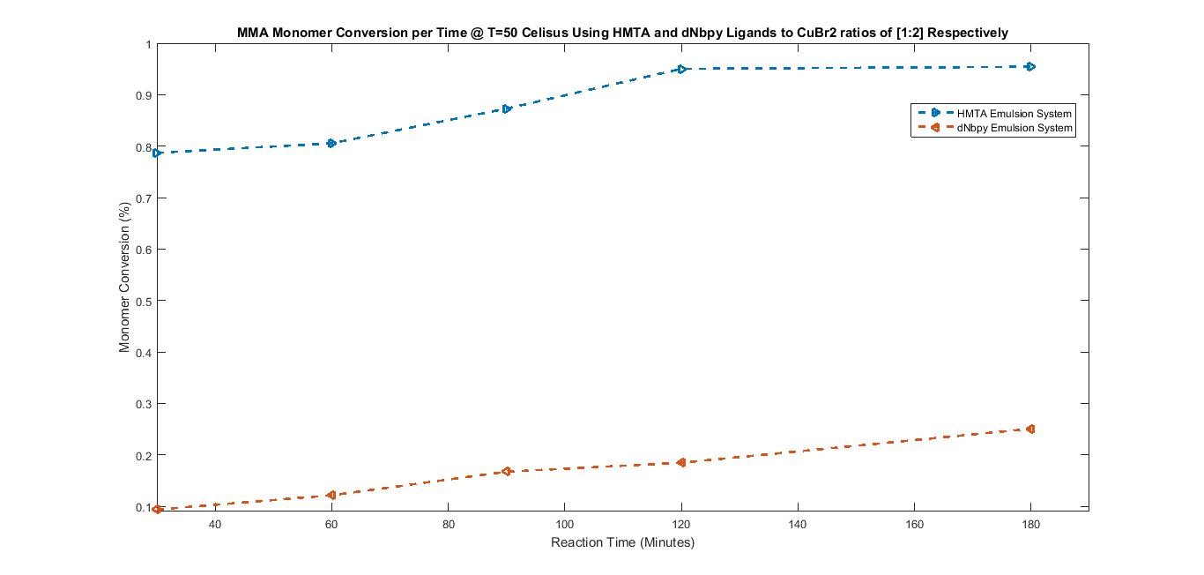
Figure 1: Conversion versus Time for Systems using HMTA and dNbpy ligands

Figure (2) shows MWD of MMA versus conversion of MMA monomer using HMTA at 180 min of the polymerization initiation. The polymer produced has a molecular weight distribution of 17,909 g/mol and a broad polydispersity index of 3.07 when using HMTA. A long tail is observed in the GPC curves which indicates a bimodal peak.

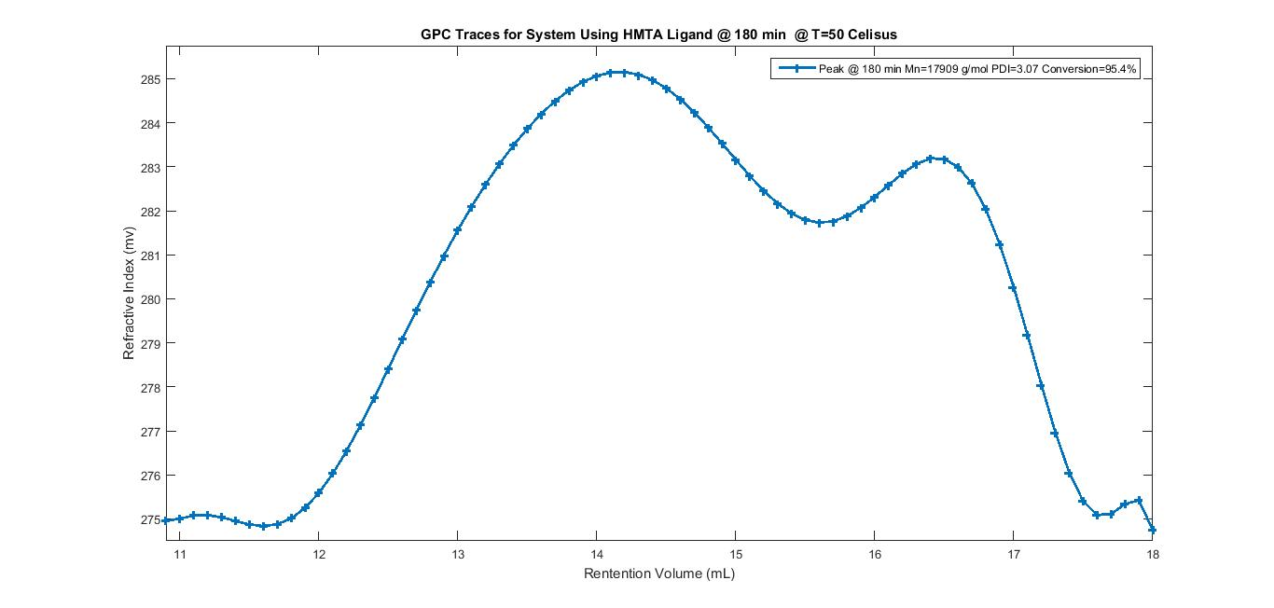
Figure 2: GPC Traces versus Conversion using HMTA Ligand

Figure (3) shows MWD of MMA versus conversion of MMA monomer using dNbpy at 180 min of the polymerization initiation. The polymer produced has a narrow molecular weight distribution 5,699 g/mol and a polydispersity index of 1.21 when using dNbpy ligand, where no long tail is observed in the GPC curves.

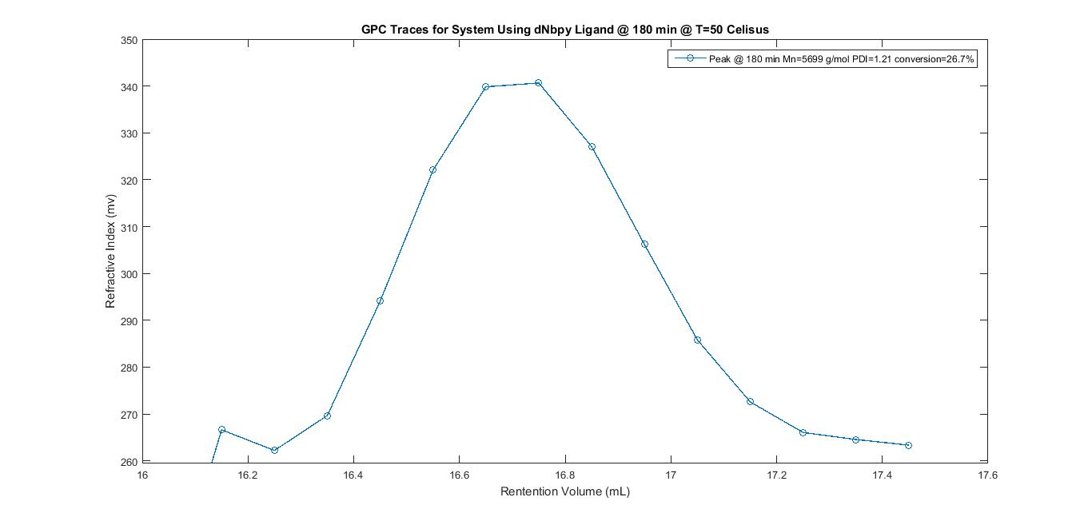
Figure 3: GPC Traces versus Conversion using dNbpy Ligand

Based on the results obtained the system using dNbpy ligand has higher solubility in the organic phase than HMTA. The solubility of the catalyst increases when hydrophobic ligand used in the organic phase where the polymerization takes place, eventually, controlled polymerization will be more efficient (giving a polydispersity below 1.50). Due to the stronger solubility of dNbpy ligand in the organic phase, dNbpy commonly used as an effective ligand for the ATRP systems in the emulsion and miniemulsion systems (Qiu et al, 2001). However, with dNbpy a high polymerization temperature is required because of the low catalytic activity of the copper complex, and in high temperatures the stability of the monomer droplets/growing particles reduces and it will lead to lower conversion during the polymerization. The reason is possibly due to the strength of steric hindrance for the ligand. The above results therefore indicated that CuBr₂/HMTA was highly soluble in water which allows an ease migration of large quantity of the complexes to the aqueous phase (Tian et al, 2012). But this was occurred due to many other reasons, since HMTA shows an evidence for livingness where Mn = 17909 g/mol is apparently low and within controlled range but the PDI is broad. HMTA should be investigated further to prove its ability for controlling the catalyst radicals in ATRP systems. There is a possibility that the particles produced using HMTA ligand can undergo an uncontrolled conventional free radical polymerization due to the absence of the copper complex as deactivator/activator. But using dNbpy as ligand which has the long alkyl substituent, the steric hindrance surrounding the nitrogen atoms was significant. Therefore, the experiments demonstrated that ATRP controllability effects depended not only on the solubility of the catalyst complex in the organic phase, but also depended on the system radical trapping ability.

References

Ajioka N., Yokoyama A., Yokozawa T.: Macromolecular Rapid Communication. (2008):29, 665–671.

Braunecher, W.A.; Matyjaszewski, K. Prog. Polym. Sci. (2007): 32(1), 93-146.

Coca S., Jasieczek C. B., Beers K. L., Matyjaszewski K.: Journal of Polymer Science Part A: Polymer Chemistry. (1998): 36, 1417–1424.

Jakubowski, W.; Matyjaszewski, K. Macromolecules. (2005): 38(10), 4139-4146.

Jia, Di. Atom Transfer Radical Polymerization in Microemulsion. A MASc Thesis. Queens University, (2008).

Matyjaszewski, Krzysztof., Jin-Shan,Wang. Journal of the American Chemical Society (1995): 117(20), 5614-5615.

Min, K.; Gao, H.; Matyjaszewski, K. J Am Chem Soc (2006): 128, 10521-10526.

Oh, Jung Kwon. Journal of Polymer Science Part A: Polymer Chemistry. (2008): 46.(21), 6983-7001.

Penlidis, A. Latex production technology - reactor design considerations. A Ph.D. Thesis, McMaster University, (1986).

Qiu J., Charleux B., Matyjaszewski K.: Progress in Polymer Science. (2001): 26, 2083–2134.

Tian, B. Y., et al. Express Polymer Letters (2012): 6(10), 837-846.

Uegaki H., Kotani Y., Kamigaito M., Sawamoto M.: Macromolecules (1997): 30, 2249–2253

