**Conformation of the Side Chains of Amylopectin in DMSO Determined by Pyrene Excimer Fluorescence and Molecular Mechanics Optimizations**

L. Li, J. Duhamel

IPR Symposium, University of Waterloo, Waterloo, ON, N2L 3G1, Canada

**Introduction**

Starch is an abundant biopolymer whose two main components are amylose and amylopectin. Whereas amylose is an essentially linear chain constituted of anhydroglucose units connected via (1-4) linkages with degrees of polymerization (DPs) between a few hundreds and a few thousands, amylopectin is a much larger highly branched polysaccharide with DPs ranging between 105 and 106 depending on the plant of origin. Amylopectin is comprised of short side chains and long chains of anhydroglucose units connected via (1-4) linkages, the side chains being covalently attached onto the long chains via (1-6) linkages.1 Small scale hydrophobic modifications of starch are often conducted in DMSO, an organic solvent that solubilizes both starch and the desired hydrophobic derivatives. However, no structural information can be found in the literature regarding the structural state of the side chains of amylopectin in DMSO. This state of affairs is hardly surprising since after gelatinization at 60 oC, amylopectin in DMSO exhibits no crystalline microdomains preventing the use of X-ray analysis and can be viewed as an ill-defined *mega*-molecule (DP around 106 makes amylopectin much larger than typical macromolecules) which complicates its characterization by traditional polymer characterization techniques such as gel permeation chromatography, static light scattering, or intrinsic viscosity, to name but a few.

It is in situations like this that the fluorescence blob model (FBM) analysis conducted on the fluorescence decays of macromolecules randomly labeled with pyrene becomes most appealing. In these experiments, the macromolecule is randomly labeled with pyrene and the kinetics for pyrene excimer fluorescence (PEF) are characterized. Contrary to FRET that depends strongly on the distance between the energy donor and acceptor, PEF occurs only on contact between an excited and a ground-state pyrene, a requirement that makes the interpretation of the fluorescence signal much simpler to interpret as described in a recent review. In recent PEF experiments carried out on dilute solutions of Py-Amylose constructs in DMSO, the fluorescence decays of the pyrene monomer and excimer were analyzed globally with the FBM. FBM analysis led to the conclusion that an excited pyrene attached to amylose formed an excimer with a ground-state pyrene that was attached to one of 10 anhydroglucose units surrounding the reference excited pyrene label. In turn, molecular mechanics optimizations (MMOs) indicated that excimer formation would occur under these conditions only if amylose adopted a helical conformation.2 This study supported the conclusion that amylose adopts a helical conformation in DMSO, a result that is still being debated in the scientific literature.

Following this early success in probing the conformation of amylose in DMSO, the present study describes how PEF experiments were also conducted on amylopectin randomly labeled with pyrene (Py-Amylopectin) in combination with MMOs to investigate whether PEF could provide some structural information about the conformation of the side chains of amylopectin in DMSO. Amylopectin was randomly labeled with 1-pyrenebutyric acid to generate several Py-Amylopectin constructs and their solutions in DMSO were characterized by steady-state and time-resolved fluorescence. Excimer formation for relatively rigid Py-Amylose was found to be surprisingly efficient in DMSO leading to the conclusion that amylose must be adopting a compact helical conformation that brought the pyrene labels closer from each other, thus favoring pyrene-pyrene encounters and excimer formation.2 But when the efficiency of pyrene excimer formation was compared between the Py-Amylose and Py-Amylopectin constructs, excimer formation was found to occur 50% more efficiently in Py-Amylopectin, a probable consequence of the highly branched nature of amylopectin. MMOs demonstrated that the increased efficiency for excimer formation in Py-Amylopectin was compatible with the proposal that the side chains of amylopectin adopt a single or double helical conformation and are held within 26-29 Å from each other, thus allowing for intra- and inter-helix excimer formation. This proposal was found to rationalize all the information retrieved from the steady-state and time-resolved fluorescence measurements and provides a first glimpse into the molecular arrangement of the side chains of amylopectin in DMSO.

|  |  |
| --- | --- |
| Py-Amylose | Py-Amylopectin |
|  |  |

**Figure 1**:Chemical structures of the pyrene-labeled polymers. Left: Py-Amylose, right: Py-Amylopectin.

**Methodology**

*Synthesis of pyrene-labeled amylose and amylopectin*: The synthesis, purification, and characterization of the pyrene-labeled amylose and amylopectin samples has been described elsewhere.2

*Steady-State Fluorescence Measurements*: Steady-state fluorescence spectra were acquired on a Photon Technology International LS-100 steady-state fluorometer with an Ushio UXL-75 Xenon lamp and a PTI 814 photomultiplier detection system. The spectra were obtained using the usual right angle geometry with a 346 nm excitation wavelength. The samples were dissolved in DMSO with pyrene concentration below 2×106 M to avoid intermolecular excimer formation.

*Time-resolved fluorescence measurements*: The monomer and excimer fluorescence decays were acquired with an IBH Ltd. time-resolved fluorometer using an IBH 340 nm NanoLED as the excitation source. Samples were prepared in the same manner as for the steady-state fluorescence experiments. Samples were excited at a wavelength of 346 nm and the monomer and excimer emission were collected at 375 nm and 510 nm, respectively. A cut off filter at 370 nm for the monomer and 500 nm for the excimer were used to reduce contamination of the fluorescence signal by light scattering. The fluorescence decays were acquired over 1024 channels using a time-per-channel of 1.02 or 2.04 ns/ch. All decays were collected with up 20,000 counts at the peak maximum for the instrument response function and decay curves.

**Results and Discussion**

The monomer and excimer decays of the Py-Amylose and Py-Amylopectin samples were fitted globally using the FBM analysis. *N*blob was plotted as a function of pyrene content in Figure 2. Within experimental error, *N*blob was found to remain constant with pyrene content. The averaged *N*blob value, <*N*blob>, was found to equal to 10 ± 1 and 20 ± 3 glucose units for amylose and amylopectin, respectively. When plotted against pyrene content in Figure 2, *k*blob×*N*blob was also found to remain more or less constant with pyrene content. The averaged value of the product *k*blob×*N*blob, <*k*blob×*N*blob*>* for amylose and amylopectin was found to equal 0.17 ± 0.01ns1 and 0.27 ± 0.01ns1, respectively. Since <*k*blob×*N*blob> reflects the frequency of pyrene-pyrene encounters within the volume defined by the macromolecule in solution, the 50% increase in <*k*blob×*N*blob> observed for Py-Amylopectin with respect to Py-Amylose agreed with the 50% increase found for the slope *m*(*I*E/*I*M) of the *I*E/*I*M plot of Py-Amylopectin with respect to that of Py-Amylose. Together, these findings reflect the higher local pyrene concentration [*Py*]loc experienced by an excited pyrene in the highly branched amylopectin.



B)

A)

**Figure 2:** Plot of A) *N*blob and B) <*k*blob×*N*blob> as a function of pyrene content. ( ) Py-Amylopectin, ( ) Py-Amylose.

If the side chains of amylopectin formed isolated helices in the same manner as amylose does in DMSO, the large *N*blob value of 20 anhydroglucose units for Py-Amylopectin compared to 10 for Py-Amylose indicates that other factors are at play. One such factor could be the double helical conformation adopted by the side chains of amylopectin in the solid state. To investigate whether a double helix conformation could lead to a larger *N*blob value, molecular mechanics optimizations (MMOs) were conducted with *HyperChem*. To this end, the structure of the optimized double helix generated with 36 anhydrogluose residues was imported into *HyperChem* and it was used to build a double helix constituted of 18 anhydroglucose units for each strand. Two pyrene labels were attached at different positions along the helix. Molecular mechanics optimizations using the Fletcher-Reeves algorithm were performed during which the following constraints were imposed. The distances separating the carbons C2 or C7 of a pyrene label from the carbons C2 or C7 of the other pyrene label was set to equal 3.4 Å by the end of the molecular mechanics optimization. Only pyrene and the atoms connecting pyrene to the glucose unit where allowed to be displaced during the optimization. At the end of the optimization, the extent of overlap between the two pyrenes was estimated by calculating the number of carbon atoms of the first pyrene molecule which were covered by the frame of the second pyrene molecule. A good overlap between the pyrene labels was observed when two pyrene labels were separated by 2, 3, 4, and 5 anhydroglucose units on the other strand and by only one anhydroglucose unit on a same strand. Larger numbers of anhydroglucose units held the pyrene labels too far apart and prevented pyrene overlap. Consequently the reference pyrene could overlap with another pyrene situated up to 5 anhydroglucose units away above and below the reference pyrene. These considerations would result in an *N*blob value equal to 2 + 8 + 1 = 11 anhydroglucose units, a value much smaller than the *N*blob value of 20 found for Py-Amylopectin. This study led to the conclusion that the origin of the large *N*blob value found for Py-Amylopectin was not due to the single or double helical conformations that might be adopted by the side chains of amylopectin in DMSO since both conformations would result in an *N*blob value of 11 anhydroglucose units based on the MMOs.

Another possibility that might lead to a higher *blob* size of amylopectin was that its side chains were packed closely enough which allowed pyrene excimers formed between the adjacent helixes. To investigate this possibility, an amylopectin cluster consisting of 6 polysaccharide helixes packed hexagonally was created using *HyperChem* as shown in Figure 3A. The first 1-pyrenebutyrate label was fixed on helix #0 while the second 1-pyrenebutyrate label was attached on different glucose units along Helix #1 or Helix #2 in Figure 3A. The anhydroglucose units bearing a pyrene label able to induce additional pyrene-pyrene overlap were recorded as a function of the distance separating the helixes. Both conformation, single helix and double helix were considered in this study, and the total *N*blob values were calculated as *Nblob*(Helix #0)+ *Nblob*(Helix #1)+2×*Nblob*(Helix #2) and plotted in Figure 3B. The simulation results indicate that in order to have a blob size of 20 glucose units, the distance between the amylopectin side chains in solution should be between 26 and 29 Å.

**Figure 3: A)** Illustration of amylopectin cluster with side chains packed in an hexagonal pattern. B) Nblob as a function of inter-helix distance if the side chains of amylopectin adopt a () double or () single helix conformation.

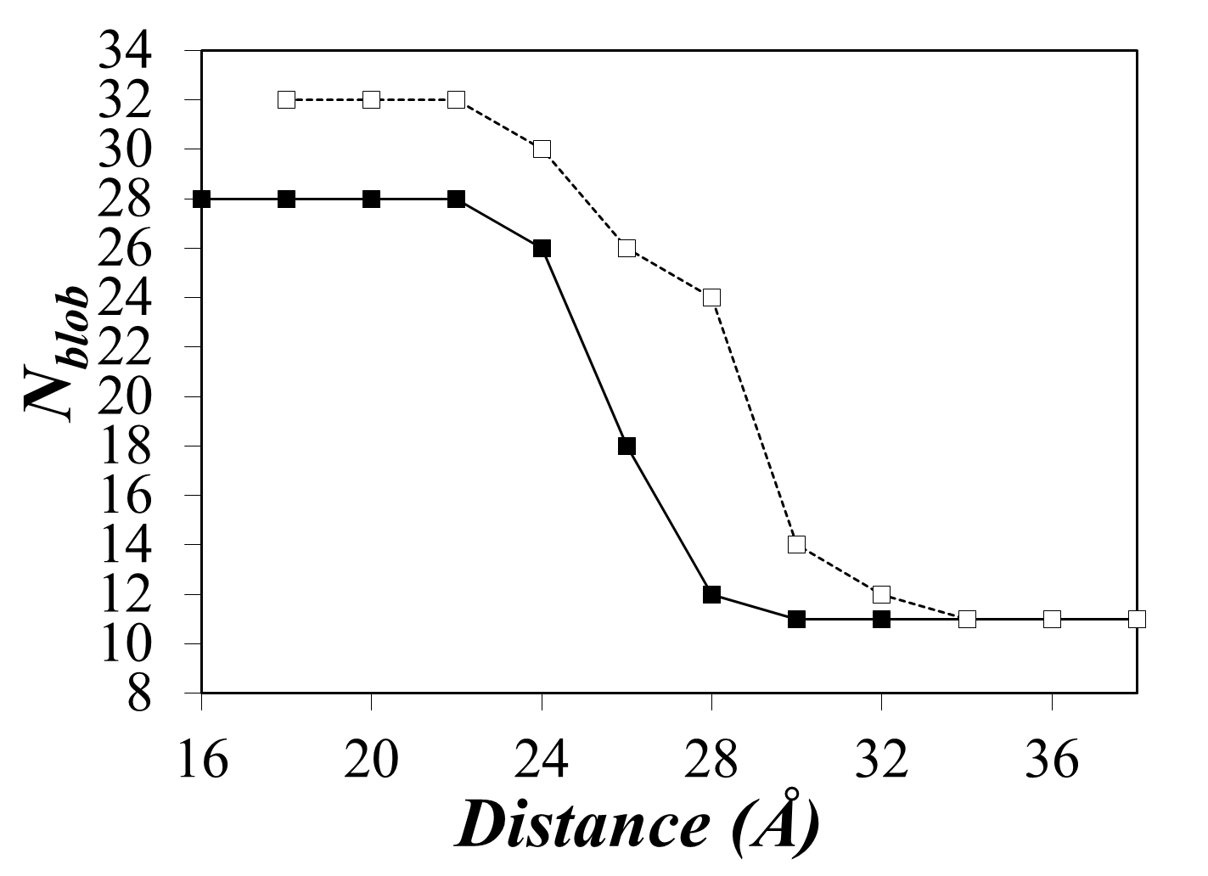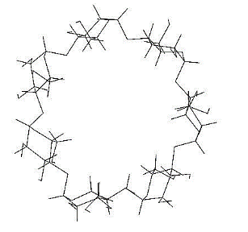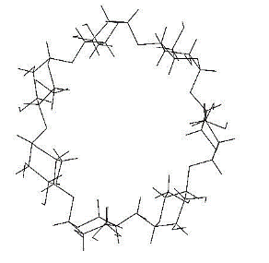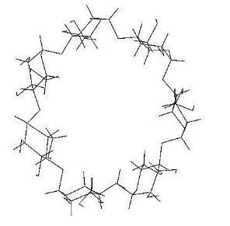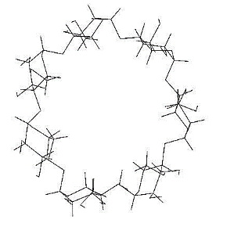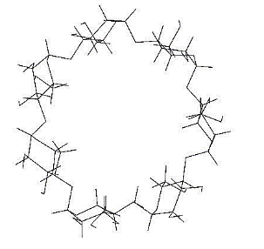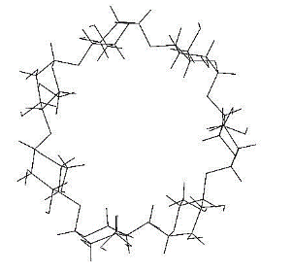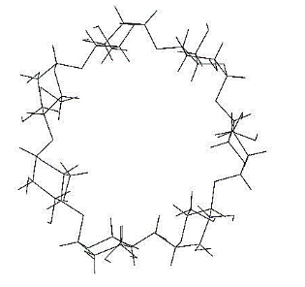

#1

#2

#3

#4

#5

#6

#0

**Conclusions**

The combination of PEF experiments and MMOs suggests that amylopectin retains single or double helices when dissolved in DMSO. In order to obtain and *N*blob value of 20 anhydroglucose units, single or double helices would have to be separated by 26 or 29 Å, respectively. If amylopectin were to expand laterally from an interhelix distance of 10 Å for perfect packing in an amylopectin crystal to 26 or 29 Å when dissolved in DMSO, it would suggest a 2.62 – 2.92 decrease in density from 1.5 g/mL for starch granules3 to 0.22 – 0.18 g/mL for amylopectin dispersed in DMSO. Such densities are much larger than the density of dispersed amylopectin expected from intrinsic viscosity measurements of about 0.005 g/mL for amylopectin in DMSO.4 This comparison suggests that densely packed domains exist in amylopectin, probably taking the form of clusters of helices as depicted in Figure 3A, that allow PEF to occur in Py-Amylopectin, but these helix clusters must be spread out in the interior of amylopectin resulting in the low density obtained from intrinsic viscosity measurements.

**References**

1. Manners, D. J. Recent Developments in our Understanding of Amylopectin Structure. Carbohyd. Polym. **1989**, 11, 87-112.
2. Li, L. and Duhamel, J. Conformation of Pyrene Labeled Amylose in DMSO characterized with Fluorescence Blob Model. *Macromolecules* **2016**, *49*, 7965-7974.
3. Pérez, S.; Brtoft, E. The Molecular Structures of Starch Components and their Contribution to Architecture of Starch Granules: A Comprehensive Review. *Starch* **2010**, *62*, 389-420.
4. Millard, M. M.; Dintzis, F. R.; Willett, J. L.; Klavons, J. A. Light Scattering Molecular Weights and Intrinsic Viscosities of Processed Waxy Maize Starch in 90% DMSO and H2O. *Cereal Chem.* **1997**, *74*, 687-691.