Fluorescently Labelled Latex Particles to Monitor Film Formation – Victoria Hisko

Introduction

Latex film formation has been of commercial importance for many years, particularly in the paint industry. Since the 1960s, latex paints have largely replaced oil-based paints known to contain hazardous amounts of lead and organic solvents. The film formation process begins with the latex particles in an aqueous dispersion. As the water evaporates, the particles come into close contact and start deforming before they coalesce and the polymer chains interdiffuse. Interparticle diffusion (IPD) of the polymer chains leads to the formation of entanglements producing a homogeneous film with good mechanical properties.
Several methods have been explored in the past to probe IPD, but all have significant drawbacks. We now propose a new method to probe IPD by labelling the polymer chains in the latex with the dye pyrene.

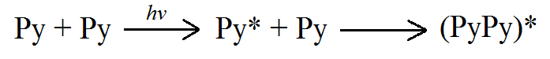
Pyrene is a widely used fluorescent molecule because of its good quantum yield and high molar extinction coefficient, making it possible to acquire noise-free fluorescence spectra at low pyrene concentrations. Pyrene is typically excited in the UV region and emits with a lifetime τ_{M}. If an excited pyrene molecule encounters a ground-state pyrene, an excimer is formed that emits with a lifetime τ_{E}. The process is depicted in Figure 1.
τ_{M}
τ_{E}
To probe IPD in latex particles, some of the particles are labelled with pyrene. Unfortunately, pyrene-containing monomers (PyLM) tend to be very hydrophobic and difficult to incorporate into polymeric chains by emulsion polymerization, since they must diffuse across the water phase. To reduce the hydrophobicity of the PyLM, an oligo(ethylene glycol)(OEG) segment can be added in the monomer.
Figure 1: Pathway for formation of excimer by diffusive encounters and the resulting spectrum
The goal of this project is to optimize the design and synthesis of PyLMs that satisfy the above conditions requirements. The PyLM will be copolymerized with n-butyl methacrylate (BuMA) to form latex particles, to be used to monitor film formation using steady-state fluorescence.

Experimental

The PyLMs were prepared by first synthesizing ethoxylated 1-pyrenemethanol. This was accomplished in two ways. The first method was via tosylation and addition (Scheme 1 a and b) and the second method via anionic polymerization (Scheme 2). The first approach was typically used for shorter spacers, up to penta(ethylene glycol) in the present study. Anionic polymerization was more suitable for longer OEG spacers. In Scheme 1, silver oxide was used as a monoprotection agent for the ethylene glycol oligomers. After ethoxylated 1-pyrenemethanol was synthesized, it was reacted with methacrylic anhydride to produce the desired PyLM (Scheme 3). Dimethylaminopyridine (DMAP) was used to promote the methacrylation reaction.
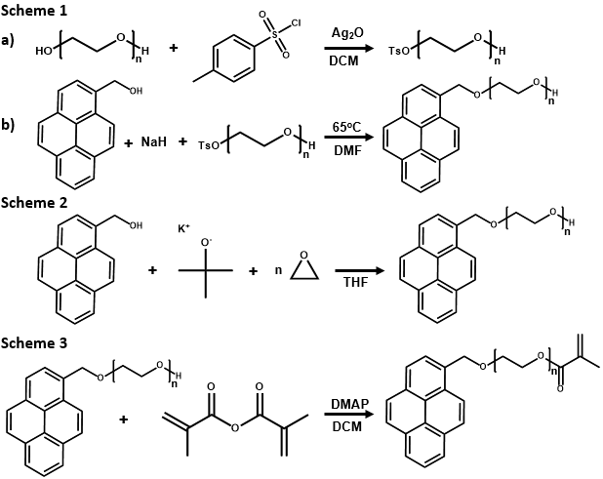
Once the PyLM was obtained, latex particles were synthesized. Since methacrylate monomers are typically used in latex paints. The emulsion copolymerization of BuMA and the synthesized PyLM was performed. In emulsion polymerization, the monomer must diffuse across the water phase and into micelles and particles to polymerize and the use of an OEG spacer in the PyLM was expected to facilitate this step. The pyrene-labelled latex was then mixed with native (unlabelled) latex in a 5:95 weight ratio. The latex mixture was deposited into a quartz tube and dried under nitrogen overnight. The resulting film was annealed in an oil bath under nitrogen, and changes in excimer formation were monitored as a function of annealing time via steady-state fluorescence.

Results

PyLMs used in this project must be hydrophilic enough to readily diffuse across the water phase during emulsion polymerization for good incorporation, but hydrophobic enough not to remain in that phase. The monomer must also be sufficiently small as to not disrupt the properties of the native latex, such as its glass transition temperature (T_{g}). PyLMs with longer OEG linkers have been shown to induce crosslinking in the emulsion polymerization step, which must be minimized.
A PyLM with four OEG units was synthesized via Scheme 1. The success of the reaction was confirmed via proton nuclear magnetic resonance (¹H NMR) analysis. The appearance of ethylene glycol resonance peaks at 3.5-4.0 ppm confirmed the ethoxylation of 1-pyrenemethanol, and the peaks at 5.5 and 6.2 ppm indicated successful methacrylation. The ¹H NMR, gel permeation chromatography and time-resolved fluorescence indicated that only the desired species were present.
A PyLM containing seven OEG units on average was synthesized by the procedure described in Schemes 2 and 3. One major lifetime was observed in the fluorescence decay with a contribution of 93%, indicating that mainly one fluorophore type was present. The monomer had a polydispersivity index (PDI) of approximately 1.5 due to variations in the length of the OEG spacer. This differs from PyLMs synthesized according to Scheme 1, since anionic polymerization yields PyLMs having a distribution of OEG segment lengths with an average length of seven units, as determined by ¹H NMR analysis. Once the PyLM is synthesized, the emulsion polymerization may be performed. The PyLM is copolymerized with butyl methacrylate to obtain the desired polymer. Currently, the PyEG₄MA-labelled polymer is the only useable emulsion that has been synthesized. The PyEG₇MA and PyEG₈MA-labelled polymers were crosslinked and not suitable for film formation. Typical characterization data obtained for a PyLM is provided in Figure 2.

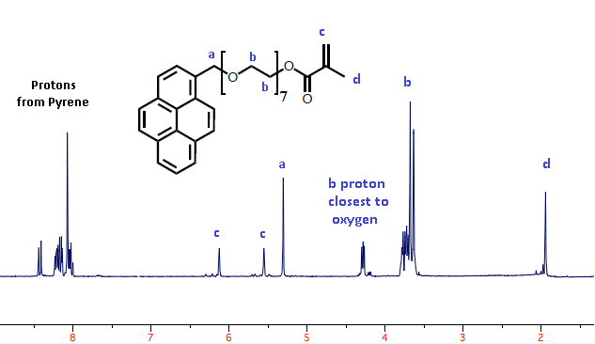
b)
a)
d)
c)

Figure 2: Characterization of PyLM: (a)¹H NMR spectrum, (b) time-resolved fluorescence decay, (c) steady-state fluorescence spectrum, (d) GPC trace

a)
Increasing
annealing time
b)

Figure 3: Annealing of PyEG₄MA labelled film at 80ºC. a) full spectrum, b) close-up of excimer formation.

Once the PyLM was synthesized, the emulsion copolymerization of the PyLM with BuMA was carried out to obtain the desired labelled latex particles. The monomer incorporation for the PyEG₄MA monomer was increased to 2.5 mol% as compared to 1.9 mol% obtained for PyEG₃MA. For PyLMs with an OEG linker longer than that in PyEG₄MA, it was necessary to use a chain transfer agent mto minimize crosslinking. With a chain transfer agent, PyEG₇MA could be incorporated at 3.2 mol% in the copolymer. It was verified by differential scanning calorimetry (DSC) analysis that the T_{g} of the copolymer was not significantly different from the BuMA homopolymer.
Latex films were then prepared with the pyrene-labelled latex and film annealing was monitored using steady state fluorescence. Initially, since the pyrene labels remain inside the original latex particles, an excited pyrene moiety is more likely to encounter a ground-state pyrene and form an excimer. As the film anneals, the latex particles boundaries gradually disappear and the pyrene-labelled chains diffuse out of the pyrene-labelled latex to entangle with the unlabelled chains. The probability of an excited pyrene encountering a ground-state pyrene the thus decreased and excimer formation is reduced. It is also predicted that if a greater amount of pyrene is incorporated into the polymer chains, it will provide a stronger excimer signal which should facilitate the study of film annealing.

Further work

Annealing of the PyEG₇MA-containing latex particles at different temperatures will be performed, to determine the diffusion coefficient of the polymer chains as they diffuse into the unlabeled latex particles in the film. An investigation into the chemical pathways leading to crosslinking will also be conducted.

