Nature-Inspired Polymers: Promising Materials for OTFT-Based Sensors
By: Jesse Quinn

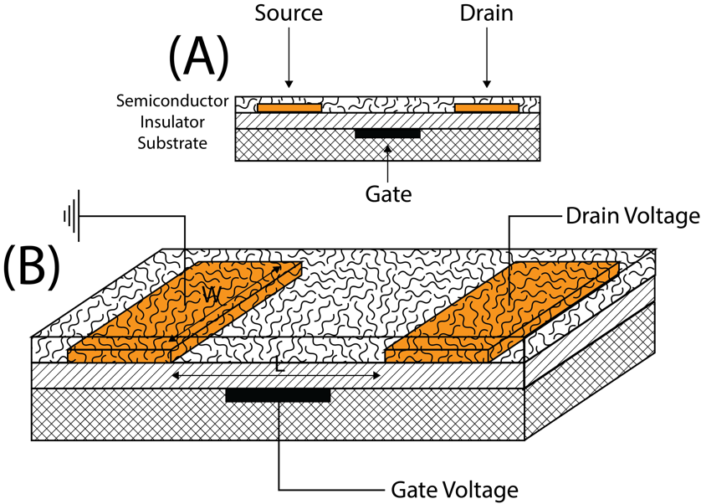
Figure 1. (A) The common bottom-gate bottom-contact OTFT; and (B) three-dimensional blow-up of said device.
The organic electronics field can be considered a fast-paced domain that has had significant progress regarding both efficacy and functionality. In addition to classic devices, namely organic light-emitting diodes (OLEDs), thin-film transistors (OTFTs), and solar cells, auxiliary functions of said devices have been recognized. For example, such devices have found crucial roles in display switches, display drivers, electronic paper, memory devices that contain radio frequency identification cards (RFIDs), electrophoretic cells, and sensors. A significant number of these device types can already be realized as “all-organic”, without inorganic constituents, thus a completely new domain is envisioned by the integration of said functional components on one common stage. The most exciting benefits from implementing organic materials in electronic devices involves aspects like mechanical flexibility and light weight. Such properties are attractive for mobile applications and wearable devices. Moreover, entirely new design concepts for consumer electronics are emerging, as organic electronic devices can conform to complex surface shapes.
The active organic semiconductors of these devices can be divided into two classes, namely, small-molecules and polymers. Although the fundamental properties of both materials are effectively the same, the separation mainly relates to the way thin films are prepared. Small-molecules are usually thermally evaporated under vacuum whereas polymers are processed from solution. However, this is not entirely true as most small-molecules can be soluble, or solubility may be improved by the addition of side chains. Nonetheless, organic materials in principle have many advantages over conventional materials such as their fabrication process, which can avoid high temperature and high vacuum deposition processes by simply depositing from solution. For preparation from solution, several techniques are available such as the standard spin-coating method, inkjet printing, screen printing, and flexographic printing that allow large-volume/large-area roll-to-roll fabrication giving way to low production costs.
Both polymer and small-molecule semiconductors have many common properties such as ionization potential (IP), electron affinity (EA), hardness (η), band-gap energy, solubility, tendency for crystal formation in solid state, and stability in ambient conditions, which all can be tuned by altering the chemical composition. Furthermore, such materials have demonstrated versatile functionalities such as optical, electrical, magnetic, and sensing properties in various types of organic electronics. With the aforesaid merits, there have been numerous reports since the 1970s incorporating organic semiconductors into conventional electronic devices that have led to performance properties that are comparable to or better than their inorganic counterparts, thereby increasing their practical commercial application interest and value.
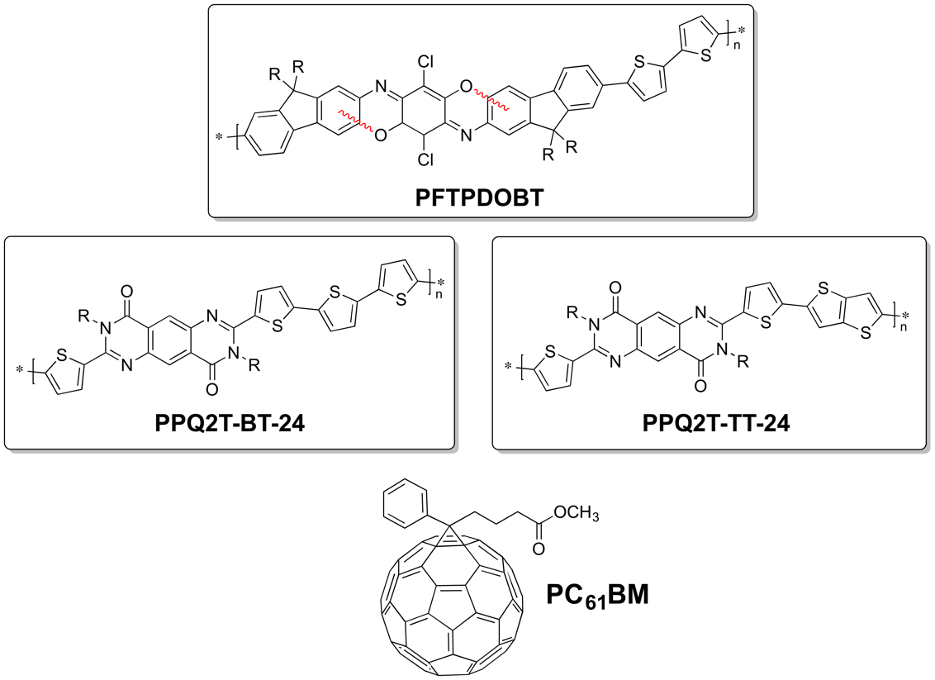
Figure 2. Chemical structures of polymers PFTPDOBT, PPQ2T-BT-24 and PPQ2T-TT-24 and the small molecule PC₆₁BM.
Although the concept of an OTFT, Figure 1, was first introduced in the late 1980s by Koezuka et al. the two key parameters of performance values, field-effect mobility (μ) and current ON/OFF ratio (I_{ON}/I_{OFF}), obtained from the initial organic semiconductors were considered impractical and continued to be for many years. With several decades of academic and industrial interest numerous organic semiconductors have now appeared that have not only met but surpassed amorphous silicon in charge carrier transport. However, a shortcoming associated with most organic semiconductors is their sensitivity to air when used as the active channel layer in OTFTs. It is commonly believed that organic semiconductors are susceptible to doping or trapping by interaction with ambient oxygen, moisture, and carbon dioxide resulting in larger off-currents and thus lower I_{ON}/I_{OFF} values. In addition, a shift to larger threshold voltages (V_{TH}) can be observed. Therefore, rigorous precautions are taken during material processing and device fabrication to exclude environmental elements that may alter the OTFT performance. These precautionary measures increase cost of manufacturing and off-set the appeal of OTFTs as inexpensive alternatives to conventional technology. Consequently, the development of organic semiconductors with high charge carrier transport as well as air stability is still needed. Although an important caveat, the intrinsic sensitivity of organic semiconductors to various elements makes them an ideal candidate for “label-free” sensors. OTFT-based sensors are conceived to function as core elements in miniaturized systems capable of detecting an analyte with high sensitivity and selectivity while delivering an immediate digital response. Nonetheless, stability to background environment elements such as air or water is highly pertinent.
Nature provides a vast diversity of materials and looking for natural or nature inspired semiconductors appears to be a promising route towards interesting and relevant materials. OTFTs based on natural or natural-inspired semiconductors such as indigo, β-carotene, indanthrene, and perylene diimide have demonstrated good charge carrier transport and some cases demonstrated equally good stability in ambient conditions.
In this work, a number of moderately to excellent air stable polymeric semiconductors were designed and synthesized that were nature inspired (Figure 2). A novel fluorene-fused triphenodioxazine based polymer (PFTPDOBT) exhibited excellent charge transport performance in ambient conditions reaching hole mobilities as high as ~10⁻² cm² V⁻¹ s⁻¹ and modest hole mobilities (~10⁻³ cm² V⁻¹ s⁻¹) under aqueous conditions using a water-gated transistor architecture. In a similar fashion, a series of pyrimido[4,5-g]quinazoline-4,9-dione (PQ) based polymers were developed and characterized. A systematic study of these PQ-based polymer semiconductors is presented in both nitrogen, ambient, and aqueous environments. Typical hole charge transport was obtained between ~10⁻² and ~10⁻³ cm² V⁻¹ s⁻¹. Both PPQ2T-BT-24 and PPQ2T-TT-24 demonstrated moderate to excellent stability in these environments. To exploit the photo-excitation caveat of organic semiconductors, a series of PQ-based polymeric semiconductors were incorporated in phototransistors and also blended with PC₆₁BM. The PPQ2T-BT-24:PC₆₁BM blend reached ultrafast response times as low as 1 ms for rise and 8 ms for fall with photoresponsivity as high as 0.88 % and EQE of 189 %.

