Detecting Minute Quantities of Nitroaromatic Compounds with Pyrene-Labeled Starch Nanoparticles
Sanjay Patel, Jean Duhamel
IPR Symposium 2018, University of Waterloo, Waterloo, ON, N2L 3G1, Canada

INTRODUCTION
Nitroaromatic compounds are well known for their utilization as explosives. They are widely used in the industry but unfortunately, they are also mutagenic to humans and toxic to the environment. Consequently, the ability to detect their presence is of the upmost importance.⁵ Current methods employed for nitroaromatic detection include the use of ion mobility spectroscopy, mass spectroscopy, or canine units.^{1,3} Although these methods offer high sensitivity, typically on the order of ppb and ppt, they suffer from high cost, non-portability, and complex instrumentation.³ Owing to these disadvantages, the suitability of alternate detection methods based on surface enhanced Raman spectroscopy, electronic olfactory systems, and sensor techniques have been investigated.^{3,7} Among sensor-based techniques, the use of fluorescence has gain much popularity, due to its lower requirements in terms of relatively simple instrumentation, portability, low cost, and high sensitivity.^{2,4,6,8} In this work, the fluorescence of pyrene-labeled starch nanoparticles (Py-SNPs) was applied to detect minute quantities of nitroaromatic compounds. Starch nanoparticles (SNPs) offer several advantages compared to traditionally used latex particles made of vinyl monomers, as they are derived from starch, a natural and cheap polymer. Pyrene was chosen as the fluorescent dye, owning to its well-known photophysical properties such as high quantum yield and large molar extinction coefficient, and its hydrophobicity. Upon labeling SNPs with pyrene, hydrophobic pyrene-rich microdomains are generated that emit as excimer. These hydrophobic microdomains can be exploited to drive sparingly water-soluble nitroaromatic compounds to them. Since most nitroaromatic compounds are well known quenchers of fluorescence, the hydrophobic microdomains generated by pyrene offer an inherent method of detection.
EXPERIMENTAL
Pyrene-Labeled Starch Nanoparticles (Py-SNPs) Synthesis: The Py-SNP samples used in this research were synthesized according to the reaction scheme shown in Figure 1. The synthesis and purification of the Py-SNPs have been described elsewhere in more detail.⁹
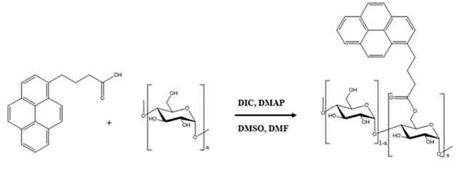
Figure 1. Reaction scheme for the synthesis of pyrene labeled starch nanoparticles.
Steady-State Fluorescence: All steady-state fluorescence spectra were acquired on a Photon Technology International LS-100 fluorimeter equipped with a Xenon Arc lamp. All samples were excited at 346 nm and the emission spectra were acquired from 356 to 600 nm. The fluorescence intensities for the monomer (F_{m}) and excimer (F_{e}) were calculated by integrating the fluorescence signal from 372 to 378 nm and 500 to 530 nm, respectively. All quenching studies conducted on Py-SNP-coated filter paper were carried out using front face geometry. All fluorescence spectra acquired for the Py-SNP-coated filter paper was background corrected with unlabeled SNP-coated filter paper.
Time-Resolved Fluorescence: All time-resolved fluorescence decays were acquired on an IBH fluorimeter equipped with an IBH 340 nm NanoLED. All solutions were excited at 346 nm and the fluorescence decays for the Py-SNPs were acquired at 375 and 510 nm for the monomer and excimer, respectively. To ensure a good signal-to-noise ratio, the fluorescence decays were acquired with 20,000 counts at the decay maximum. All decays were fitted with a sum of exponentials. For all the decay fits, a χ² value between 0.98 and 1.20 was obtained with the residuals and autocorrelation function of the residuals randomly distributed around zero, thus demonstrating a good fit.
Quenching studies in solution: All quenching experiments conducted in DMSO were carried out at a pyrene concentration of 2.5∙10⁻⁶ M, while progressively increasing the concentration of quencher. The selected pyrene concentration, corresponding to an absorbance of 0.1 at 346 nm, ensured minimal particle-particle interactions. A stock solution of Py-SNPs ([Py]=3.4∙10⁻⁶ M) was made in DMSO. The stock solution (3.7 g) was diluted with 1.3 g of DMSO to yield the solution “Sol A” with a pyrene concentration of 2.5∙10⁻⁶ M, corresponding to an absorbance of 0.1. A stock solution of quenchers, namely nitromethane (NM, 0.2 M), 4-nitrotoluene (MNT, 0.04 M) and 2,6-ditrotoluene (DNT, 0.04 M) were made in DMSO. The stock solutions with quencher (1.3 g) were diluted with 3.7 g of the Py-SNP stock solution in DMSO, yielding the solution “Sol Q” with a same pyrene concentration as Sol A. The fluorescence spectrum and decay at 375 nm were acquired for Sol A to determine the fluorescence intensity (F_{o}) and lifetime (τ_{o}) of the pyrene monomer without quencher. Then known quantities of Sol Q was added to the cuvette directly and the fluorescence intensity (F) and decay (τ) were acquired. This process was repeated until 10 data points were obtained. Since Sol A and Sol Q have the same concentration of Py-SNPs, this procedure enabled to progressively increase the quencher concentration while still maintaining the same Py-SNP concentration. Quenching studies conducted in water were prepared in a similar manner as in DMSO. A Py-SNP stock solution was prepared in DMSO (4.6∙10⁻⁴ M), and 0.06 g of this stock solution was diluted with 8 g of milliQ water to yield an aqueous solution of Py-SNP with a pyrene concentration of 3.4∙10⁻⁶ M. This water stock was subsequently used to prepare 5 g of Sol A and Sol Q, using water to dilute the samples. The final pyrene concentrations of the solutions, namely Sol A and Sol Q, was 2.5∙10⁻⁶ M. All solutions were prepared in water with 0.8 wt% of DMSO.
Py-SNP-Coated filter papers: The drop method was developed to coat pieces of Whatman No1 filter papers with Py-SNP. A dispersion of Py-SNP in milliQ water was prepared with a final pyrene concentration of 3.2∙10⁻⁵ M with 0.67 wt% DMSO. This stock solution (0.03 g) was deposited directly onto 1 cm×1 cm pieces of Whatman No1 filter paper, resulting in Py-SNP-coated filter paper with approximately 1.6∙10⁻¹¹ mol of pyrene per mm² of filter paper. The resulting papers were dried under N₂ in the dark. A series of quenching solution using MNT, DNT, and TNT were prepared in ethanol or acetonitrile. A same volume of 10 µL of the different quenching solutions was deposited directly on the filter paper which was allowed to completely dry. The filter papers were rewetted with 10 µL of water and the fluorescence spectra were acquired. To account for the change in the fluorescence intensity due to the addition of ethanol when depositing the quencher solution, 4 pieces of paper were wetted with 10 µL of ethanol, allowed to dry, and rewetted with water. The ^{W}F_{o}/^{E}F_{o} values were averaged among the 4 pieces of paper and plots of (^{W}F_{o}/^{E}F_{o})/(F_{o}/F) as a function of quencher mass per mm², where ^{W}F_{o} and ^{E}F_{o} are the fluorescence intensities of Py-SNP-coated filter papers with no quencher before and after ethanol addition, respectively. F_{o} and F are the fluorescence intensity of the filter paper without and with quencher, respectively.

RESULTS AND DISCUSSION
Quenching studies in DMSO: Quenching studies were conducted with Py-SNP dispersions in DMSO as nitromethane (NM), nitrotoluene (MNT), dinitrotoluene (DNT), and the pyrene labels are soluble and SNPs are dispersible in DMSO. From the steady-state fluorescence (SSF) spectra and time-resolved fluorescence (TRF) decays, Stern-Volmer plots of F_{o}/F and τ_{o}/τ were constructed and the bimolecular quenching rate constants were determined using the τ_{o}/τ ratios. As expected, F_{o}/F and τ_{o}/τ increased linearly with increasing NM concentration. A good overlap between the trends obtained with F_{o}/F and τ_{o}/τ was indicative of dynamic quenching being the predominant mode of quenching. Quenching studies conducted with MNT and DNT showed a linear and exponential increase of, respectively, the τ_{o}/τ and F_{o}/F ratios with increasing quencher concentration. Typically, the combination of an exponential increase for F_{o}/F and linear increase for τ_{o}/τ is indicative of mixed dynamic and static quenching. However at concentrations of 4 and 3 mM for MNT and DNT, the absorption of the dispersion would equal 1.7 and 1.9 at 346 nm, respectively. Such absorbances are too high for fluorescence measurements because they hinder access of the excitation beam to the center of the cell, which decreases the fluorescence intensity resulting in the exponential increase in the F_{o}/F ratio. Fortunately excessive absorption does not affect the TRF measurements, implying that the bimolecular quenching rate constant k_{q} obtained from the slope of τ_{o}/τ represented as a function of quencher concentration were reliable. Upon plotting the k_{q} values in Figure 2, k_{q} was found to be independent of pyrene content. This result demonstrates that all pyrene labels were equally accessible to the quenchers in DMSO, as would be expected. k_{q} values of 1.7 (± 0.1) M⁻¹ns⁻¹, 4.0 (± 0.3) M⁻¹ns⁻¹, and 2.2 (± 0.2) M⁻¹ns⁻¹ were found for NM, MNT, and DNT, respectively. The efficiency of quenching, as reflected by the k_{q} values, was found to decrease as MNT>DNT>NM, where MNT and NM were the best and worst quencher, respectively. Interestingly, DNT was 1.8-fold less efficient compared to MNT. Since DMT has an extra nitro-group compared to MNT, DNT was expected to have a higher k_{q} value than MNT. The decrease in k_{q} for DNT compared to MNT was attributed to enhanced H-bonding between DNT and the starch hydroxyls which restricted the diffusion of DNT, thus restricting its mobility as it interacted with starch to quench the pyrene labels.
Quenching Studies in Water: Quenching studies, similar to those carried out in DMSO, were conducted in water. NM has a high solubility in water (10 g/L), whereas MNT, DNT, and TNT have a much lower water solubility (0.361 g/L, 0.279 g/L, and 127 g/L, respectively). Stern-Volmer plots obtained with Py-SNP samples with a degree of substitution (DS) of 0.0265 (2.65 mol% of pyrene labels per anhydroglucose unit) and lower followed similar trends a those observed in DMSO. However Py-SNP samples with a DS of 0.08 and higher resulted in Stern-Volmer plots with a downwards curvature. A downwards curvature in a Stern-Volmer plot is indicative of protective quenching. A modified Stern-Volmer equation was used to determine k_{q} and f_{a}, the fraction of dyes accessible to the quencher. As observed before in DMSO, k_{q} remained constant in water regardless of the pyrene content when quenched by nitromethane. Furthermore, f_{a} decreased linearly with increasing content of pyrene labels attached to the Py-SNPs. A decrease in f_{a} suggests that, as more hydrophobic pyrene is attached to the Py-SNPs, the hydrophobic domains are less accessible to the water-soluble NM quencher.
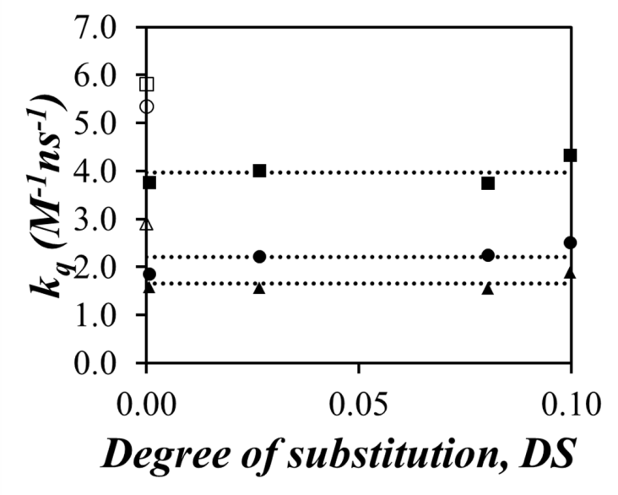
Figure 2: Plot of k_{q} as a function of degree of substitution (DS) for NM (), MNT (), and DNT (). Filled and hollowed symbols correspond to Py-SNPs and molecular pyrene, respectively.
Quenching studies were repeated in water for the Py-SNP samples with MNT, DNT and 2,4,6-trinitrotoluene (TNT). Addition of MNT, DNT, and TNT resulted in little change (< 10%) in the fluorescence intensity of the pyrene monomer between 356 and 400 nm, but led to a substantial decrease (up to 60%) of the excimer fluorescence intensity between 430 to 600 nm. This result suggested that MNT, DNT, and TNT targeted the hydrophobic microdomains generated by the pyrene labels on the SNPs. The TRF decays acquired for the monomer at 375 nm and the excimer at 510 nm with increasing quencher concentration overlapped, demonstrating the absence of dynamic quenching. Together, the SSF and TRF results led to the conclusion that MNT, DNT, and TNT would target the hydrophobic domains on the Py-SNPs generated by the pyrene labels with a binding constant K_{s}. Quenching of pyrene excimer would happen instantaneously in a static manner for the quenchers bound to the pyrene aggregates. Considering the excimer fluorescence, a linear relationship was obtained between the F_{o}/F ratio and the quencher concentration whose slope yielded K_{s}. As shown in Figure 3, K_{s} increased with increasing pyrene content. Increasing the pyrene content generated more hydrophobic microdomains, thereby resulting in increased binding of the hydrophobic quenchers. K_{s} for the different quenchers decreased according to the following sequence: TNT>DNT>MNT. The trend obtained with K_{s} implied that each additional nitro-group on the aromatic rings led to stronger binding of the quencher to the hydrophobic microdomains. Increasing the pyrene content generated more hydrophobic microdomains that led to stronger binding as indicated by an increase in K_{s}.
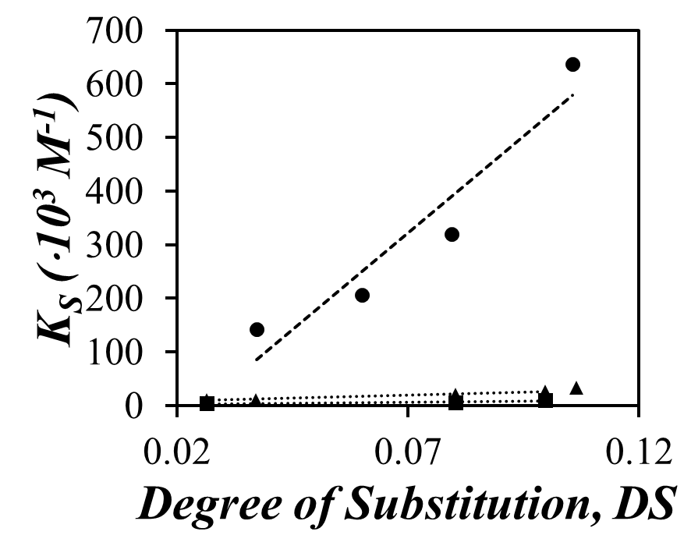
Figure 3: Plot of K_{s} as a function of the pyrene content of the Py-SNP for MNT (), DNT (), and TNT ().
Py-SNP-Coated Papers: The use of Py-SNPs deposited onto a solid substrate was also investigated to develop a paper-based sensor. The Py-SNPs were deposited according to the drop method which was developed to coat filter paper with Py-SNPs and quenching studies were conducted on Whatman Filter Paper No1 with MNT, DNT, TNT, and naphthalene using a Py-SNP sample with a DS of 0.11. Detection limits of 80 (± 10), 35 (± 2), and 5 (± 1) ng per mm² for MNT, DNT, and TNT, respectively, were determined in Figure 4. Interestingly, the detection limit of TNT was about 10 and 16 fold lower compared to that of DNT and MNT, respectively.
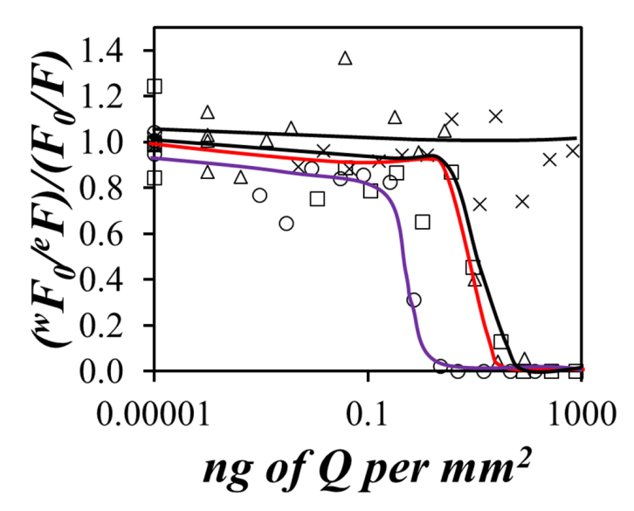
Figure 4: Plot of (^{W}F₀/^{E}F)/(F₀/F) as a function of quencher mass per mm² for MNT (), DNT (), TNT (), and naphthalene ().
This decrease in the detection limit was also reflected by the K_{s} trends, where K_{s} for TNT was significantly higher compared to MNT and DNT. To demonstrate the selectivity of Py-SNP-coated filter papers, quenching studies were repeated with naphthalene as an aromatic contaminant. As seen in Figure 4, no significant quenching was observed within experimental error, confirming that the quenching observed for the Py-SNPs was selective towards nitroaromatic compounds.
CONCLUSIONS
This study has demonstrated that the fluorescence of Py-SNP can be employed to detect minute quantities of nitroaromatic compounds via fluorescence quenching. Detection limits for Py-SNP in water where 50% quenching occurred were found to equal 1.1·10⁻⁴ M, 2.5·10⁻⁵ M, and 1.6·10⁻⁶ M for MNT, DNT, and TNT, respectively. The use of Py-SNP-coated filter papers was investigated. Detection limits for MNT, DNT, and TNT where 100% quenching occurred, was found to be 80 (± 10), 35 (± 2) and 5 (± 1) ng per mm², respectively. Quenching studies with naphthalene, as an aromatic contaminant, demonstrated the selectivity of the Py-SNP-coated filter papers towards nitroaromatic compounds.
REFERENCES
- Akhgari, F. et al. Recent Advances in Nanomaterial-Based Sensors for Detection of Trace Nitroaromatics Explosives. Polym. Sens. Actuators 2015, 221, 867-878.
- Beyazkilic, P. et al. Formation of Pyrene Excimers in Mesoporous Ormosil Thin Films for Visual Detection of Nitro-explosives. M. ACS Appl. Mater. Interfaces 2014, 6, 4997–5004.
- Caygill, S. et al. Current Trends in Explosive Detection Techniques. Talanta 2012, 88, 14-29.
- He, G. et al. Pyrene-Containing Conjugated Polymer-Based Fluorescent Films for Highly Sensitive and Selective Sensing of TNT in Aqueous Medium. Macromolecules 2011, 44, 4759-4766.
- Kou-San, J.; Parales, R. Nitroaromatic Compounds, from Synthesis to Biodegradation Microbiol. Mol. Biol. Rev. 2010, 74. 2, 250-272.
- Senthamizhan, A. et al. Highly Fluorescent Pyrene-Functional Polystyrene Copolymer Nanofibers for Enhances Sensing Performance of TNT. ACS Appl. Mat. Interfaces. 2015, 7, 21038–21046.
- Singh, S. Sensors-An Effective Approach for the Detection of Explosives. J. Hazard. Mater. 2007, 144, 15-28.
- Tao, T. et al. Tuning Aggregation-Induced Emission Properties with the Number of Cyano and Ester Groups in the Same Dibenzo[b,d]thiophene Skeleton for Effective Detection of Explosives. Sens. Actuators, B 2018, 257, 303–311.
- Yi, W. Characterization of Starch Nanoparticles by Fluorescence Techniques, M.Sc Thesis, University of Waterloo, 2014.

