Sensor Array for Volatile Organic Compounds based on Doped

Poly (o-anisidine)

Katherine M. E. Stewart and Alexander Penlidis
Institute for Polymer Research, Department of Chemical Engineering, University of Waterloo, 200 University Avenue West, Waterloo, Ontario, N2L3G1, Canada

Monitoring various volatile organic compounds (VOCs) is important for a variety of applications. For example, ethanol detection to prevent a person from driving while intoxicated, acetone detection in disease diagnosis such as diabetes, and benzene detection in indoor air quality. In any application, multiple VOCs are present and will interact with both the sensing materials and the other VOCs. This makes the identification of highly selective sensing materials difficult.

To improve the most important and basic sensing properties (sensitivity and selectivity) of a polymer, the polymer may be modified by changing its functional groups. A polymer may also be modified by incorporating metal oxide nanoparticles (known as doping). This results in the formation of a polymeric nanocomposite, where changing the amount or type of either the polymer or nanoparticles, results in a new nanocomposite (or material). Therefore, a very large number of combinations are possible; however, not all metal oxide nanoparticles are able to be incorporated into all polymer matrices.

A solution to this problem is to use a sensing array or ‘electronic nose’ that combines the different responses from a variety of sensing materials to various analytes. With the use of a filtering algorithm, such as principal component analysis (PCA), these numerous responses are evaluated and ranked, thus allowing multiple analytes to be identified, simultaneously. This is possible because each analyte interacts slightly differently with different sensing materials (in essence, it has a different signature spectrum).

Good sensing materials must not only respond when interacting with various analytes, but must also have good environmental stability and be reusable. Polymers are ideal sensing materials for VOCs because they satisfy the above and can, in addition, be readily tailored for specific analytes. Depending on the analyte and polymeric sensing material, the polymer may behave differently when the two interact. For example, a conductive polymer, such as polyaniline, becomes more resistive when the hydrogens from a polar analyte bond to the amine group, which can be detected by a resistive type sensor. Some polymers change dielectric constants when an analyte sorbs onto them, which can be detected by a capacitive sensor. Other polymers, such as poly (methyl methacrylate), can swell when an analyte sorbs, which can also be detected by a capacitive sensor.

Poly (o-anisidine) (PoANI) was used both doped with different metal oxides and undoped, to create an efficient sensor array that was capable of identifying three different analytes (ethanol, acetone, and benzene) at very low concentrations (below 5 ppm). Three PoANI sensing materials (undoped PoANI, PoANI doped with 20% NiO, and PoANI doped with 20% ZnO) were evaluated for sorption using individually tested gases and gas mixtures.

For example, different combinations of ethanol, acetone, and benzene were used to evaluate the PoANI sensing materials (see Figure 1). Note that none of the PoANI sensing materials are selective to any of the three gases; however, when all three sensing materials are combined into a sensing array, which uses PCA as its filtering algorithm, the gas analytes were separated and identified (see Figure 2). Not only were the individual gas analytes separated into identifiable clusters, but the gas mixtures of two and three gases were also identifiable. Therefore, in a gas mixture containing at least one of the following gases (ethanol, acetone, and benzene), it is possible with this sensor array to identify which of the three gases are present and in what combination.

As seen in Figures 1 and 2, the partial selectivity of multiple sensing materials can be improved by combining the sensing materials into a sensor array. Mixtures of gas analytes are analyzed and compared to a reference plot (like the one in Figure 2), and the gases within the mixture are identified by which cluster of points on the reference plot the unknown sample is closest to. Therefore, reference plots for the sensor array must have clusters that represent specific gas mixtures that are sufficiently separated. This separation of gas mixtures (clusters) on a reference plot is dependent on the sensing materials (both type and number), the quality of the reference points (high reproducibility), and filter algorithm.

A demonstration with an unknown sample will be conducted at the time of the IPR conference presentation.

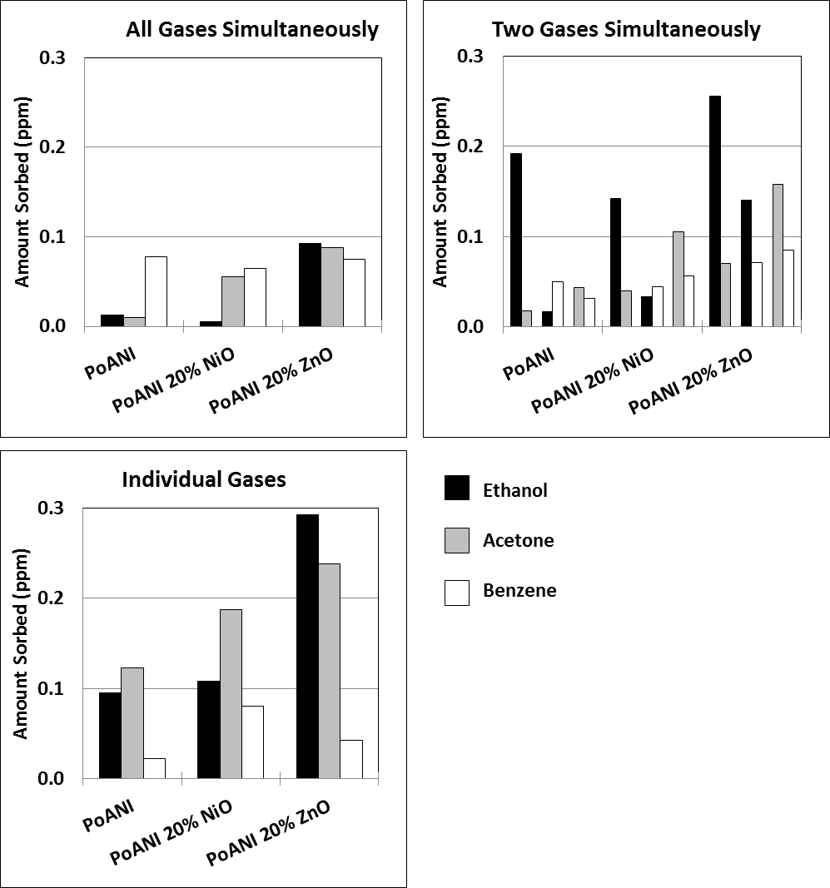

Figure 1: The amount of each gas analyte sorbed onto each sensing material when analytes were evaluated with all three gases present (top left), in mixtures of two gases (top right) and individually (bottom left).

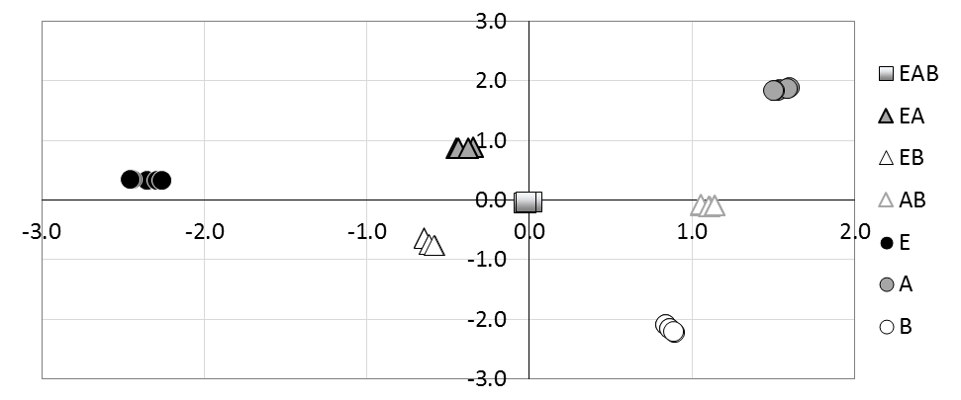
Figure 2: The PCA plot of Factor 1 versus Factor 2 for all mixtures, where E, A, and B are ethanol, acetone, and benzene, respectively. Note that individual gases are circles, two gas mixtures are triangles and the three gas mixture is represented by squares.

