INSTRUCTIONS FOR ICEFM ABSTRACT PREPARATION USING

MS WORD

|  |  |
| --- | --- |
| **First Author**  Department of ...  Organization/University  Address  email | **Second Author**  Department of ...  Organization/University  Address  email |
| **Third Author**  Department of ...  Organization/University  Address  email | |

**ABSTRACT**

This document is a template for preparing an abstract for ICEFM on A4 size paper.

The maximum length of the abstract is two (2) pages of text and one (1) page of figures.

Lorem ipsum dolor sit amet, consectetur adipiscing elit, sed do eiusmod tempor incididunt ut labore et dolore magna aliqua. Ut enim ad minim veniam, quis nostrud exercitation ullamco laboris nisi ut aliquip ex ea commodo consequat. Duis aute irure dolor in reprehenderit in voluptate velit esse cillum dolore eu fugiat nulla pariatur. Excepteur sint occaecat cupidatat non proident, sunt in culpa qui officia deserunt mollit anim id est laborum.

# TEXT HEADING #1

Lorem ipsum dolor sit amet, consectetur adipiscing elit, sed do eiusmod tempor incididunt ut labore et dolore magna aliqua. Ut enim ad minim veniam, quis nostrud exercitation ullamco laboris nisi ut aliquip ex ea commodo consequat. Duis aute irure dolor in reprehenderit in voluptate velit esse cillum dolore eu fugiat nulla pariatur. Excepteur sint occaecat cupidatat non proident, sunt in culpa qui officia deserunt mollit anim id est laborum. Lorem ipsum dolor sit amet, consectetur adipiscing elit, sed do eiusmod tempor incididunt ut labore et dolore magna aliqua. Ut enim ad minim veniam, quis nostrud exercitation ullamco laboris nisi ut aliquip ex ea commodo consequat. Duis aute irure dolor in reprehenderit in voluptate velit esse cillum dolore eu fugiat nulla pariatur. Excepteur sint occaecat cupidatat non proident, sunt in culpa qui officia deserunt mollit anim id est laborum.

Lorem ipsum dolor sit amet, consectetur adipiscing elit, sed do eiusmod tempor incididunt ut labore et dolore magna aliqua. Ut enim ad minim veniam, quis nostrud exercitation ullamco laboris nisi ut aliquip ex ea commodo consequat. Duis aute irure dolor in reprehenderit in voluptate velit esse cillum dolore eu fugiat nulla pariatur. Excepteur sint occaecat cupidatat non proident, sunt in culpa qui officia deserunt mollit anim id est laborum. Lorem ipsum dolor sit amet, consectetur adipiscing elit, sed do eiusmod tempor incididunt ut labore et dolore magna aliqua. Ut enim ad minim veniam, quis nostrud exercitation ullamco laboris nisi ut aliquip ex ea commodo consequat. Duis aute irure dolor in reprehenderit in voluptate velit esse cillum dolore eu fugiat nulla pariatur. Excepteur sint occaecat cupidatat non proident, sunt in culpa qui officia deserunt mollit anim id est laborum.

## Text Heading #2

Lorem ipsum dolor sit amet, consectetur adipiscing elit, sed do eiusmod tempor incididunt ut labore et dolore magna aliqua. Ut enim ad minim veniam, quis nostrud exercitation ullamco laboris nisi ut aliquip ex ea commodo consequat. Duis aute irure dolor in reprehenderit in voluptate velit esse cillum dolore eu fugiat nulla pariatur. Excepteur sint occaecat cupidatat non proident, sunt in culpa qui officia deserunt mollit anim id est laborum. Lorem ipsum dolor sit amet, consectetur adipiscing elit, sed do eiusmod tempor incididunt ut labore et dolore magna aliqua. Ut enim ad minim veniam, quis nostrud exercitation ullamco laboris nisi ut aliquip ex ea commodo consequat. Duis aute irure dolor in reprehenderit in voluptate velit esse cillum dolore eu fugiat nulla pariatur. Excepteur sint occaecat cupidatat non proident, sunt in culpa qui officia deserunt mollit anim id est laborum.

Text Heading #3.

Lorem ipsum dolor sit amet, consectetur adipiscing elit, sed do eiusmod tempor incididunt ut labore et dolore magna aliqua. Ut enim ad minim veniam, quis nostrud exercitation ullamco laboris nisi ut aliquip ex ea commodo consequat. Duis aute irure dolor in reprehenderit in voluptate velit esse cillum dolore eu fugiat nulla pariatur. Excepteur sint occaecat cupidatat non proident, sunt in culpa qui officia deserunt mollit anim id est laborum.

# PAGE NUMBERS

Number the pages at the bottom centre, as shown in the template.

EQUATIONS/FORMULAE

Equations should be centred in the column with two or three line spaces to separate equations from text. They also should be numbered consecutively, using Arabic numerals enclosed in parentheses and positioned flush right along the final baseline of the equation. Do not include any ellipses (dots) from the equation to the equation number, or any punctuation at the end of the equation itself.

Example:



FIGURES/PHOTOGRAPHS

All figures, graphs and line drawings should be clear and of high quality. Colour figures are allowed. All figures must be placed at the end of the abstract.

All figures should be numbered consecutively and captioned. The caption should be 9 pt, and upper and lower case letters, and centered under the figure/photograph. All callouts/text within the figure should be no smaller than 7 pt when sized to fit the column.

TABLES

A table should look like Table 1.

Table 1. This is an example of a table.

|  |  |  |
| --- | --- | --- |
| Re | *b*/*a* | G |
| 450 | 2 | 3.182 |
| 475 | 2 | 2.982 |
| 500 | 4 | 1.768 |

All tables should be numbered consecutively and captioned; the caption should be 9 pt, and upper and lower case letters. It should be placed above the table and centered, if less than one line long, or fully justified if longer. The body of the table should be no smaller than 7 pt. The use of boldface and italics is encouraged to make necessary distinctions within the table. Nine point (9 pt.) leading is recommended.

Tables should be preferably placed at the top of the page in which they are first cross-referenced. Follow the guidelines for figures outlined above for special handling (tables not generated with text, but created separately) and sizes (with specific regard to placement).

REFERENCES

Within the text, references should be cited by giving the last name of the author(s) and the year of publication of the reference. The year should always be enclosed in parentheses; whether or not the name of the author(s) should be enclosed within the parentheses depends on the context. The two possibilities are illustrated below.

It was shown by Prandtl (1904) and Newton (1687) that the width of the plume decreases under these conditions.

or

It has been shown that the width of the plume decreases under these conditions (Prandtl, 1904; Newton, 1687).

References to original sources for cited material should be listed together at the end of the paper; footnotes should not be used for this purpose. References should be arranged in alphabetical order according to the last name of the author, or the last name of the first-named author for papers with more than one author. Each reference should include the last name of each author followed by his/her initials. In all cases, titles of books, periodicals, and conference proceedings should be underlined or in italics. A sample list of references in which these forms are illustrated follows.

REFERENCES

Descartes, René 1637 Discours de la Méthode pour bien conduire sa raison, et chercher la vérité dans les sciences.

Newton, Isaac 1687 Philosophiæ Naturalis Principia Mathematica.

Prandtl, L 1904 Ueber flussigkeitsbewegung bei sehr kleiner reibung. Verhandl. III, Internat. Math.-Kong., Heidelberg, Teubner, Leipzig, 1904 pp. 484–491.

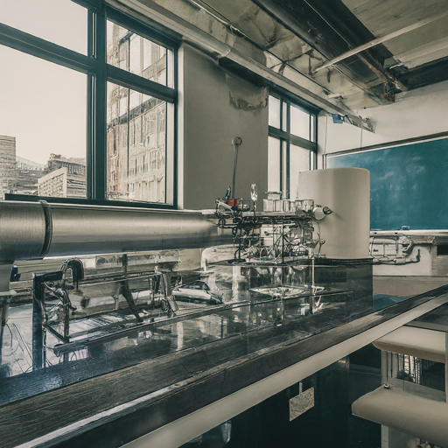

Figure 2. The fluid mechanics laboratory

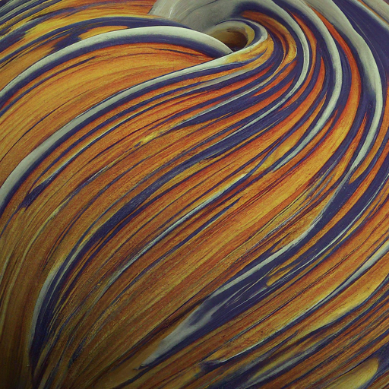

Figure 1. Flow visualisation.