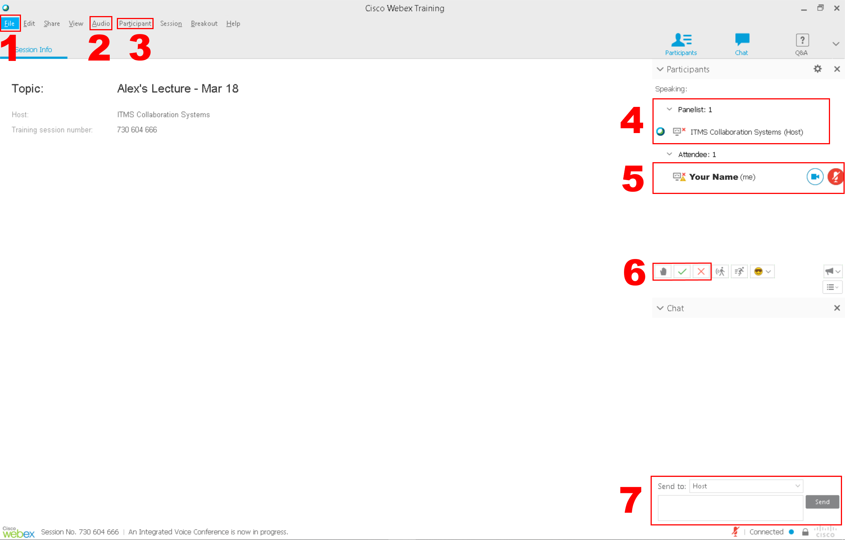
WebEx Training Interface for Students

- File – use “Leave Training Session” to exit the session and close WebEx Training
- Audio – click “Speaker/Microphone Audio Test…” to ensure audio devices are working properly
- Participant – Use “Mute” and “Unmute” if you have to speak or not (Only if lecturer has granted microphone privileges to students)
- Panelist – Name(s) of lecturer/presenter/TA
- Attendee – Names of those attending the session
- Interactive Feature
a. Raise Hand – Beeps the lecturer and indicates your hand is raised
b. Yes/No – Use the check (yes) and x (no) to respond to general questions from the lecturer
- Chat – Select “Send to” to choose who (Prof., TA, Presenter, etc) you want to message.

