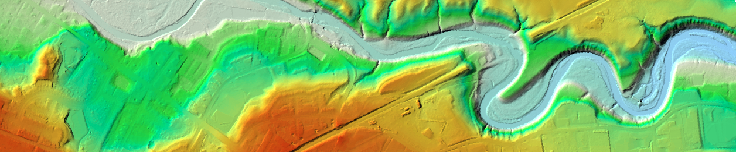
Pixel Editor: ArcPro raster modification tool


This tutorial is designed as a quick and light walk through of ArcPro’s Pixel Editor showing a common use case. Pixel Editor is designed to edit rasters much like image editing software but since it is within the confines of GIS software, it is able to edit discrete or continuous raster cells by value.
Pixel Editor is part of the Image Analysis suite of tools in ArcPro. It is a handy tool for modifying elevation rasters. Since, elevation is a key part of any environmental analysis preparing rasters has always been time consuming. One example of editing elevation is stream burning to remove bridges on DEM’s, DSM’s etc. Usually, a global function that was a bit unwieldy to run effectively. A “stream burned” DEM is created as part of the process for Watershed and Stream Network Delineation. It is a set of bridge burning algorithms. Having this type of DEM is very important because the data collecting sensors that create the cloud point data that the DEM is based on just ‘see’ the tops of bridges and represent them as changes in elevation. Thus, creating a block the virtual flow of rivers for various flow analysis like dynamic flood simulation (HEC-RAS) or flow accumulation.
Algorithmic Stream Burn issue or culvert compensation but in the wrong area North of the stream

Proper Stream burn

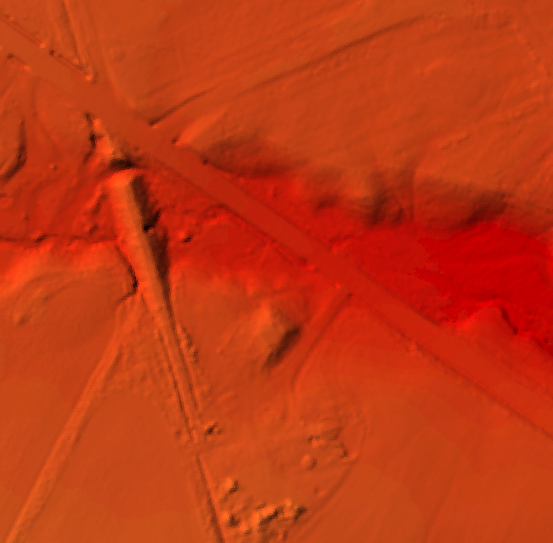
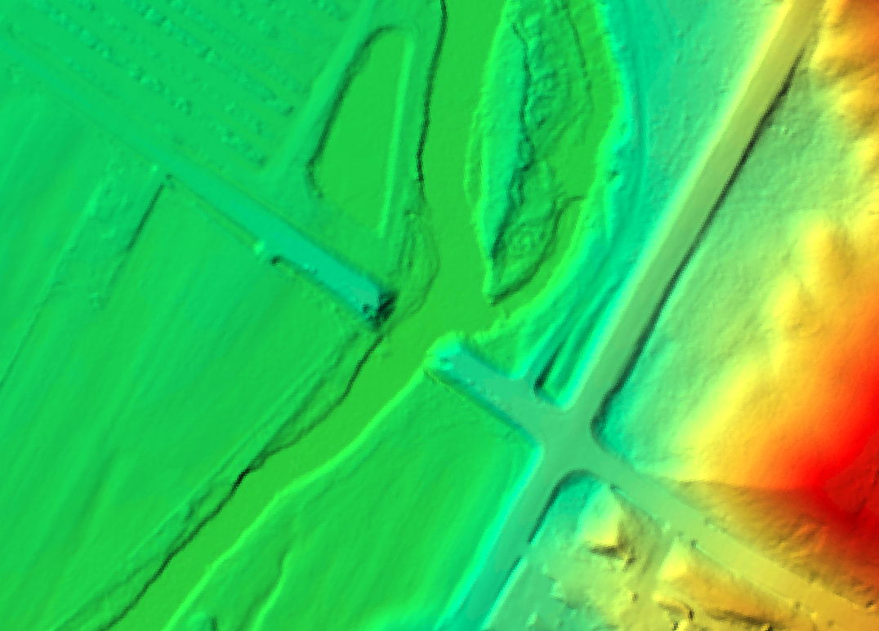

Other examples of elevation raster modification are leveling an area of land for a building envelope or creating low points in the terrain for flood water mitigation and testing with HEC-RAS dynamic flood simulation.
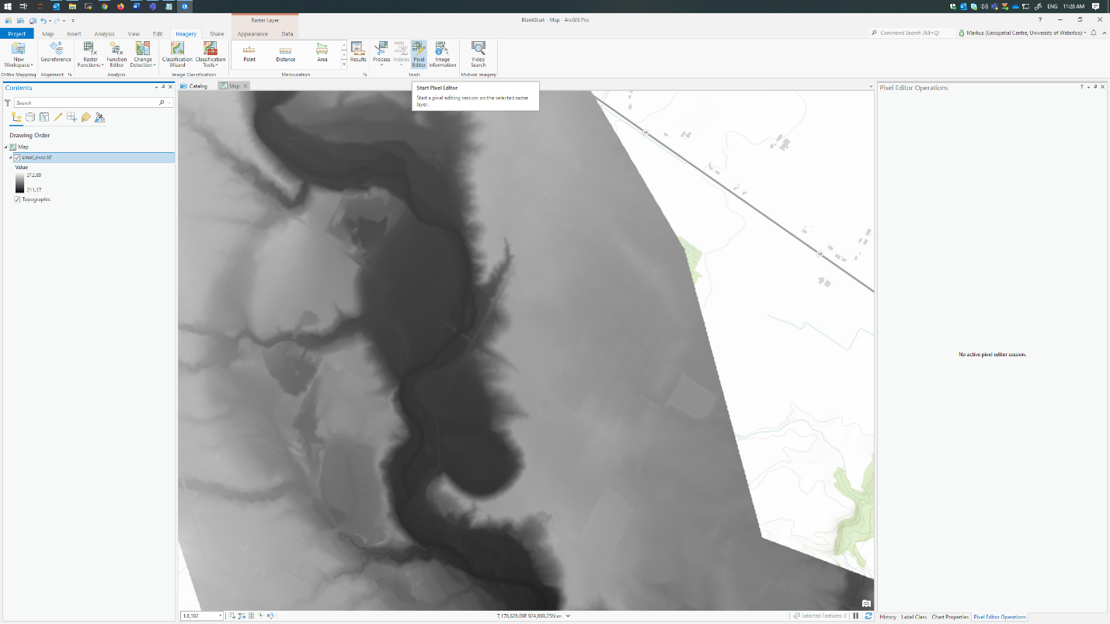

For example: “diging” a virtual trench or pond in the low lying (Green) flood plain near Georgetown to mitigate possible floodwaters. This may keep the crops, roads and building envelops from being affected by the dynamic flood models created to test mitigation hypothesis.
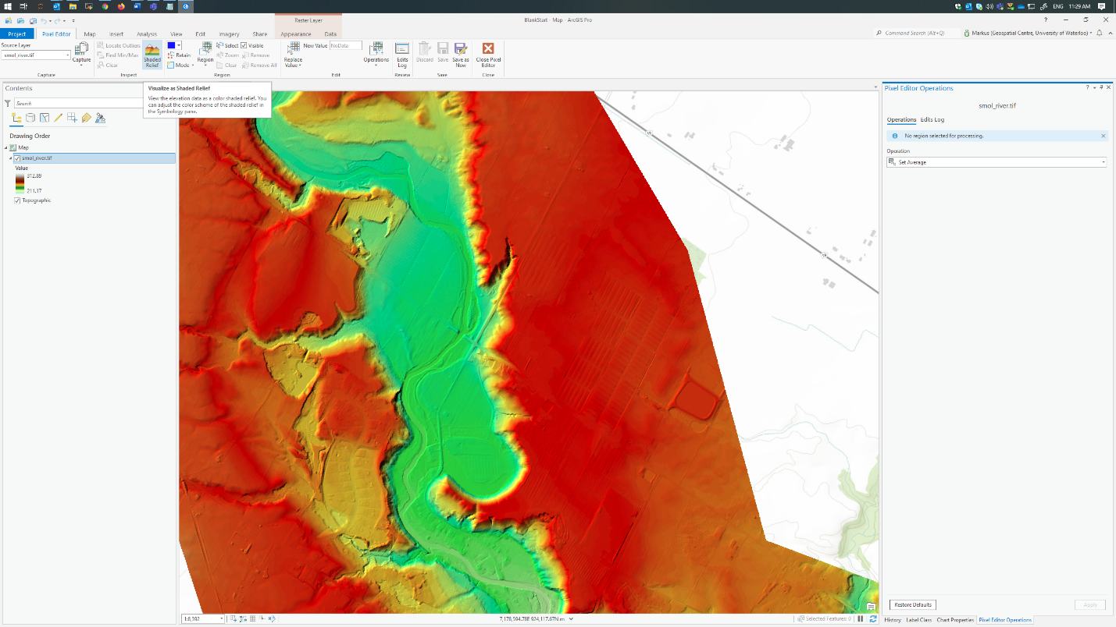

Areas of possible
concern:
Farm fields

Housing

Step 1: Import the image into ArcGIS Pro. You can drag and drop the image into ArcGIS Pro or use the Catalog pane to add it.
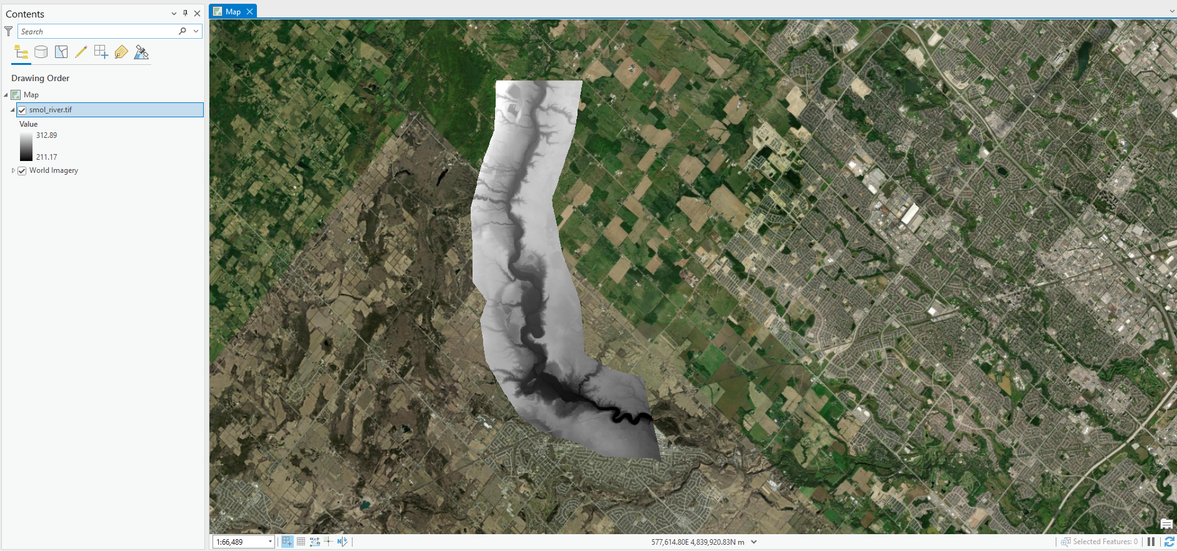
Step 2: Select image in Contents pane, Click Imagery tab, click Pixel Editor in the Tools section.
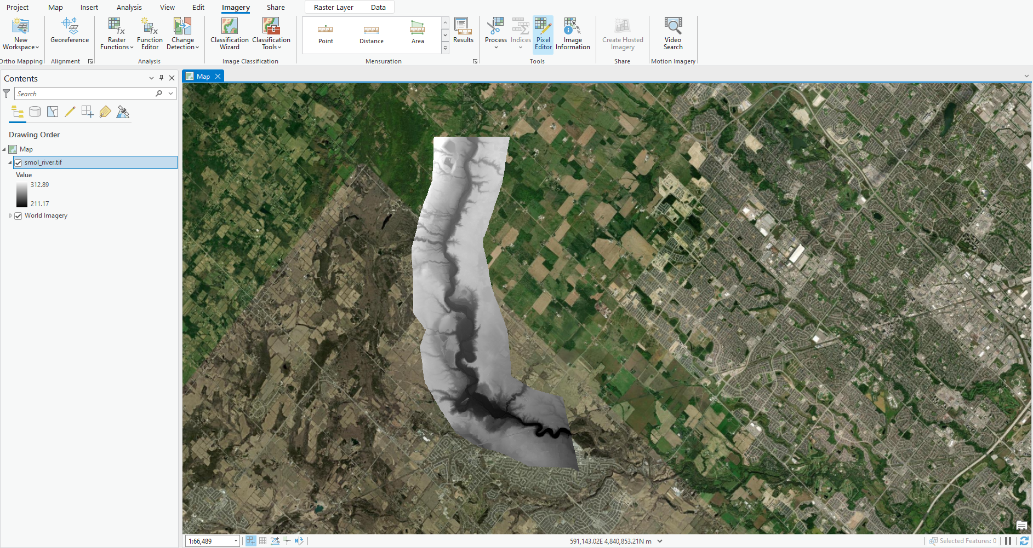

Step 3: In the Pixel Editor tab, click Shaded Relief. This will change the image symbology colour to make it easier to see the elevation changes. (Note: If you do not have the proper tools in the Pixel Editor, make sure that you Raster Source Type is either Generic or Elevation. You can do this by right clicking on your image in the Contents pane, click Properties, and check you Source type under Source -> Raster Information).
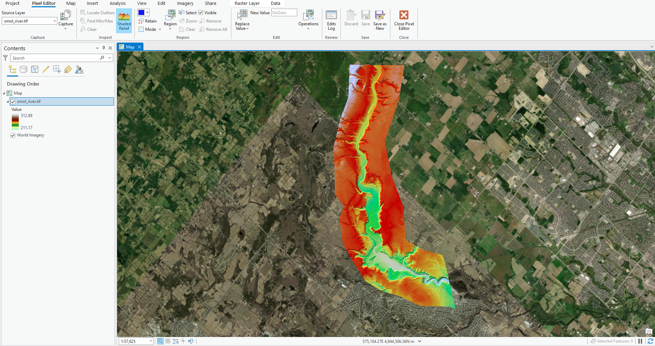
Step 4: Using the Region select tool in the Region section, select the area that you want to burn. You can use which ever select types works best for the area.
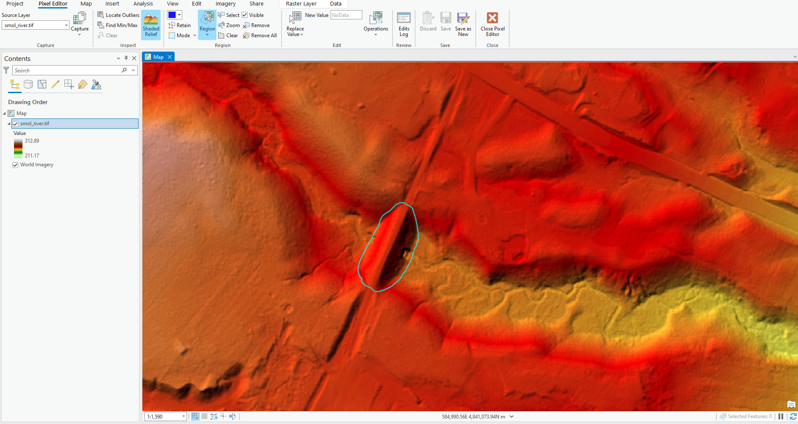

Step 5: Click Operations in the Edit section, select Interpolate from Edges. You do not need to change the default options.
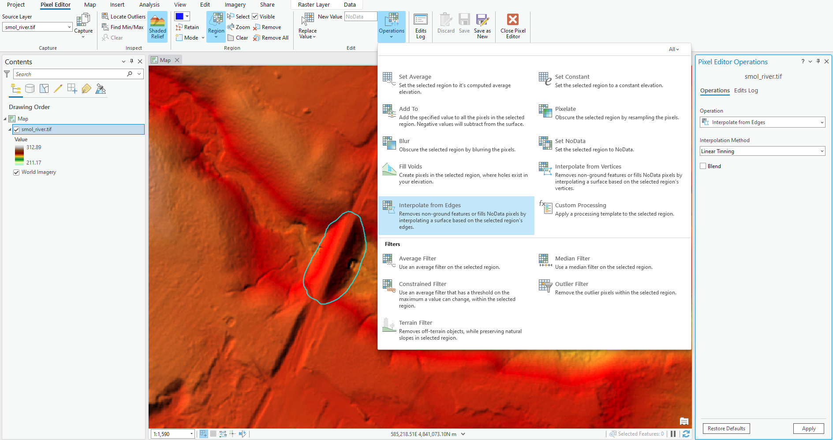

Step 5: While the area is still selected, open Operations again and select Terrain Filter. You do not need to change the default options.
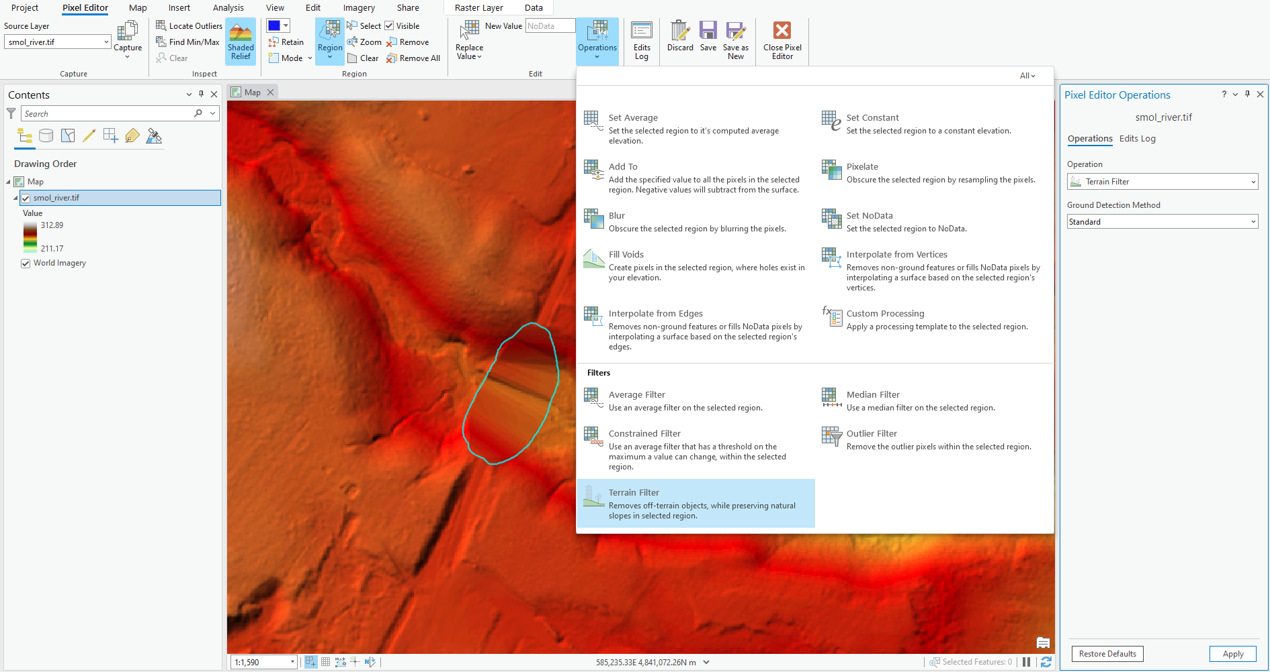

Step 6: Click Save in the Save section. If you close the Pixel Editor without saving, you will lose all changes. You can also use the Discard tool to reset the Image to the last save.
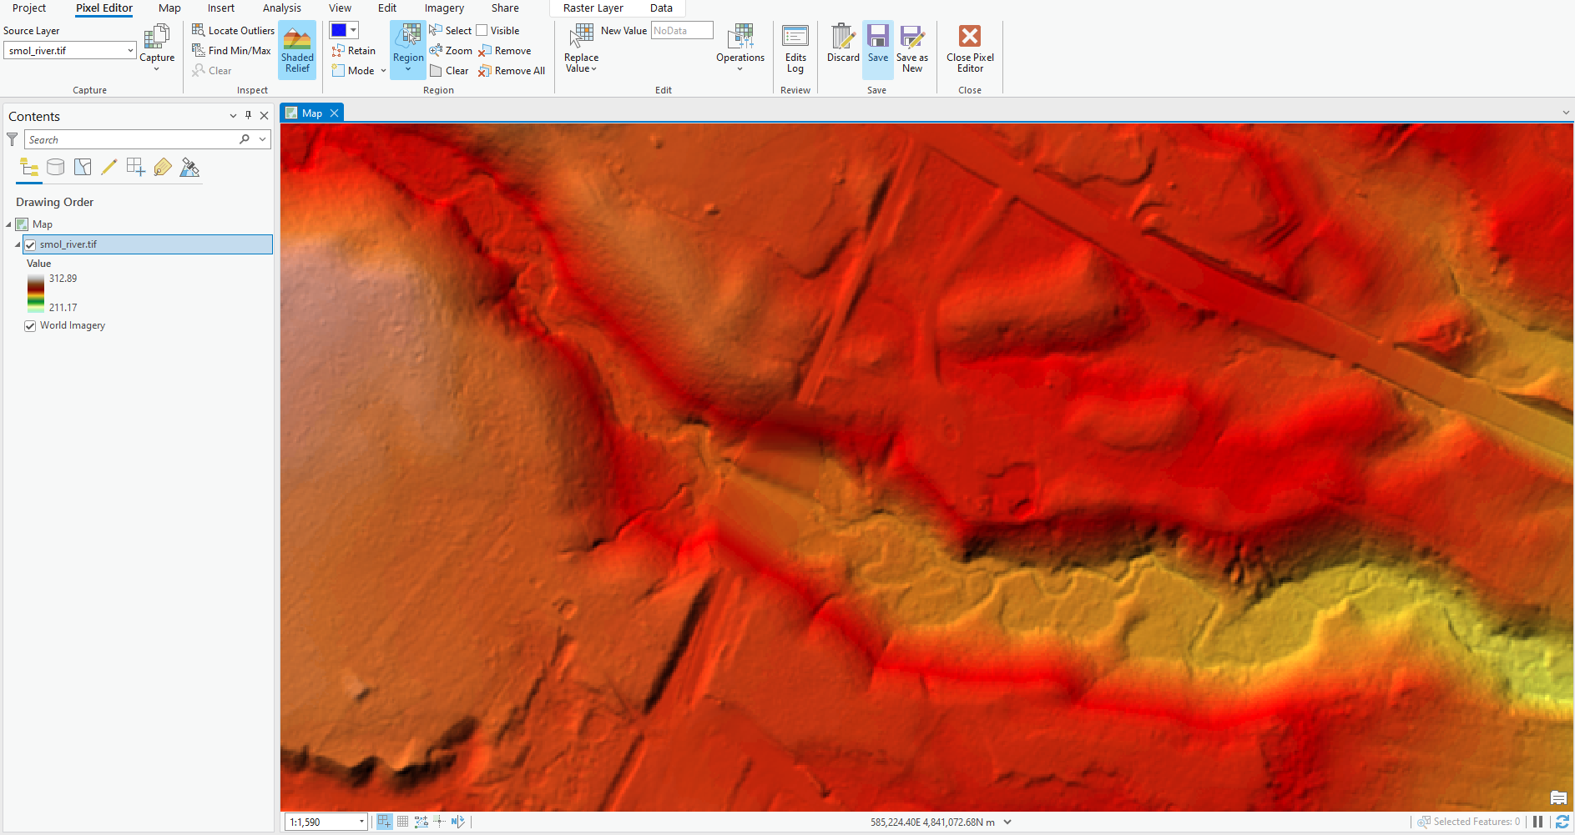

Before:
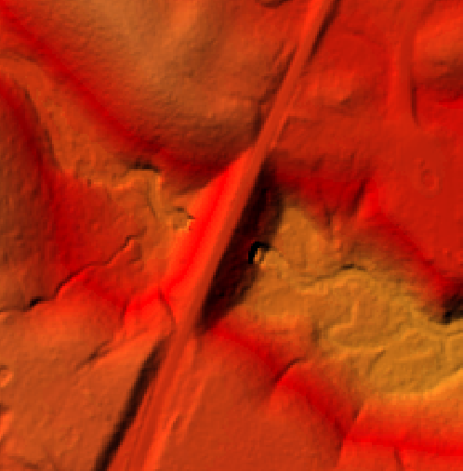
After:
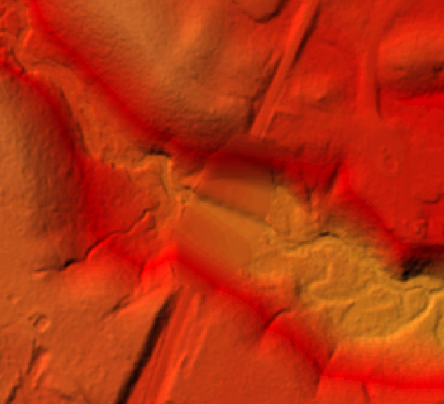

The tool has removed the road bridge and preserved the virtual elevation and slope by interpolating the new surface from the edges given in the DEM.
This tutorial covered a typical scenario for the Pixel Editor tool within the ArcPro suite. If you have any questions on learning more about ArcGIS and how to incorporate it into research, please contact us.
Contact Us
Geospatial Centre
Dana Porter Library, Room 328
University of Waterloo Library
Waterloo, Ontario N2L 3G1 (519) 888-4567 ext 32795
LibraryGEO@library.uwaterloo.ca

Updated August 6, 2024
Created by Markus Wieland and Mahd Ashfaq for the University of Waterloo Geospatial Centre

