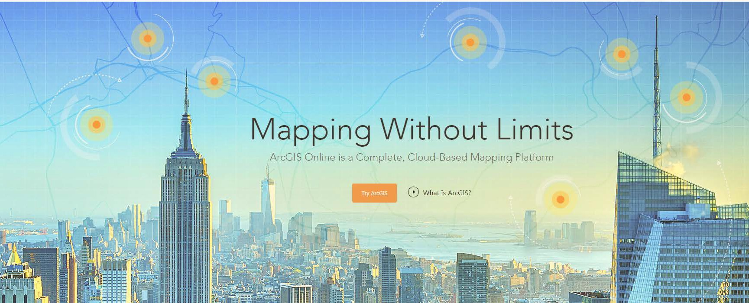
ArcGIS Online

Overview
ArcGIS Online is a web-based mapping and app-building site created by Esri, the world leader in GIS software. In an effort to empower users of all levels to create interactive maps and applications that are easy to share, Esri developed the ArcGIS Online platform to realize its vision. With both a free version for lay users and an organizational account for larger enterprises, the functionality is tailored to different mapping and application needs. Not only can users create custom maps using their own data, but they can also publish ready-to-use apps that make sharing the information easy and intuitive for their audience. This guide explores the capabilities that come with the free version, which is available to anyone with an Esri Global Account.

Setting Up
Although ArcGIS Online can be used without setting up an account, it also means not being able to save your maps and applications. For the purpose of this guide, we will set up a free Esri Global Account, which you can use to access not only ArcGIS Online but all of Esri’s training resources. Go to http://www.arcgis.com and click on Sign In at the top-right corner of the page. At the bottom left of the page, click on Create a Public Account and fill in the necessary info. Once you’ve created your account (which includes receiving a verification email), sign in to ArcGIS Online.

In this guide, we are going to learn how to use many features in ArcGIS Online including creating basic maps, adding in layers, changing the symbology of the layers and creating and sharing web applications. Once you have finished this tutorial, you should have a high understanding of the main functions of ArcGIS Online and be able to produce simple maps by using data available online through their server as well as learning how to upload and use your own data from multiple sources.

Getting Started
To begin, click on the Map tab along the top of the ArcGIS Online home screen. This will pull up a new blank map named My Map. Take a moment to become familiar with the different parts of your map. Next to the title is a dropdown menu for navigating through ArcGIS Online. In the top-right-hand corner of the page is a New Map button that opens a new blank map (you will be prompted to save your current map if it has any unsaved changes). Next to that is your account username with a dropdown menu for account settings. The left sidebar contains the Details of your map, including an About tab, a Content tab, and a Map Legend tab.

Along the top of the map are several buttons that allow you to do various things within your map. The Add button provides a dropdown menu with different options for adding data. The Basemap button allows you to choose from 10 different styles of map that will underlie your data (Topographic is the default).
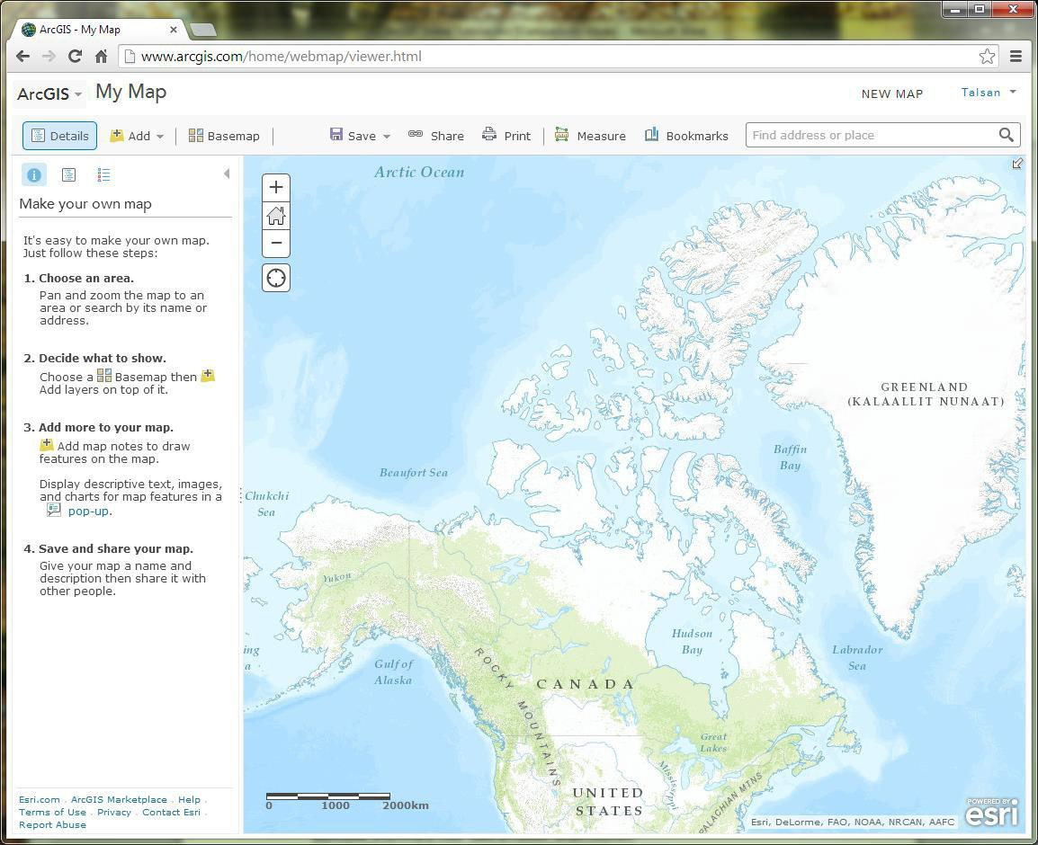

The Save button lets you save the map as you add features to it. Share pops up a dialog box giving various options for distributing your map. Print takes a snapshot of the map and its peripheral info that can then be printed. You can also get Directions from A to B and Measure distances, areas, or latitude-longitude coordinates. If there’s a certain place you want to be able to quickly return to on the map, create a Bookmark of that location, which records the extent and position of the map. In order to get to that place the first time, you may want to use the Search box to find an address or a place. Navigating the map is relatively easy: click and drag to Pan the map and Zoom In and Out using the scroll wheel on your mouse.

TUTORIAL BEGINS
Picking a Location
For this tutorial, you will be creating a map that displays various parks and popular tourist attractions located in Honolulu, Hawaii. Honolulu is the capital city of Hawaii and it is located on Oahu Island, which is one of the eight main islands in Hawaii. You will be using data primarily from the ArcGIS Online server and the City and County of Honolulu’s Open Data Catalogue (http://honolulu-cchnl.opendata.arcgis.com). You will also learn how to add additional features to your map.

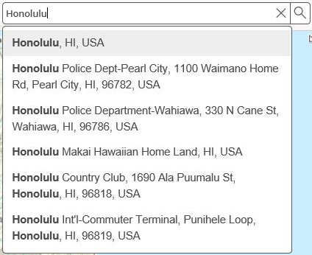
The first step in working with your map will be to choose a location to work in. For this guide, we will use Honolulu, Hawaii. In the Search box, begin typing Honolulu. Select the “Honolulu, HI, USA” option.

At this point, let us take a moment to Save the map and give it some information. Note that the map extent will also be saved, so make sure you are zoomed into Honolulu. The image below displays the map extent that covers the City of Honolulu.

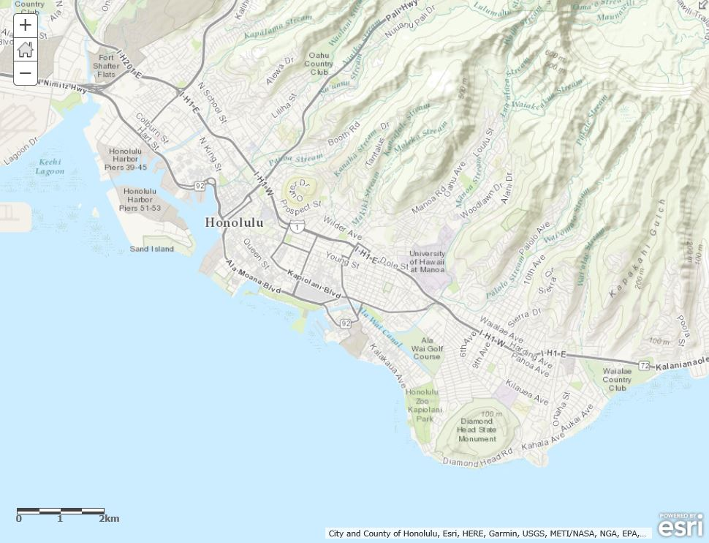

Click on either the Save or Save As option and name the map. You can use the information below to populate the fields or come up with your own Title (something short but descriptive), Tags (keywords that are used for searching purposes), and Summary (a brief description of what the map is or what it shows).
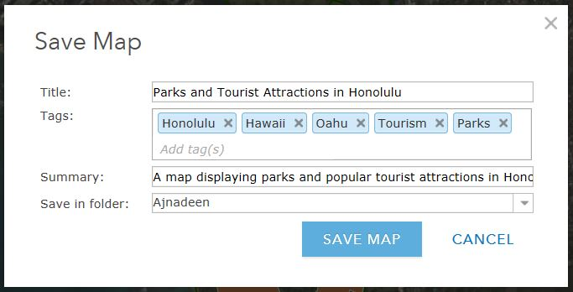

Creating New Data
Now that we have a location, we can start to add features to our map. To do this, we need to Add Map Notes, which function as editable layers in the map. Click the Add menu and choose Add Map Notes. This pops up a dialog box, which allows you to name your notes and choose from several different templates for different applications. For now, just keep the default settings and click Create.

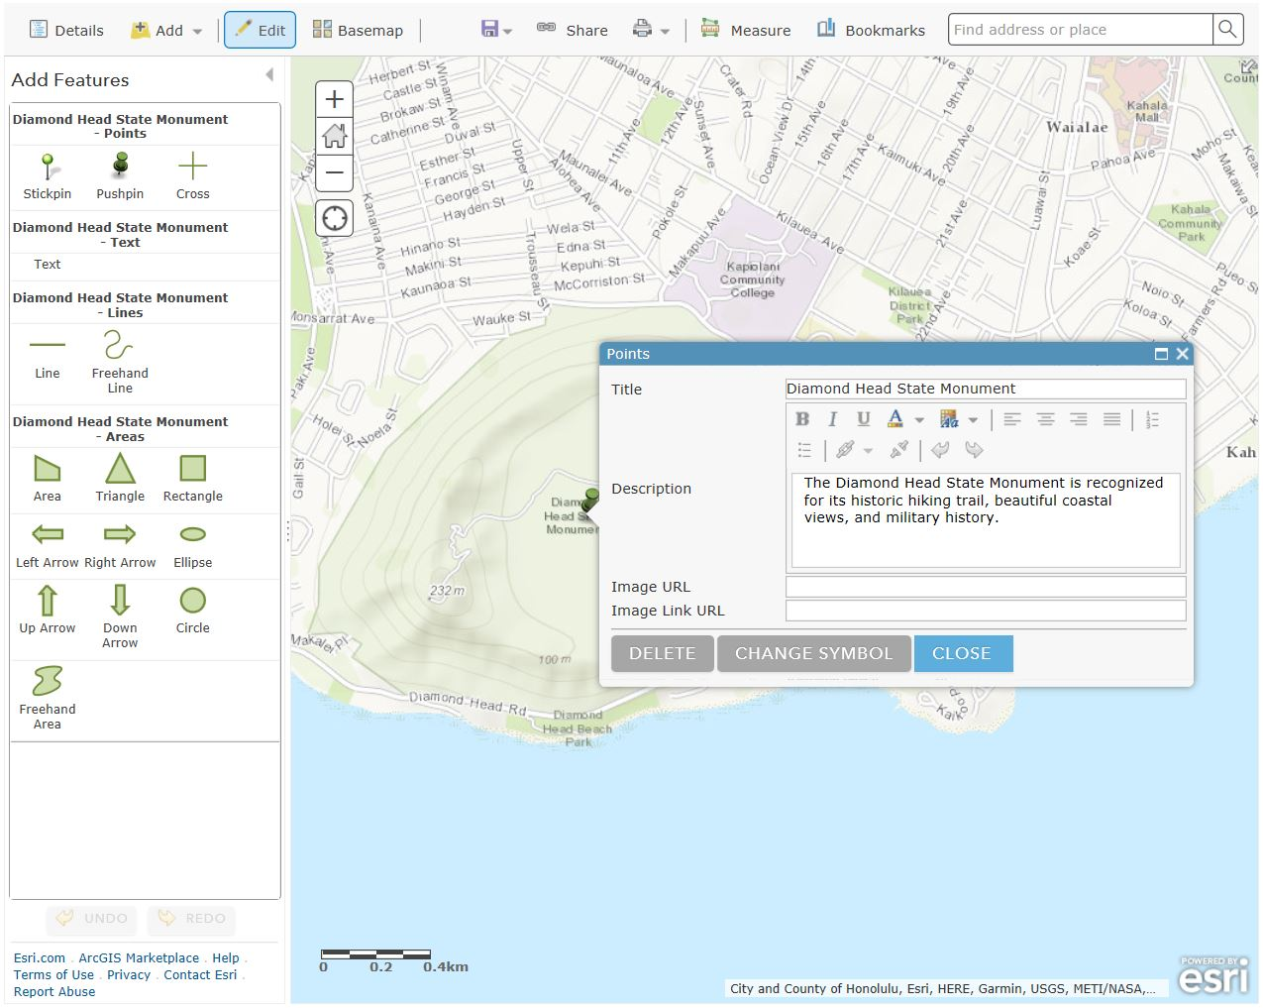
You will notice that the Details pane on the left automatically changes to Edit pane, which contains tools for creating four basic features. Points, Text, Lines, Areas. We will start by creating a point feature using the Pushpin. Click on the point tool, and then zoom into the Diamond Head State Monument. Click on the center of the Diamond Head State Monument to place your Pushpin marker. Name the point Diamond Head State Monument. You can either leave the description blank or fill it in with a brief overview about the site. If you want to change the appearance of your marker, click Change Symbol and choose from the various menu options and colors (these options would be good to explore for future reference).

There are numerous options for adding an Area (also known as a polygon), each of which you can experiment with, but probably the most commonly used tool is Area, which allows you to draw each vertex of your feature with a click of the mouse (double-click to finish your drawing and close the polygon). Choose this tool and draw an area around Honolulu Zoo.
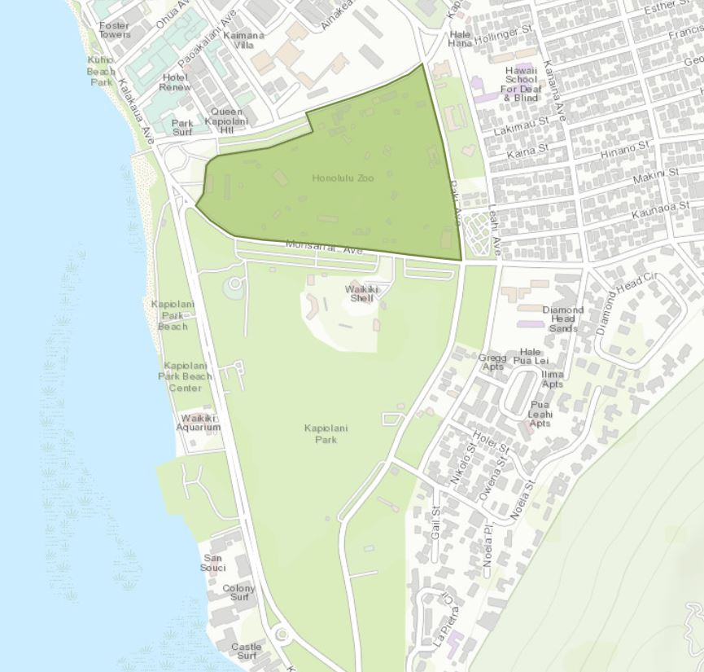

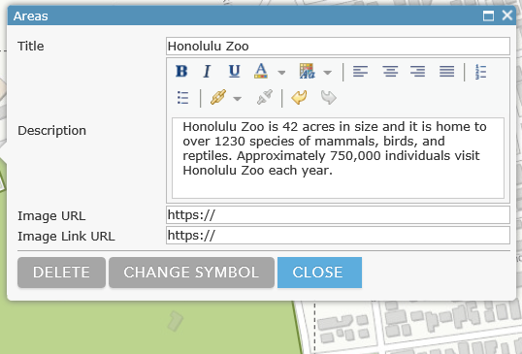
When the callout box appears after you have created the area, enter the information as seen below.

Next, we will add a path using a Line feature. There are two options for this: Line and Freehand Line. The former lets you draw each vertex with a click of the mouse; the latter requires you to click and hold while you draw your segment freehand. Choose one of these options and draw a path from the Kapiolani Community College to Ala Wai Golf Course (you can draw the route any way you please, as long as you follow established roadways/pathways in Honolulu). Name the path Kapiolani Community College to Ala Wai Golf Course and click Close.
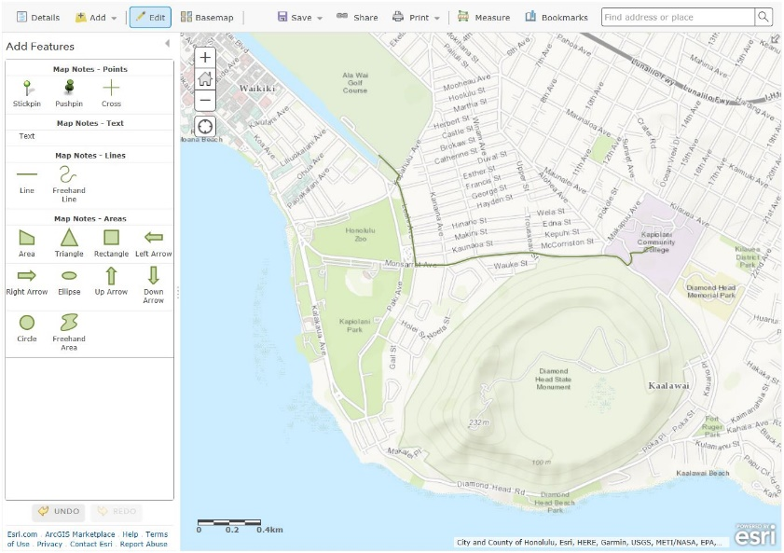

As with the point marker, you can change the symbol for any of the features you create. Since the features we have created so far have a space for Name and Description, we will not cover the Text feature. However, if you simply wanted to add a Text note to your map, this would be a useful tool.

Adding Pre-existing Data
With the Map Notes, we created our own data layers right inside the map. However, sometimes the data you need already exists. ArcGIS Online has several ways of adding data to your map. The easiest way is to search for data from the Add menu. Click on Add and choose Search for Layers. In the search box, type in Honolulu Parks in “Find” under “In: ArcGIS Online” and then hit enter. Look for the file label Parks and add the Parks onto your map and click Done Adding Layers below the results list.
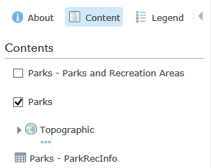
Two layers and a table are added to your map. The two layers symbolize the same information in different ways. Leave the Parks layer on and turn off the Parks – Parks and Recreation Areas layer.
You can adjust the way in which the parks are symbolized by going to Contents, and hovering your mouse over Parks where five icons will appear under it.

Shows Legend Change Style More Options
Show Table Filter
Select the Change Style icon. Under “Choose an Attribute to Show,” leave the option to “Show location only.” Under “Select a drawing style,” click “Options.” Click on Symbols, and the pop-up window enables you to change the color of the symbol, the transparency, size, and pattern.
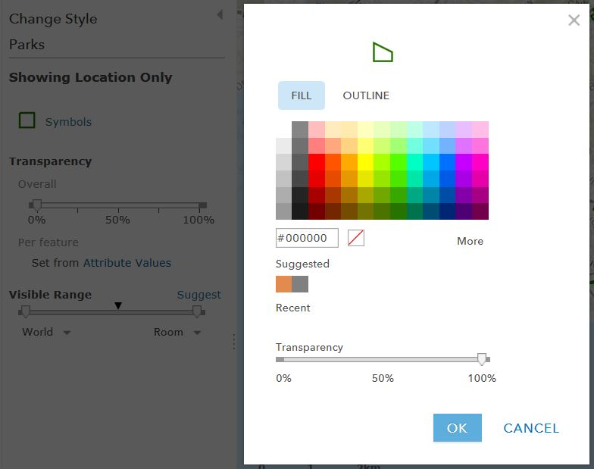

Show legend will drag down a legend of that specific attribute.
Show table will open up the attribute table.
Change Style enables you to customize the symbol.
Filter allows to you filter out specific features you want to show on the map.
More Options contains more useful tools that will be described later in this tutorial.

Another method for adding data is through a hosted web service. Click on the Add dropdown menu and choose Add Layer from Web. In the dialog box, enter the following URL:
https://geodata.hawaii.gov/arcgis/rest/services/SoH_Imagery/WV2_2016/MapServer.
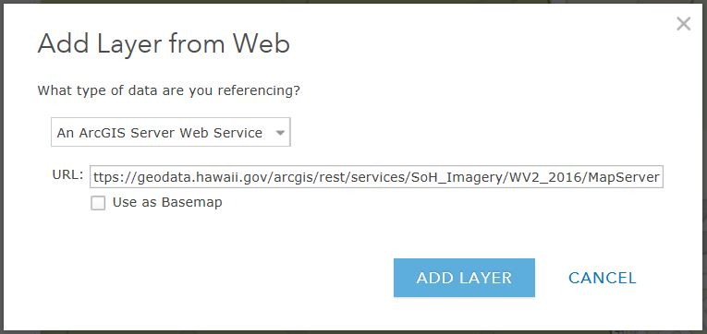

You should then click Add Layer. This imagery service is provided by the State of Hawaii. Please note that due to copyright restrictions on this layer, you can only view it up to a certain view level – once you have zoomed too far, it will stop drawing.

The final method of adding data is to Add Layer from File, which uses your own locally stored data files. There are several file types you can upload: Esri Shapefiles (in zipped format); comma, semi-colon, or tab delimited text files (CSV or TXT); and GPS Exchange Format (GPX); each allows you to upload a maximum of 1000 features.

Note: If you would like to explore the Add Layer from File function another time, you can move ahead to Customizing Your Layers on page 10.

Uploading Data Files
For this section, we are going to utilize the City and County of Honolulu’s Open Data Catalogue, which features datasets available to the public for general use (see the Open Data City and County of Honolulu User Licence for details). To access the data, go to the following link:
http://honolulu-cchnl.opendata.arcgis.com/.

Shapefiles
We’ll begin with one of the most common geospatial data formats, the Shapefile (.shp). Although the shapefile format was created by Esri, it can be read by virtually any GIS program, including some programs that aren’t primarily intended for GIS such as AutoDesk’s drafting software AutoCAD.

In ArcGIS Online, shapefiles need to be uploaded in zipped format in order to be read properly. This is due to the fact that a shapefile (singular) is actually made up of several different files (plural) all with the same name but different file extensions. By itself, the .shp file is incomplete.

In the City and County of Honolulu website (http://honolulu-cchnl.opendata.arcgis.com), select the Parks and Recreation data category. Scroll, if necessary, to the Regional Parks layer and click on it. The Regional Parks layer displays the location of all the Regional Parks that are on Oahu Island. The data viewer lets you preview the data on the map in spatial format (Details), in tabular format (Table), and plotted format (Charts). In the right corner under the viewer, click the Download Dataset dropdown and select Shapefile. The file is delivered in zipped (.zip) format.
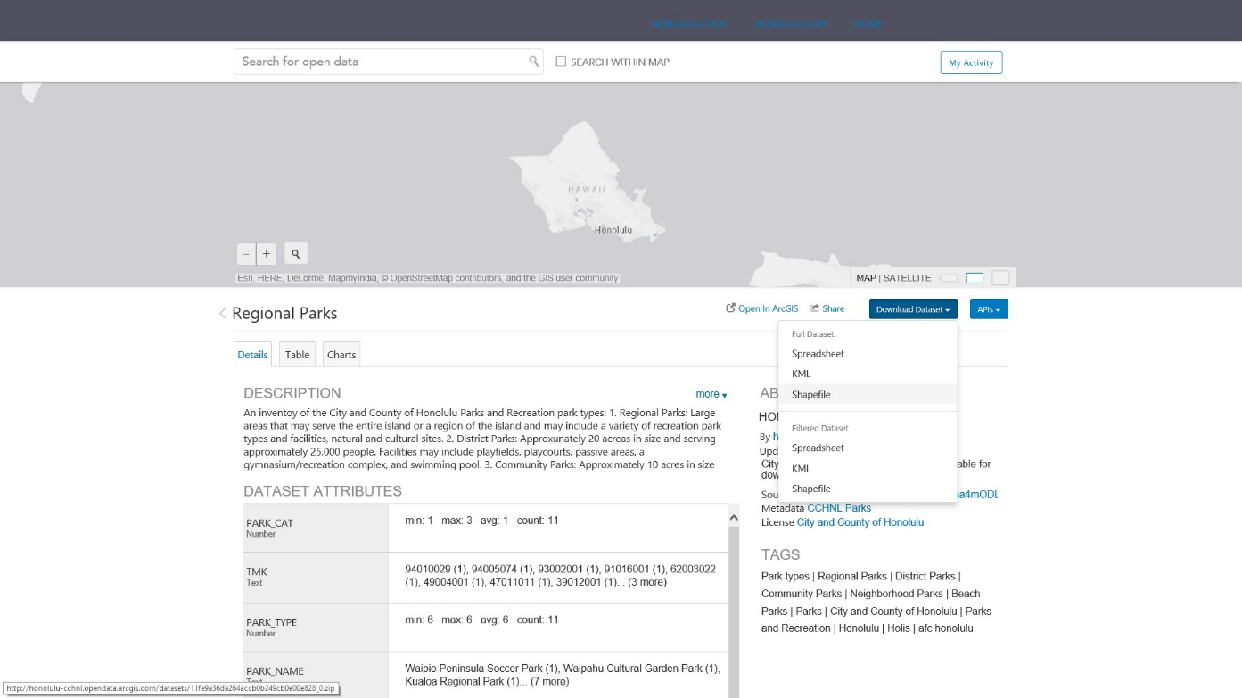
From the Add menu, choose Add Layer from File and use the Choose File button to upload the Regional_Parks.zip file you just downloaded. Accept the default selection to Generalize features for web display and then click Import Layer. The newly imported layer is now visible in the Contents pane as well as on the map (you may need to zoom out or pan the map to see the features). You can click on a Regional Park feature to reveal a pop-up window with more information about that park.
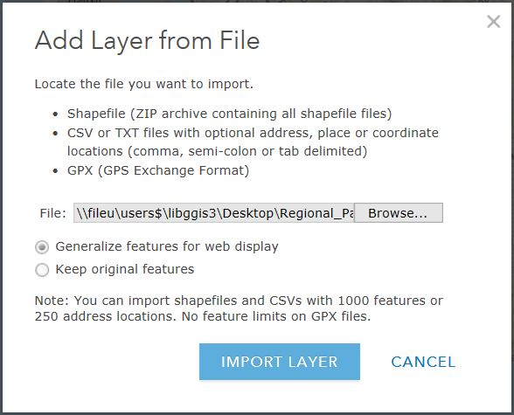

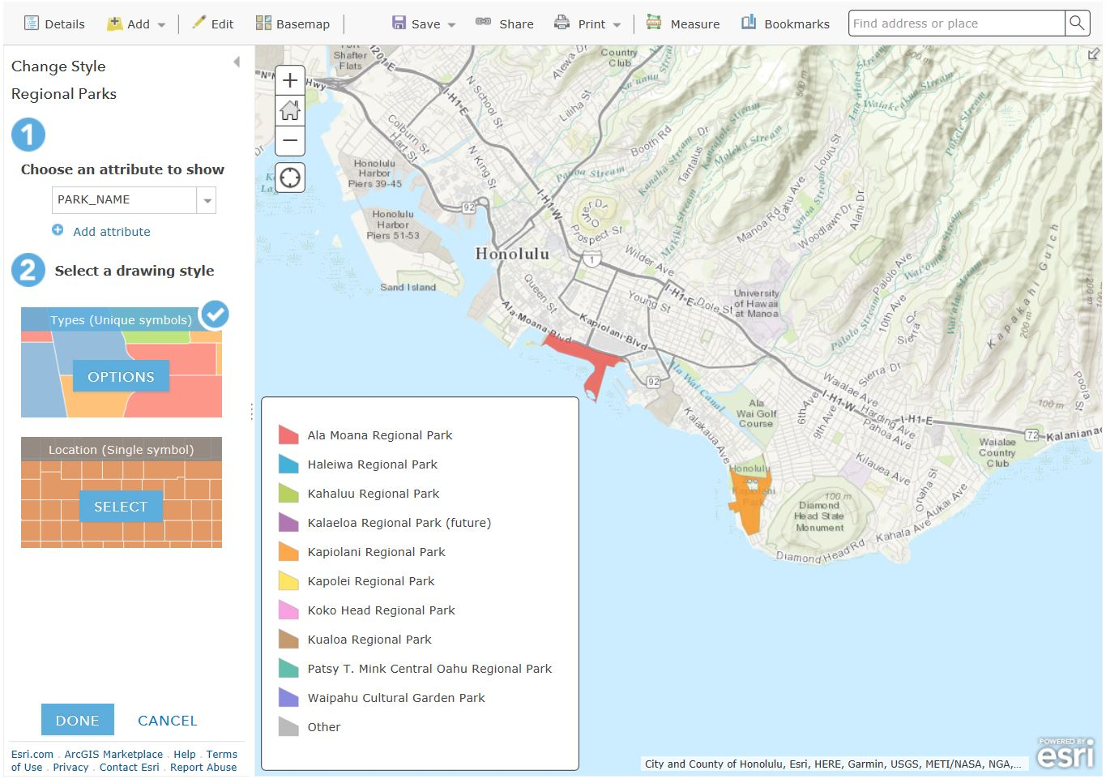
After uploading the file, options to change the style of the Regional Park features appear in the content panel. First, select an attribute to display. Select PARK_NAME. By selecting this, your map will represent the names of the various Regional Parks that are located on Oahu Island. The regional parks will be represented using different features (ex. Colour, linewidth, types). Next, select the drawing style. Select the first option, Types (Unique symbols). Your map should look similar to the one below.

The various coloured polygons represent different regional parks. Take a notice at the legend located at the bottom left corner. As can be seen by looking at the map, Ala Moana Regional Park and Kapiolani Regional Park are located in Honolulu.

Tab Delimited Files
As you may have noted while adding the Regional Parks shapefile, one of the options under export is exporting data to CSV (Comma Separated Values) file format. When formatted correctly, CSV and TXT files provide tabular information that can be plotted by either physical address or geographic coordinates (i.e. latitude-longitude, or lat-long).
Once again, go to the Data Catalogue on the City and County of Honolulu website (http://honolulu-cchnl.opendata.arcgis.com) and search for the Universities layer. Click on it. Make sure the file type is set to Spreadsheet (Table) and download the file. With CSV and TXT files, you can use the standard Add Layer from File method or you can simply drag and drop the file on the map (be sure to drop it on the map and not the Contents pane).
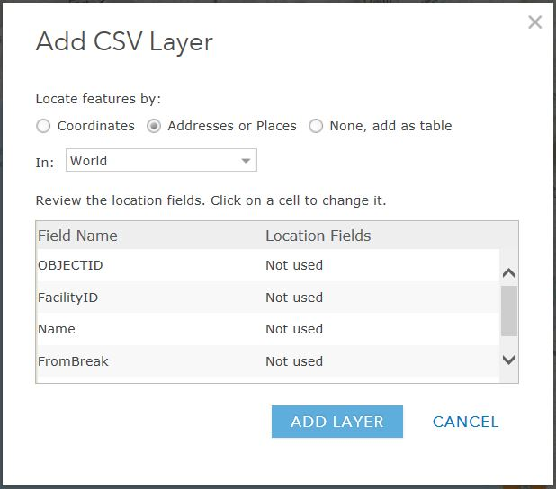
Note: If lat-long data is automatically detected in a file (column names may prevent ArcGIS Online from recognizing those fields), ArcGIS Online will automatically plot the points using those locations. However, if the location data is stored as addresses, you will be prompted to set up the geocoding parameters, which includes choosing a Country and assigning Field Names to the appropriate data type (i.e. Address, City, Postal, etc.). The United States Address Locator is a sophisticated geocoder built by Esri and is especially useful if your list contains addresses from more than one country. The dialog for setting up geocoding is shown below and acts much like the other Add Layer from File options.

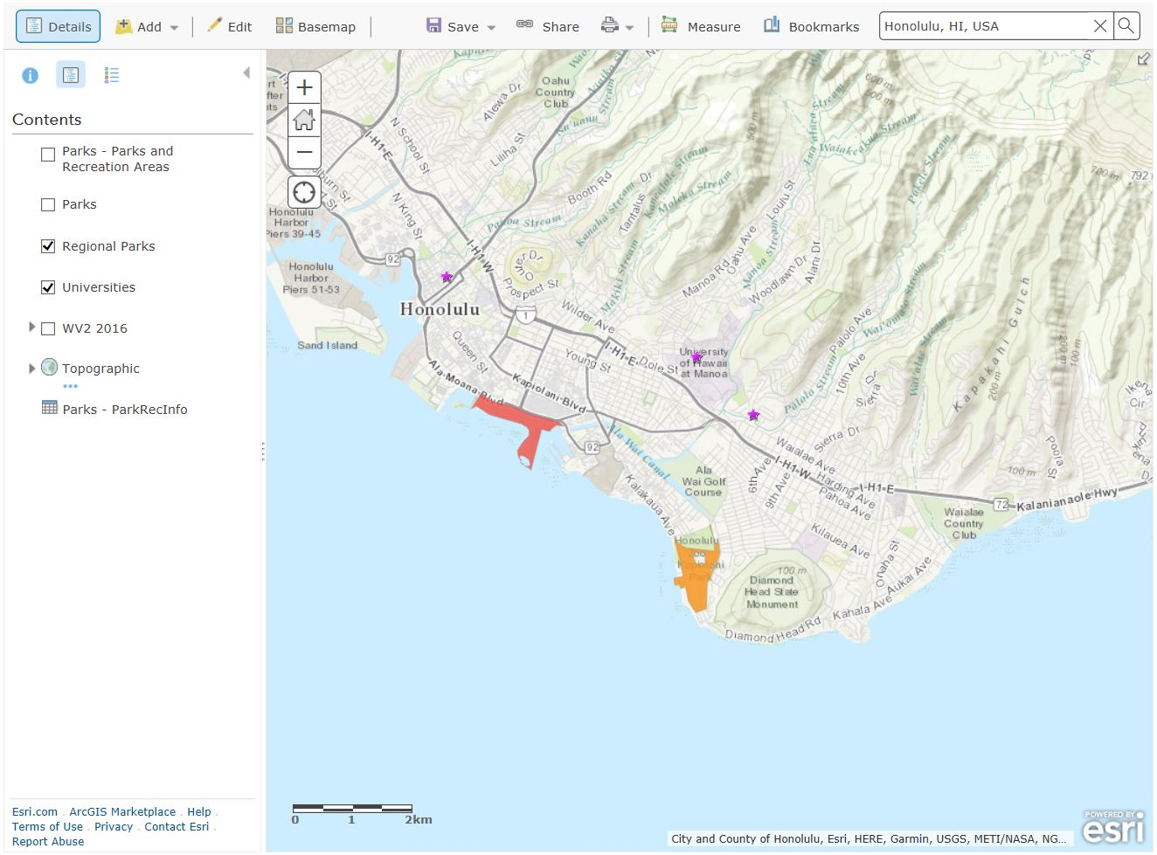
After the CSV file has been imported, your map will look like the image below. Select the attribute to show location only and the drawing style to Location (single symbol). The purple stars seen on the map are the various universities located in Honolulu. You may change the feature, such as symbol (color, fill, outline), transparency and visible range by clicking on “options” in the Location (single symbol) tab.

KML Files
Although they are not mentioned in the Add Layer from File dialog, KML files can also be added to ArcGIS Online and used in your maps. This popular file format (Keyhole Markup Language) was created by Google and is used in their popular Google Earth application. The City and County of Honolulu’s Open Data Catalogue offers their data in KML format.

From the City and County of Honolulu’s Open Data Catalogue (http://honolulu-cchnl.opendata.arcgis.com), search Existing Bike Facilities and download the dataset as a KML file. From your map window, go to the ArcGIS dropdown menu (may also say Home) in the top-left corner and choose My Content. On this page, you’ll see all the items you create in ArcGIS Online. Above the list of items, click on + Add Item and browse to the Existing_Bike_Facilities.kml file you just extracted.

From your map window, go to the ArcGIS dropdown menu (may also say Home) in the top-left corner and choose My Content. On this page, you’ll see all the items you create in ArcGIS Online. Above the list of items, click on + Add Item and browse to your KML file you just extracted. The Add Item dialog also requires you to add Tags to your new item, which helps your item get found in searches. Type the words Honolulu and Bike Facilities in the box (use the Tab key to add additional tags) and click Add Item.

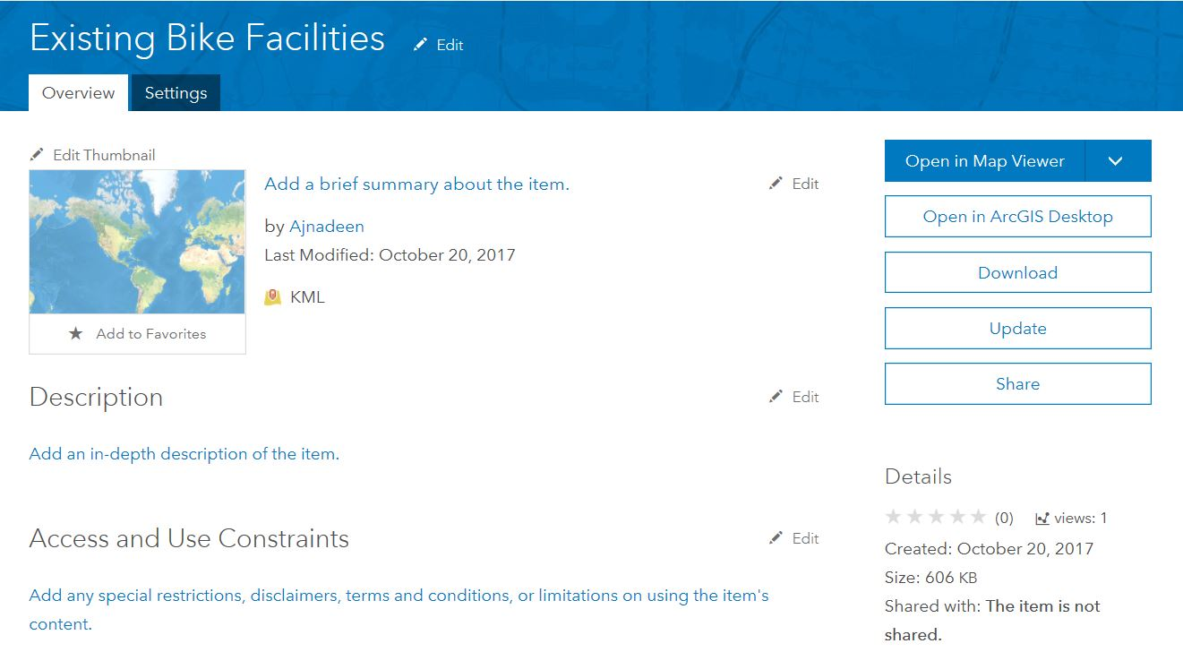
Once the KML has finished uploading, the item description page will appear showing the details of your newly added layer.

Before you can add the KML file to your map, you will need to share it with the public. Under the thumbnail image, click Share, then check the box to Share the item(s) with: Everyone (public) and click OK.
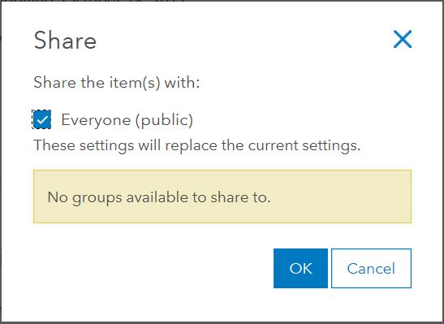

Click on the image at the top of the page to go back to the My Content page where you will now see your Existing Bike Facilities layer listed in the Content Table.

*Note: Another way of importing such data is through Search by Layer. You can search your desired layer and click ADD*

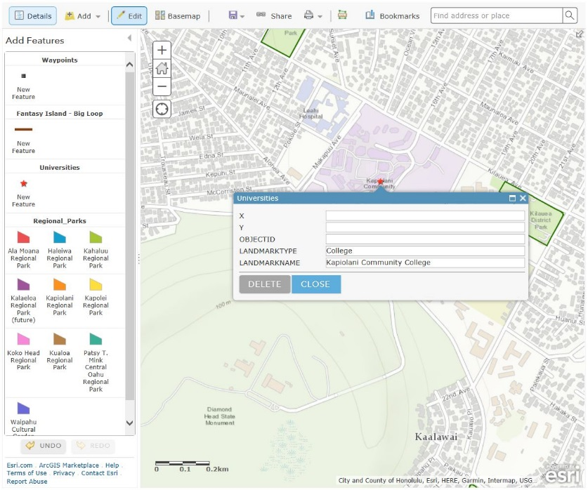
Editing and viewing attribute information
Turn off all the layers except for the Universities and the WV2 2016 layers. Let’s add 2-3 colleges to the Universities layer. Click on the Edit tab. Choose the feature you want to edit; in our case, it would be Universities. Locate a few colleges in Honolulu and add a point on the map. You can use the WV2 2016 layer to help you find the colleges located in Honolulu. Upon adding the new features, make sure that you label the LANDMARKTYPE as “College” and the LANDMARKNAME as the college name (example pictured). Leave the rest blank. Once you have added a few colleges, rename the layer to Universities and Colleges.

Customizing Your Layers
Under the Contents tab of your map’s Details, you should now see a number of different layers and a basemap (Topographic). You will also notice that to the right of each item is 3 blue dots. Clicking the arrow reveals a dropdown menu showing the various actions you can perform on a given layer. Click the arrow next to one of the layers and you will see options such as Zoom to, Transparency, Set Visibility Range, and so forth. The options vary by layer, so what can be done with one layer may not be possible with another.

Let’s use some of the menu options to tidy things up a bit. First, rename WV2 2016 to Oahu Aerial 2016. Finally, change the Transparency of the Oahu Aerial 2016 layer to 50%. You can also optionally remove the event types (layers) that aren’t being used.

One last customization we’ll perform is Set Visibility Range. This allows you to control which layers are visible at various zoom levels. Since the aerial imagery is of little use when zoomed out too far to see much detail, we’ll set the visibility range so it doesn’t show past a certain extent. Click on the menu next to Oahu Aerial 2016 and hover over Set Visibility Range. Change the dropdown for In closer than: to 1:40,000 (Town). Now zoom out on the map until the aerial imagery disappears. Notice how much easier it is to read the map at this scale when the aerials are hidden from view.

Note: ArcGIS Online also has tools that can be used to Perform Analysis on the data you add or create. This functionality is only available on layers where editing has been enabled. Where editing has been disabled (as is the case with Canada Median Age), Perform Analysis will not be an option in the dropdown menu. However, you can still customize the pop-up information on such layers by using the Configure Pop-up option in the menu. Because this guide is intended as an overview of ArcGIS Online, we won’t cover the Perform Analysis or Configure Pop-up tools. Nevertheless, feel free to explore these options on your own to see what the possibilities are for you and your data.

Accessing the Attribute Table
Behind each piece of spatial data there is tabular information. Often times this information can be very useful to determine what an ambiguous dataset can be used for, or give you an insight as to what types of analysis you can do with a dataset. For example, a set of address points may also contain information about the type of building it is.

To view the attribute table of a layer, there is a table icon under the layer title. Click on it to reveal the attribute table.
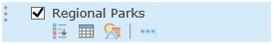

You can then sort the table based on different columns. Record what entries show up at the top and bottom of the list when you sort the table by each column name.

Sharing Your Map
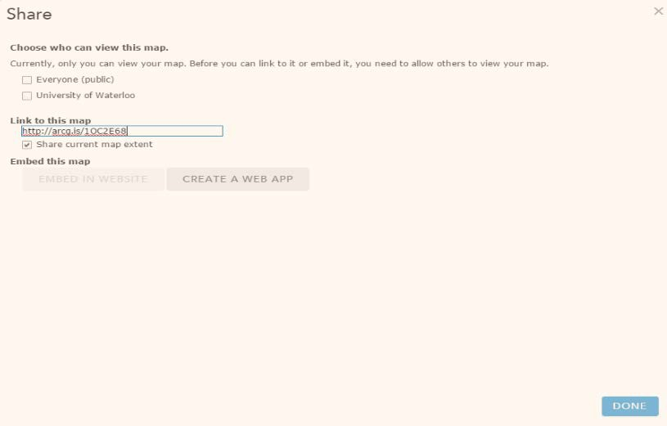

Up to this point, your map has been saved to your free ArcGIS Online public account. However, since only you have access to this account, you’ll need to Share your map for others to see it. Sharing a map can be done from many different places on the site as well as in many different ways.

You can share directly from the map by saving the most current changes and then clicking Share. You can also share your map from the My Content page or the Web Map details page. After checking the box to share with Everyone (public), the link to your map will be accessible to anyone you share it with.

Besides linking to and posting through social media, you can also Embed in Website and Make a Web Application. The option to embed the map in a website provides you with simple configurations that are incorporated into the HTML code seen inside the text box. You then copy and paste that code to embed it in a website.

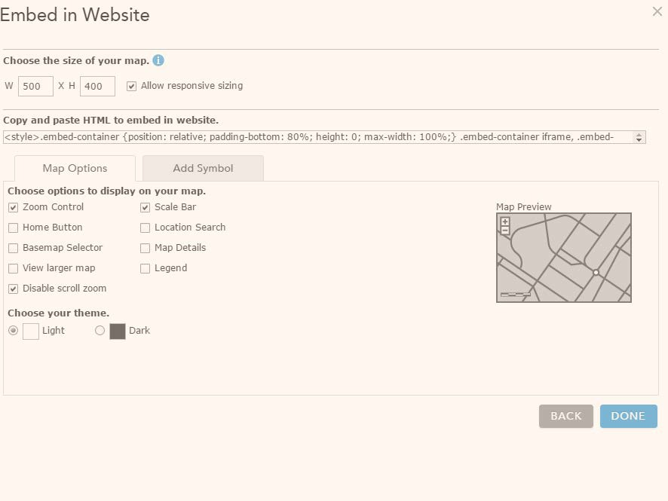

The option to Make a Web Application is slightly more involved, but still relatively easy to set up. Click this option to open the dialog box, which features numerous templates for publishing your map as a web application. Click on the thumbnail images and it will give you a brief description of what the template is used for.

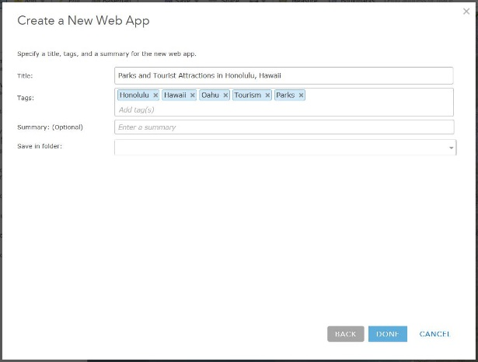
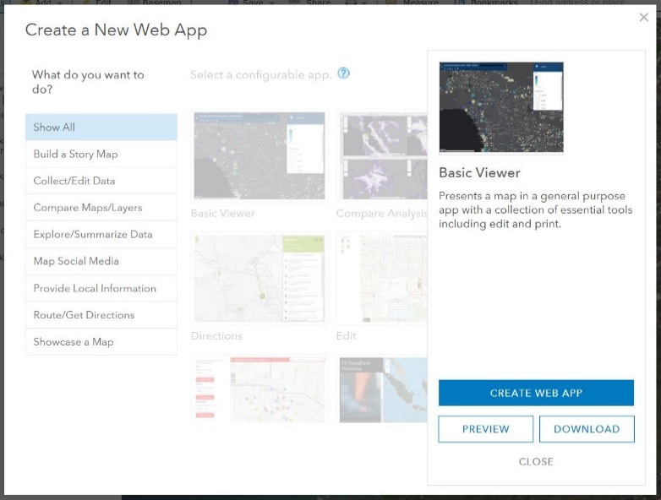
For this map, we will use the Basic Viewer template as a way to share our web map outside of the ArcGIS Online viewer where we created it. Select Create App and then enter the information for your web application as seen below, and then click Done.

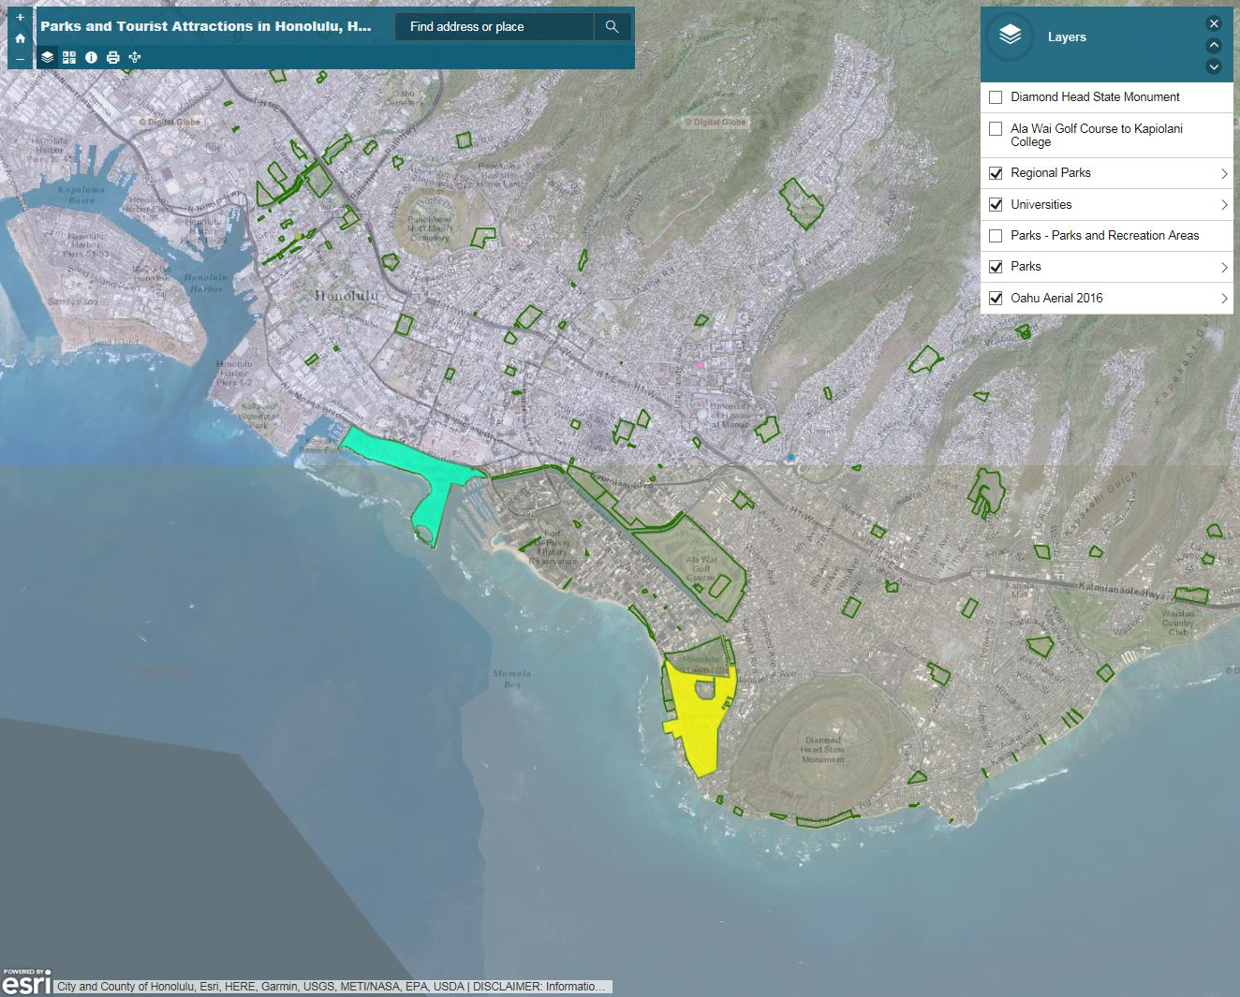
At this point, some important information appears on the screen. Although the web map was shared, the web application is not yet shared. Therefore, you will want to Save and View Item so you can share the web application.

Open the application to see what you’ve created. If you want to make changes to the default settings, go through the tabs on the left to adjust general, theme, splash screen, toolbar, and other settings.

If you are looking to show two different maps for your web application, you may wish to look into using the “Compare Analysis” under the Compare Maps/Layer web app. This web application allows you to compare up to four different web maps you have created. This is useful if you want to display different pathways you have created but do not want all the pathways on the one map, giving a cleaner end result.

Start by creating a new map and importing the Oahu 2016 orthophoto (The layer from Web). Create a new path using the Map Notes feature that differs from the path you previously created, but still starts and ends at the same locations. Set your basemap to be the same as your first map and save your map to My Content. Now that we have two maps created, we can create a comparison web app. Click the Share button on the new map you just created and create a web application.

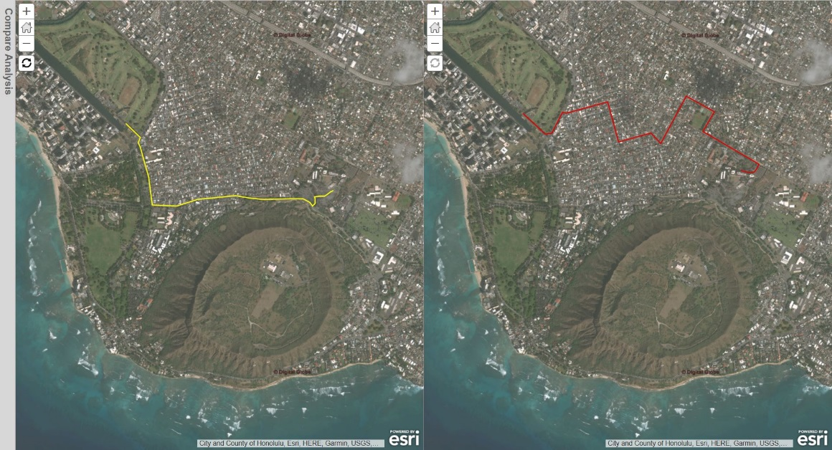
Choose the “Compare Analysis” web app and have your two maps displayed. Enter a description describing the differences between the two paths in the Description box and click Save at the bottom of the right hand sidebar. Your changes will appear instantly, showing the two maps side by side.

Crowdsourcing with ArcGIS Online
One of the great things that ArcGIS Online offers is the ability for multiple users to contribute spatial data to a public space. Unfortunately, with the free account we cannot create our own crowdsourcing layer (publishing an editable hosted layer is only available to organizational accounts), but we can use an existing layer to demonstrate.

Create a new map and search for the layer “WhatsNearby”. Add this to your new map and save it as ‘Crowdsourcing’. Now that we have a map with an editable layer in it, we can create a crowdsourcing form/app. Create a web app, but this time choose the GeoForm option (Scroll down). Choose the WhatsNearby layer as the editable layer. The default input settings are dropdown (“select”) menus and text, but you may wish to use the other options they give you.
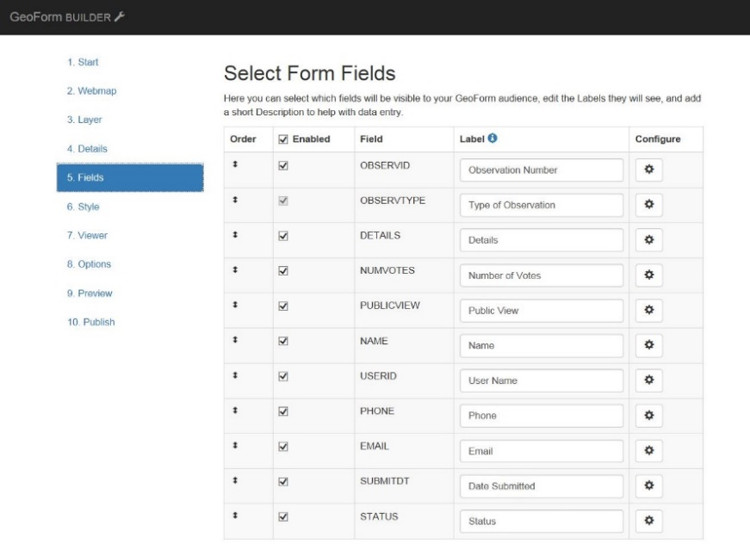

Fields such as OBSERVID, NUMVOTES, and USERID can be left out for this tutorial, as the field names are not descriptive enough for us to enter correct information or useful help text. You can disable the fields by unchecking the checkbox in the Enabled column. You can also reorder the fields by clicking and dragging in the Order column. Be sure to add help text to the fields so that the user will know what to put into the fields (ex. “(123) 456-7890” for the phone number help field to prompt the user to enter their phone number in the correct format).
The GeoForm comes with a variety of themes you can choose from. Depending on your audience and the data you are presenting, you may prefer a different theme than the default one chosen. In the final step, you will be able to preview the web app to determine whether or not you wish to change anything. Be sure to try out your web app by entering a few points around Honolulu, Hawaii. Your final app should look similar to the screenshot below.

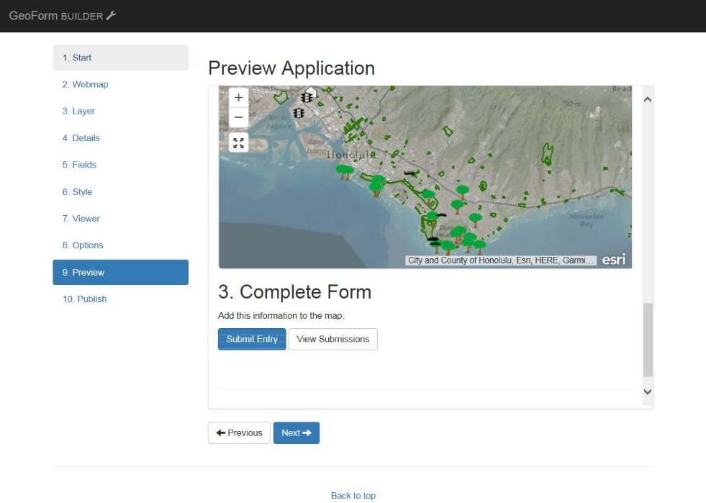
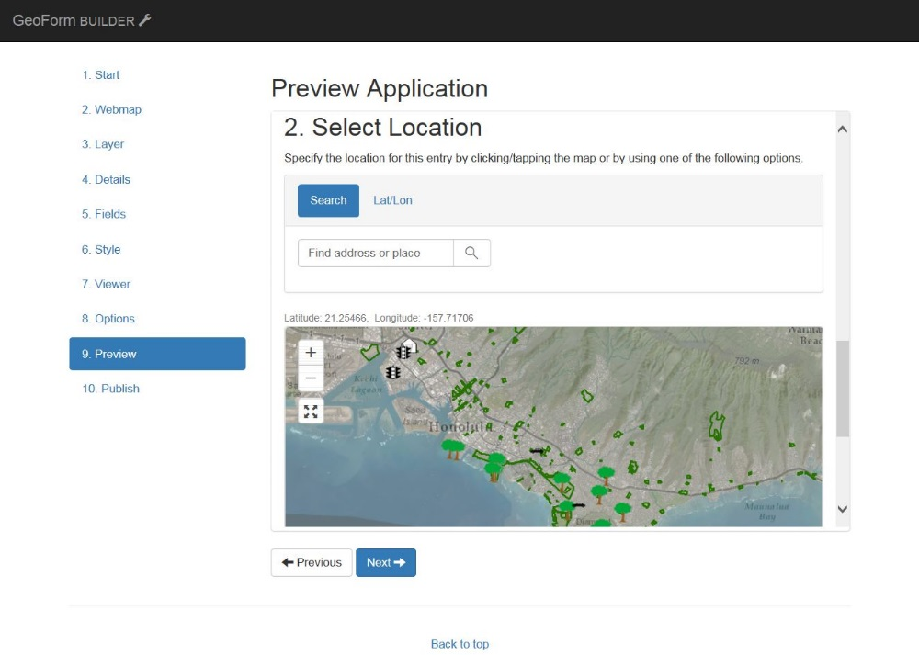
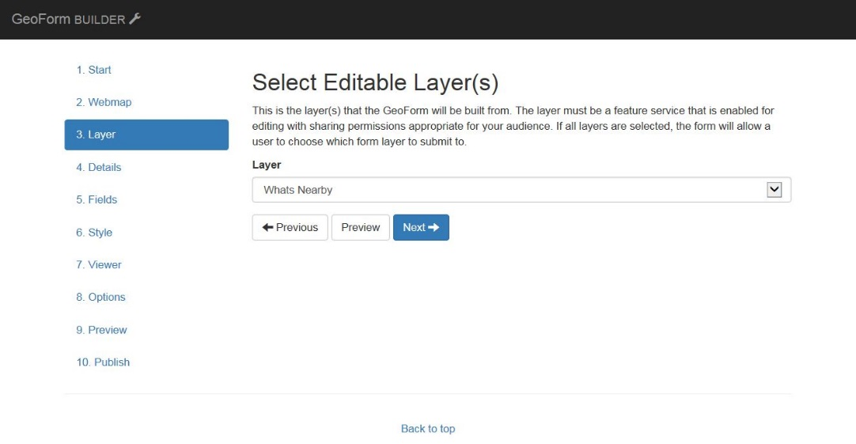

Wrapping Up
ArcGIS Online provides an easy way for users to create and share maps. The free public account does, of course, have some limitations, when compared with an organizational account. For example, you cannot upload image files to your My Content folder with a public account, but this functionality is possible with an organizational one. But even with the public account, you probably noticed that there are many other features of this mapping platform that weren’t covered in this guide. However, this introduction should give you the foundation for continuing to explore the options on your own.
Much of how and what you learn will be by trial-and-error—even with this guide. So take the time to discover the different tools and templates, the data and displays. See how geospatial data can enhance your digital information and make data more meaningful by adding the geographic element!

Reference
Images from http://www.arcgis.com

Updated November 2015 by Marcus Wieland Updated May 20, 2016 by Anna Yu
Updated by Ajnadeen Al-Shawa

UNIVERSITY OF WATERLOO GEOSPATIAL CENTER
https://uwaterloo.ca/library/geospatial/

