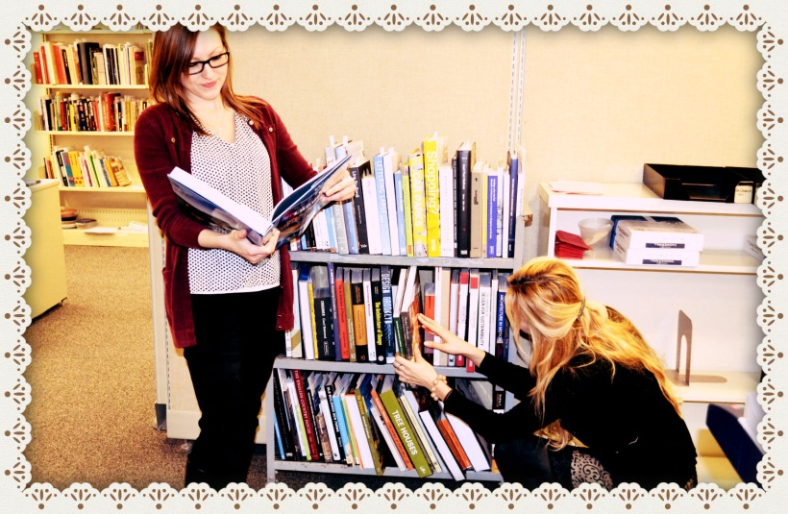

Have you ever wondered how a book gets ordered? Find out how we do it through our Approval Plans!

Most book requests are generated through the Liaison Librarians. Vendors will ship books based on the liaison librarians’ profiles. These profiles include different information about the types of books that are wanted, such as the type of subject, format, budget etc.  This is one of the ways books are received and is called a “*physical plan*.” Once the books arrive at the library, they automatically go to the ***Approval Unit***—the unit that initially deals with the books. The liaison librarians will then come and review the books in order to decide which ones are useful for their subject. It is important that librarians review the books relevant to their subject since vendors send books covering a wide range of subject areas, such as philosophy, psychology, sciences etc. Once decided, the liaison librarians will put their initials on the slips that are found in the books—this tells the Approval Unit that they have accepted and approved these books. Any books that are not wanted are sent back to the vendor. The Approval Unit then creates a brief bibliographic and holding record for the books and the ***Invoicing Department*** will pay for the books. The books are then sent, on trucks, next door to the Cataloguing Department.

Stay tuned to find out what happens to the book in the Cataloguing Department!