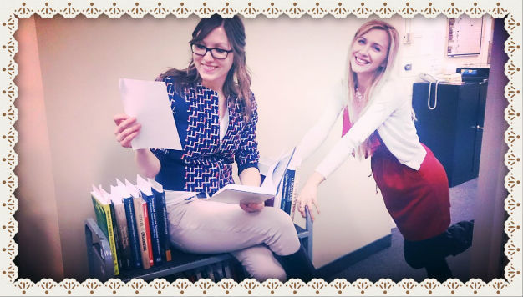

Find out what happens to the book in the Library Clerk Derived Cataloguing department!

Once the Approval Unit has accepted and approved the books requested by the Liaison librarians, they then get sent, on trucks, next door to the ***Library Clerk Derived Cataloguing department***. The staff here then takes the books and shelves them in date order. The staff in this part of the Cataloguing department works only with books whose bibliographic records can be found in the Library of Congress catalogue. The bibliographic record that has been created by the Approval Unit, for example, is built on, edited and made perfect by copying bibliographic information from the Library of Congress library. For instance, information that is copied from an LC to a UW record includes the call number, title and author, contents note and any other information that the Library of Congress has added to the record. They also create access points for students to locate the books they are looking for. In addition, while copying the record, the staff here also corrects any mistakes found in an LC record and adds any missing information. If a book’s record is not in the Library of Congress catalogue, then it is put aside and left for the Cataloguers to do. We will explore how the cataloguers work with a non-Library of Congress bibliographic record next time!

Previous post: [How a book gets ordered](https://uwaterloo.ca/library/library-lens/blog/post/library-lens-week-1)