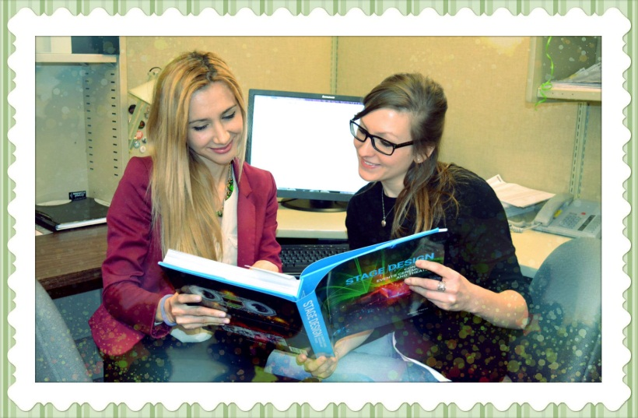

Find out what happens to the book in the (actual) Cataloguing Department!

When a Cataloguer receives a book, he or she will have to copy a bibliographic record from another University’s OPAC (if it exists) or will have to develop one from scratch! When developing a bib record from scratch, Cataloguers will follow appropriate Anglo-American Cataloging Rules (AACR2), Resource Description and Access (RDA) rules and follow appropriate MARC21 coding practices. They will also catalogue a book in a different language and will assign call numbers from scratch using the Library of Congress Classification System. They will also add entries for authors, series and subjects—entries that are crucial in helping you find the book you’re looking for. Once the bib record is created for the book, the cataloguer will place an RFID (Radio-frequency identification) tag on the inside of the book (in order to be able to track the book and see who has signed it out once it becomes available to students). After this final step is completed, the book then goes to the Item Prep Department. Tune in to find out what else happens to the book in the Item Prep Department!!

Alex & Meredith