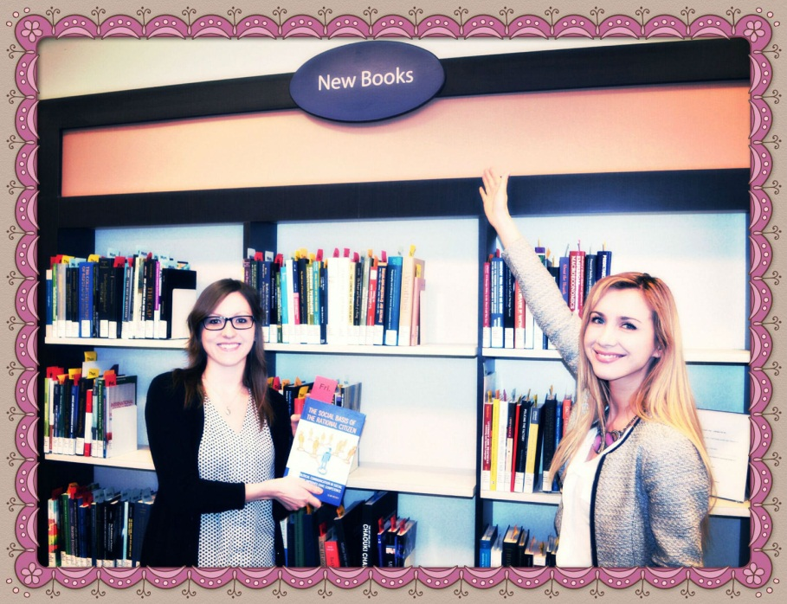

The “**New Books**” Shelf

Once Item Prep has finished preparing the books, Circulation staff will then bring the books, on a book truck, down to the Main Floor. The books are then placed on the “New Books” shelf, found beside the Information Desk. The books are left on the New Books shelf for a whole week in order to give patrons an opportunity to explore new and exciting titles that are available at the library. A flag, that specifies the day of the week, is placed inside each book. This guides Circulation staff as to when to take the book off the shelf. For example, if the book gets placed on the shelf on Wednesday, the flag will say “Wed” and therefore, the book will be taken off the shelf on the Wednesday of the following week.

The books on the New Shelf are shelved differently from the stacks. Although classified alphabetically by call number, similar to the stacks, the books are organized differently. For example, the top shelf can have books ranging from A to F, the second range from G to L and so on. In addition, each bay (or section of the shelf) contains books from different days of the week.

Stay tuned to find out what Circulation staff does to the new books once a full week has passed!

Thanks,

Alex & Meredith