Word Search

Can you find all the Library resources?

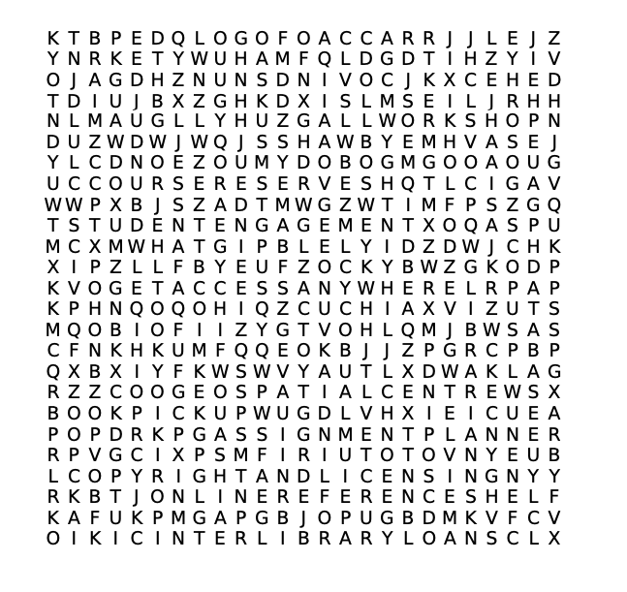

omni | interlibrary loans | get access anywhere
online reference shelf | student engagement | geospatial centre
course reserves | database | librarian
ask us | assignment planner | scopus
copyright and licensing | book pickup | workshop

