Co-op Students’ Council — Pre-read Information from WatPD

1. What does WatPD do?
- WatPD was founded in 2006 as a means to grant academic credit for work terms.
- You can think of WatPD as the lecture to the workplace’s lab. Students learn new concepts in their PD courses outside of work hours (the lecture) and put those concepts to the test in the workplace (the lab).
- Every PD course is designed to address employer wants and needs. The program gives students the opportunity to consciously develop their professional skills in a focused manner early in their career.

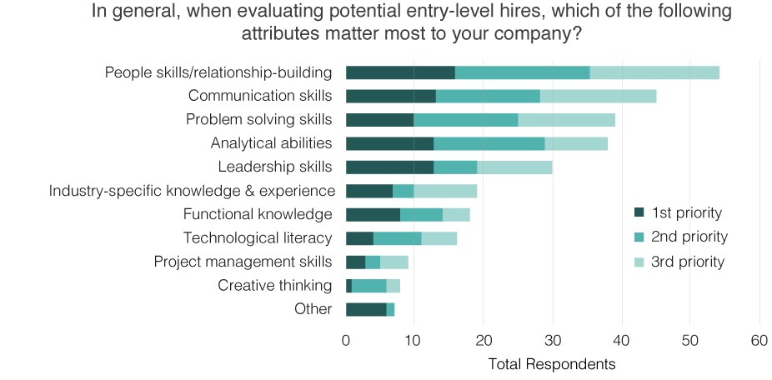
Canadian Council of Chief Executives (CCCE)

Source: “Preliminary Survey Report: The Skill Needs of Major Canadian Employers.” Canadian Council of Chief Executives. January 2014.

2. What are WatPD’s values?
We’ve spent the last few months outlining a set of core values that define our approach to professional development and student support. These values inform our communication with students, staff, faculty, and employers, and we’re committed to expressing them through our courses as well.

Workplace success
- We know the skills we help students develop are crucial for success in the workplace.
- We know that students who make an active effort to connect our courses to the workplace will excel.
- We know that WatPD, the co-op program, and academic study work in concert to help every Waterloo student maximize their employability.
- We want to help every student understand the importance of lifelong learning. Successful professionals need to continue developing their skills for the entirety of their careers.

We’re invested
- Our WatPD team is largely made up of students like you. We hire dozens of co-op students every term, and all of them understand the pressures and struggles that can arise over the course of a work term.
- We’re committed to providing our students with clear, thorough feedback and quick, comprehensive solutions to their issues.
- We’re always trying to improve the support we offer our students, and we take feedback about our processes and service seriously.

Compelling courses
- Our courses are all designed by experts to meet employer needs, and some of them offer pathways to professional standards and certificates.
- We know our courses will help students develop their skills faster than they could manage through trial and error alone.
- We’re always working to make our courses more relevant and engaging, and we take feedback about our content and assessments seriously. Our courses get better when students tell us about their experiences.

3. How can we work together?
WatPD is hoping to conduct a focus group with CSC members and other students this term. We’re hoping to learn more about students’ experiences with the program and any potential changes they’d recommend. Here are the details:
- The focus group will last about an hour.
- We’ll host the focus group at our offices in EC1.
- We’re looking for 10-12 participants. Students from all faculties and with all levels of experience are welcome.
Our plan moving forward is to work with Franco and the CSC to select an appropriate time for the focus group. We’re also planning to intensify our outreach efforts towards other key student groups on campus (e.g. student societies). These new connections may result in the creation of additional focus groups in the terms to come.

