Acrobat Pro uninstall and reinstall

This document is for users who have Adobe products installed before the University site license was activated.

What is happening and why
You have older versions of Adobe Creative Cloud and Acrobat Pro installed.
When you open Acrobat Pro either from Creative Cloud Desktop or from the Desktop shortcut, the title bar shows it is the 32-bit version. Some systems will show the name as Adobe Acrobat Pro DC as in these screen shots. These instructions work in both cases.
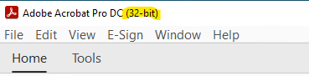

What you need to do
Make sure you close all Adobe products except for Creative Cloud Desktop then sign out of your account in Creative Cloud Desktop.
Make sure you know your administrative account credentials (username and password) in case you get prompted for them.
Sign in with your UW email address (8 character WatIAM ID, not friendly email) and select ‘Company or School Account’. You will go through the familiar process of a UW sign in using your WatIAM password and Duo authentication.
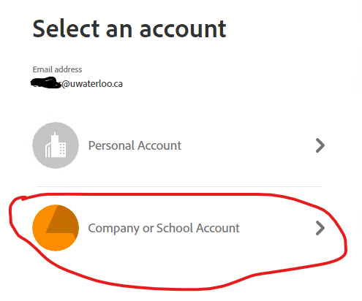
In Creative Cloud Desktop, under Installed, find Acrobat and click on the three dots on the right-hand side. Select Uninstall.
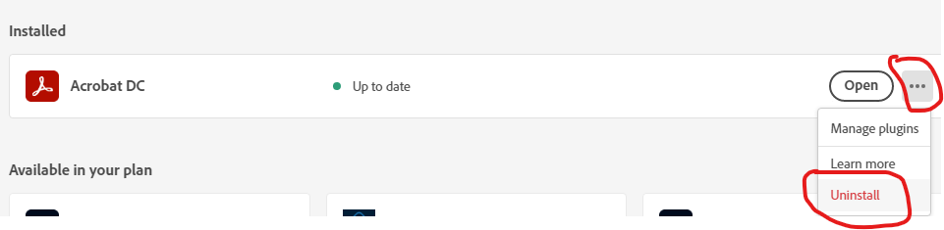
If you get a conflict message, close the listed applications, and then continue. Allow the uninstall to complete.
Now Acrobat appears as ‘Available in your plan’. Click the Install button.
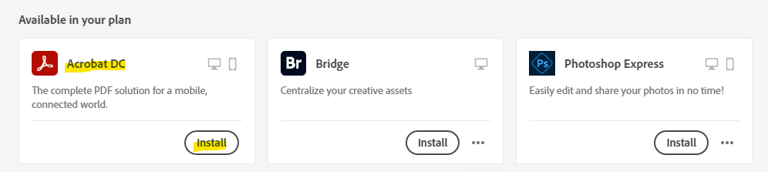
Allow the install to complete. The install includes downloading the installation files so it can take some time.
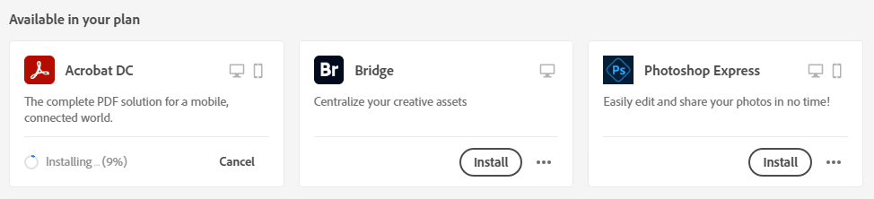
The slow progress warning is normal. Don’t be alarmed.
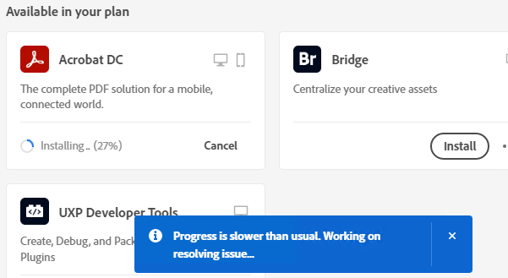
Once the installation is complete, open Acrobat and it will show as being the 64-bit version.
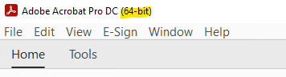
Creative Cloud Desktop and Acrobat will update regularly to stay at the latest versions. Accept any pop ups to install upgrades or updates.

