Academic Plan and Program Tracker Instructions
- Open the template with the Academic Plan Tracker Template link that can be found on the Graduating with Multiple Credentials website.
Once opened, your excel workbook should look like the figure below. Note, you may need to scroll horizontally and vertically to view the entire document.
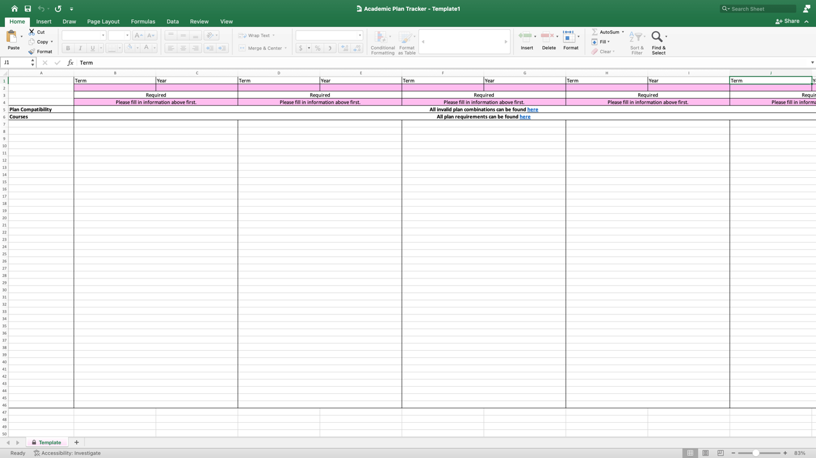
- Once the template is open, you can start filling out your plan information.
- Start by filling out the term and year that you declared your plan. Click on the pink highlighted cells and choose from the drop-down menus.
If you are not sure which term your plan applies too, refer to your plan modification form you sent in to change your plan.
You can also reach out to your academic advisor if you aren’t sure which term to follow. All academic advisor contact information can be found here.
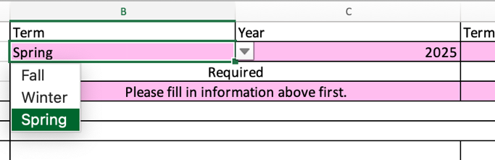
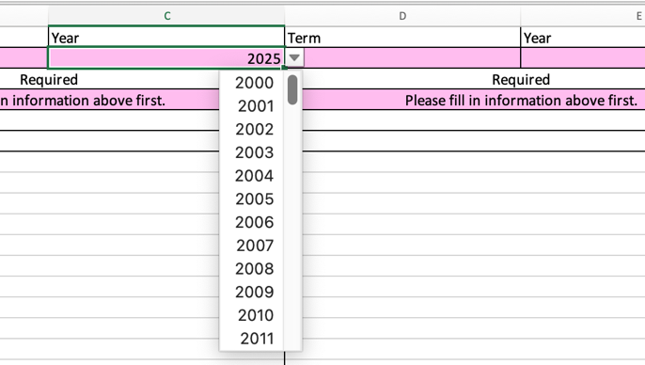

- Next, click on the cell that says “Required” to choose from a drop-down menu of the different plan options.
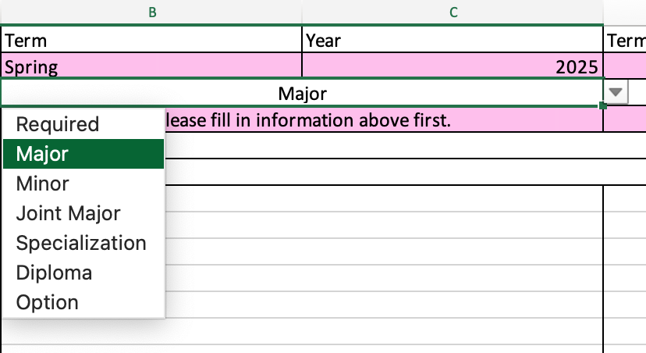
- Once you have done steps a) and b), type in the cell the title of your credential. For example, Statistics.
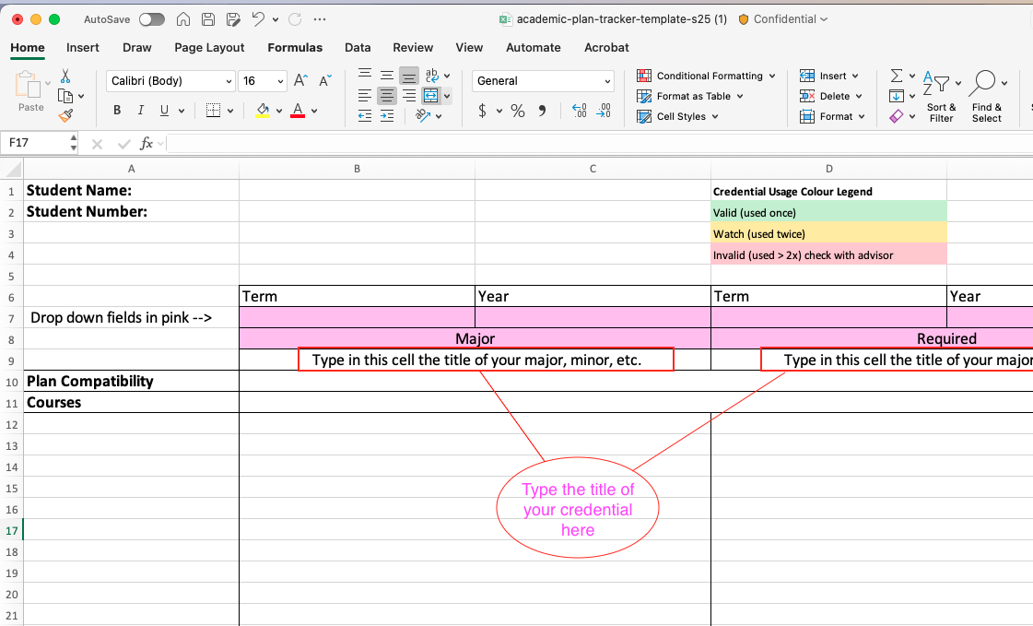
- Once you add your plan, please check if your plans contain invalid combinations.
Row 10, the “Plan Compatibility” row, provides a link that will bring you to the school’s official invalid credential list (see figure below). Also, it is always good to check with your academic advisor to confirm your plan is valid.
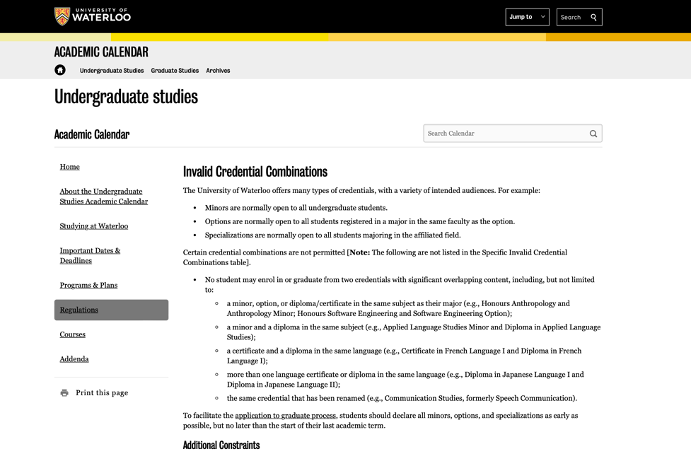

- Once you have entered all your plan information, it is time to start filling out your course requirements.
- Start by opening the University of Waterloo’s undergraduate studies calendar by clicking the cell that says, “All plan requirements can be found here”.
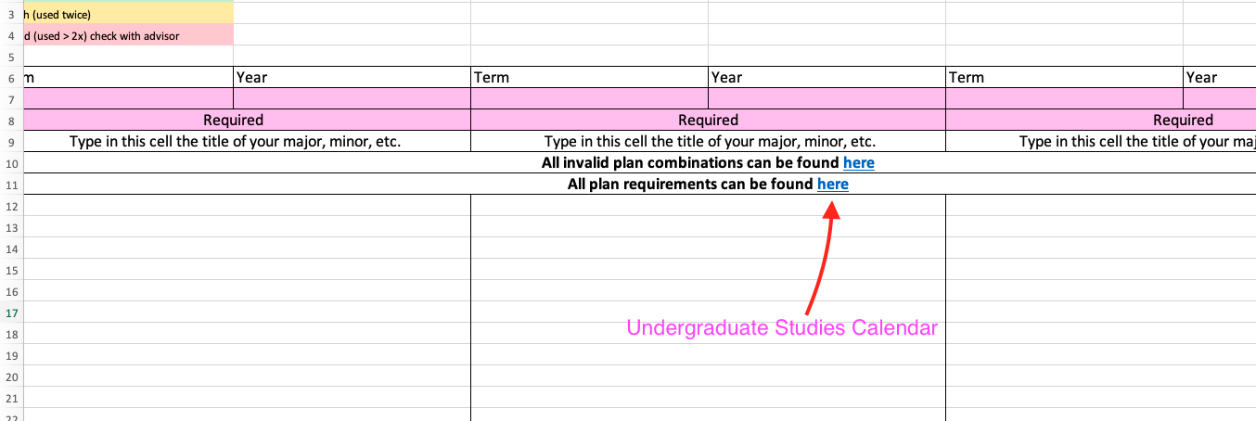
- Click on the “Archives” on the top bar to access Undergraduate Studies Archived Calendars.
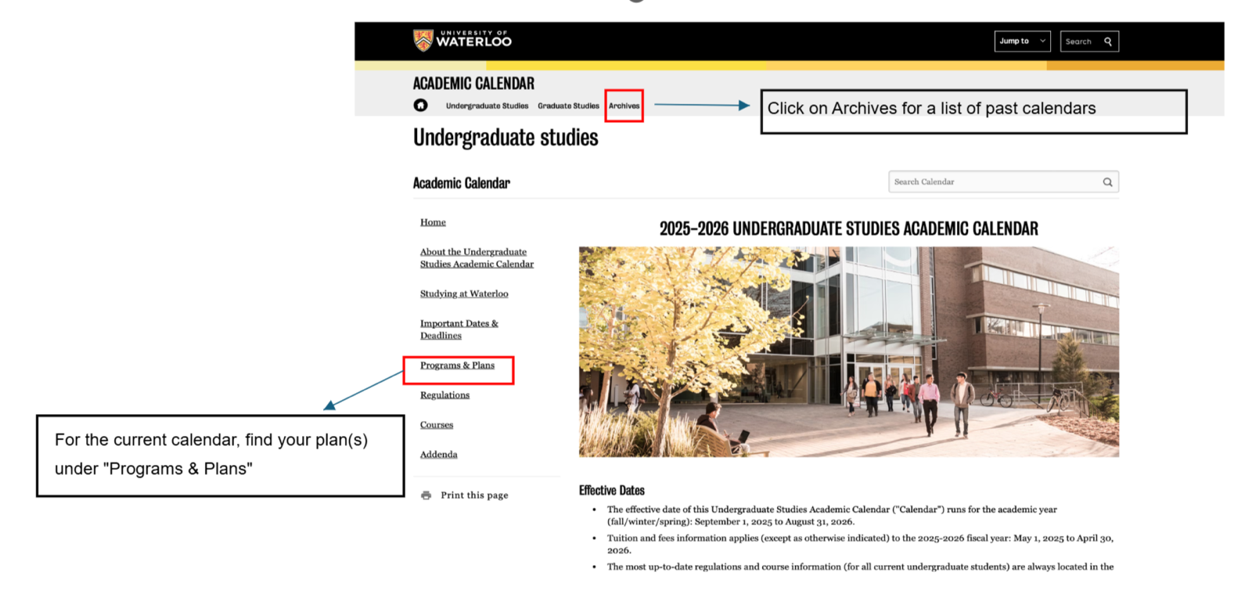
- Click on the correct calendar year for your plan. Once you’ve selected the correct calendar year, click on the link that will have your corresponding plans.
- Once you have found your plan, look at the requirements for your plan.

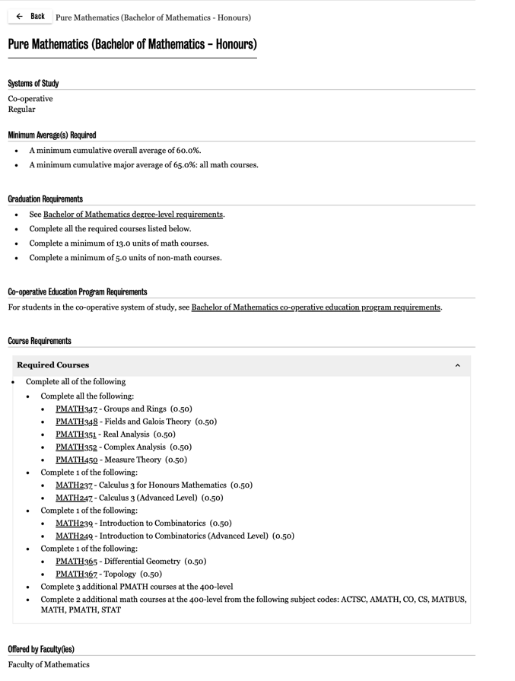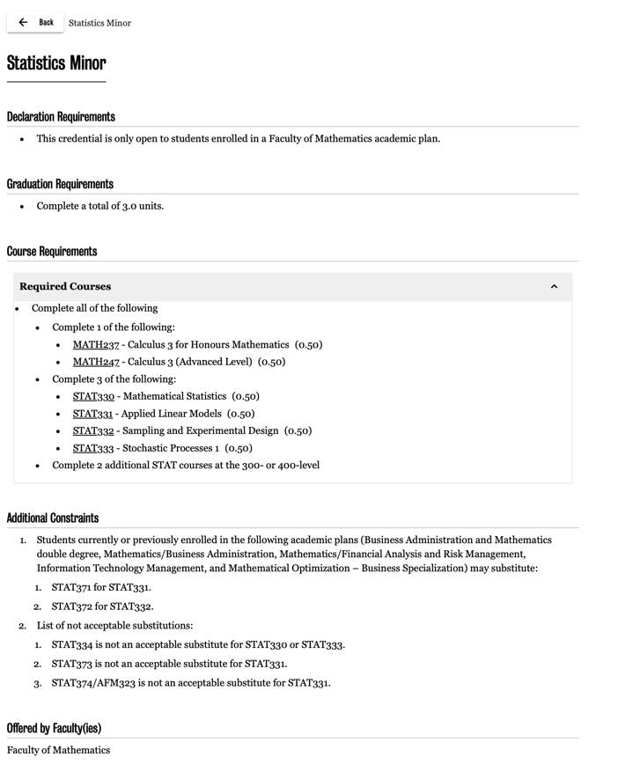

- Now, go back to your excel template, and start filling in the courses you’ve taken in the left most column under the cell that says “Courses”.
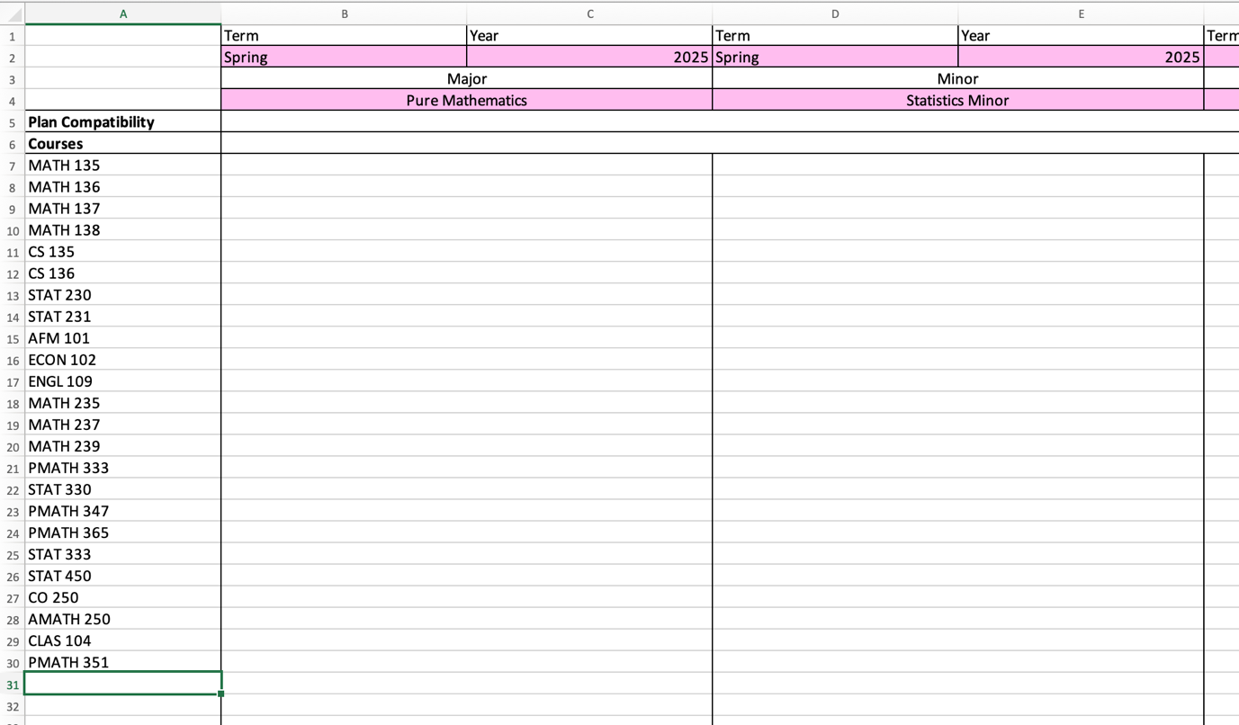

- Next, you are going to compare the courses you have taken and the requirements for your plan and keep track of what course is required for what plan.
This can be done however you would like, but we recommend keeping track of which list or table your courses are coming from. See the example below.
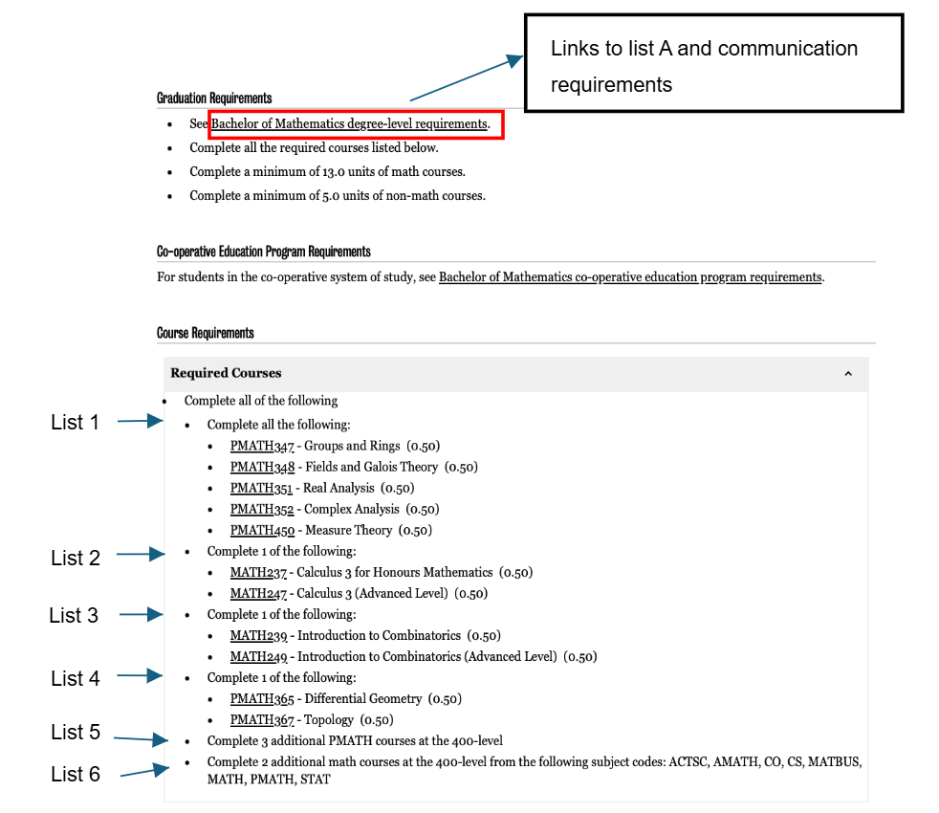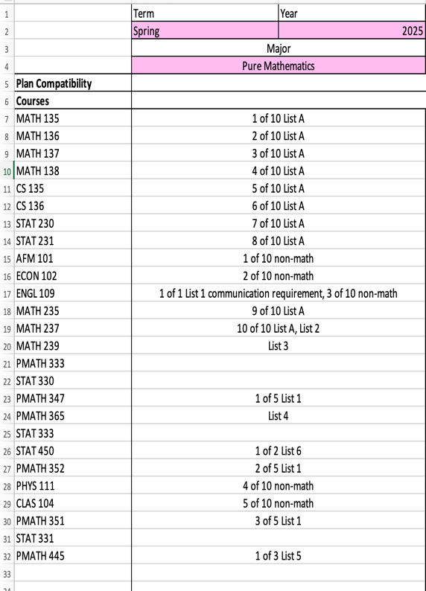

- Once you have gone through steps 1-3, you can review your excel sheet for your course compatibility.
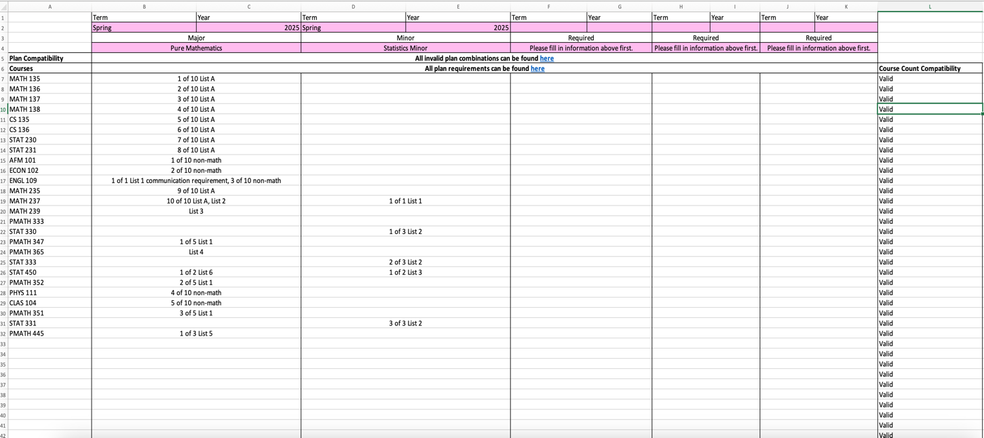

If the cells below “Course Count Compatibility” only say “Valid”, then your courses follow the counting of courses rule, and you are fine.
If you get a warning message in any of these cells, it means you have used a course to satisfy too many credentials, and it becomes invalid.
Contact your academic advisor to see if there are any alternatives if a warning message appears.

IMPORTANT: Students are responsible for their academic progress through to graduation. They must follow all requirements of their academic plan(s) (including co-operative education requirements, if applicable). Source: Student Responsibility for Degree Requirements

