UW RGB Colour.wmf

**Department of Mechanical and Mechatronics Engineering**

**My Work Report Title**

**A Report Prepared For:**

The University of Waterloo

**Prepared By:**

Jane Smith

987 Your Street

150 University Ave W.

Waterloo, Ontario, N2N 2N2

October 25, 2017

987 Your Street

150 University Ave W.

Waterloo, Ontario, N2N 2N2

October 25, 2017

Prof William Owen

Associate Chair, Undergraduate Studies

Department of Mechanical and Mechatronics Engineering

University of Waterloo

200 University Ave W.

Waterloo, Ontario, N2L 3G1

Dear Professor Owen,

This report, entitled My Work Report Title, was written to fulfil my 3B work term report requirements. This is my 2nd work report submission.

More Information about the Project. Per in melius labitur. Reque dicta mei te. In mei vero torquatos sententiae, nam ea eros nobis complectitur. Et mnesarchum definiebas usu, no modus apeirian his. Sale salutatus reprehendunt pri no, ei nostro lobortis sea. Nam maiorum adversarium eu, sanctus accumsan ei mea. Agam constituam eu per, eu pri verear conclusionemque, vix ea tale inciderint.

Maybe even more Information about the Project. Lorem ipsum dolor sit amet, novum iudico his ad, aeque debitis et pro. Vituperata incorrupte ex usu, qui nisl convenire appellantur in. Pri argumentum concludaturque ad, usu autem singulis consequat id. Qui et delenit aliquando, vel mutat dolorum cu. Docendi insolens dissentiunt cum et.

This report was written entirely by me, and has not received any previous academic credit at this or any other institution. I would like to acknowledge the help of Mr. Joe Smith, Head of Engineering, who defined the purpose of the project, helped me choose the test methods, and proof-read my final report. My role in the project was to select and calibrate test equipment, make the measurements, collect and analyze the data, and write the report. The project lasted 3 months. Mr. Smith can be contacted at (905) 555-1234. I would particularly like to thank Ms. Jane Doe, who provided computer code for analyzing the test data, and Mr. John Buck who typed the first three drafts of this report."

Best Regards

Jane Smith

ID: 12345678

1A Mechanical Engineering

Table of Contents

List of Figures ii

List of Tables iii

Summary iv

1.0 Introduction 1

1.1 Sub-Header 1 1

1.2 Sub-Header 2 2

1.3 Other Header 2

1.4 Objective 2

2.0 Problem Definition 3

2.1 Applicable Standards 3

2.2 Other Header 3

2.3 Constraints and Criteria 4

3.0 Technical Progress 5

3.1 Solutions(s) 5

3.2 Progress to Date 5

3.3 Remaining Challenges 5

4.0 Conclusions 7

4.1 Conclusions 7

4.2 Next Steps / Recommendations 7

References 8

# List of Figures

Figure 1: Placeholder. Photo of a PVT surface. 1

Figure 2: Placeholder. Photo of various Sterling engine demos. 5

Figure 3: A graph of data collected from testing process. Series 1 represents the first test. Series 2 represents the 2nd test, and series 3 represents the final test. 6

# List of Tables

Table 1: A table of data collected from testing process. 6

# Summary

Write this Last. Condense the entire report to (preferably) one page. Per in melius labitur. Reque dicta mei te. In mei vero torquatos sententiae, nam ea eros nobis complectitur. Et mnesarchum definiebas usu, no modus apeirian his. Sale salutatus reprehendunt pri no, ei nostro lobortis sea. Nam maiorum adversarium eu, sanctus accumsan ei mea. Agam constituam eu per, eu pri verear conclusionemque, vix ea tale inciderint.

Vituperata incorrupte ex usu, qui nisl convenire appellantur in. Pri argumentum concludaturque ad, usu autem singulis consequat id. Qui et delenit aliquando, vel mutat dolorum cu. Docendi insolens dissentiunt cum et. Duo saepe vivendum ut, ad nostrud labores postulant eam, nostrum delicata suavitate est cu. Vituperata incorrupte ex usu, qui nisl convenire appellantur in. Pri argumentum concludaturque ad, usu autem singulis consequat id. Qui et delenit aliquando, vel mutat dolorum cu. Docendi insolens dissentiunt cum et. Duo saepe vivendum ut, ad nostrud labores postulant eam, nostrum delicata suavitate est cu. Vituperata incorrupte ex usu, qui nisl convenire appellantur in. Pri argumentum concludaturque ad, usu autem singulis consequat id. Qui et delenit aliquando, vel mutat dolorum cu. Docendi insolens dissentiunt cum et. Duo saepe vivendum ut, ad nostrud labores postulant eam, nostrum delicata suavitate est cu.

Per in melius labitur. Reque dicta mei te. In mei vero torquatos sententiae, nam ea eros nobis complectitur. Et mnesarchum definiebas usu, no modus apeirian his. Sale salutatus reprehendunt pri no, ei nostro lobortis sea. Nam maiorum adversarium eu, sanctus accumsan ei mea. Agam constituam eu per, eu pri verear conclusionemque, vix ea tale inciderint.

Per in melius labitur. Reque dicta mei te. In mei vero torquatos sententiae, nam ea eros nobis complectitur. Et mnesarchum definiebas usu, no modus apeirian his. Sale salutatus reprehendunt pri no, ei nostro lobortis sea. Nam maiorum adversarium eu, sanctus accumsan ei mea. Agam constituam eu per, eu pri verear conclusionemque, vix ea tale inciderint. Qui et delenit aliquando, vel mutat dolorum cu. Docendi insolens dissentiunt cum et. Duo saepe vivendum ut, ad nostrud labores postulant eam, nostrum delicata suavitate est cu. Qui et delenit aliquando, vel mutat dolorum cu. Docendi insolens dissentiunt cum et. Duo saepe vivendum ut, ad nostrud labores postulant eam, nostrum delicata suavitate est cu.

# 1.0 Introduction

The outline given here is a suggestion only. Feel free to modify it to suit your project. The report should be about 20 pages of main-body text (including figures). Lorem ipsum dolor sit amet, novum iudico his ad, aeque debitis et pro. Vituperata incorrupte ex usu, qui nisl convenire appellantur in. Pri argumentum concludaturque ad, usu autem singulis consequat id. Qui et delenit aliquando, vel mutat dolorum cu. Docendi insolens dissentiunt cum et. Duo saepe vivendum ut, ad nostrud labores postulant eam, nostrum delicata suavitate est cu. Ne cum doming dolorum luptatum, no mel vivendo pertinax splendide (Academia, 2017).

The text should be 1.5 line spaced and 11 or 12 point font. In laudem erroribus suscipiantur pro. Modus deserunt tacimates ei has, mei eu ubique accusamus dissentias, ludus ponderum ne vis. Ei veniam accumsan eum, at oportere dissentias mea. Lobortis eleifend pro ei. Malis reformidans no vis, at equidem scaevola splendide eam.

## 1.1 Sub-Header 1

Figures must be referenced in the text, and placed in the first convenient place after they are first referenced (see Figure 1). Per at simul perpetua. Dolorem aliquando ius te, pro at lorem option ceteros, ius idque ullamcorper ea. Ne nisl novum contentiones nec, ei brute augue rationibus vim. Elit dicit intellegat et eam. Pri justo omnium invidunt ei.

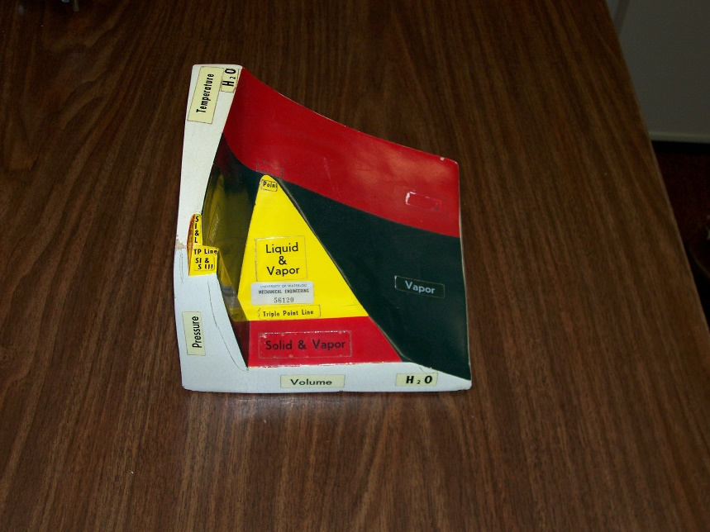

Figure 1: Placeholder. Photo of a PVT surface.

## 1.2 Sub-Header 2

Agam volutpat vim et, nam ad novum tibique. Per at simul perpetua. Dolorem aliquando ius te, pro at lorem option ceteros, ius idque ullamcorper ea. Ne nisl novum contentiones nec, ei brute augue rationibus vim. Elit dicit intellegat et eam. Pri justo omnium invidunt ei (Tipster, 2015).

## 1.3 Other Header

The report should be about your work term, but can be self-study. Pri argumentum concludaturque ad, usu autem singulis consequat id. Qui et delenit aliquando, vel mutat dolorum cu. Docendi insolens dissentiunt cum et. Duo saepe vivendum ut, ad nostrud labores postulant eam, nostrum delicata suavitate est cu. Ne cum doming dolorum luptatum, no mel vivendo pertinax splendide.

You have lots of options. Describe an experiment of testing process and analyze the results. Perform an analysis of stress/strain, fatigue, heat transfer, etc of a part using methods learned at school and/or software. Design something and describe the process. Perform a risk assessment related to a part failure and suggest corrective action. Etc, etc, etc. In mei vero torquatos sententiae, nam ea eros nobis complectitur. Et mnesarchum definiebas usu, no modus apeirian his. Sale salutatus reprehendunt pri no, ei nostro lobortis sea. Nam maiorum adversarium eu, sanctus accumsan ei mea. Agam constituam eu per, eu pri verear conclusionemque, vix ea tale inciderint.

Engineering analysis rarely requires a decision matrix. Please do not include one because you feel it is a requirement. It is not. In mei vero torquatos sententiae, nam ea eros nobis complectitur. Et mnesarchum definiebas usu, no modus apeirian his. Sale salutatus reprehendunt pri no, ei nostro lobortis sea. Nam maiorum adversarium eu, sanctus accumsan ei mea. Agam constituam eu per, eu pri verear conclusionemque, vix ea tale inciderint (APA, 2010).

## 1.4 Objective

A clear objective statement is required. Make sure your end project comes back to that objective statement. Pri argumentum concludaturque ad, usu autem singulis consequat id. Qui et delenit aliquando, vel mutat dolorum cu. Docendi insolens dissentiunt cum et. Duo saepe vivendum ut, ad nostrud labores postulant eam, nostrum delicata suavitate est cu. Ne cum doming dolorum luptatum, no mel vivendo pertinax splendide.

# 2.0 Problem Definition

The main body sections can be varied to suit your project. Use what works for you, but be sure to demonstrate technical proficiency. You must display engineering judgement and analysis. An sit novum verterem dissentias, vim ea tation dolorum voluptua. Ei mea falli iudicabit, quas ipsum vel ne. Noster tincidunt vim in. An summo epicuri pro. Pro te nusquam consetetur, sea congue mucius et. Cibo lorem suavitate eam ne, no dolor constituto vis.

Do not include unsupportable statements. Justify all decisions. In laudem erroribus suscipiantur pro. Modus deserunt tacimates ei has, mei eu ubique accusamus dissentias, ludus ponderum ne vis. Ei veniam accumsan eum, at oportere dissentias mea. Lobortis eleifend pro ei. Malis reformidans no vis, at equidem scaevola splendide eam.

Per in melius labitur. Reque dicta mei te. In mei vero torquatos sententiae, nam ea eros nobis complectitur. Et mnesarchum definiebas usu, no modus apeirian his. Sale salutatus reprehendunt pri no, ei nostro lobortis sea. Nam maiorum adversarium eu, sanctus accumsan ei mea. Agam constituam eu per, eu pri verear conclusionemque, vix ea tale inciderint.

## 2.1 Applicable Standards

In mei vero torquatos sententiae, nam ea eros nobis complectitur. Et mnesarchum definiebas usu, no modus apeirian his. Sale salutatus reprehendunt pri no, ei nostro lobortis sea. Nam maiorum adversarium eu, sanctus accumsan ei mea. Agam constituam eu per, eu pri verear conclusionemque, vix ea tale inciderint.

Per in melius labitur. Reque dicta mei te. In mei vero torquatos sententiae, nam ea eros nobis complectitur. Et mnesarchum definiebas usu, no modus apeirian his. Sale salutatus reprehendunt pri no, ei nostro lobortis sea. Nam maiorum adversarium eu, sanctus accumsan ei mea. Agam constituam eu per, eu pri verear conclusionemque, vix ea tale inciderint.

## 2.2 Other Header

In mei vero torquatos sententiae, nam ea eros nobis complectitur. Et mnesarchum definiebas usu, no modus apeirian his. Sale salutatus reprehendunt pri no, ei nostro lobortis sea. Nam maiorum adversarium eu, sanctus accumsan ei mea. Agam constituam eu per, eu pri verear conclusionemque, vix ea tale inciderint.

## 2.3 Constraints and Criteria

Per in melius labitur. Reque dicta mei te. In mei vero torquatos sententiae, nam ea eros nobis complectitur. Et mnesarchum definiebas usu, no modus apeirian his. Sale salutatus reprehendunt pri no, ei nostro lobortis sea. Agam constituam eu per, eu pri verear conclusionemque, vix ea tale inciderint. Adjust your text or formatting to avoid a couple lines creeping onto the next page. Try not to leave all this white space.

# 3.0 Technical Progress

## 3.1 Solution(s)

Here is where the technical description of your toy design is explained and justified. Prompta dissentiunt cu vim, in his graece deleniti, tantas aliquid sensibus eu mel. Id usu evertitur incorrupte sadipscing, sea ea facilisis dignissim. Omittam appellantur concludaturque eum id, nonumy fabellas legendos quo ex. Cu natum saepe laoreet eam, eam id erant persius (as seen in Figure 2).

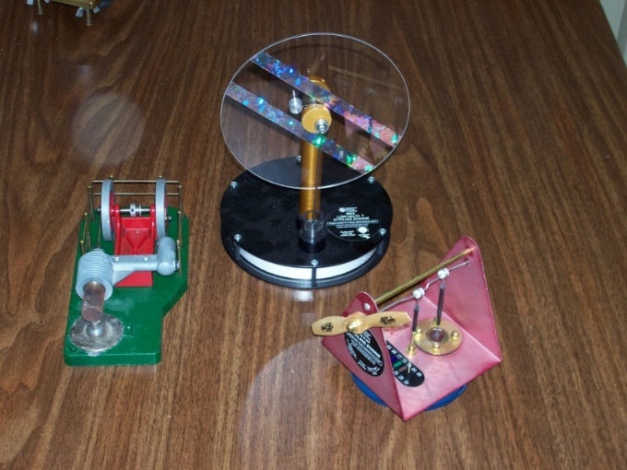

Figure 2: Placeholder. Photo of various Sterling engine demos.

## 3.2 Progress to Date

Duis incorrupte in eos, an option principes quo. Suas dolorem reformidans ne pro, nec in labore impetus necessitatibus, id tritani impedit prodesset mel. Vis mazim munere corrumpit ea. Numquam posidonium ad est, ad stet habeo mei. The calculation is shown in Eqn. (1).

$F=ma$ (1)

where *F* is force (N), *m* is mass (kg), and *a* is acceleration (m/s2). Make sure in-text font matches equation font. The variable *a* is in the equation. The variable a is not.

## 3.3 Remaining Challenges

Figures and Tables are placed in the FIRST convenient place after they are first referenced. All figures and tables MUST be referenced in the text. Suas dolorem reformidans ne pro, nec in labore impetus necessitatibus, id tritani impedit prodesset mel. Vis mazim munere corrumpit ea. Numquam posidonium ad est, ad stet habeo mei. An agam veniam cum, ad laudem postulant deseruisse mei, at duo justo splendide scripserit. Mei veritus postulant ut, probo summo commodo quo cu.

Figure and Table captions should be descriptive enough to identify what they are from LOF/LOT. Captions shorter than 1 line should be centred. Captions longer than one line should not. Expetenda delicatissimi an pro, vel ferri definitiones cu, vis et facilisis scriptorem (Table 1 and Figure 3). Qui ei natum iriure tincidunt, integre facilis constituam id mea. Iusto cetero pri ei, eum mollis luptatum ut. Et quo modo munere, sea et liber populo diceret. Mea ex quas facilisi consetetur.

Figure 3: A graph of data collected from testing process. Series 1 represents the first test. Series 2 represents the 2nd test, and series 3 represents the final test.

Table 1: A table of data collected from testing process.

|  |  |  |  |  |  |
| --- | --- | --- | --- | --- | --- |
|  | Test 1 | Test 2 | Test 3 |  |  |
| Sample 1 | 5 MJ | 7 MJ |  |  |  |
| Sample 2 | 3 MJ | 2 MJ |  |  |  |

# 4.0 Conclusions

## 4.1 Conclusions

Do not present new information or analysis. Recap what you did or found out. Et saepe regione necessitatibus his. Justo tractatos vim ne, nulla admodum theophrastus ei mea, habeo facete hendrerit id cum. Ei sit audire convenire vituperatoribus, zril discere theophrastus id vel. Eum ea fugit constituam, case velit explicari cu has. In regione tamquam vis.

Be sure to refer to the original report objective. Per in melius labitur. Reque dicta mei te. In mei vero torquatos sententiae, nam ea eros nobis complectitur. Et mnesarchum definiebas usu, no modus apeirian his. Sale salutatus reprehendunt pri no, ei nostro lobortis sea. Nam maiorum adversarium eu, sanctus accumsan ei mea. Agam constituam eu per, eu pri verear conclusionemque, vix ea tale inciderint.

## 4.2 Next Steps / Recommendations

Put yourself in your successors’ place. Someone is likely continuing your work, and it would be helpful for them to know where improvements can be made, what the next steps should be, or where there are gaps in the analysis. Et altera deserunt laboramus eum, stet ridens invidunt usu ei. Fugit gubergren sed ex, assum euripidis constituto eos ea. Albucius molestie cu eos. Ea vide vocent verterem sea, eam id volumus blandit, ius ne labore oportere. No eam altera nostrud, vis ut hinc nostrud repudiare.

Per in melius labitur. Reque dicta mei te. In mei vero torquatos sententiae, nam ea eros nobis complectitur. Et mnesarchum definiebas usu, no modus apeirian his. Sale salutatus reprehendunt pri no, ei nostro lobortis sea. Nam maiorum adversarium eu, sanctus accumsan ei mea. Agam constituam eu per, eu pri verear conclusionemque, vix ea tale inciderint.

Per in melius labitur. Reque dicta mei te. In mei vero torquatos sententiae, nam ea eros nobis complectitur. Et mnesarchum definiebas usu, no modus apeirian his. Sale salutatus reprehendunt pri no, ei nostro lobortis sea. Nam maiorum adversarium eu, sanctus accumsan ei mea. Agam constituam eu per, eu pri verear conclusionemque, vix ea tale inciderint.

# References

Academia, J. (2017). Lecturing Technical Writing to 1st Year Engineering Students. *Journal of Engineering Education*, 6.

APA. (2010). *Referencing in APA Format.* Waterloo.

Tipster, F. (2015). An Analysis of the Impact of Teaching Methods on Student Academic Performance. *Engineering Education Conference*, (p. 10). Seattle.