Predictors of Happy, Healthy Relationships

**Monday, November 25 at 2:30pm in ML 349**

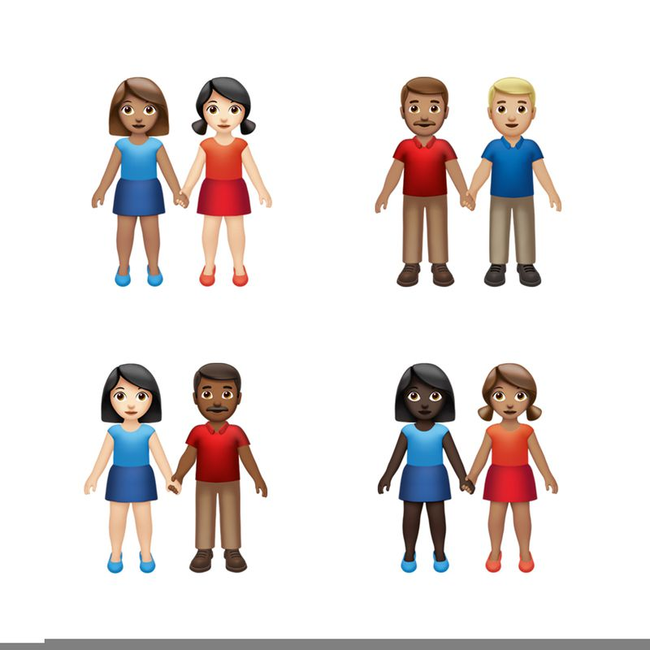

A free, research-oriented talk in partnership with the Centre for Mental Health Research & Treatment and 16 Days of Activism Against Gender-Based Violence. Find out more about all the 16 Days activities happening across campus at: uwaterloo.ca/16-days.

What does the research tell us about what makes a happy, healthy relationship? Join us to find out more about relationship patterns, communication, and sexual satisfaction!

**Light refreshments will be provided.**