Blood Pressure 101
What is it?
- The pressure or force exerted against the blood vessel walls
What do the numbers mean?
- 120 Systolic - measure of the pressure when your heart contracts (beats) and pumps the blood.
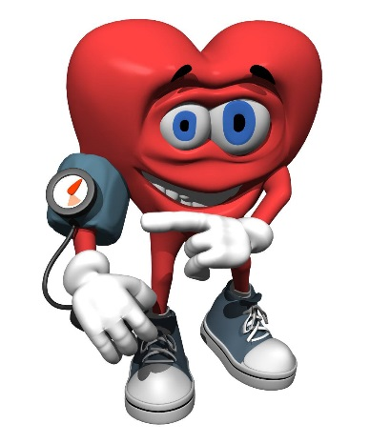
- 80 Diastolic - measure of the pressure when your heart relaxes between beats.
Blood Pressure Ranges
Category | Systolic/Diastolic
Normal | 120-129/80-84
High-Normal | 130-139/85-89
High Blood Pressure (Hypertension) | 140/90 or higher

Blood Pressure 101
What is it?
- The pressure or force exerted against the blood vessels walls
What do the numbers mean?
- 120 Systolic - measure of the pressure when your heart contracts (beats) and pumps the blood.
- 80 Diastolic - measure of the pressure when your heart relaxes between beats.
Blood Pressure Ranges
Category | Systolic/Diastolic
Normal | 120-129/80-84
High-Normal | 130-139/85-89
High Blood Pressure (Hypertension) | 140/90 or higher

Where can I check my blood pressure?

- Occupational health nurses
- Health services kiosk
- Kiosk at your local pharmacy
- Family Doctor’s office
- Home self-monitoring

How to manage blood pressure?
- Healthy eating
> Monitor sodium intake (2000mg per day) | > Low fat dairy products
> Emphasize fruit, vegetables, and fiber | > Leans meats, or plant based proteins
- Stress management
- Regular physical exercise
- Weight Reduction
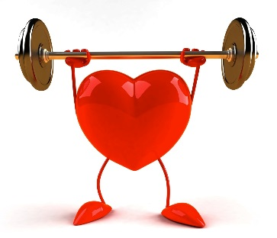
- Make healthy lifestyle choices (quit smoking, reduce alcohol consumption)
Where to find more information?
- Heart and Stroke Foundation website
- Hypertension Canada website
- Occupational Health Nurses @UW
- Your family Doctor

Where can I check my blood pressure?

- Occupational health nurses
- Health services kiosk
- Kiosk at your local pharmacy
- Family Doctor’s office
- Home self-monitoring

How to manage blood pressure?
- Healthy eating
> Monitor sodium intake (2000mg per day) | > Low fat dairy products
> Emphasize fruit, vegetables, and fiber | > Leans meats, or plant based proteins
- Stress management
- Regular physical exercise
- Weight Reduction
- Make healthy lifestyle choices (quit smoking, reduce alcohol consumption)
Where to find more information?
- Heart and Stroke foundation website
- Hypertension Canada Website
- Occupational Health Nurses @UW
- Your family Doctor

