PARTNERING TOGETHER FOR CHANGE
“What I really liked is that we have staff, management, we have family members, some residents, all coming together around the table and talking about common goals.”

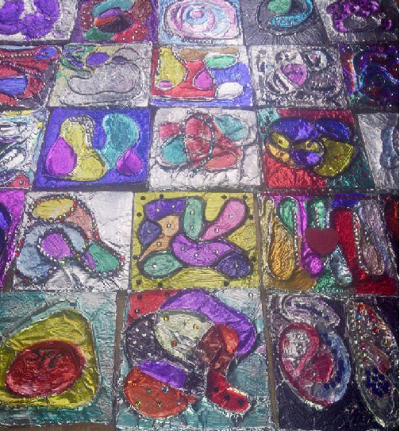
Living Quilt - made by residents representing Bloomington Cove’s unique community.
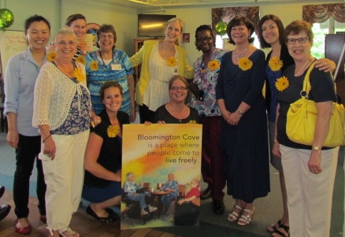

“It’s actually changed…my leadership style...It hit home with me…there’s always an opportunity…to talk to them appreciatively and
ask and seek their input and I think being an advocate of that has taken me a long way.”

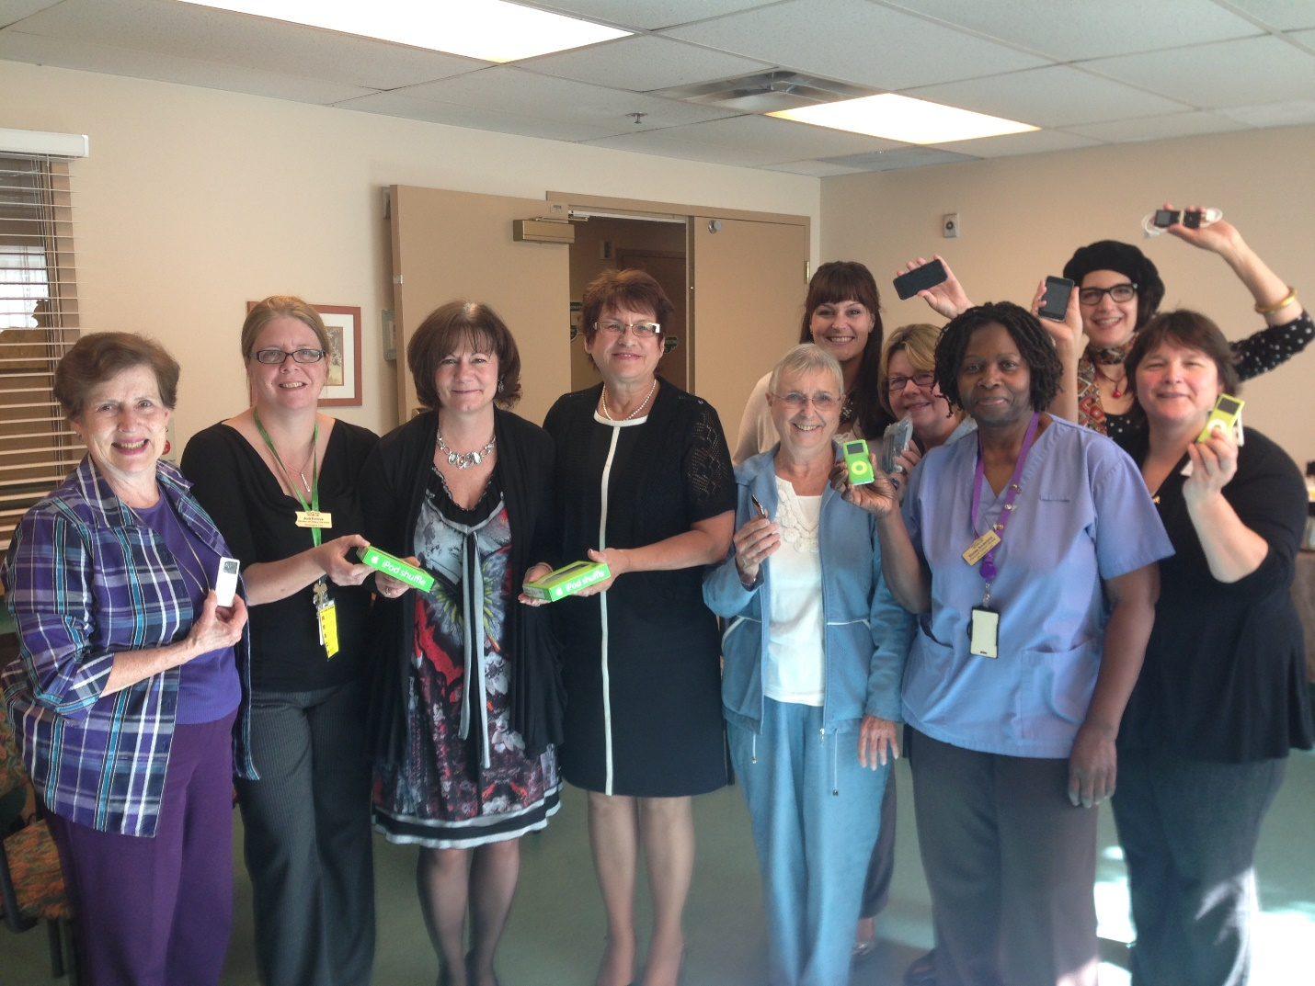
“It’s more confidence I think is maybe a better word, confidence in their relationships, more human relationships.”

