HURON COUNTY PARTNERS FOR DEMENTIA SUPPORT
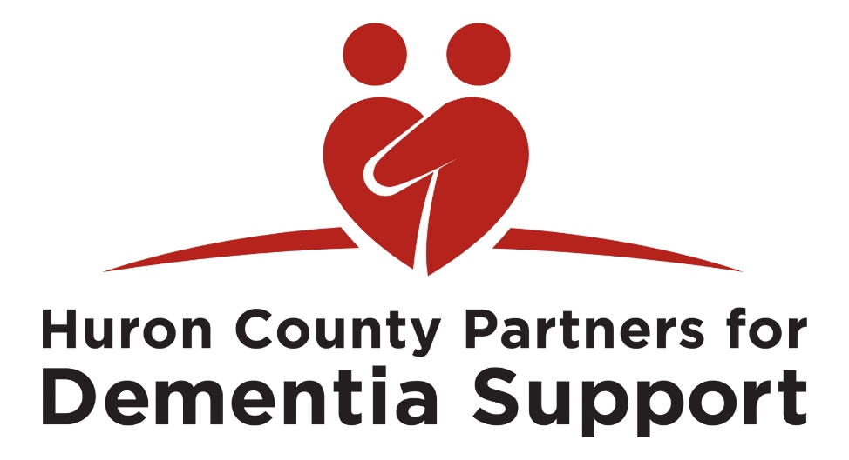
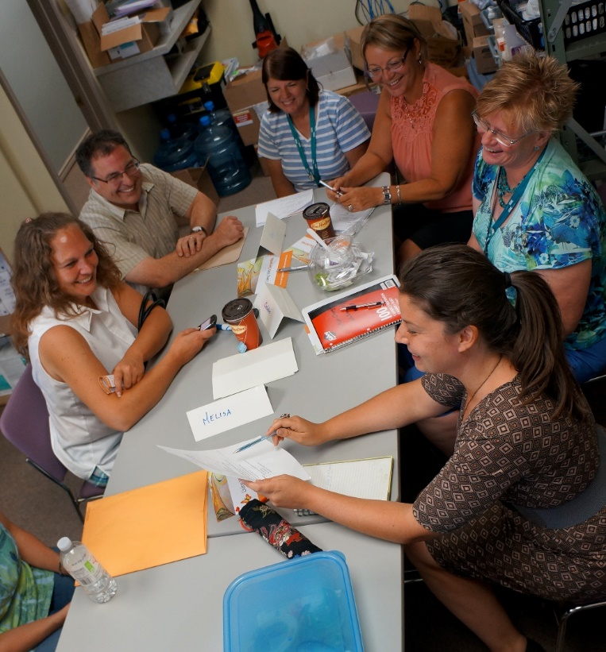

“My awareness and my interest is peaked. I want to know more, I want to know how can I look after my clients better? how can link them better? support them better at home. It’s been my linkages here…hearing that we are struggling with same issues… I have benefited from that. So building those relationships is what I have seen...”

“Have them tell you what they need, and just listen. Stop focusing on what we think they need… you got to see them for where they are today…make them feel comfortable and building that trust.
Really listen, hear what they have to say – both the person with dementia and their family.
Work together as a team and really build that relationship.”

“I have become more aware of the need for culture change and advocate for it at every opportunity. I make every effort to be empathetic in all my interactions with people with dementia, their families and professionals.”
